COUNTRY REPORT MAP FOCUSING ON
BORDER POINTS, PLANTATIONS AND VEGETATIONS

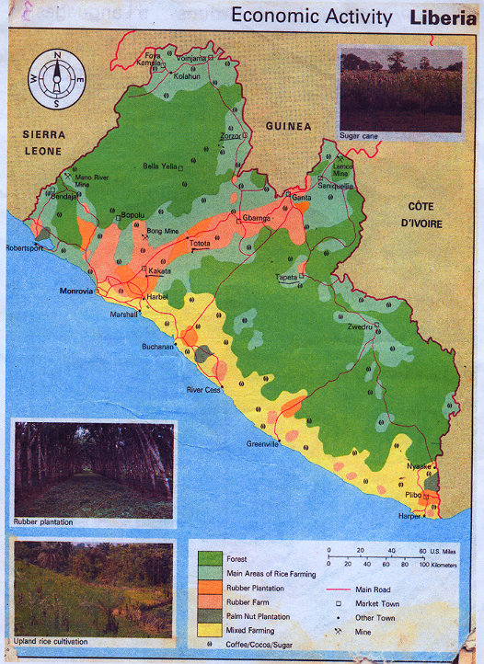
COUNTRY REPORT
BY LIBERIA NPPO, OCP, IPP AND TECHNICAL COORDINATOR
NATIONAL QUARANTINE AND ENVIRONMENTAL SERVICES

I. Introduction: Liberia

Liberia is an English speaking country found on the western coast of Africa.

Country: Liberia, Capital: Monrovia. Independent: July 26, 1847

Boundaries: Atlantic Ocean, 579 km; Guinea, 563 km; Ivory Coast, 716 km, and Sierra Leone, 306 km.

Population: 3,482,211 or 3.5 million

Area: 111,370 sq km (water 15,050 sq km and land 96,320 sq. km)

Climate: Tropical; hot, humid; dry winters with hot days and cold nights; wet, cloudy summers with frequent heavy showers.

Terrain: Flat to rolling coastal plains rising to rolling plateau and low mountains in northeast.

Season: Raining season (April to October) dry season (November to March)

Agriculture products: Rubber, Palm Oil, Kola Nut, Coffee, Cocoa, Rice, Cassava, Sugar Cane, Banana, Assorted vegetable, cattle, sheep, Goat, Pig, Poultry and Timber. Most of these are not on large scale farming.

Export Agricultural Commodities:
- Logs, timbers, palm products, cocoa, coffee, kola nuts and other wide forest fruits (bitter kola nuts), etc.

Because of the 15 years civil crisis in the country most of these products are not exported again. For now, there is a ban on logs and timbers from Liberia.

The only commodities that are exported are rubber and processed foodstuffs.

II. National structure for the exchange of information, including responsibility and pathway:

The country capacity is not yet built to that extent.

III. What systems are in place for information exchange?
There is a national communication services (radio, postal, new journals and/or paper, telephone, fax, e-mail and internet systems but on a commercial basis

IV. What data is currently available compared to that which is obligatory under the IPPC.
The only data available is that which is on wood packaging materials treatment which I have copies on hand for your information.

V. Summary of country’s internal as well as external Phytosanitary date bases. For either, how many records, what categories, how often updated?

The internal as well as external Phytosanitary data bases, has not been placed on electronic format as text documents (e.g. ward) or the link. Most information is kept on file and in cabinet as references.

VI. Summary background internet infrastructure in the country particularly in the Government.

There is an internet programme in Liberia, but it is on commercial bases. The Ministry of Agriculture is not connected to this system nor, does she have enough computers in her offices.

Most of my work is done at the FAO-Liberian Headquarter, whenever I have any information

- Brief summary of (past/present) experience with using the IPP… including the pros and cons in each WS-participating country.

I have no past/present experience with using the IPP. in the Liberia’s case.

The pros to the IPP WS- in country are that:
1. The availability of electricity or source of energy
2. Have a website or internet system in your countries and be computer literate.
3. Have a computer with its necessary programs and accessories.
4. Having the necessary logistics and stationery for research.

The cons to the IPP WS – in countries that are contacting parties will be, to not have in place any of the above mentioned pros.

VII. Is there state province as well as national data collection for Phytosanitary information?

No. We only regulate Phytosanitary Measures, Zoo-sanitary ,Chemical Applications, and issue import and export permit, and prepare Certificates for active growth ,live and processed products.

VIII. What are the capacity building needs – in summary?
1. We need Desktop and Laptop computers with printers.
2. Vehicles to assess and monitor the various border points and agricultural plantation.
3. An office furnished with needed and useful stationery
4. Source of energy that will provide electricity for the equipment.
5. Establishment of a laboratory
6. Training of technicians and expertise in the various fields of Phytosanitary measures.

Submitted by:

Augustus B. G. Fahnbulleh
NPPO, OCP, IPP-FAO/MOA -LIBERIA

DATA FOR USE DURING THE WORKSHOP
TO UPDATE LIBERIA INFORMATION ON THE IPP

1. Official Contact Point – Article VII 2

The NPPO of Liberia accepts and adopts all bullet-points (a) to (i), but line two (2) of Article VV 2 (b)
“Publish and transmit Phytosanitary requirements” is not yet ready for Liberia. Said document will be published and transmitted at a later date.

2. Description of NPPO and Changes – Article IV 4:

The description of Liberia NPPO is known as; “Plant and Animal Quarantine”. The “Act” was established in 1949-50 and revised in the Liberian Codes of Law, Volume II: Page 90 in 1973. Also we abide by all Phytosanitary conventions and measures in the regions and international scene.

It shall be the purpose of this Chapter to prevent entry into Liberia of injurious plant and animal pests and diseases existing in foreign countries; to prevent the spread of such pests and diseases should they become established in Liberia; and to promulgate rules and regulations to govern export and import of plants and animals to conserve dwindling species and protect the food supplies of the Republic.

“Plant” shall be construed to mean living plant materials and products of every description, and “Animals” shall be construed to means all non-human animal life and its products.

In 1991 after the IPPC 1979 revised text, the service was re-named “National Quarantine and Environmental Services”. This formation added to the service additional responsibilities of monitoring the movement and applications of agro-chemicals in the Agro-sectors of the Republic, food safety and soil.

3. Non-compliance – Article VII 2 (f):

This point is accepted and adopted.

4. List of regulated pests Article VII 2 (i)

It will be submitted during our publication and transmission.

5. Pest reporting – Article IV) 2 (b)

This point is accepted and adopted.

6. Exchange of information – Article VIII 1 (a)

This point is accepted and adopted.

7. Technical and biological information necessary for PRA- Article VIII 1 (a)

This point is accepted and adopted.

8. Specified points of entry – Article VII 2 (d)

To avoid the many communication exchange, we suggest for such a consignments be shipped or transported directly from exporting country to the importing without passing through transit points, and be declared as “Restrictive Consignment” whereby information will only be submitted by those countries involve.

9. Organizational arrangements for plant protection – Article IV 4

The “National Quarantine and Environmental services” of Liberia is arranged as followed:

a) Deputy Minister for Technical Services
b) Technical Coordinator or Expertise
c) Director
d) Station Supervisors and
e) Technicians

10. Emergency action – Article VII 6

This point is accepted and adopted.

11. Phytosanitary requirements, restrictions and prohibitions – Article VII 2 (b)

This point is accepted and adopted.

12. Adequate information on pest status – Article VII 2 (j)

This is point is accepted and adopted.

13. Rationale for Phytosanitary requirement, restriction and prohibitions – Article VII 2 (c)

This point is accepted and adopted.

