Spodoptera frugiperda, a new invasive pest on maize in Sao Tome and Principe

On April 15, 2016, the FAO Sub-Regional Office of FAO for Central Africa (SFC) received an official request from the Minister of Agriculture, Fisheries and Rural Development of Sao Tome and Principe (dated April 14, 2016) for assistance in dealing with an infestation of the maize crop caused by an insect pest, Spodoptera Sp (the exact identity of the species was not known at this point), so as to find a lasting solution to this apparently recurrent problem.

In response to this request, a mission was dispatched to the country from 24 to 29 April 2016 to assess the extent of the problem. Surveys were conducted in the main maize producing areas, namely in Porto Alegre, Pinheira, Canavial, Obo Moro, as well as BECAF (Experimental Centre for Food and Forestry Crops) that produces maize seeds among others. Interviews were also held with various departments of the Ministry of Agriculture and with farmers to take note of their perception of the problem.
According to information provided by the Ministry of Agriculture, the national maize production in 2014 amounted to 815 tons. In 2015, losses caused by the pest were estimated at 20% and total production was 651.92 tons. Loss of production for 2016 was estimated at 40%. It was also estimated that 750 producers, covering virtually all maize growers, were somehow affected by the infestation. The seed production capacity of BECAF, which is responsible for seed multiplication and maintenance of crop varieties including maize, was affected. A total of 5 hectares of maize planted by this center were destroyed by the pest. Overall, the results of surveys carried out during the mission confirmed widespread infestation rate ranging from 93% to 100% in most visited fields (see table 1 below). The severity of the infestation was such that country’s maize production was greatly compromised.

Table 1: Infestation observed in the locations visited by the assessment mission.

N° | LOCALITY | OBSERVATIONS
1 | BECAF | The crop was at flowering and cob formation stage 100% of the plants were attacked, with severe damage.
2 | Porto Allegre | The crops in the fields were at four different phenological stages: emergence, 5 to 7 leaf stage, stems elongation stage and cob/grain formation. The infestation rate was estimated at 93%.
3 | Pinheira | Cobs well developed (soft and hard dough stages). The infestation rate was moderate (due probably to earlier planting by farmers of this area). Nevertheless, pest attack was visible on younger plants that were sown as replacements of non-germinated seeds.
4 | Obo Moro | Very heavy infestation observed and all the fields were affected. Some farmers have abandoned their fields because of the severity of the infestation.
5 | Canavial | Because of infestation by this pest, some farmers decided to produce sugarcane instead of maize. The level of infestation was the same as in the other areas visited.

Samples of the infested plants were collected and diagnosed at the Entomology Laboratory at CIAT (Agricultural Research and Technology Centre). Larval specimens examined under the microscope, revealed distinguishing characteristics on the head capsule and the abdominal segments that are peculiar in Spodoptera frugiperda, a new world species. Given that no known records of this species were reported in Africa before, larval and adult samples were sent to Dr. Georg Goergen (G.Goergen@cgiar.org) at the International Institute of Tropical Agriculture (IITA) in Benin for further diagnosis. Molecular (DNA) and male genitalia studies were performed on these samples, as well as other samples received concurrently from some countries on the mainland. The results of the DNA barcoding were able to confirm that the species is indeed Spodoptera frugiperda. The other samples that reached IITA from the mainland (Nigeria, Benin and Togo) were also identified as S.frugiperda, even though it was found out that the haplotype from Sao Tome and Principe is different from the ones from the mainland, meaning that there might have been multiple introductions of the species.

This leads to the relevance of this information, that we have an invasive species on an important food crop that poses risks of introduction in other countries in West and Central Africa, especially given the weak phytosanitary services and porous borders in most of the countries in these sub-regions.

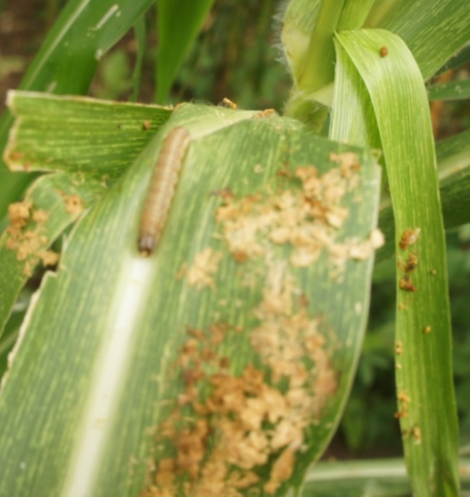
In this regard, a letter was sent to the Minister of Agriculture in Sao Tome and Principe officially informing him about the confirmed identification of the species, and seeking his permission to publish the report on the International Phytosanitary Portal. This permission was granted through a letter sent to SFC on 20 July 2016.
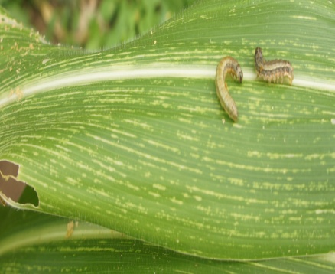
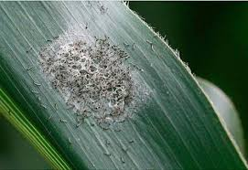
B
A
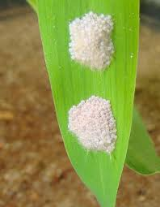
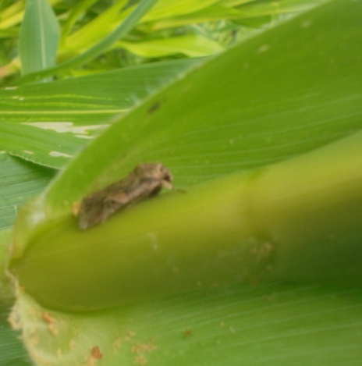
D
E
C
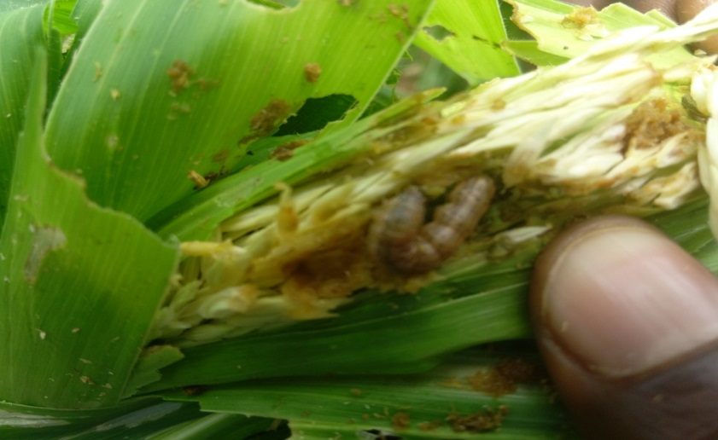
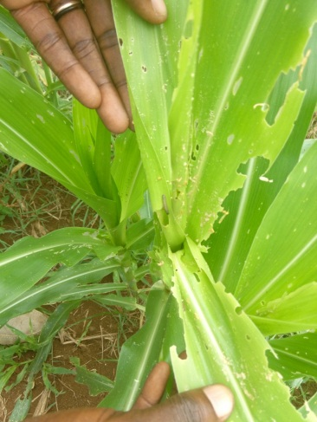
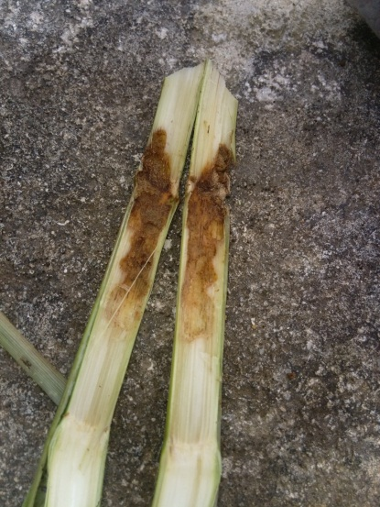
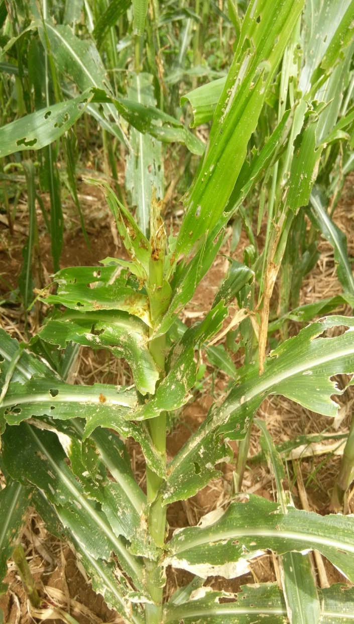
Figure 1: Damages of S. frugiperda on maize: A (adult); B (eggs); C (neonatal larva); D (larva); E (larva and damages );
F (male inflorescence); G (whorl); H (stem); I (whole plant)

F
I
H
G

The mission was conducted by Mr. Sankung B. SAGNIA, plant production ant protection officer at SFC.

