Torres Strait Protected Zone and the Torres Strait Permanent Biosecurity Monitoring Zone
The islands of Torres Strait, while part of Australia, hold a special biosecurity designation. Under the Biosecurity Act 2015, no plant or animal material or soil can be moved from Papua New Guinea into the Torres Strait Protected Zone; southwards from the Torres Strait Protected Zone to the Torres Strait Permanent Biosecurity Monitoring Zone; or onto the Australian mainland or Tasmania without meeting biosecurity regulations. Live animals and live plants are not permitted to be moved from Papua New Guinea to Torres Strait at any time.
This is in recognition of the additional risks posed by proximity to Papua New Guinea and the traditional movement of indigenous people between certain villages in Papua New Guinea and islands in the Torres Strait Protected Zone.
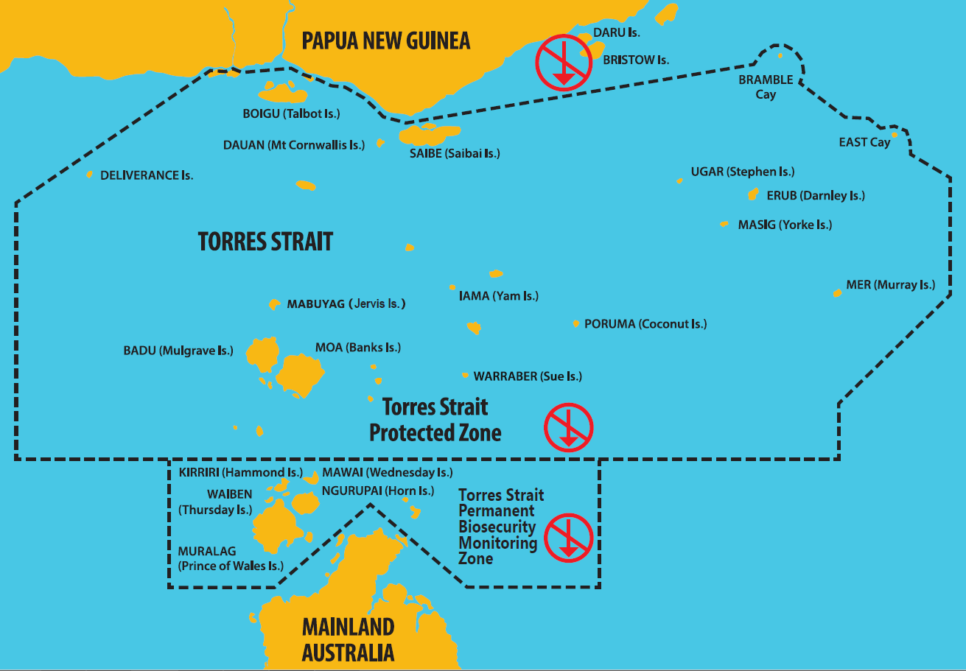
Map showing movement restrictions in Torres Strait under the Biosecurity Act 2015
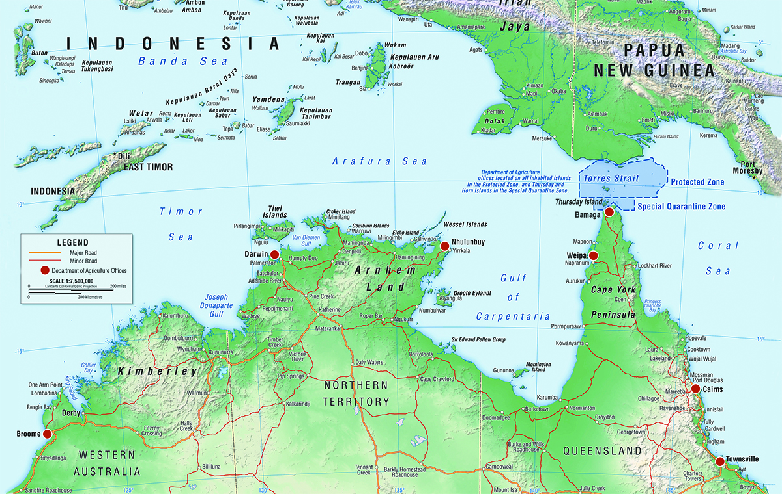
Map of Northern Australia, illustrating the Torres Strait. The closest commercial production area is more than 600 km away from the southern part of the Torres Strait, in Lakeland Downs.

