TECHNICAL CONSULTATION AMONG REGIONAL PLANT PROTECTION ORGANIZATIONS
Eighteenth Session
Rome, 11-14 September 2006
A Case Study on Fruit Fly Surveillance in the Pacific

A Case Study on Fruit Fly Surveillance in the Pacific
Nacanieli Waqa, Roy Masamdu, Ema Tora Vueti, Sidney.Suma, Biosecurity & Trade Support Team, Land Resources Division, Secretariat of the Pacific Community, Suva, Fiji Islands.

Backgroud
1. Fruit flies of the Family Tephritidae constitute one of the world’s major groups of insect pests of fresh fruit and fleshy vegetables. In every Pacific island country and territory (PICT), there is at least one pest species present. These are serious pests infesting a wide range of edible fruits and vegetables. It has been recognized that unless fruit flies are understood and managed effectively, the prospects for improving the production and marketing quality of fresh fruits and vegetables can be limited including the development of a good horticultural export industries.
2. In the past ten years, there has been a gradual and steady increase in awareness of the importance of fruit flies in Pacific Island Countries and Territories. This is due to their impact on exports of fresh fruits and vegetables especially to New Zealand and Australia and the incursions of new species into areas and countries. A regionally coordinated initiative on fruit fly management was initiated to address loss of EDB fumigation treatments for fruit fly host commodity exports, loss of overseas markets fresh fruits and vegetables, quarantine threats from exotic fruit fly species, harmonization of quarantine practices in the region, increased public awareness particularly amongst the traveling public on the quarantine threats and risks associated with fruit flies and increased local production and consumption of fresh fruits and vegetables in the islands.
3. The regional initiative included; a regional-wide project funded by FAO, three separate national or sub-regional projects funded by the Australian Centre for International Agricultural Research (ACIAR), a New Zealand and United States co-sponsored collaborative project that included all the PICTs and Hawaii. These operations were all integrated with other nationally initiated country programs. The major project has now ended by the surveillance programmes and area wide management programmes in exporting countries are on-going.

Objectives
4. The objectives of the integrated projects were to:
  - improve knowledge on fruit flies (confirm species and determine host ranges)
  - develop and transfer field control technology for fruit flies
  - develop quarantine treatments to replace EDB fumigation
  - establish quarantine surveillance systems nationally and regionally
  - improve emergency response preparedness nationally and regionally
  - upgrade technical skills of national staff

Regional Fruit Fly Activities
5. The regional fruit fly activities are categorised into four main focus areas.

Determination of species, host plants, distribution and economic importance
6. Surveys were conducted in all of the 22 Pacific Island Countries and Territories (PICT’s). The surveys resulted in the identification of the 22 known pest fruit fly species in the world being found in the PICT’s. The information collected on the host plant specificity of the pest species contributed to testing various quarantine treatment options for fresh fruits and vegetables for export. The host plants were also test for non host status in order to negotiate market access for this class of commodities for export. The information collected on distribution nationally and regionally assisted in enabling countries to establish fruit fly surveillance and monitoring programmes. The studies are determined which species were of economic importance in each of the PICT’s. The above basic information provided the catalyst for the next series of activities.

Establishment of surveillance, emergency response plans and assistance in eradication programmes
7. In each country, staff were trained on fruit fly surveillance methods and assisted with materials for surveillance. A regional fruit fly identification center was established and all specimens were identified and each record entered into a database. Training was also conducted on emergency responses and eradication in which real situation in Nauru was used as an example where staff from different countries were brought in to assist with the eradication program. Since then at least two incursions have been eradicated in Cook Islands and French Polynesia. As there are very close cultural links between many island countries and territories, surveillances is a must as different islands have different species.

Field management and farmer extension
8. SPC has been assisting PICT’s through the regional program to identify suitable management methods. The methods identified and recommended include; protein bait sprays, fruit bagging, tolerant varieties and now area wide pest management. Farmers and extension agents in each country have been trained to adopt suitable and sustainable practices, given the fragile island environments.

Post harvest treatments and market access
9. The systems approach to pest risk management developed by SPC through the regional fruit fly project has also enable countries several countries to export various fruit fly host commodities. The high temperature forced air treatment (HTFA) technology and treatment regime was developed under the project. This treatment option has been adopted in five countries in the region and has proven successful in treating fruit fly host commodities for export. In Fiji, for instance we have achieved substantial increases in range and volume of fruit host commodities exported.

Conclusions
10. The Pacific Regional Fruit Fly Programme has been and is one of the successful regional initiatives undertaken by SPC. The various donors FAO, ACIAR, AUSAID, NZAID, EU, USAID and France have provided generous funds to ensure the programme was successfully implemented. The results thus far, particularly the export trade statistics show the achievements of the programme and the sustainable mechanisms it developed. For small island countries with limited resources, regional collaboration would continue to play a significant role in combating pests and diseases and securing market access for export. Fruit fly management remains and will continue to remain a focal area for SPC-LRD.

Acknowledgment
11. SPC acknowledges FAO, EU, and the Governments of Australia (ACIAR and AUSAID), New Zealand (NZAID), France and the United States for their funding support for the Pacific Regional Fruit Fly Programme.

Figure 1: The three phases of the Regional Fruit Fly Project

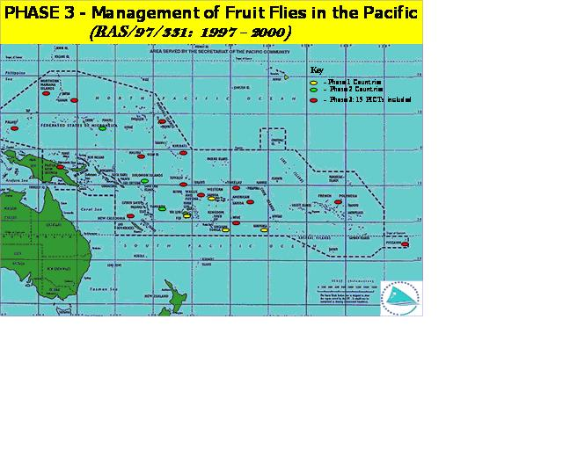

Figure 2: Fruit fly species distribution in the Pacific

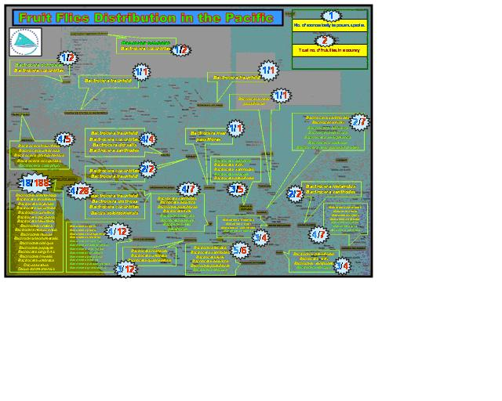

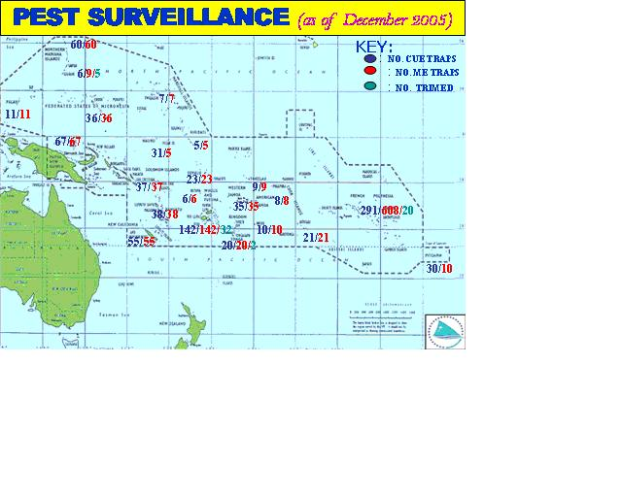

Figure 4 : The fruit fly surveillance system on Nauru
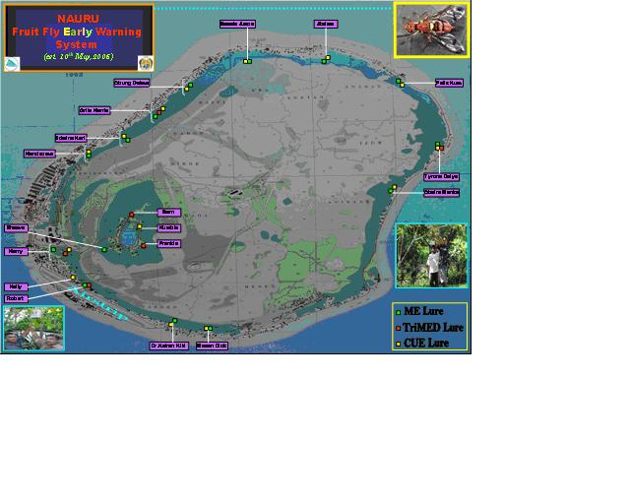

Fig 5 . Components of Systems Approach



