NOTES FROM SECRETARIAT:
1. The proper formatting for tables and keys will be applied before publishing the diagnostic protocol.
[1] | Draft Annex to ISPM 27– Genus Liriomyza (2006-017)
[2]
  Status box
  This is not an official part of the standard and it will be modified by the IPPC Secretariat after adoption.
  Date of this document | 2016-06-30
  Document category | Draft new annex to ISPM 27 (Diagnostic protocols for regulated pests)
  Current document stage | To DP Notification Period for adoption
  Major stages | 2006-11 Standards Committee (SC) added original subject: Liriomyza spp. (2006-017)  2007-03 CPM-2 (2007) added topic to the work programme (Insects and mites)  2014-02 Expert consultation on draft diagnostic protocols (DPs)  2014-07 Technical Panel on Diagnostic Protocols (TPDP) reviewed and approved the draft for SC e-decision for approval for member consultation  2014-10 SC e-decision for approval for member consultation (2014_eSC_Nov_12)  2014-10 DP drafting group and TPDP revised the draft based on SC comments  2015-02 Member consultation  2015-11 DP drafting group reviewing draft DP and responses to member comments  2016-02 TPDP e-decision for approval to submit to the SC for approval for DP Notification Period (2016_eTPDP_Feb_01)  2016-03 SC e-decision for approval to be submitted to the 45 day DP Notification Period (2016_eSC_May_09)
  Discipline leads history | 2015-11 SC Ms Juliet GOLDSMITH (JM)  2008-11 SC Ms Ana Lía TERRA (UY)
  Consultation on technical level | The first draft of this protocol was written by:  - Mallik MALIPATIL ((Lead Author) Department of Primary Industries Research, Australia)  - Dom COLLINS (Fera Science Ltd., United Kingdom)  - Mark BLACKET (| Department of Environment and Primary Industries, Australia)  - Norman BARR (APHIS-USDA, United States of America).  This draft protocol was reviewed by Stephen GAIMARI (US), Anthony RICE (AU), Ren IWAIZUMI (JP) and Ramona VAITKEVICA (LV).
  Main discussion points during development of the diagnostic protocol | - Footnotes and brand names (based on SC decision and according to TPDP instruction to authors): If in the DP there is more than one mention to a brand name, the second mention (and the sub sequential mentions) to a brand name shall be associated with the footnote number with the full text (e.g. If the first mention to a brand name is “footnote 1”, the subsequent mentions to brand names should be accompanied by the same footnote number, i.e., “footnote number 1”).
  Notes | 2014-09 Edited  2015-12 Edited  This is a draft document
[3] | Adoption  This diagnostic protocol was adopted by the Commission on Phytosanitary Measures in 20--.  Contents
[4] | To be added later.
[5] | 1. Pest Information
[6] | Agromyzidae is a family of small flies whose larvae feed on the internal tissue of plants, often as leafminers and stem miners. The majority of agromyzid species are either host-specific or restricted to a small group of plants that are related to each other. However, a few highly polyphagous species have become agricultural and horticultural pests in many parts of the world. These include four species of Liriomyza that are listed in plant quarantine legislation in various countries: L. bryoniae, L. huidobrensis, L. sativae and L. trifolii. These are all polyphagous pests of both ornamental and vegetable crops. The species level identification in this protocol is restricted to these four species.
[7] | Liriomyza is predominantly found in the north temperate zone but species are also found in the Afrotropical, Neotropical and Oriental regions. The adult flies of the 300-plus species of Liriomyza look very similar: they are all small (1–3 mm in length) and, from above, are seen to be largely black with, in most species, a yellow frons and scutellum (e.g. Figure 1). As a result, separating the species of the genus can be difficult. Furthermore, in order to identify the four species of quarantine concern a diagnostician not only has to distinguish between these four species, but also has to distinguish them from the relevant background fauna of indigenous Liriomyza species.
[8] | L. bryoniae is essentially a Palaearctic species with records from across Europe and Asia, and from Egypt and Morocco in North Africa (CABI, 2013). It is highly polyphagous and has been recorded from 16 plant families (Spencer, 1990). It is a pest of tomatoes, cucurbits (particularly melons, watermelon and cucumber) and glasshouse-grown lettuce, beans and lupins (Spencer, 1989, 1990).
[9] | L. huidobrensis is thought to have originated in South America and has now spread throughout much of the world, including parts of North America, Europe, Africa, Asia and the Pacific (Lonsdale, 2011; CABI, 2013). However, the species as formerly taxonomically defined was recently split into two morphocryptic species – L. huidobrensis and L. langei – and there is some uncertainty about the precise delineation of their relative distribution. Currently, L. langei has been confirmed only from the United States and is highly likely that all invasive populations outside the United States are L. huidobrensis as now taxonomically defined (Scheffer and Lewis, 2001; Scheffer et al., 2001; Takano et al., 2008; Lonsdale, 2011). L. huidobrensis is highly polyphagous and has been recorded from 14 plant families (Spencer, 1990). The most economically important crops it attacks are sugar beets, spinach, peas, beans, potatoes and ornamental plants (most commonly Gypsophila, rarely carnations and chrysanthemums) (Spencer, 1989).
[10] | L. sativae originated in North, Central and South America and has now been spread to many parts of Asia, Africa and the Pacific, but not to Europe or Australia (Lonsdale, 2011; CABI, 2013). However, distributional notes on L. sativae are likely to be incomplete as there is evidence to indicate that the species is continuing to expand its range rapidly. It is another highly polyphagous pest of many vegetable and flower crops (Spencer, 1973, 1990). It has been recorded from nine plant families, though it is mainly found on hosts in the Cucurbitaceae, Fabaceae and Solanaceae (Spencer, 1973,1990).
[11] | L. trifolii, also originally from North, Central and South America, has been spread to large parts of Europe, Africa, Asia and the Pacific, most likely as the result of trade in chrysanthemums cuttings (Martinez and Etienne, 2002; Lonsdale, 2011; CABI, 2013). It is highly polyphagous and has been recorded from 25 plant families (Spencer, 1990). The most economically important crops it attacks are beans, celery, chrysanthemums, cucumbers, gerberas, Gypsophila, lettuce, onions, potatoes and tomatoes (Spencer, 1989).
[12] | A further (fifth) species, L. strigata, is included in the diagnostic protocol because it is closely related to both L. bryoniae and L. huidobrensis, and is as such a species that a diagnostician must be able to eliminate when seeking to positively identify the four quarantine species. L. strigata is an Eurasian species (Pitkin et al. (n.d.) quoting Spencer (1976), Dempewolf (2001), Ellis (2013) and Pape et al. (2013). The eastern borders of its distribution are not clearly defined, but the range extends beyond the Ural Mountains (Spencer, 1976) and it has been doubtfully recorded in Southeast Asia (Dempewolf, 2004). It is highly polyphagous, having been recorded from 29 plant families worldwide (Spencer, 1990).
[13] | 2. Taxonomic Information
[14] | Name: Liriomyza Mik, 1894
[15] | Synonyms: Agrophila Lioy, 1864
[16] | Antineura Melander, 1913
[17] | Haplomyza Hendel, 1914
[18] | Praspedomyza Hendel, 1931
[19] | Craspedomyza Enderlein, 1936
[20] | Triticomyza Blanchard, 1938
[21] | Taxonomic position: Insecta, Diptera, Agromyzidae, Phytomyzinae
[22] | Name: Liriomyza bryoniae (Kaltenbach, 1858)
[23] | Synonyms: Liriomyza solani Hering, 1927; Liriomyza hydrocotylae Hering, 1930; Liriomyza mercurialis Hering, 1932; Liriomyza triton Frey, 1945; Liriomyza citrulli Rohdendorf, 1950; Liriomyza nipponallia Sasakawa, 1961
[24] | Common name: Tomato leafminer
[25] | Name: Liriomyza huidobrensis (Blanchard, 1926)
[26] | Synonyms: Liriomyza cucumifoliae Blanchard, 1938; Liriomyza decora Blanchard, 1954; Liriomyza dianthi Frick, 1958
[27] | The taxonomic relationship between L. huidobrensis (Blanchard) and L. langei Frick is complex. L. huidobrensis was originally described from specimens taken from Cineraria in Argentina by Blanchard (1926). Frick (1951) described L. langei from California as a species that he noted was primarily a pest of peas although it had also damaged Aster. In 1973, Spencer then synonymized the two species as they were (and de facto remain) morphologically indistinguishable. Following a study of their mitochondrial and nuclear DNA sequences (Scheffer, 2000; Scheffer and Lewis, 2001), and supported by later rearing experiments (Takano et al., 2008), the two species were formally separated as two cryptic species (Lonsdale, 2011). The name L. langei Frick was resurrected and applied to the cryptic species from California, and the name L. huidobrensis (Blanchard) was applied to the cryptic species from South and Central America.
[28] | Lonsdale (2011) attempted to delineate diagnostic morphological characters that could differentiate “most” specimens of the two species, but found the characters “subtle and sometimes overlapping” so he recommended the use of molecular data to support identification whenever possible. Scheffer and her collaborators consider that the ranges of the two species do not overlap (although Lonsdale (2011) recorded L. huidobrensis from California, once in 1968 and once in 2008, he states that it is unknown if the populations established), and that all of the invasive populations that they had studied were L. huidobrensis as so defined (Scheffer and Lewis, 2001; Scheffer et al., 2001). This means that reports from California in the literature predating Scheffer's papers should almost certainly be considered as applying to L. langei. L. langei is predominantly a Californian species although it has apparently been introduced into Hawaii, Oregon and Washington; populations found in Florida, Utah and Virginia in the mid-1990s did not establish (Lonsdale, 2011). Only L. huidobrensis has been confirmed in Mexico (Lonsdale, 2011), but Takano et al. (2005) reported that specimens of L. langei (described as the Californian clade) were intercepted at a Japanese inspection site on fresh vegetables originating from Mexico.
[29] | Common names: Serpentine leafminer, pea leafminer, South American leafminer, potato leafminer fly
[30] | Name: Liriomyza sativae Blanchard, 1938
[31] | Synonyms: Agromyza subpusilla Frost, 1943; Liriomyza verbenicola Hering, 1951; Liriomyza pullata Frick, 1952; Liriomyza canomarginis Frick, 1952; Liriomyza minutiseta Frick, 1952; Liriomyza propepusilla Frost, 1954; Liriomyza munda Frick, 1957; Liriomyza guytona Freeman, 1958; Lemurimyza lycopersicae Pla and de la Cruz, 1981
[32] | Common names: Vegetable leafminer, American leafminer, chrysanthemum leafminer, serpentine vegetable leafminer, melon leafminer
[33] | Name: Liriomyza trifolii (Burgess, 1880)
[34] | Synonyms: Agromyza phaseolunulata Frost, 1943; Liriomyza alliovora Frick, 1955
[35] | Common names: American serpentine leafminer, serpentine leaf miner, broad bean leafminer, Californian leafminer, celery leafminer, chrysanthemum leaf miner
[36] | 3. Detection
[37] | Feeding punctures and leaf mines are usually the first and most obvious signs of the presence of Liriomyza. While fully formed mines should be readily visible to quarantine officials, early signs of infestation are much less obvious and are easily overlooked (Spencer, 1989). Mines remain intact and relatively unchanged over a period of weeks. Mine configuration is often considered a reliable guide to the identification of agromyzid species (as in many such cases the species are host-specific). However, with the polyphagous pest species, mine configuration is affected by the host, by the physical and physiological condition of each leaf, and by the number of larvae mining the same leaf. This wider variability means that identification from mine configuration alone should be treated with caution (EPPO, 2005). Examples of mine configuration for the four quarantine species and L. strigata are provided in Figures 2 to 4.
[38] | Female flies use their ovipositor to puncture the leaves of the host plants, causing wounds that serve as sites for feeding (by both female and male flies) or for oviposition. Feeding punctures of Liriomyza species are rounded, usually about 0.2 mm in diameter, and appear as white speckles on the upper surface of the leaf. Oviposition punctures are usually smaller (0.05 mm) and more uniformly round. Feeding punctures made by the polyphagous agromyzid pest species Chromatomyia horticola and Chromatomyia syngenesiae are distinctly larger and more oval than those made by Liriomyza flies. The appearance of feeding and oviposition punctures does not differ among Liriomyza species, and the pattern of their distribution on the leaf cannot be used to identify species. Feeding punctures cause the destruction of a large number of cells and are clearly visible to the naked eye (EPPO, 2005).
[39] | The larvae feed mostly in the upper part of the leaf, mining through the green palisade tissue. Mines are usually off-white, with trails of frass appearing as broken black lines along the length of the leaf. Repeated convolutions in the same small area of the leaf will often result in discoloration of the mine, with dampened black and dried brown areas appearing, usually as the result of plant-induced reactions to the leafminer (EPPO, 2005).
[40] | There are three larval stages, all of which feed within the leaves. The larvae predominantly feed on the plant in which the eggs are laid. The larvae of Liriomyza spp. leave the leaf when ready to pupariate (Parrella and Bethke, 1984), and their exit hole characteristically takes the form of a semicircular slit; in contrast, the larvae of C. horticola and C. syngenesiae pupate inside the leaf at the end of the larval mine, with the anterior spiracles usually projecting out from the lower surface of the leaf. Liriomyza puparia, therefore, may be found in crop debris, in the soil or sometimes on the leaf surface.
[41] | Species may be found in different locations of the plant and surrounds depending on the life stages present, as follows:
[42] | - eggs: inserted just below the leaf surface
[43] | - larvae: inside mines on leaves
[44] | - pupae: in crop debris, in the soil or sometimes on the leaf surface
[45] | - adult: free-flying, or on leaf surfaces while producing feeding and oviposition punctures.
[46] | 3.1 Collection and preservation of specimens
[47] | Liriomyza flies can be collected as immature life stages in association with mined leaf samples or as adults. Because the morphological characters used to diagnose species are based on male genitalia, adult males are needed in order to confirm species identification. Adult females are often identifiable with certainty only to genus level. Collecting multiple specimens from a plant or a location will increase the likelihood of obtaining male flies, which is important unless molecular tests are to be used for diagnosis of immature life stages.
[48] | 3.1.1 Collecting adults
[49] | Adult flies are normally found on the foliage, and can be collected by hand or swept from the foliage with a hand net into glass vials, or collected with a vacuum sampler. Alternatively, they can be collected by using yellow sticky traps, particularly in glasshouses. However, the most practical and reliable method for collecting leafminer flies such as Liriomyza species is to collect mined leaves containing live larvae. These can be placed in a large jar for rearing to adult flies in the laboratory. Techniques for rearing agromyzids are described in Griffiths (1962) and Fisher et al. (2005).
[50] | Adults and larvae can be placed in 70% ethanol and stored indefinitely, although their colour fades gradually with time. Vials of specimens in ethanol should be sealed to avoid leakage and packed with cushioning material in a strong box. Dry storage of adults, for example as pinned specimens, is also possible.
[51] | Specimens required for molecular diagnostic work should be killed and preserved in 96–100% ethanol, stored frozen (at about –20 or–4.0 °C) or preserved on FTA cards (Whatman)¹ (Blacket et al., 2015).
[52] | 3.1.2 Collecting immature life stages
[53] | If the intention is to collect and preserve plant samples, leaves with suspect feeding punctures or mines should be picked and placed between sheets of newspaper to permit slow drying.
[54] | Leaves with occupied mines from which it is intended to rear individuals in the laboratory in order to obtain life stages, particularly adults, for identification need to be packed in slightly damp, but not overly wet, laboratory tissue, and mailed in padded and sealed bags. In the laboratory, the mined leaves with live larvae can be placed in sealed Petri dishes with damp filter paper inserts and stored in an incubator at about 23 °C (checking every two or three days to remove leaves that are developing fungus, bacteria, etc.).
[55] | 4. Identification
[56] | Identification of leafminer species by morphological examination is restricted to adult male specimens because there are no adequate keys for the species-level identification of adult females or for eggs, larvae or pupae. Identification of adult material is possible by examination of morphological characters, in particular the genitalia of the male fly. The morphological characters of the male genitalia are examined under a high-power microscope (at about 100× magnification). Using this protocol with good quality preparations should allow adults of the four quarantine species of Liriomyza to be identified with certainty by morphological examination alone (with the exception of L. huidobrensis and L. langei for the reasons discussed in section 1).
[57] | Molecular tests for identification can be applied to all life stages, including the immature stages for which morphological identification to species level is not possible. Additionally, in cases where adult specimens are atypical or damaged, molecular tests may provide further relevant information about identity. However, the specificity of molecular tests may be limited as they will have been developed for a purpose and evaluated against a restricted number of species, using samples from different geographic regions. Therefore, the results from molecular tests need to be carefully interpreted.
[58] | 4.1 Morphological identification of the adult Liriomyza
[59] | Examination of the male genitalia (in particular, the distiphallus (Figure 5)), is necessary in order to obtain a positive identification for any of the four target species of Liriomyza. A brief account of a satisfactory method of preparing specimens (based on Malipatil and Ridland, 2008) is outlined below. More details on or variations to the method are provided by Spencer (1981, 1992), Spencer and Steyskal (1986) and EPPO (2005). Evidence of distiphallic structure should be compared with characters of external morphology (Table 1) in order to confirm the species identification.
[60] | 4.1.1 Preparation of the genitalia of adult male Liriomyza for microscopic examination
[61] | 4.1.1.1 Determining the sex of flies
[62] | In the male fly, the lobes of the epandrium, which are dark and pubescent and not as heavily sclerotized as the female tube, curve around and down at the rear of the abdomen, from the dorsal to the ventral sides (Figure 6(a)). A slit-like opening is seen between the lobes, triangular when more fully open, through which the rest of the male genitalia can be viewed. The lobes barely extend beyond the last tergite. In the female fly, the abdominal segments beyond segment 6 form a black, heavily sclerotized tube that extends beyond the 6th tergite (Figure 6(b)), with a circular opening visible in posterior view at the end of the tube. The 6th tergite covers the basal half of the tube from above, though it is visible in lateral and ventral views.
[63] | 4.1.1.2 Preparation of the male distiphallus for examination
[64] | The abdomen should be removed from the body to enable clearing of tissues and observation. This can be accomplished by using fine dissecting needles (which can be made by gluing the blunt end of pointed micro pins into the end of a wooden matchstick, first making a shallow hole with a normal pin), to carefully separate the abdomen from the rest of the fly. The abdomen can be boiled in 10% potassium hydroxide (KOH) or sodium hydroxide (NaOH) for 2–4 min or, alternatively, left in cold 10% KOH or NaOH overnight to clear the tissues. Transferring the treated abdomen to a bath of distilled water will neutralize the KOH or NaOH. The abdomen is then ready for transfer to a drop of glycerol on a cavity slide.
[65] | Under a binocular stereomicroscope and using the fine dissecting needles, the genital complex is carefully dissected out from the surrounding membranes, cuticle and associated musculature. Using the fine dissecting needles, the genital complex is positioned for lateral viewing under a compound microscope at up to 400× magnification. The genital complex is repositioned for ventral viewing of the distiphallus at 400× magnification, without the addition of a cover. The distiphallus needs to be viewed in different orientations (e.g. lateral, dorsal, ventral), which requires repositioning under a lower magnification.
[66] | To make semi-permanent slides (e.g. for routine identification), the genital complex should be transferred to a drop of glycerol on a clean flat slide. The genitalia are immersed gently in the mountant, and a round coverslip is lowered carefully over it to evenly spread the mountant.
[67] | If permanent slide mounts are required, the abdomen should be cleared in KOH and neutralized in cold glacial acetic acid as described above. Then, the abdomen can be transferred to 70% ethanol and, using the fine dissecting needles under a binocular stereomicroscope, the genital complex carefully dissected from the surrounding membranes, cuticle and associated musculature. The dissected genitalia should be transferred first to absolute ethanol for 2–4 min, then to clove oil (in which, if necessary, they can be stored for any length of time). The genitalia are transferred to 70% ethanol (for approximately 10 min), then to 95% ethanol (for approximately 10 min) and finally to clove oil (for at least 5 min). The genitalia can then be permanently mounted on a slide in a drop of Canada balsam under a coverslip. All slide mounts must be labelled with adequate data detailing locality, host, date of collection, name of collector (if known), species name, name of identifier, and a code label to cross-reference to the remaining specimen.
[68] | The remainder of the fly specimen should be mounted on a card point with an appropriate label cross-referenced to its genitalia mounted on the slide.
[69] | 4.1.2 Identification of the family Agromyzidae
[70] | Worldwide, the family Agromyzidae comprises about 2 500 species (Spencer, 1989, 1990). Detailed descriptions of agromyzid morphology are given by Spencer (1972, 1973, 1987), Dempewolf (2004) and Boucher (2010).
[71] | Morphological nomenclature here follows Yeates et al. (2004). This online resource can also be consulted for clear illustrations of the anatomy of a typical acalyptrate fly (such as Agromyzidae).
[72] | The following combination of characters define the family Agromyzidae (Hennig, 1958; Spencer, 1987; Boucher 2010) (Figure 7):
[73] | - small in size, up to 1–6 mm, but usually 1–3 mm
[74] | - vibrissae present
[75] | - one to seven frontal setae present
[76] | - wing with costal break present at the apex of Sc
[77] | - wing cell cup small; wing veins A₁+CuA₂ not reaching wing margin
[78] | - male with pregenital sclerites with a fused tergal complex of tergites 6–8, with only two spiracles between tergite 5 and the genital segment
[79] | - female with the anterior part of abdominal segment 7 forming an oviscape.
[80] | Generally the larvae (Figure 8(a)) are cylindrical in shape, tapering anteriorly, with projections bearing the anterior and posterior spiracles (Figure 8(b) and (d)), the former located on the dorsal surface of the prothorax, the latter posteriorly directed at the rear. The larvae also possess strongly sclerotized mouthparts; the mandibles with their longitudinal axis are at about right angles to the rest of the cephalopharyngeal skeleton (Figure 8(c)) and usually bear two or more pairs of equally sized anteriorly directed teeth, with the ventral cornua (the posteriorly directed paired “arms”) commonly shorter than the dorsal ones.
[81] | In practice, agromyzids are recognizable because their larvae feed in the living tissue of plants (three-quarters of them are leafminers). However, there are leafminers in other Dipteran families such as Anthomyiidae and Drosophilidae. For a summary of information on the morphology and biology of the immature stages of agromyzids, with an extensive bibliography and illustrations of the cephalopharyngeal skeleton and posterior spiracles for a number of species, see Ferrar (1987).
[82] | 4.1.3 Identification of the genus Liriomyza
[83] | Adult flies of the genus Liriomyza have the following morphological characters (EPPO, 2005; Spencer 1976):
[84] | - fronto-orbital setulae reclinate (backward pointing)
[85] | - dark pre-scutellar area concolorous with the scutum in most species, rarely yellow
[86] | - scutellum yellow in most species, rarely dark  - subcosta becomes a fold distally and ends in costa separately
[87] | - costa extends to vein M₁₊₂
[88] | - discal cell (dm) small
[89] | - second (outer) crossvein (dm-cu) present in most species
[90] | - stridulating organ present in males (a “scraper”, a chitinized ridge on the hind femora; and a “file”, a line of low chitinized scales on the connecting membrane between the abdominal tergites and sternites).
[91] | In practice, most species of Liriomyza (including the four target species included in this diagnostic protocol) are seen from above to be mostly black with a yellow frons and a bright yellow scutellum. The legs are variably yellow. The target species possess the typical wing venation (Figure 9) and the generalized male genitalia of the genus.
[92] | There are several genera that may be confused with Liriomyza. The closely related genera Phytomyza, Chromatomyia and Phytoliriomyza can generally be separated from Liriomyza by their proclinate (forward pointing) fronto-orbital setulae (always reclinate or occasionally upright or missing in Liriomyza), and by the scutellum, which is generally grey or black but occasionally slightly yellowish centrally (entirely yellow in most Liriomyza). In Phytomyza and Chromatomyia, the costa extends only to R₄₊₅, whereas in Phytoliriomyza and Liriomyza it extends to vein M₁₊₂ (Spencer, 1977). Phytoliriomyza species are gall-forming (on a stem or leaf) internal feeders, whereas Chromatomyia, Phytomyza and Liriomyza species are typically leafminers.
[93] | 4.1.4 Identification of Liriomyza species
[94] | 4.1.4.1 Morphological characters of adult Liriomyza spp.
[95] | A simplified summary of the main diagnostic characters for L. bryoniae, L. huidobrensis, L. sativae and L. trifolii (as well as for L. strigata for the purposes of elimination) is given in Table 1. This is accompanied by illustrative images (photomicrographs) of the distiphallus in Figures 10 and 11.
[96] | More detailed descriptions and illustrations of the morphology of these species are provided by Spencer (1965, 1973), Dempewolf (2004), Malipatil et al. (2004) and Shiao (2004). Key diagnostic features are shown in the Pest and Disease Image Library (PaDIL) (Malipatil 2007a, 2007b, 2007c).
[97] | Identification of the adults can also be carried out with keys. Malipatil and Ridland (2008) provide a key to 17 species of economic importance, including a few species endemic to Australia. In addition, an identification system for pest species from around the world based on photomicrographs is available in Dempewolf (2004). With particular reference to keys for Liriomyza species, there are some extensive regional back catalogues and keys available through the works of Spencer. These cover the regional background fauna, which obviously differs from region to region, and by doing so differentially affects the positive process of eliminating non-target taxa. A full list of these works is listed in Spencer (1973).In addition, considering the host plant on which the suspected quarantine Liriomyza species has been detected can help by narrowing down the other potential agromyzid species that may occur in the same biological context and which may need to be eliminated from consideration (e.g. for Europe, see Ellis (n.d.).

[98] | Table 1. Adult morphological characters of selected Liriomyza species†
[99]
[100]
[101]
   | L. bryoniae | L. huidobrensis‡ | L. sativae | L. strigata | L. trifolii
  Male distiphallus | Two distal bulbs; bulb rims circular | Two distal bulbs, meeting only at their rims; bulb rims drawn out antero-ventrally | One distal bulb with a slight constriction between upper and lower halves in dorso-ventral view; bulb appears more strongly sclerotized with a shorter basal stem | Two distal bulbs, meeting from their rims to their bases; bulb rims drawn out antero-ventrally | One distal bulb with marked constriction between lower and upper halves in dorso-ventral view; bulb appears less distinctly sclerotized with a longer basal stem
  Vertical setae | Both vertical setae on yellow ground | Both vertical setae on black ground | Outer vertical setae on black ground that may just reach inner vertical setae, which are otherwise on yellow ground | Black coloration behind the eyes extending to at least the outer vertical setae, but inner vertical setae on yellow ground | Both vertical setae on yellow ground
  Anepisternum | Predominantly yellow, small black mark at front lower margin | Yellow with variable black patch generally across the lower three-quarters | Predominantly yellow, with dark area varying in size from a small bar along the lower margin to a patch along the entire lower margin, well up the front margin and narrowly up the hind margin | Yellow, but with black patch variable on lower and front margins, and this can extend along the lower half | Yellow, small blackish grey mark at front lower margin
  Vein Cu 1A | a twice length of b | a 2–2.5 times length of b | a 3–4 times length of b | a 2–3 times length of b | a 3–4 times length of b
  Third antennal segment | Small, yellow | Slightly enlarged, usually darkened | Small, yellow | Small, yellow | Small, yellow
  Frons and orbits | Frons bright yellow, orbits slightly paler | Frons yellow, generally more orange than pale lemon-yellow; upper orbits slightly darkened at least to upper orbital setae | Frons and orbits bright yellow | Frons and orbits yellow | Frons and orbits yellow
  Femur | Bright yellow with some brownish striations | Yellow, variably darkened with black striations | Bright yellow | Yellow with some brownish striations | Yellow, occasional slight brownish striations
  Mesonotum | Black, largely shining but with distinct matt undertone | Black, matt | Black, shining | Black, shining but slightly matt | Matt black with grey undertone
  Male abdominal tergites | Second and third visible tergites divided by a yellow medial furrow | Only the second visible tergite divided by a yellow medial furrow | Only the second visible tergite divided by a yellow medial furrow | – | Second to fifth visible tergites divided by a yellow medial furrow
  Wing length | 1.75–2.1 mm | 1.7–2.25 mm | 1.3–1.7 mm | 1.8–2.1 mm | 1.3–1.7 mm
[102] | Source: Compiled from Spencer (1973, 1976), with information on the distiphallus from EPPO (2005) and information on the male abdominal tergites from Shiao (2004) (who did not include L. strigata in his analysis).  † See also Figures 7 to 11.  ‡ L. langei is morphologically indistinguishable from L. huidobrensis.

[103] | 4.1.4.2 Distiphallic structure of adult male Liriomyza spp.
[104] | The Liriomyza species considered here separate into two distinct natural groups based on the structure of the male genitalia (particularly the distiphallus) as well as the body colour and the structure of the posterior spiracles of the larvae:
[105] | - group 1: L. bryoniae, L. huidobrensis and L. strigata
[106] | - group 2: L. sativae and L. trifolii.
[107] | However, the external characters of the adult flies useful for identification (Table 1), particularly those based on colour, do not fall neatly into these two groupings.
[108] | The distiphallus is a very small, fragile structure enclosed by membranes. It is the terminal part of the aedeagus (the intromittent organ, part of the male genitalia) (Figure 9) and its complex three-dimensional structure is of considerable diagnostic value. Indeed, the distiphallus provides a single character by which all four target species can be identified reliably. The basic structure of the distiphallus differs in the two natural species groups: in group 1, there are two distal bulbs side by side (Figure 10), while in group 2, there is only one distal bulb, which has a medial constriction dividing it into distinct lower and upper sections (Figure 11). A key that facilitates identification of the four target species using the distiphallus is provided below. For convenience, the key also includes L. strigata, which is closely related to L. bryoniae and L. huidobrensis and is also polyphagous and therefore to be found on similar host plants.
[109] | However, the differences between some of the species pairs are subtle and the evidence of the distiphallic structure should be cross-checked with the evidence of external morphology (Table 1) in order to ensure that the distiphallic structure has not been misinterpreted. If all the evidence correlates, all other species of Liriomyza, including those not discussed here, can be eliminated.
[110] | Diagnostic key for identification of Liriomyza spp. using the male distiphallus
[111] | This key is to be used in conjunction with Figures 10 and 11.
[112] | 1. With one distal bulb (Figure 11(e), (f)) ............................................................................................................2
[113] | – With a pair of distal bulbs (Figure 10(a)–(c), (g)–(k)) .....................................................................................3
[114] | 2. With marked constriction between the apical and basal parts of the bulb: basal section strongly curved (Figure 11(f)) ..........................................................................................................................................L. trifolii
[115] | – With slight constriction only between the apical and basal parts of the bulb: basal section not strongly curved (Figure 11(e)) .......................................................................................................................................L. sativae
[116] | 3. With bulb rims circular (not drawn out antero-ventrally); evenly sclerotized (Figure 10(a)) ............................................................................................................................................................L. bryoniae
[117] | – With bulb rims spiralled (drawn out antero-ventrally) (Figure 10(b), (c)) ..............................................................................................................................................................................4
[118] | 4. With bulbs meeting in the midline only at their rims (Figure 10(h)) ...................................................................................................................................................L. huidobrensis*
[119] | – With bulbs meeting in the midline from their rims to their bases (Figure 10(i)) ..............................................................................................................................................................L. strigata
[120] | * L. langei is morphologically indistinguishable from L. huidobrensis.
[121] | 4.1.4.3 Morphological characteristics of the immature stages of the four target species of Liriomyza
[122] | Of the four life stages (egg, larva, pupa and adult) only the adult male flies can be positively identified to species level using morphological features (the shape of the male genitalia). The morphological characteristics of larvae and pupae can be used to distinguish between the members of the two natural species groups described in section 4.1.4.2. This information can contribute towards species identification but is insufficient by itself to allow species identification. To complement morphological identification, molecular assays can be used to distinguish between the species included in the protocol (section 4.2).
[123] | Eggs
[124] | The eggs are laid into the leaf tissue. They are white and oval, about 0.25 mm in length. Neither genus nor species identification is possible.
[125] | Larvae and pupae
[126] | There are three larval instars, which feed as they tunnel through the leaf tissue. The newly emerged larvae are about 0.5 mm long but reach 3.0 mm when fully grown. They are typical of agromyzids in their gross form (see section 4.1.2). Pupae (Figure 12) are oval cylinders in shape, about 2.0 mm in length, very slightly flattened ventrally, with projecting anterior and posterior spiracles. In practice, for larvae and pupae, the two natural groups can be distinguished from each other (but not the species within the groups) morphologically as follows.
[127] | Group 1 larvae
[128] | Larvae of L. bryoniae, L. huidobrensis and L. strigata are cream-coloured but in the final instar develop a yellow–orange patch dorsally at the anterior end, which can extend around to the ventral surface (Figure 13)). Each posterior spiracle consists of an ellipse with pores along the margin. It can be difficult to observe the number of pores, which according to Spencer (1973) are: L. bryoniae, 7–12 pores; L. huidobrensis, about 6–9 pores; and L. strigata, 10–12 pores. Puparia are variable in colour, from yellow–orange to dark brown. In L. bryoniae and L. strigata, puparia are mostly, but not exclusively, at the lighter end of the colour range. The colour of L. huidobrensis puparia mostly tends to anthracite. The form of the larval spiracles is retained in the puparium although the pores are less clearly discernible.
[129] | Group 2 larvae
[130] | Larvae of L. sativae and L. trifolii are translucent when newly emerged and yellow–orange over the entire body later. Each posterior spiracle is tricorn-shaped with three pores, each on a distinct projection, the outer two elongate. Puparia are yellowish orange, sometimes a darker golden brown. The form of the larval spiracles is retained in the puparium but the detail is less obvious.
[131] | 4.2 Molecular identification of Liriomyza species
[132] | Various polymerase chain reaction (PCR)-based molecular tests have been used to identify Liriomyza species, including PCR-restriction fragment length polymorphism (RFLP), end-point PCR using species-specific primers, real-time PCR, and DNA sequence comparison. Of these tests, the ones that can be used to distinguish between the four target species (i.e. L. bryoniae, L. huidobrensis, L. sativae and L. trifolii) or between L. huidobrensis and L. langei are described below.
[133] | In this diagnostic protocol, tests (including reference to brand names) are described as published, as these defined the original level of sensitivity, specificity and/or reproducibility achieved. No method reported for these species has been formally validated for analytical sensitivity and reproducibility. The use of names of reagents, chemicals or equipment in these diagnostic protocols implies no approval of them to the exclusion of others that may also be suitable. Laboratory procedures presented in the protocols may be adjusted to the standards of individual laboratories, provided that they are adequately validated.
[134] | The specificity of each method is described below. This indicates the Liriomyza species against which each method was evaluated and the original use for which the assay was designed. Considering the specific limitations of molecular tests, a negative molecular test result does not exclude the possibility of positive identification by morphological tests.
[135] | 4.2.1 Controls for molecular tests
[136] | For the test result obtained to be considered reliable, appropriate controls – which will depend on the type of test used and the level of certainty required – should be considered for each series of nucleic acid isolation and amplification of the target pest nucleic acid. For PCR a positive nucleic acid control, a negative amplification control (no template control) and, when relevant, a negative extraction control are the minimum controls that should be used. .
[137] | 4.2.2 DNA Extraction
[138] | DNA suitable for PCR applications can be successfully extracted from a single larva, pupa or adult Liriomyza specimen using various commercial DNA extraction kits and following manufacturer instructions (Scheffer et al., 2001, 2006; Kox et al., 2005; Nakamura et al., 2013). For additional information on the kits used for each of the tests described below, refer to the source paper. Laboratories may find that alternative extraction techniques work equally well; DNA may be extracted using any DNA extraction method suitable for insects. The treated tissue is crushed or ground using a sterile micropestle or similar apparatus in all published protocols.
[139] | Positive nucleic acid control. This control is used to monitor whether or not the test performed as expected under the experimental conditions and parameters. A positive control can be any nucleic acid that contains the target sequence (i.e. Liriomyza nucleic acid that has been analysed previously).
[140] | Negative amplification control (no template control). This control is necessary for PCR to rule out false positives due to contamination during preparation of the reaction mixture or non-specific amplification. PCR-grade water that was used to prepare the reaction mixture is added in place of the DNA volume at the amplification stage.
[141] | Negative extraction control. This control is used to monitor contamination during nucleic acid extraction and/or cross-reaction with the host tissue. The control comprises an extraction reaction without tissue sample added.
[142] | 4.2.3 PCR-RFLP identification of the four target species
[143] | Kox et al. (2005) report a PCR-RFLP assay of a region on the Cytochrome oxidase II (COII) gene that can be used to distinguish the four target species. The specificity of the assay was further investigated by analysing four additional Liriomyza species: L. strigata, L. langei, L. chinensis and L. scorzonerae. The L. langei and L. huidobrensis specimens could not be distinguished with this assay. The other three species were separated successfully.
[144] | 4.2.3.1 Amplification of the COII gene
[145] | According to Kox et al. (2005), samples are amplified in a 50 μl reaction mixture composed of the following final concentrations of reagents: 0.6 μM each primer, 0.2 mM dNTPs, 1 U HotStarTaq DNA polymerase, 1× PCR buffer and 1.5 mM MgCl₂. Each reaction includes either 1–5 μl DNA as a template or PCR-grade water as a negative control. PCR is performed using the following primer pair:
[146] | TL2-J-3037-forward (F): 5´-ATGGCAGATTAGTGCAATGG-3´ (Simon et al., 1994)
[147] | K-N-3785Lir-reverse (R): 5´-GTT(A/T)AAGAGACCATT(A/G)CTTG-3´ (Kox et al., 2005)
[148] | The thermal cycling parameters for PCR are a 15 min denaturation step at 95 °C followed by 35 cycles of (15 s at 94 °C, 1 min at 55 °C and 45 s at 72 °C) and a final extension step for 10 min at 72 °C before cooling to room temperature. After PCR amplification, 5 μl of the PCR product is subjected to electrophoresis on a 1.5% agarose gel in Tris-acetate-ethylenediaminetetraacetic acid (EDTA) (TAE) buffer with a 100 base pair (bp) DNA ladder to confirm the presence of PCR products before RFLP analysis.
[149] | The COII PCR is considered valid only if:
[150] | - the positive control produces an amplification product of the expected size for the target COII gene
[151] | - the negative extraction control and the negative amplification control do not produce an amplification product of the expected size for the target COII gene.
[152] | 4.2.3.2 Restriction digestion and separation of products
[153] | For each sample, 5 μl of PCR product is digested with restriction enzymes DdeI, HinfI, SspI and TaqI, each in a separate reaction, according to the manufacturer’s instructions. Digested PCR product is then separated by electrophoresis on a 3% agarose gel in TAE buffer along with a 100 bp DNA ladder to allow the size of the fragments to be determined.
[154] | It is not possible to determine the exact fragment size of digested products separated under the electrophoretic conditions described, but relative separation values are used to compare results with expected RFLP profiles for the species. Positive control samples with known fragment sizes and patterns can be run alongside test samples to enable comparison of sizes more precisely. A positive control should be included for each digestion enzyme tested to ensure that the enzyme digests the DNA as expected. The RFLP test is considered valid only if the positive control produces fragments of the expected size for the target COII gene. The RFLP patterns observed on the agarose gel allow differentiation of the four target species of Liriomyza. Diagnostic profiles for the species are provided in Table 2 by enzyme. If the composite fragment profile of a sample matches the known fragment profile of one of the five species in the table, the sample can be identified as that species based on the assay. If the fragment profile does not match one of the known species fragment profiles, the sample is not diagnosed to species based on the assay. If a sample is diagnosed as L. huidobrensis, further testing may be needed to confirm it is not the cryptic species L. langei (section 4.2.5).
[155] | Table 2. Restriction fragment length polymorphism profiles for Liriomyza species
[156]
   | Predicted fragment sizes (base pairs) for restriction enzymes
  Species | DdeI | HinfI | SspI | TaqI
  L. bryoniae | 790 | 421, 369 | 392, 326, 72 | 486, 163, 111, 30
  L. huidobrensis† | 790 | 421, 369 | 399, 391 | 306, 163, 159, 111, 30, 21
  L. sativae “USA”‡ | 567, 223 | 421, 282, 59, 27 | 399, 391 | 306, 210, 163, 81, 30
  L. sativae “Asia”‡ | 790 | 421, 310, 59 | 717, 73 | 306, 210, 163, 81, 30
  L. strigata | 790 | 421, 342, 27 | 399, 391 | 267, 219, 141, 72, 67
  L. trifolii | 619, 171 or 386, 223, 171 | 421, 310, 59 | 391, 326, 73 | 306, 163, 159, 141, 21 or  306, 163, 159, 111, 30, 21
Source: Data from Kox et al. (2005).
† Including cryptic species L. langei.
‡ USA and Asia are known alternative variants; both of these are L. sativae.
[157] | 4.2.4 Species-specific PCR primers for identification of the four target species
[158] | A multiplex PCR assay to distinguish the four target species without the need for a post-PCR restriction digestion procedure was reported by Nakamura et al. (2013). This assay uses six primers that target the Cytochrome oxidase I (COI) gene. Five of these each bind to a sequence unique to a Liriomyza species, and are used as forward primers. The sixth primer binds to a segment of the COI gene conserved in all Liriomyza species, and is used as a reverse primer, to complete primer pairing. The size of the PCR products can be used to discriminate among L. bryoniae, L. huidobrensis, L. sativae, L. trifolii and L. chinensis. Unlike the PCR-RFLP assay of Kox et al. (2005) (section 4.2.3), the specificity of this assay against L. strigata has not been verified.
[159] | 4.2.4.1 Amplification of the COI gene
[160] | According to Nakamura et al. (2013), samples are amplified in a 10 μl reaction mixture composed of the following final concentrations of reagents: 0.5 μM of each of the six primers, 0.2 mM dNTPs, 1 U TaKaRa1 Ex Taq DNA polymerase, 1× TaKaRa1 Ex Taq PCR buffer and 2 mM MgCl₂. Each reaction includes either 0.5 μl DNA as a template or PCR-grade water as a negative control. PCR is performed using the following six primers designed by Nakamura et al. (2013):
[161] | Lb600-F: 5′-CTAGGAATGATTTATGCAATG-3′
[162] | Lc920-F: 5′-CATGACACTTATTATGTTGTTGCA-3′
[163] | Lh1150-F: 5′-CAATCGGATCTTCAATTTCCCTTC-3′
[164] | Ls1040-F: 5′-TTATTGGTGTAAATTTAACC-3′
[165] | Lt780-F: 5′-TTATACACCAACTACTTTGTGAA-3′
[166] | L1250-R: 5′-GAATWGGRWAAATYACTTGACGTTG-3′
[167] | The thermal cycling parameters for PCR are a 1 min denaturation step at 94 °C followed by 32 cycles of (30 s at 94 °C, 30 s at 55 °C and 2 min at 72 °C). PCR products are visualized by electrophoresis on a 1.8% agarose gel with a 100 bp DNA ladder to allow the product size to be determined.
[168] | The multiplex COI PCR is considered valid only if:
[169] | - the positive control produces an amplification product of the expected size for the target COI gene
[170] | - the negative extraction control and the negative amplification control do not produce an amplification product of the expected size for the target COI gene.
[171] | The expected PCR product sizes for the five species are 649 bp (L. bryoniae), 359 bp (L. chinensis), 107 bp (L. huidobrensis/L. langei), 207 bp (L. sativae) and 461 bp (L. trifolii). It is not possible to determine the exact fragment size of PCR products separated under the electrophoretic conditions described, but relative separation values are used to compare results with expected species-specific primer profiles for the species. Positive control samples with known band size for the species can be run alongside test samples to enable comparison of sizes more precisely.
[172] | A sample is identified as one of the five species if it produces a single PCR product of the expected size for that species. This assay is not able to distinguish L. huidobrensis from L. langei. If a sample is suspected as L. huidobrensis, further testing may be needed to confirm it is not the cryptic species L. langei (section 4.2.5). This assay was developed for Liriomyza identification in Japan and specificity has been directed to that purpose. As a result, cross-reactivity with L. strigata and populations of L. trifolii outside Japan has not been verified.
[173] | 4.2.5 Distinguishing the cryptic species L. langei and L. huidobrensis
[174] | 4.2.5.1 PCR-RFLP
[175] | Scheffer et al. (2001) described a PCR-RFLP assay for distinguishing L. huidobrensis and L. langei based on variation at a mitochondrial locus including part of the COI gene, the leucine tRNA and all of the COII gene. This 1 031 bp region is amplified using primers reported in Simon et al. (1994):
[176] | C1-J-2797-F: 5′-CCTC-GACGTTATTCAGATTACC-3′
[177] | TK-N-3785-R: 5′- GTTTAAGAGACCAGTACTTG-3′
[178] | The thermal cycling parameters for PCR are a 2 min denaturation step at 92 °C followed by 35 cycles of (1 min 30 s at 92 °C, 1 min 30 s at 50 °C and 2 min 30 s at 72 °C) and a final extension step for 7 min at 72 °C. After PCR amplification, the PCR product is subjected to electrophoresis with a DNA ladder to check PCR success before RFLP analysis.
[179] | The COI–COII PCR is considered valid only if:
[180] | - the positive control produces an amplification product of the expected size for the target COII gene
[181] | - the negative extraction control and the negative amplification control do not produce an amplification product of the expected size for the target COII gene.
[182] | For each sample, PCR product is digested with restriction enzymes SpeI and EcoRV, each in a separate reaction, according to the manufacturer’s instructions. Digested PCR product is then separated by electrophoresis on a 1.5% agarose gel along with a 100 bp DNA ladder to allow the size of the fragments to be determined.
[183] | It is not possible to determine the exact fragment size of digested products separated under the electrophoretic conditions described, but relative separation values are used to compare results with expected RFLP profiles for the species. Positive control samples with known fragment sizes and patterns can be run alongside test samples to enable comparison of sizes more precisely. A positive control should be included for each digestion enzyme tested to ensure that the enzyme digests the DNA as expected. The RFLP test is considered valid only if the positive control produces fragments of the expected size for the target gene.
[184] | L. huidobrensis samples produce a single uncut (1 031 bp) fragment when digested with SpeI and two cut (175 bp and 856 bp) fragments when digested with EcoRV. In contrast, L. langei samples produce two cut (420 bp and 611 bp) fragments when digested with SpeI and a single uncut (1 031 bp) fragment when digested with EcoRV. If the composite fragment profile of a sample matches these known fragment profiles the sample can be identified as that species based on the assay.  4.2.5.2 DNA sequence comparison
[185] | Scheffer (2000) reported PCR and DNA sequence information for a mitochondrial DNA locus including partial sequences of the COI and COII genes that can distinguish the two cryptic species L. huidobrensis and L. langei. A subsequent publication by Scheffer et al. (2006) included additional sequences of the 3' end of the COI gene for investigation of species diversity. These data were analysed using molecular phylogenetic techniques but were not developed into diagnostic protocols.
[186] | 4.2.6 DNA barcoding
[187] | Efforts to generate a more taxonomically comprehensive resource of DNA sequence records for the 5' region of the Liriomyza COI gene used in animal DNA barcode studies are ongoing (e.g. Bhuiya et al., 2011; Maharjan et al., 2014). There are currently DNA barcode records for 31 species of Liriomyza (including the four target species) available on the Barcode of Life Data System (BOLD) (http://www.boldsystems.org). Alternative barcodes and procedures are provided on Q-bank (www.q-bank.eu), a curated database including sequences obtained from reference material. A recent study (Maharjan et al., 2014) included details for the separation of L. huidobrensis, L. trifolii, L. sativae, L. bryoniae and L. chinensis. Despite these advances in DNA sequencing resources, the methodology is not described in detail here for Liriomyza species identification because interpretation rules for the resources have not yet been published in the scientific literature. DNA barcoding identification results should be interpreted carefully for possible issues such as: (1) potential preferential PCR amplification of parasitoids or nuclear mitochondrial copies of the COI gene (i.e. nuclear mitochondrial pseudogenes (numt); (2) the possibility of misidentification with closely related sister species (i.e. species complexes); and (3) a different scope of geographic coverage of the reference specimens in the sequence databases.
[188] | 5. Records
[189] | Records and evidence should be retained as described in section 2.5 of ISPM 27 (Diagnostic protocols for regulated pests).
[190] | In cases where other contracting parties may be adversely affected by the results of the diagnosis, the following records and evidence and additional material should be kept for at least one year in a manner that ensures traceability: preserved or slide-mounted specimens, photographs of distinctive taxonomic structures, DNA extracts and photographs of gels.
[191] | 6. Contact Points for Further Information
[192] | Further information on this protocol can be obtained from:
[193] | State Government of Victoria Department of Economic Development, Jobs, Transport and Resources, AgriBio, 5 Ring Road, Bundoora, Vic. 3083, Australia (Mallik Malipatil; e-mail: mallik.malipatil@ecodev.vic.gov.au; tel.: +61 3 9032 7302; fax: +61 3 9032 7604).
[194] | Fera Science Ltd (Fera), National Agri-Food Innovation Campus, Sand Hutton, York, YO41 1LZ, United Kingdom (Dominique Collins; e-mail: dom.collins@fera.co.uk; tel.: +44 1904 462215; fax: +44 1904 462111)
[195] | A request for a revision to a diagnostic protocol may be submitted by national plant protection organizations (NPPOs), regional plant protection organizations (RPPOs) or Commission on Phytosanitary Measures (CPM) subsidiary bodies through the IPPC Secretariat (ippc@fao.org), which will in turn forward it to the Technical Panel on Diagnostic Protocols (TPDP).
[196] | 7. Acknowledgements
[197] | The first draft of this protocol was written by Mallik B. Malipatil (State Government of Victoria Department of Economic Development, Jobs, Transport and Resources, Australia), Dominique W. Collins (Fera, United Kingdom) and Mark Blacket (State Government of Victoria Department of Economic Development, Jobs, Transport and Resources, Australia), Norman Barr (United States Department of Agriculture – Animal and Plant Health Inspection Service, United States) drafted the section on molecular identification.
[198] | The following reviewers provided comments on the draft version of this document: Stephen Gaimari (California Department of Food and Agriculture, United States), Anthony Rice (Department of Agriculture and Water Resources, Australia), Ren Iwaizumi (Yokohama Plant Protection Station, Ministry of Agriculture, Forestry and Fisheries, Japan) and Ramona Vaitkevica (State Plant Protection Service of Latvia).
[199] | 8. References
[200] | The present annex refers to ISPMs. ISPMs are available on the International Phytosanitary Portal (IPP) at https://www.ippc.int/core-activities/standards-setting/ispms.
[202] | Bhuiya, B.A., Amin, S. & Mazumdar, S. 2011. First report of vegetable leafminer Liriomyza sativae Blanchard (Diptera: Agromyzidae) through DNA barcoding from Bangladesh. Journal of Taxonomy and Biodiversity Research, 5: 15–17.
[203] | Blacket, M.J., Rice, A.D., Semeraro, L. & Malipatil, M.B. 2015. DNA-based identifications reveal multiple introductions of the vegetable leafminer Liriomyza sativae (Diptera: Agromyzidae) into the Torres Strait Islands and Papua New Guinea. Bulletin of Entomological Research, doi:10.1017/S0007485315000383
[204] | Blanchard, E.E. 1926. A dipterous leaf-miner on Cineraria, new to science. Revista de la Sociedad Entomologica Argentina, 1: 10–11.  Boucher, S. 2010. Family Agromyzidae (leaf-mining flies). In B.V. Brown, A. Borkent, J.M. Cumming, D.M. Wood, N.E. Woodley & M. Zumbado, eds. Manual of Central American Diptera, Vol. 2, pp. 1057–1071. Ottawa, National Research Council. 728 pp.
[206] | CABI. 2013. Crop protection compendium. Wallingford, UK, CABI. Available at http://www.cabicompendium.org/cpc/home.asp (last accessed 24 August 2014).
[208] | Dempewolf, M. 2001. Larvalmorphologie und Phylogenie der Agromyzidae (Diptera).University of Bielefeld, Germany (Dissertation)
[209] | Dempewolf, M. 2004. Arthropods of economic importance: Agromyzidae. Amsterdam, Netherlands Biodiversity Information Facility. Available at http://wbd.etibioinformatics.nl/bis/agromyzidae.php (last accessed 24 August 2014).
[210] | Ellis, W.N. n.d. Leafminers and plant galls of Europe. Available at http://www.bladmineerders.nl/ (last accessed 24 August 2014) (in English and Dutch).
[211] | EPPO (European and Mediterranean Plant Protection Organization). 2005. Liriomyza spp. PM 7/53(1). EPPO Bulletin, 35: 335–344.
[213] | Ferrar, P.A. 1987. A guide to the breeding habits and immature stages of Diptera: Cyclorrhapha. Entomograph, 8: 1–907.
[214] | Fisher, N., Ubaidillah, R., Reina, P. & La Salle, J. 2005. Liriomyza parasitoids of Southeast Asia. Melbourne, Australia, CSIRO. Available at http://www.ento.csiro.au/science/Liriomyza_ver3/index.html (last accessed 24 August 2014).
[215] | Frick, K.E. 1951. Liriomyza langei, a new species of leaf-miner of economic importance in California. Pan-Pacific Entomologist, 21: 81–88.
[216] | Griffiths, G.C.D. 1962. Breeding leaf-mining flies and their parasites. Entomologist's Record and Journal of Variation, 74: 178–185, 203–206.
[217] | Hennig, W. 1958. Die Familien der Diptera Schizophora und ihre phylogenetischen Verwandschaftsbeziehungen. Beiträge zur Entomologie, 8: 505–688.
[218] | Kox, L.F.F., van den Beld, H.E., Lindhout, B.I. & de Goffau, L.J.W. 2005. Identification of economically important Liriomyza species by PCR-RFLP analysis. EPPO Bulletin, 35: 79–85.
[219] | Lonsdale, O. 2011. The Liriomyza (Agromyzidae: Schizophora: Diptera) of California. Zootaxa, 2850: 1–123.
[220] | Maharjan, R., Oh, H-W. & Jung, C. 2014. Morphological and genetic characteristics of Liriomyza huidobrensis (Blanchard) (Diptera: Agromyzidae) infesting potato crops in Korea. Journal of Asia-Pacific Entomology, 17: 281–286.
[221] | Malipatil, M.B. 2007a. Chickpea leafminer (Liriomyza cicerina). Pest and Disease Image Library (PaDIL). Available at http://www.padil.gov.au/pests-and-diseases/pest/main/136238 (last accessed 24 August 2014).
[222] | Malipatil, M.B. 2007b. Pea leafminer (Liriomyza huidobrensis). Pest and Disease Image Library (PaDIL), images and fact sheets. Available at http://www.padil.gov.au/pests-and-diseases/pest/main/136237 (last accessed 24 August 2014).
[223] | Malipatil, M.B. 2007c. American serpentine leafminer (Liriomyza trifolii). Pest and Disease Image Library (PaDIL), images and fact sheets. Available at http://www.padil.gov.au/pests-and-diseases/pest/main/136236 (last accessed 24 August 2014).
[224] | Malipatil, M. & Ridland, P. 2008. Polyphagous agromyzid leafminers: Identifying polyphagous agromyzid leafminers (Diptera: Agromyzidae) threatening Australian primary industries. Canberra, Department of Agriculture, Fisheries and Forestry, Australian Government. Available at http://keys.lucidcentral.org/keys/v3/leafminers/ (last accessed 24 August 2014).
[225] | Malipatil, M.B., Ridland, P.M., Rauf, A., Watung, J. & Kandowangko, D. 2004. New records of Liriomyza Mik (Agromyzidae: Diptera) leafminers from Indonesia. Formosan Entomologist, 24: 287–292.
[226] | Martinez, M. & Etienne, J. 2002. Liste systématique et biogéographique dês Agromyzidae (Diptera) de la région néotropicale. Bollettino di Zoologia Agraria e di Bachicoltura (Serie II), 34: 25–52 (in French).
[227] | Nakamura, S., Masuda, T., Mochizuki, A., Konishi, K., Tokumaru, S., Ueno, K. & Yamaguchi, T. 2013. Primer design for identifying economically important Liriomyza species (Diptera: Agromyzidae) by multiplex PCR. Molecular Ecology Resources, 13: 96–102.
[228] | Pape, T., Beuk, P. & Martinez, M., eds. 2013. Fauna Europaea, version 2.6. Available at http://www.faunaeur.org (last accessed 24 August 2014).
[229] | Parrella, M.P. & Bethke, J.A. 1984. Biological studies of Liriomyza huidobrensis (Diptera: Agromyzidae) on chrysanthemum, aster and pea. Journal of Economic Entomology, 77: 342–345.
[230] | Pitkin, B., Ellis, W., Plant, C. & Edmunds, R. n.d. The leaf and stem mines of British flies and other insects. Available at http://www.ukflymines.co.uk (last accessed 24 August 2014).
[231] | Scheffer, S.J. 2000. Molecular evidence of cryptic species within the Liriomyza huidobrensis (Diptera: Agromyzidae). Journal of Economic Entomology, 93: 1146–1151.
[232] | Scheffer, S.J. & Lewis, M.L. 2001. Two nuclear genes confirm mitochondrial evidence of cryptic species within Liriomyza huidobrensis (Diptera: Agromyzidae). Annals of the Entomological Society of America, 94: 648–653.
[234] | Scheffer, S.J., Lewis, M.L. & Joshi, R.C. 2006. DNA barcoding applied to invasive leafminers (Diptera: Agromyzidae) in the Philippines. Annals of the Entomological Society of America, 99: 204–210.
 | Scheffer, S.J., Wijesekara, A., Visser, D. & Hallett, R.H. 2001. Polymerase chain reaction-restriction fragment-length polymorphism method to distinguish Liriomyza huidobrensis from L. langei. Journal of Economic Entomology, 94: 1177–1182.
[235] | Shiao, S.F. 2004. Morphological diagnosis of six Liriomyza species (Diptera: Agromyzidae) of quarantine importance in Taiwan. Applied Entomology and Zoology, 39: 27–39.
[236] | Simon, C., Frati, F., Beckenbach, A., Crespi B., Liu, H. & Flook, P. 1994. Evolution, weighting, and phylogenetic utility of mitochondrial gene sequences and a compilation of conserved polymerase chain reaction primers. Annals of the Entomological Society of America, 87: 651–701.
[237] | Spencer, K.A. 1965. A clarification of the status of Liriomyza trifolii (Burgess) and some related species (Diptera: Agromyzidae). Proceedings of the Entomological Society of Washington, 67: 32–40.
[238] | Spencer, K.A. 1972. Diptera, Agromyzidae. Royal Entomological Society of London Handbooks for the Identification of British Insects, Vol. 10, Part 5(g). London, Royal Entomological Society of London. 136 pp.
[239] | Spencer, K.A. 1973. Agromyzidae (Diptera) of economic importance. Series Entomologica 9. The Hague, W. Junk. 418 pp.
[240] | Spencer, K.A. 1976. The Agromyzidae (Diptera) of Fennoscandia and Denmark. Fauna Entomologica Scandinavica, 5: parts 1 and 2.
[241] | Spencer, K.A. 1977. A revision of the Australian Agromyzidae (Diptera). Western Australian Museum Special Publication No. 8. 255 pp.
[242] | Spencer, K.A. 1981. A revisionary study of the leaf-mining flies (Agromyzidae) of California. University of California, Division of Agricultural Sciences Publication 3273. 489 pp.
[243] | Spencer, K.A. 1987. Agromyzidae. In J.F. McAlpine, ed. Manual of Nearctic Diptera, Vol. 2. Monograph no. 28, pp. 675–1332. Ottawa, Research Branch Agriculture Canada.
[244] | Spencer, K.A. 1989. Leaf miners. In R.P. Kahn, ed. Plant protection and quarantine, Vol. 2, Selected pests and pathogens of quarantine significance, pp. 77–98. Boca Raton, FL, CRC Press.
[245] | Spencer, K.A. 1990. Host specialization in the world Agromyzidae (Diptera). Series Entomologica 45. Dordrecht, Netherlands, Kluwer Academic Publishers. 444 pp.
[246] | Spencer, K.A. 1992. Flycatcher: Memoirs of an amateur entomologist. The Hague, Netherlands, SPB Academic Publishing. 414 pp.
[247] | Spencer, K.A. & Steyskal, G.C. 1986. Manual of the Agromyzidae (Diptera) of the United States. Agriculture Handbook 638. Washington, DC, United States Department of Agriculture. 478 pp.
[248] | Stehr,F.W. 1991. Immature Insects. Vol.2 Kendall/Hunt Publishing company, USA. 974 pp
[249] | Takano, S.I., Iwaizumi, R., Nakanishi, Y. & Someya, H. 2008. Laboratory hybridization between the two clades of Liriomyza huidobrensis (Diptera: Agromyzidae). Applied Entomology and Zoology, 43: 397–402.
[250] | Takano, S.I., Iwaizumi, R. Nakanishi, Y., Someya, H. & Iwasaki, A. 2005. Genetic differentiation and morphological comparison between two clades of Liriomyza huidobrensis (Blanchard) (Diptera: Agromyzidae). Research Bulletin of the Plant Protection Service, Japan, 41: 43–46 (in Japanese with English summary).
[251] | Yeates, D.K., Hastings, A., Hamilton, J.R., Colless, D.H., Lambkin, C.L., Bickel, D., McAlpine, D.K., Schneider, M.A., Daniels, G. & Cranston, P. 2004. Anatomical atlas of flies. Melbourne, Australia, CSIRO. Available at http://www.ento.csiro.au/biology/fly/fly.html (last accessed 24 August 2014).

[252] | 9. Figures
Figure 1. Adult of Liriomyza bryoniae.
Photo courtesy of Department of Environment, Food and Rural Affairs, United Kingdom
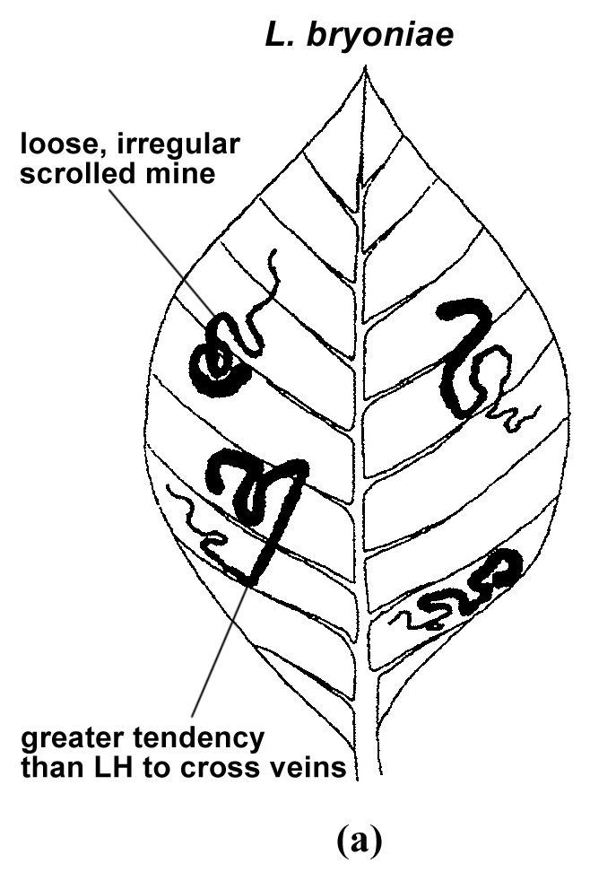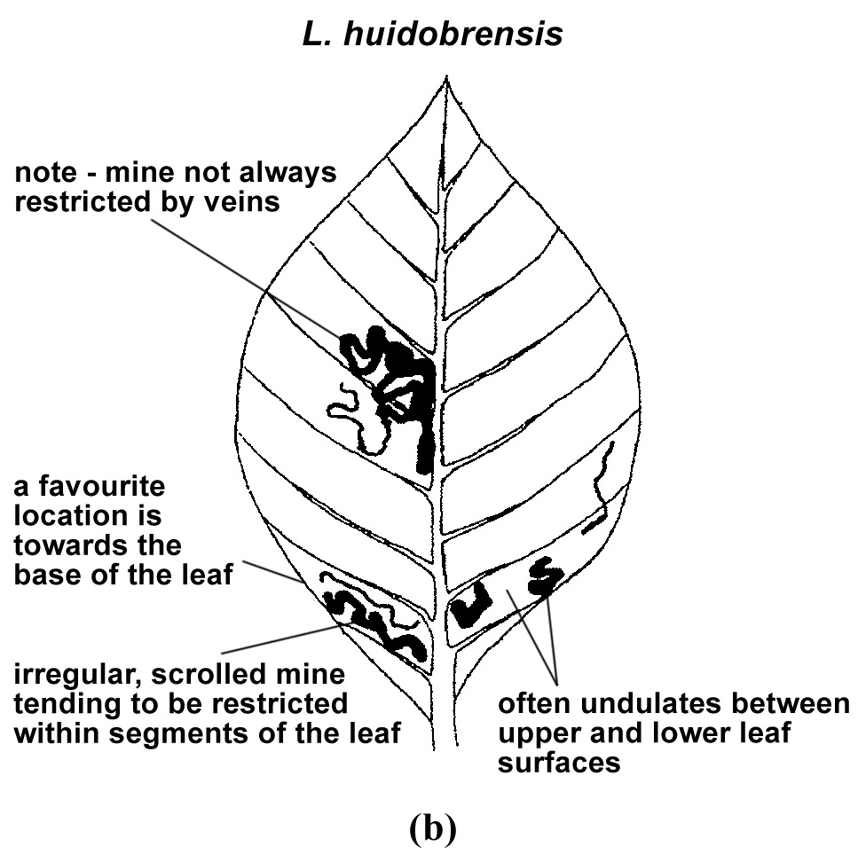
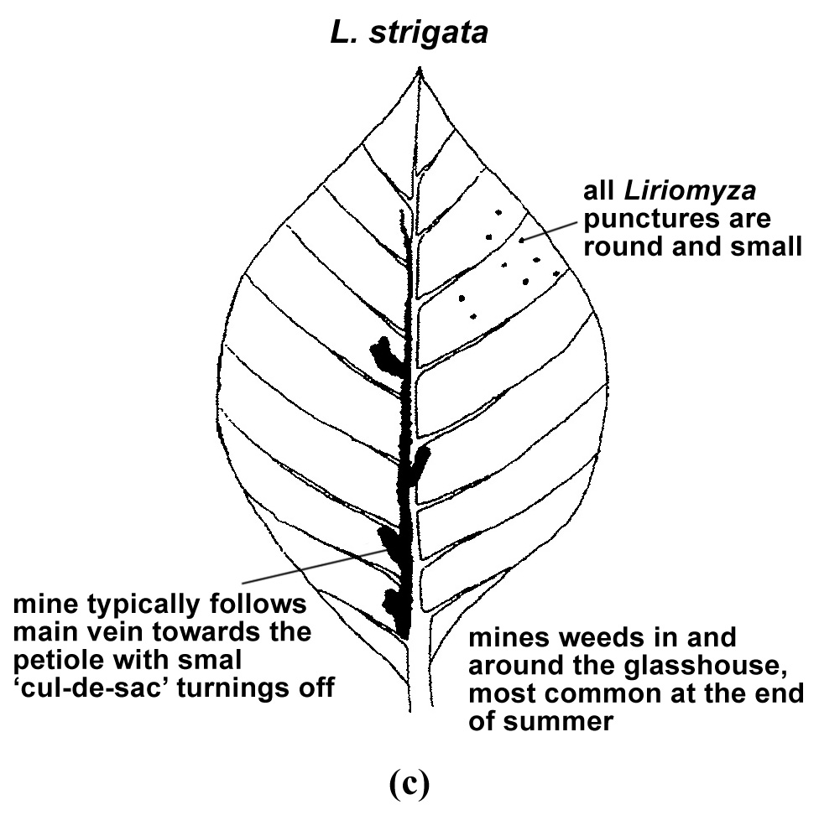
Figure 2. Typical characteristics of mines of (a) Liriomyza bryoniae, (b) Liriomyza huidobrensis and (c) Liriomyza strigata.
Source: EPPO (2005).
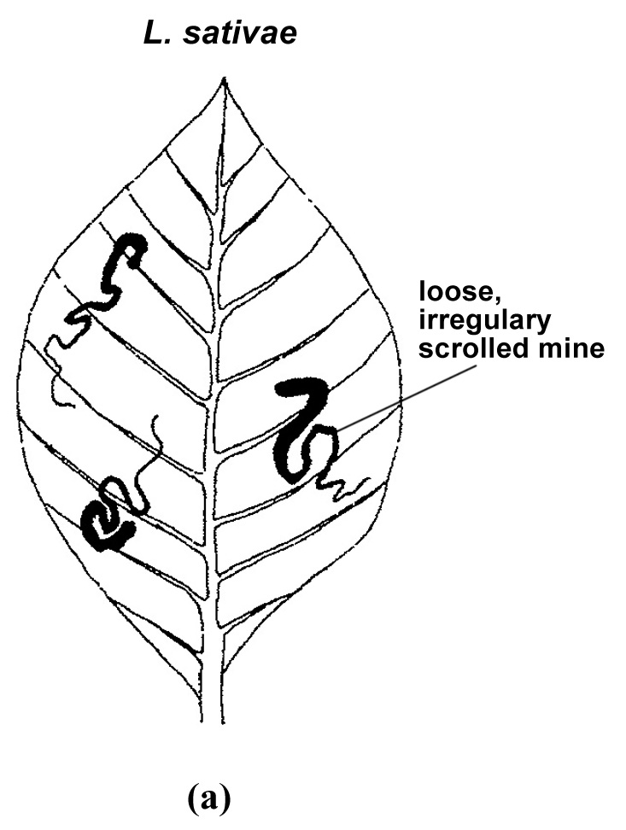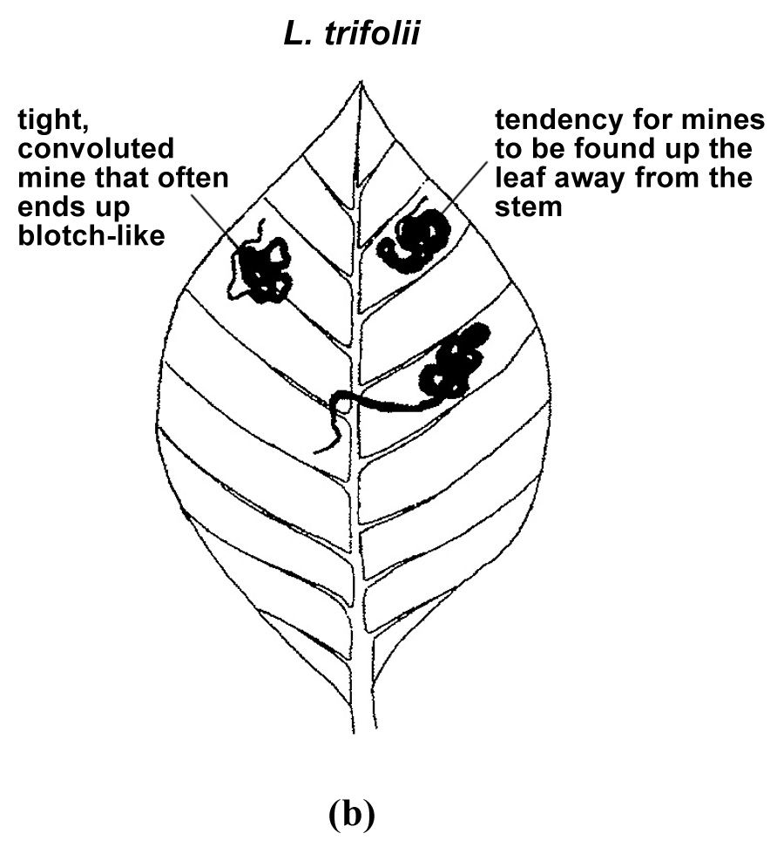
Figure 3. Typical characteristics of mines of (a) Liriomyza sativae and (b) Liriomyza trifolii.
Source: EPPO (2005).

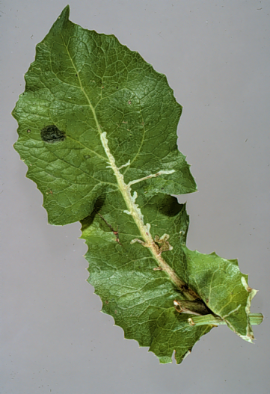
Figure 4. Typical mines of Liriomyza spp.: (a) L. bryoniae on tomato; (b) L. huidobrensis on chrysanthemum; (c) L. trifolii on chrysanthemum; (d) L. sativae on pepper; and (e) L. strigata on an unidentified host.
Photos courtesy of: Department of Environment, Food and Rural Affairs, United Kingdom

Figure 5. Male genitalia of Liriomyza huidobrensis (lateral view).
Photo courtesy Department of Environment, Food and Rural Affairs, United Kingdom.

Figure 6. Abdomen in (a) male and (b) female Liriomyza.
Photo courtesy Department of Environment, Food and Rural Affairs, United Kingdom United Kingdom
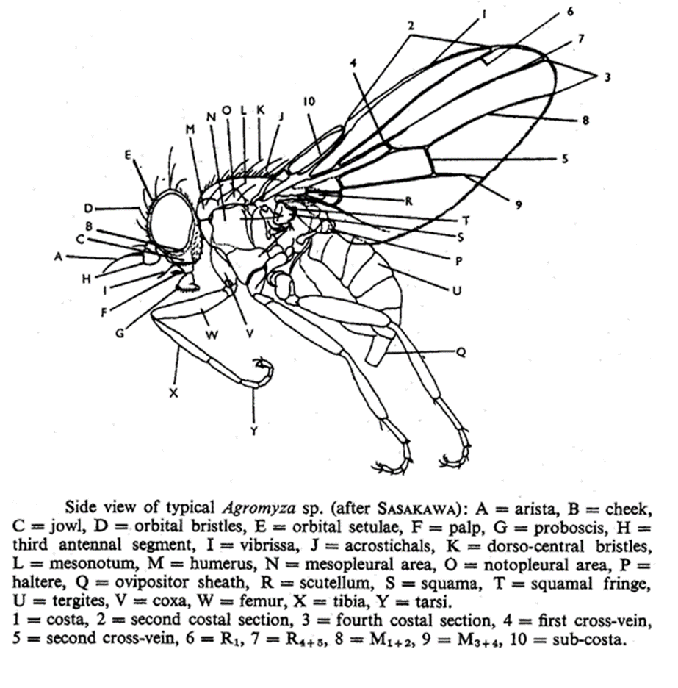
Figure 7. Adult morphology of Agromyzidae.
Source: Spencer (1973).

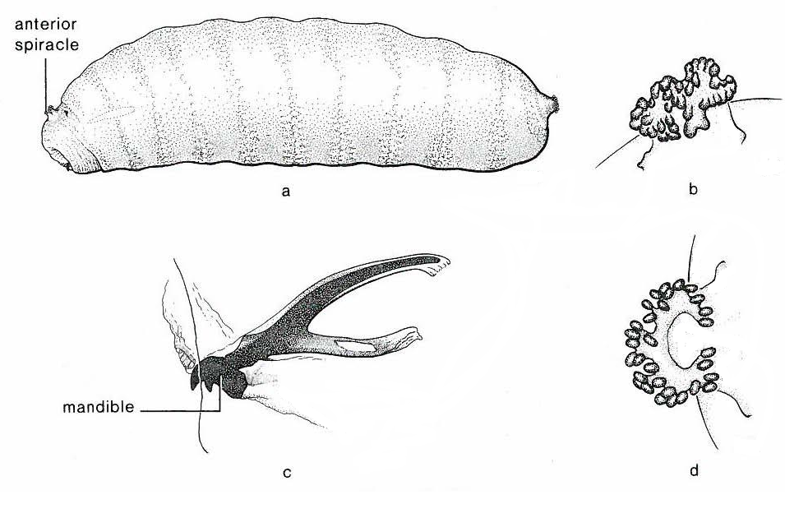
 | Figure 8. Larval morphology of Agromyzidae (Phytomyza chelonei): (a) lateral view; (b) anterior spiracle; (c) cephalopharyngeal skeleton; and (d) posterior spiracle.
Source: Stehr, 1991
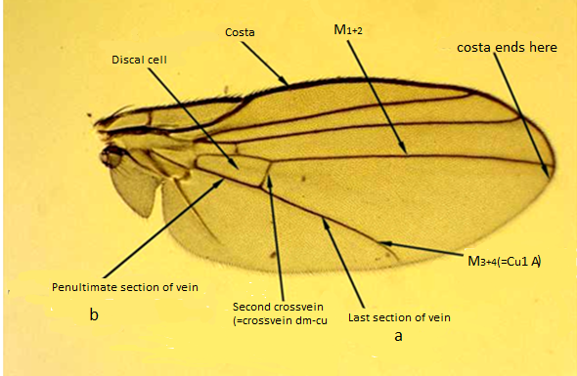

Figure 9. Wing venation of Liriomyza.
Photo courtesy Victorian State Government Department of Environment, Land, Water and Planning, Australia.
 |  | Figure 10. Distiphallus of Liriomyza spp. (×400 magnification): (a) L. bryoniae, anterior view; (b) L. huidobrensis, anterior view; (c) L. strigata, anterior view; (d) L. bryoniae, lateral view; (e) L. huidobrensis, lateral view; (f) L. strigata, lateral view; (g) L. bryoniae, dorso-ventral view; (h) L. huidobrensis, dorso-ventral view; (i) L. strigata, dorso-ventral view; (j) L. bryoniae, dorso-ventral view (in a different plane from (g)); and (k) L. huidobrensis, dorso-ventral view (in a different plane from (h)).
 |  | Photos courtesy Department of Environment, Food and Rural Affairs, United Kingdom
 |  | Figure 11. Distiphallus of Liriomyza spp. (×400 magnification): (a) L. sativae, anterior view; (b) L. trifolii, anterior view; (c) L. sativae, lateral view; (d) L. trifolii, lateral view; (e) L. sativae, dorso-ventral view; and (f) L. trifolii, dorso-ventral view.
 |  | Photos courtesy Photos courtesy Department of Environment, Food and Rural Affairs, United Kingdom
Figure 12. Pupa of Liriomyza sp
Photos courtesy Victorian State Government Department of Environment, Land, Water and Planning, Australia

Figure 13. Third larval instar of L. bryoniae
Photos courtesy Photos courtesy Department of Environment, Food and Rural Affairs, United Kingdom

In this diagnostic protocol, methods (including reference to brand names) are described as published, as these defined the original level of sensitivity, specificity and/or reproducibility achieved. The use of names of reagents, chemicals or equipment in these diagnostic protocols implies no approval of them to the exclusion of others that may also be suitable. Laboratory procedures presented in the protocols may be adjusted to the standards of individual laboratories, provided that they are adequately validated.

