Good Practices
for participation
in IPPC Standards Committee Meetings

Updated April 2017

Food and Agriculture Organization of the United Nations

Good practices for participation in IPPC Standards Committee meetings
Table of contents
List of Abbreviations 3
1. Purpose 4
2. Background 4
2.1 A brief history of the IPPC 4
2.2 List of tools to keep in mind 4
2.3 ISPMs and the IPPC standard setting process 5
3. Standards Committee (SC) 5
3.1 SC membership 5
3.2 Restricted work area on the IPP 6
4. SC work in relation to the IPPC Standard Setting Process 6
4.1 What does it imply to be a SC member? 6
4.2 Overview of SC meetings and how to prepare 7
5. Stewards of ISPMs 8
6. Specific tasks related to the four stages of the Standard Setting Process 9
6.1 Developing the IPPC Standard Setting work programme 9
6.2 Drafting 11
6.3 MC on draft ISPMs 13
6.4 Adoption and publication 14
Appendix 1. Flowcharts of the IPPC Standard Setting Process…………………………………….17

List of Abbreviations
CPM | Commission on Phytosanitary Measures
DP | Diagnostic Protocol
EDG | Expert Drafting Group
EWG | Expert Working Group
FAO | Food and Agriculture Organization
IICA | Inter-American Institute For Cooperation on Agriculture
IPP | International Phytosanitary Portal
IPPC | International Plant Protection Convention
ISPM | International Standard for Phytosanitary Measures
LOT | List of topics for IPPC standards
NPPO | National Plant Protection Organization
OCS | Online Comment System
RPPO | Regional Plant Protection Organization
SC | Standards Committee
SC-7 | Standards Committee Working Group
SPS | Agreement on the Application of Sanitary and Phytosanitary Measures
TP | Technical Panel
TPDP | Technical Panel on Diagnostic Protocols
TPFF | Technical Panel on Pest Free Areas and Systems Approaches for Fruit Flies
TPFQ | Technical Panel on Forest Quarantine
TPG | Technical Panel on the Glossary
TPPT | Technical Panel on Phytosanitary Treatments
WTO | World Trade Organization

1. Purpose
- The purpose of this manual is to provide information to members of the International Plant Protection Convention (IPPC) Standards Committee (SC) (particularly newly appointed members) regarding the activities and functions of the SC, and how SC members achieve their tasks and objectives. It also provides a time frame of the standard setting process, with due dates for the major steps involved during the development of a standard. The information was taken from various sources, including the IPPC Procedure Manual for Standard Setting activities, the SC Terms of Reference and Rules of Procedures and the Inter-American Institute for Cooperation on Agriculture (IICA) Handbook of good practices for participation in meetings of the IPPC.
- This manual is partly organized according to the four stages of the IPPC standard setting process, highlighting how each SC member can provide input and contribute to the process.

2. Background

2.1 A brief history of the IPPC
- The IPPC came into force in April 1952. It was recognized by the 1989 Uruguay Round of the General Agreement on Tariffs and Trade as a standard setting organization for the Agreement on the Application of Sanitary and Phytosanitary Measures (SPS Agreement) of the World Trade Organization (WTO). WTO members agreed to base their phytosanitary measures on international standards developed by the IPPC.
- In 1992, the IPPC Secretariat was established at the Food and Agriculture Organization (FAO) of the United Nations and headquartered in Rome, Italy. In 1995, contracting parties requested a revision of the Convention to reflect contemporary phytosanitary concepts and the role of the IPPC in relation to the SPS Agreement. In the same year, the FAO Conference approved the first three international standards for phytosanitary measures (ISPMs).
- There are currently 183 contracting parties to the IPPC, all sharing the same goal of protecting the world’s cultivated and natural plant resources from the spread and introduction of plant pests, while minimizing interference with the international movement of goods and people.

2.2 List of tools to keep in mind
- To perform their duties, SC members should be familiar with the following key IPPC documents:
- Text of the ConventionIPPC Procedure Manual
- IPPC Procedure Manual for Standard Setting
- The IPPC Style Guide (guidance to drafting of standards)
- Adopted ISPMs, in particular conceptual ISPMs that are the foundation of the IPPC, such as ISPM 1 Phytosanitary principles for the protection of plants and the application of phytosanitary measures in international trade and ISPM 5 Glossary of phytosanitary terms
- Framework for standards
- List of topics for IPPC standards
- Criteria for justification and prioritization of proposed topics
- Explanatory Document on ISPM 5 “Annotated Glossary”

2.3 ISPMs and the IPPC standard setting process
- ISPMs are adopted by IPPC contracting parties through the CPM. Standards in themselves are not binding and should not be considered as regulatory instruments, but come into force when countries establish requirements within their national legislation. Existing standards are revised as necessary. Adopted ISPMs include texts on a long range of systemic concepts (anything from pest surveillance to pest risk analysis) and on pest-specific or commodity/pathway-specific phytosanitary measures.
- The first draft of an ISPM is normally produced by either a Technical Panel (TP) or an Expert Working Group (EWG). There are currently five TPs, established for specific phytosanitary technical areas:
- Technical Panel on Diagnostic Protocols (TPDP)
- Technical Panel on Forest Quarantine (TPFQ)
- Technical Panel on pest free areas and systems approaches for Fruit Flies (TPFF)
- Technical Panel on the Glossary (TPG)
- Technical Panel on Phytosanitary Treatments (TPPT)
- The IPPC Standard Setting process consists of four stages explained in further details under section 6.

3. Standards Committee (SC)
- The SC is responsible for managing the development of ISPMs and overseeing the standard setting process, including providing oversight to the work of TPs and EWGs. The SC does not write standards, but reviews and revises draft ISPMs, monitors their development, ensures they are of consistent quality and use harmonized terms. The SC may also be assigned additional tasks by the CPM, such as the review of procedural and administrative documents to ensure consistency with the standard setting process.
- The Guidelines on the duties of members of the SC can be found in section 6.5 of the IPPC Procedure Manual for Standard Setting. Detailed information on the tasks of SC members is also provided in the IPPC Procedure Manual for Standard Setting, under each stage of the standard setting process.
- The SC may agree to use electronic means for internal consultation among SC members and for the approval of specific issues between SC meetings. The usual amount of time allowed for responses is three weeks. Detailed information on electronic decisions is included in section 6.8 of the IPPC Procedure Manual for Standard Setting.

3.1 SC membership
- The membership of the SC is explained in details in the Terms of reference and Rules of procedure for the SC, cf. sections 6.2 and 6.4, respectively, of the IPPC Procedure Manual for Standard Setting. Here is a summary:
- The SC consists of 25 members from each of the seven FAO regions. Having experts from various regions allows for the SC to obtain a range of views that can produce globally acceptable standards
- SC members are expected to act as individual experts, not as country or regional representatives. However, the views of the expert are usually those characteristic of the region the expert comes from
- The SC selects its own chair, vice chair and rapporteur, cf. section 6.1 of the IPPC Procedure Manual for standard setting
- The SC usually meets twice a year, in May and November. Ad hoc working groups and drafting groups consisting of SC members may be required to address special issues or undertake specific drafting tasks.
- Each region must nominate potential replacements for their SC members. In addition, SC members from each region select one SC member to the Standards Committee Working Group (SC-7) to review comments and revise draft standards. The SC-7 selects its own chair and rapporteur.

3.2 Restricted work area on the IPP
- The work area is a restricted area on the International Phytosanitary Portal (IPP) with work spaces available for various groups, including SC members. This virtual workspace can include documents for meetings, message boards, discussion forums and tools for electronic decision making. Each SC member should be familiar with this key tool and be able to navigate it to find relevant information.
- Access to the work area is password restricted and users are only able to access the section of the work area for the group(s) they belong to. To use the work area, SC members should log in with their username and password and then go to the dashboard, which provides links enabling each user to quickly access the relevant information and other tools, such as forms for updating contact information, viewing groups, changing preferences and the electronic decision tool.

4. SC work in relation to the IPPC Standard Setting Process

4.1 What does it imply to be a SC member?
- The commitment and general responsibilities of an SC member during the three year term include the following:
- Allocate time for preparation, travel and attendance to the meeting, and follow-up activities after the meeting. Additionally, SC members should receive the support from their manager or supervisor. The time needed could be estimated at, as a minimum:
- 2-4 weeks for meetings (depending on involvement in the SC-7 and travel distance)
- 2 weeks to review draft standards
- 2 weeks to review consultation comments
- this amount of time may increase if the SC member participates in regional workshops on draft standards and is a steward of an ISPM.
- Consult and liaise with relevant national and international experts.
- Read all meeting documents prior to the meeting and provide discussion papers or comments.
- Maintain a functioning email address and join in email discussions or conference calls outside of regular meeting dates and times.
- Regional communication:
- SC members should assist with the communication of information regarding draft ISPMs to countries within their region by discussions with other regional experts, attending regional workshops, or contributing to supplementary written information on the draft standards.
- Regions may assign one or more SC members to play a lead role in facilitating the communication between the SC and National Plant Protection Organizations (NPPO) and Regional Plant Protection Organizations (RPPO) within their region.

4.2 Overview of SC meetings and how to prepare
- SC members’ preparation and organization are key to ensure a successful event. Some essential aspects to consider are below.
Overview of SC meetings
At the May meeting, SC members:
- Assign stewards and review draft specifications submitted for new topics added at the previous CPM, and approve draft specifications for consultation
- Review and approve draft ISPMs for consultation
- Review TP work
At the SC-7 meeting (May), SC-7 members:
Review and revise draft ISPMs that had been sent for the first consultation, and approve them to be sent for the second and subsequent consultation(s)
At the November meeting, SC members:
- Review revised ISPMs from the SC-7 (with compiled second and subsequent consultation comments and steward’s responses, plus recommendations from the SC-7) and recommend the draft for adoption by the CPM
- Approve specifications after consultation
- Propose revisions to the List of topics for IPPC standards (LOT) and recommend to the CPM.
Working papers for SC meeting should be submitted to the Secretariat at least five weeks prior to the meeting.
The Secretariat will post working papers on the SC restricted area up to two weeks prior to the meeting.
- Before the meeting, the SC member should:
- Regularly visit the restricted work area of the IPP to access the meeting documents, including the agenda, the draft specifications or standards that will be discussed, summaries of compiled comments following a consultation (see box below), etc.
- Review the meeting agenda to be aware of the topics that will be discussed.
- Consult other background documents, such as reports from past SC meetings, CPM reports, TP and EWG reports and discussion papers.
- Bring a copy (electronic or paper) of the documents that will be discussed at the meeting and of those which may facilitate the discussions. These may also include adopted ISPMs, the IPPC Procedure Manual, etc.
- Make travel arrangements well in advance (e.g. flights, hotel accommodation, ground transportation, and passport and visa requirements).
- Communicate with other SC members within the region to coordinate discussions and follow up with NPPOs and stakeholders to develop a position.
- Prepare positions and circulate them to appropriate people within the region (e.g. NPPOs, RPPOs and stakeholders).
The tables of compiled comments on draft standards and the related steward’s comments and responses are among the most important documents to consult, both as learning material and to prepare for SC meetings. These tables summarize global considerations and the work and discussion of experts. It is the SC’s responsibility to ensure all comments are appropriately addressed. The tables of compiled comments are often very long. In practice, the detailed scrutiny of comments after the first consultation is performed by the SC-7 and the steward, and after the second and subsequent consultation by the steward. However, as a learning exercise, it is suggested that in preparation for a SC meeting, you:
- Read all draft ISPMs carefully and note preliminary comments, distinguishing between substantive, technical, editorial and possible translation issues.
- Select, in accordance with your personal interests, the table(s) of compiled comments you’d like to focus on, with the related steward’s responses to comments. Read it thoroughly and reflect on the validity, relevance and importance of each comment in the table. Take note of your conclusions or questions as you go through the table.
- In preparation for the SC meeting, list or note the comments you would like to raise and discuss during the meeting.

- At the meeting, the SC member should:
- Take detailed notes on the discussions for possible reporting back home; these notes will also be useful at the end of the meeting when the report is being reviewed for adoption.
- Make interventions when required. Interventions should be clear and brief, allowing for translators to convey the appropriate message.
- Attend evening sessions on topics that could not be concluded during the day.
- Read or write new draft texts in the evening, in preparation for next day’s sessions.
- After the meeting, the SC member should:
- Carefully review your meeting notes and, if required, prepare a report for your home organization or region, identifying key elements discussed and any required follow up action.
- Regularly check the SC IPP work area because some issues may require follow up.

5. Stewards of ISPMs
- An SC member who has been selected as steward for an ISPM will be responsible to oversee the development of the particular standard from the time of drafting the specification to the adoption by the CPM, and to serve as a liaison between the EWG and the SC. Section 6.7 of the IPPC Procedure Manual for Standard Setting provides detailed information on the duties of a steward. An overview is provided in the following paragraphs.
- A steward is expected to have good knowledge of the IPPC standard setting process and a thorough understanding of the relevant specification. Before and during the meeting of the EWG or TP, the steward should liaise with the Secretariat to ensure that discussion papers are produced and to assist with the running of the meeting and the preparation of the meeting report. The steward should also ensure the correct phytosanitary terminology is used when drafting the standard (refer to ISPM 5, the Annotated Glossary and the IPPC Style guide, as appropriate).
- In preparation for consultation on the draft ISPM, the steward will prepare a short presentation to be posted on the IPP and used at regional workshops or individual country consultation. The steward is encouraged to attend and facilitate discussions at the SC and SC-7 meetings approving the draft for the first consultation, revising the draft for the second and subsequent consultation and approving the draft for CPM adoption. If the steward is not able to attend the meeting in person, the steward should provide documentation about the standard, brief the assistant steward or another SC member or be available for a conference call with the SC.
Exercise:
- Elaborate on the differences between the SC and SC-7.
- How do they interact with each other?
- As an SC member, how would you prepare for the next meeting?
- Where would you find the appropriate documentation, e.g. agenda, working papers, draft ISPMs?
- Where can you find the list of SC members and the report from the last SC meeting?

6. Specific tasks related to the four stages of the Standard Setting Process
Figure 1: Stages of the IPPC standard setting process
- The IPPC Standard Setting Process consists of four stages:
- Developing the List of topics for IPPC standards
- Drafting
- Consultation and review
- Adoption and publication
- Each stage contains several steps, as indicated in the following sections.

6.1 Developing the IPPC Standard Setting work programme

Figure 2: Stage 1, Step 1 of the IPPC Standard Setting Process

- The Standard Setting process begins with the development of the List of topics for IPPC standards (LOT). The SC, taking into account the IPPC Strategic Framework and the Criteria for justification and prioritization of proposed topics, reviews the existing LOT and the compiled list of proposed new topics. The SC recommends a revised LOT, adding topics from the compiled list, deleting or modifying topics in the existing LOT and prioritizing each topic. The proposed LOT is then submitted to the CPM for adoption.
Figure 3: Stage 1, Step 2 of the IPPC Standard Setting Process
- The SC reviews the LOT annually and recommends changes to the CPM. In exceptional circumstances, such as in response to a specific need, the SC may recommend an addition to the LOT. The CPM reviews the LOT recommended by the SC and adopts the LOT.
- In any year, when a situation arises in which an ISPM or a revision to an ISPM is required urgently, the CPM may insert such a topic to the LOT.

6.2 Drafting
Figure 4: Stage 2, step 3 of the IPPC Standard Setting Process

- Once the LOT has been adopted by the CPM, the SC assigns a lead steward and assistant(s) for each topic. Assistants could be from outside the SC, such as former SC members, TP members or EWG members.
- The SC reviews the draft specification submitted by the IPPC contracting party or RPPO and sends it for consultation, which lasts 60 days.
- SC members carefully review the draft specification by:
- ensuring the draft specification will produce a globally acceptable standard
- ensuring the draft specification accurately describes the title, scope and purpose of the intended standard
- ensuring the tasks and other elements of the draft specification are correctly identified
- proposing modifications if necessary
- assisting in the analysis of consultation comments and revising the draft specification.
- After consultation, the Secretariat compiles comments and forwards them to the steward(s) and the SC for review of the draft specification and its approval. Once the specification has been approved, the Secretariat posts a call for nominating experts for the EWG or TP. The SC will review nominations and approve the experts.
Figure 5: Stage 2, step 4 of the IPPC Standard Setting Process
- The EWG or TP drafts the ISPM in accordance with the relevant specification. EWGs or TPs usually have 6-10 participants representing a wide geographic area. The resulting draft ISPM is forwarded to the SC for review. The SC will decide whether to send it for first consultation (often following some modification by the SC), to return it to the steward(s) or to an EWG or TP, or to put it on hold.

Key dates to remember during stage 2: Drafting
Specifications
- Consultation on draft specifications (60 days) can be any time of the year, but usually in June-July and December-January
- The Secretariat sends compiled comments on draft specification to the steward(s) one week after consultation ends
- The steward reviews the compiled comments, adjusts the draft specification and returns the responses to the Secretariat five weeks before the SC meeting
- The Secretariat posts the draft specification with the steward’s responses in the SC restricted area two weeks before the SC meeting
- Following SC approval, the Secretariat posts the approved specification on the IPP two weeks after approval
Draft ISPMs
- EDGs must submit the draft ISPM to the Secretariat by 15 December for consideration by the SC for the May SC meeting; otherwise the draft needs to wait another year for the next May SC meeting
- The Secretariat posts the draft ISPMs on the SC restricted area by 1 March

6.3 MC on draft ISPMs
Figure 6: Stage 3, step 5 of the IPPC Standard Setting Process

The IPPC Online Comment System (OCS) facilitates the submission of comments on draft specifications and ISPMs sent for consultation. The OCS is a system for CPs, RPPOs and other organisations to develop, share, analyse, and submit comments on documents; for the Secretariat to compile comments in an easy and efficient manner; and to provide commenting data for analysis.
It is also a useful tool for sharing comments within a region before, during and after regional workshops, and it provides a simple, efficient, user-friendly online system to share, collect and compile comments.

Key dates to remember during Stage 3
First consultation on draft ISPMs
- The first consultation on draft ISPMs (90 days) is always from 1 July to 30 September
- The Steward’s presentations for draft ISPMs are due to the Secretariat by 15 June
- The Secretariat forwards compiled comments to the steward one week after the first consultation ends
- Regional workshops are held from July to early September
Second and subsequent consultation(s) on draft ISPMs:
- The second and subsequent consultation on draft ISPMs (90 days) is always from 1 July to 30 September
- The Secretariat forwards compiled concerns to the steward immediately after the second consultation ends
- Following approval by the SC, the Secretariat submits the draft ISPM to CPs, RPPOs, and other organizations for the first consultation, along with background information. During this consultation period, regional workshops are held to assist members within a region to discuss and prepare national comments on draft ISPMs. SC members are strongly encouraged to attend regional workshops.
- Comments received during this consultation will be compiled by the Secretariat and forwarded to the steward(s) and SC-7 for consideration.
- In preparation for the SC-7 meeting, the steward reviews the consultation comments, prepares responses and revises the draft ISPM. The SC-7 will further revise the draft standard and determine whether it is ready for the second consultation.
Figure 7: Stage 3, step 6 of the IPPC Standard Setting Process
- The Steward will review the comments submitted by CPs, RPPOs, and other organizations, revise the draft standard accordingly and submit it to the Secretariat, to be posted for the SC. The SC will further revise the draft standard and determine whether to recommend the draft standard to the CPM, or to put it on hold, return it to the steward(s) or to an EWG or TP, or submit it for another round of consultation.

6.4 Adoption and publication
Figure 8: Stage 4, step 7 of the IPPC Standard Setting Process (excluding DPs)

Figure 9: Stage 4, step 7 of the IPPC Standard Setting Process for DPs

Objections
- CPs may submit objections on draft ISPMs presented for adoption at CPM, along with technical justification and suggestions for improvement, to the Secretariat no later than three weeks prior to the CPM meeting. Concerned CPs should make every effort to seek agreement before the CPM session. The objection is added to the CPM session agenda and the CPM decides on a way forward. If no objection is received, the CPM adopts the ISPM without discussion.
- The SC adopts DPs on behalf of the CPM. Once approved, the draft is sent for a 45 day consultation. If a CP has an objection, the draft DP is returned to the SC. If no objection is received, the SC adopts the protocol. DPs adopted through this process will be noted at CPM meeting and attached to the CPM meeting report.

Exercise:
- Identify the stages of the standard setting process and elaborate on the key elements for each of them.
- Identify and elaborate on the opportunities that CPs, RPPOs and other organizations have to provide comments on draft specifications and ISPMs.
- In preparation for the next SC meeting, you are reviewing the List of topics for IPPC standards and proposed changes. What criteria will you use when you review the relevance of the topics that are proposed?

Key dates to remember in Stage 4 – Adoption and publication
- The Secretariat posts draft ISPMs on the IPP in languages six weeks before the CPM meeting
- CPs submit objections to the secretariat three weeks before the CPM meeting
- The Secretariat compiles the objections, creates a CPM paper and posts it publicly as soon as possible
- The Secretariat publishes adopted ISPMs eight weeks after the CPM meeting
- For DPs, the 45-day notification periods are 1 July to 15 August and 15 December to 30 January

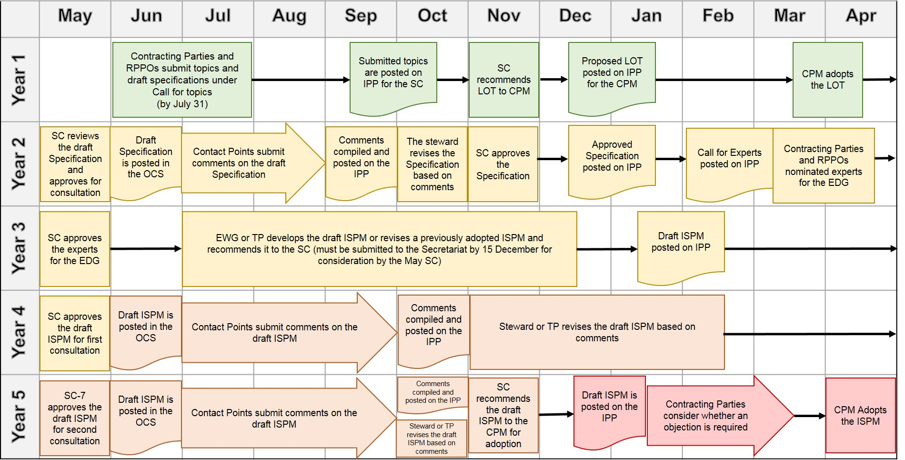

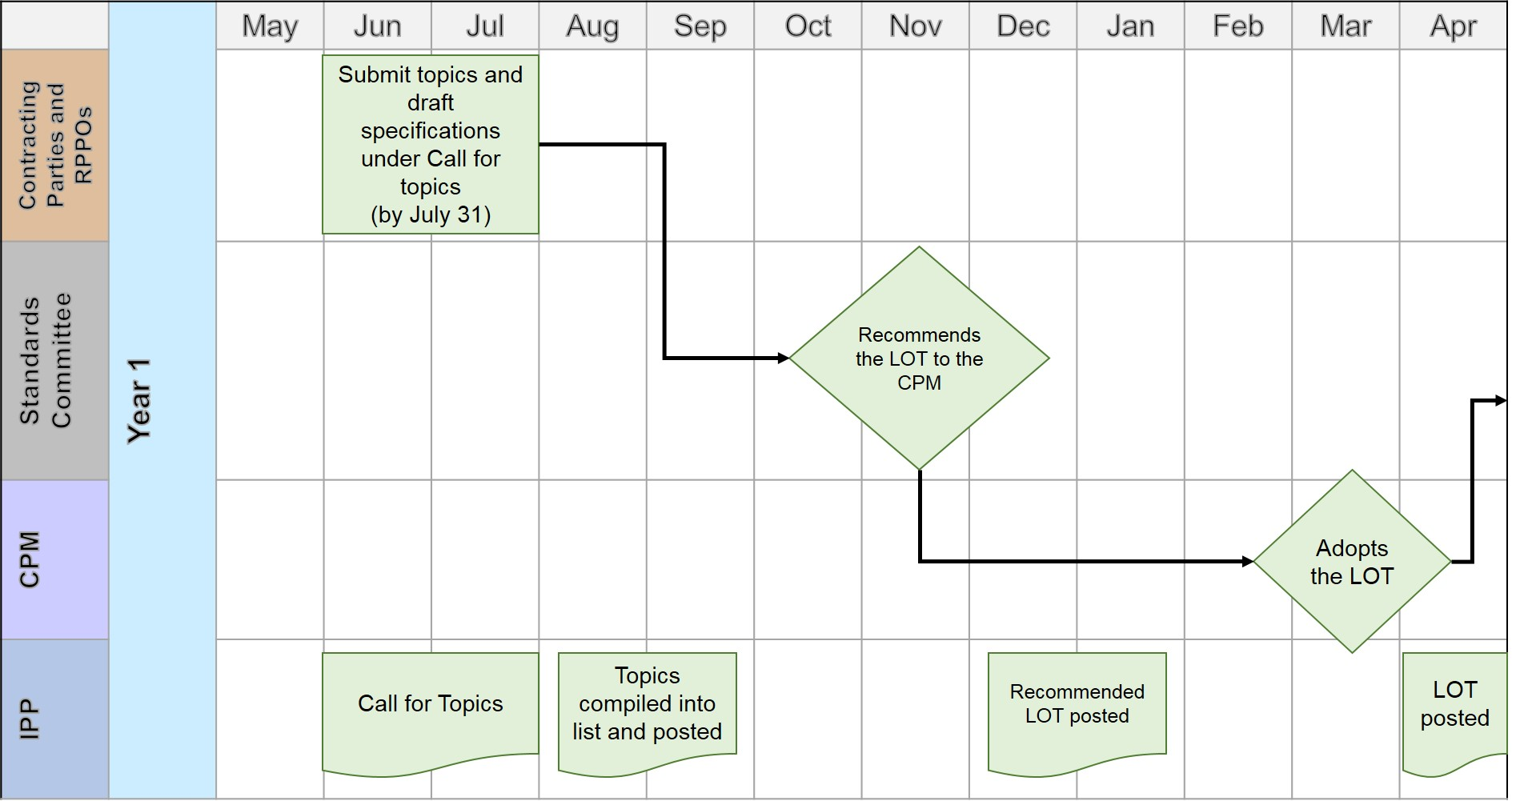

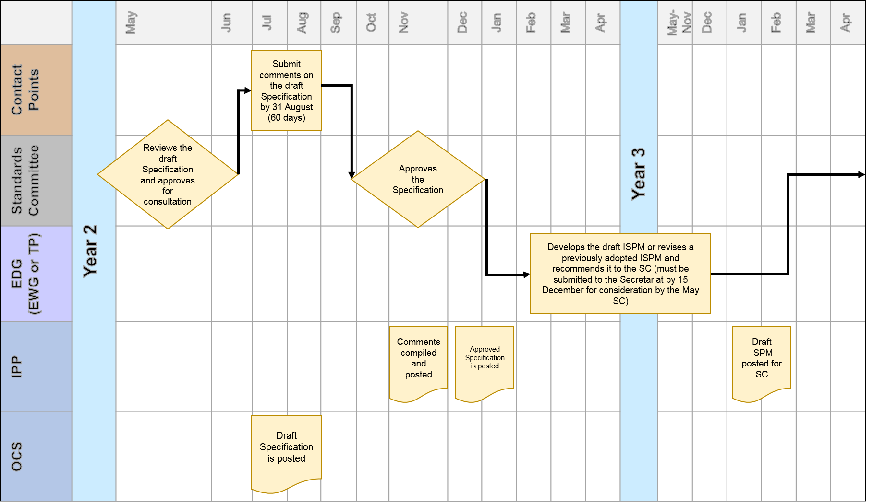
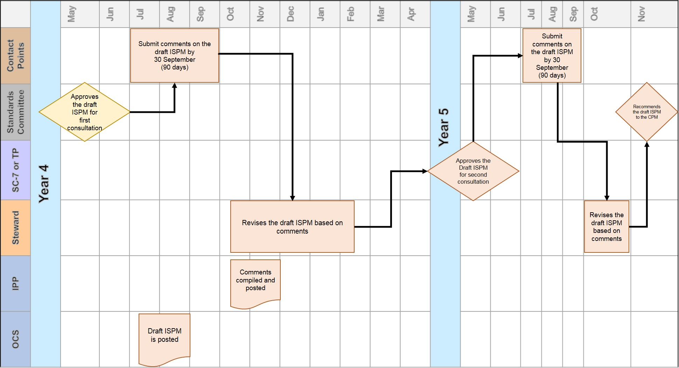

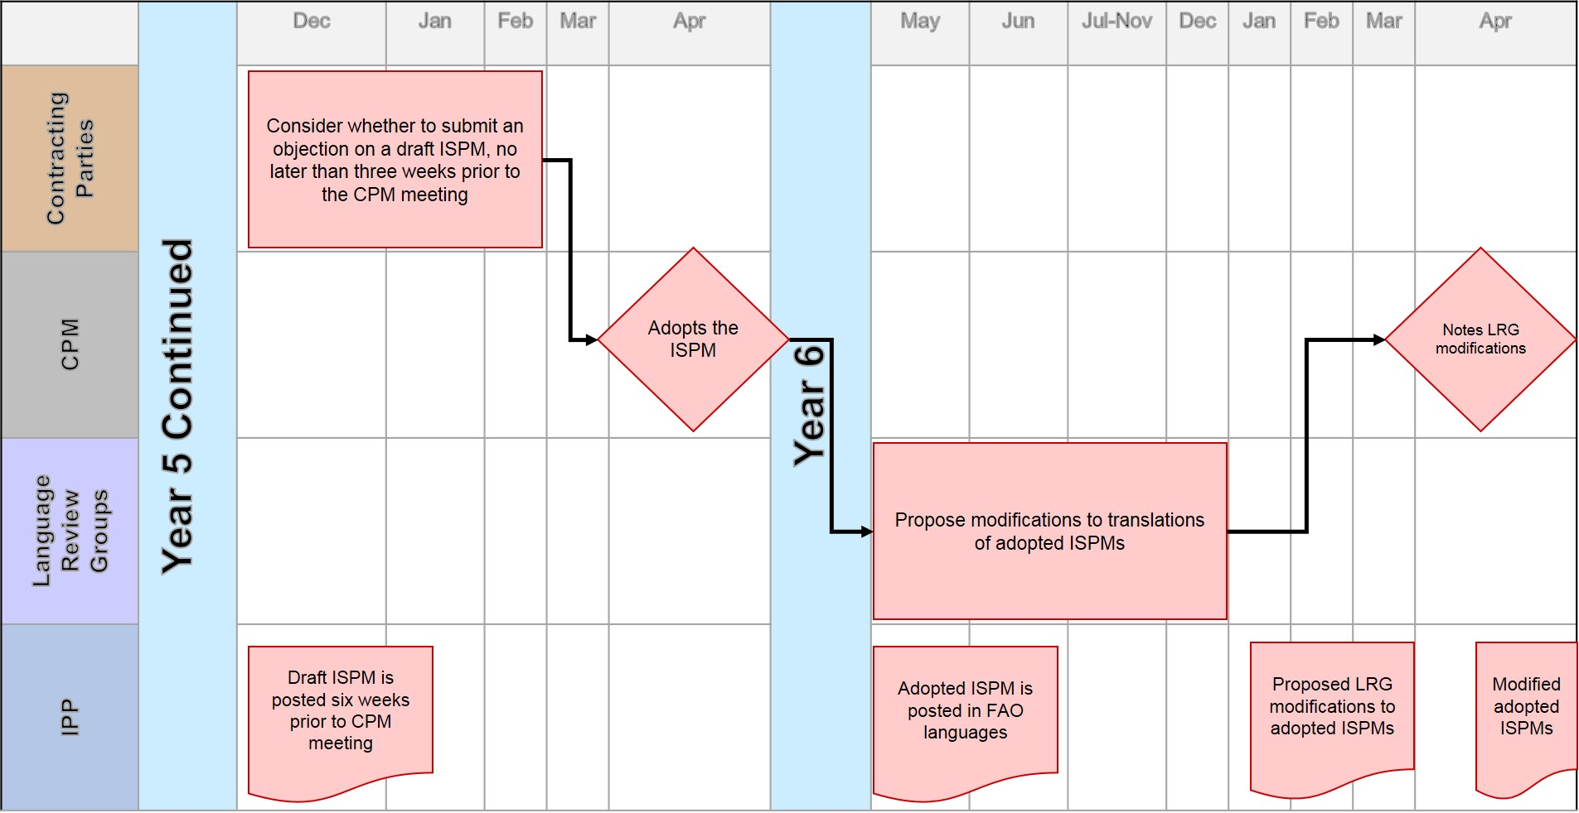

Text of the Convention: https://www.ippc.int/en/core-activities/governance/convention-text/
IPPC Procedure Manual: https://www.ippc.int/en/core-activities/governance/ippc-procedure-manual/
IPPC Procedure Manual for standard setting: https://www.ippc.int/en/core-activities/ippc-standard-setting-procedure-manual/
IPPC Style Guide: https://www.ippc.int/en/publications/ippc-style-guide/
ISPM 5: Glossary of phytosanitary terms: https://www.ippc.int/en/core-activities/standards-setting/ispms/
Framework for standards: https://www.ippc.int/en/core-activities/standards-setting/list-topics-ippc-standards/
List of topics for IPPC standards: https://www.ippc.int/en/core-activities/standards-setting/list-topics-ippc-standards/
Criteria for justification and prioritization of proposed topics: https://www.ippc.int/en/core-activities/standards-setting/list-topics-ippc-standards/
Explanatory document on ISPM 5, Glossary on Phytosanitary terms: https://www.ippc.int/en/core-activities/standards-setting/explanatory-documents-international-standards-phytosanitary-measures/
Diagnostic Protocols are adopted by the SC on behalf of the CPM.
Adopted ISPMs, including a printable list: https://www.ippc.int/en/core-activities/standards-setting/ispms/
International Phytosanitary Portal (IPP): https://www.ippc.int/
A link to the login form of the restricted work area is provided in the upright corner of the IPP or at https://www.ippc.int/en/accounts/login/?next=/en/
Excerpt from the Statement of Commitment (Annex 6 of the IPPC Procedure Manual): https://www.ippc.int/en/core-activities/ippc-standard-setting-procedure-manual/

