Calls for experts & DP authors
Once the Standards Committee (SC) approves a specification and resources are identified to hold an expert working group (EWG) meeting, the IPPC Secretariat contacts NPPOs and RPPOs through a call to nominate experts to be members of the EWG to develop a draft ISPM. In order to get nominated as an expert the nominee is requested to sign a statement of commitment. The SC selects the technical experts identified by the NPPOs and RPPOs for the EWG. The EWG meets and produces a draft ISPM and a meeting report. The draft ISPM is then approved for consultation by the SC. Members of Technical Panels (TPs) should have the necessary scientific expertise and subject matter experience, and should be able to participate and contribute to the proceedings. The steward of the TP is considered a member. Membership of TPs should be reviewed by the SC on a regular basis and may be adjusted as necessary, taking into account, in particular, changes in the needs of scientific or other expertise required and in the professional duties of the experts.

Once the Standards Committee (SC) approves a new subject to the Technical Panel on Diagnostic Protocols (TPDP) work programme and is inserted into the List of topics for IPPC standards the IPPC Secretariat contacts NPPOs and RPPOs through a call to nominate authors to be part of the diagnostic protocols (DPs) drafting groups develop a draft ISPM. Authors will work in liaison with the member of the Technical Panel on Diagnostic Protocols (TPDP) in charge of this protocols to develop two draft protocols as annexes to ISPM 27:2006 (Diagnostic Protocols for Regulated Pests). Please also refer to the procedure manual (link provided below) for further guidance.
In order to get nominated as a DP author, the nominee is requested to sign a statement of commitment. The TPDP selects the author (s) according to the criteria specified in the call letter.
Usually the requirements are:
Curriculum Vitae (CV) of experts nominated as authors should outline the specific diagnostic expertise with the pest. Technical and scientific expertise with the pest, especially diagnostic expertise, is considered a core requirement.
Additional expertise that would be helpful is:
• taxonomy and molecular diagnostics
• practical experience related to the pest (detection, identification, isolation etc.)
• quarantine diagnostic protocol expertise
• drafting of diagnostic protocols (such as regional diagnostic protocols)
• development of novel diagnostic methods
• experience using diagnostic protocols for diagnosis of regulated pests
• ability to work in English (written).
Nominees for authorship of diagnostic protocols should also be able to demonstrate the ability to work primarily through e-mail discussions in English (as it is not anticipated that authors will be required to meet in person) and that appropriate time to dedicate to drafting the diagnostic protocol via e-mail will be available.
All nominations are considered, although it is encouraged that nominations be submitted through national plant protection organizations (NPPOs) or regional plant protection organizations (RPPOs). Nominations should be supported by the submitting organization and self nominations should be supported by an accompanying letter from a government authority.
Please also see the documents posted below:
- IPPC statement of commitment (English, French, Spanish)
- TPDP Working Procedures
- ISPM 27:2006 (Diagnostic protocols for regulated pests)
- Instruction to authors
- Procedure Manual
This web page was last updated on 2016-04-20. For queries or comments regarding the contents of this page, please contact Piotr.Wlodarczyk@fao.org.
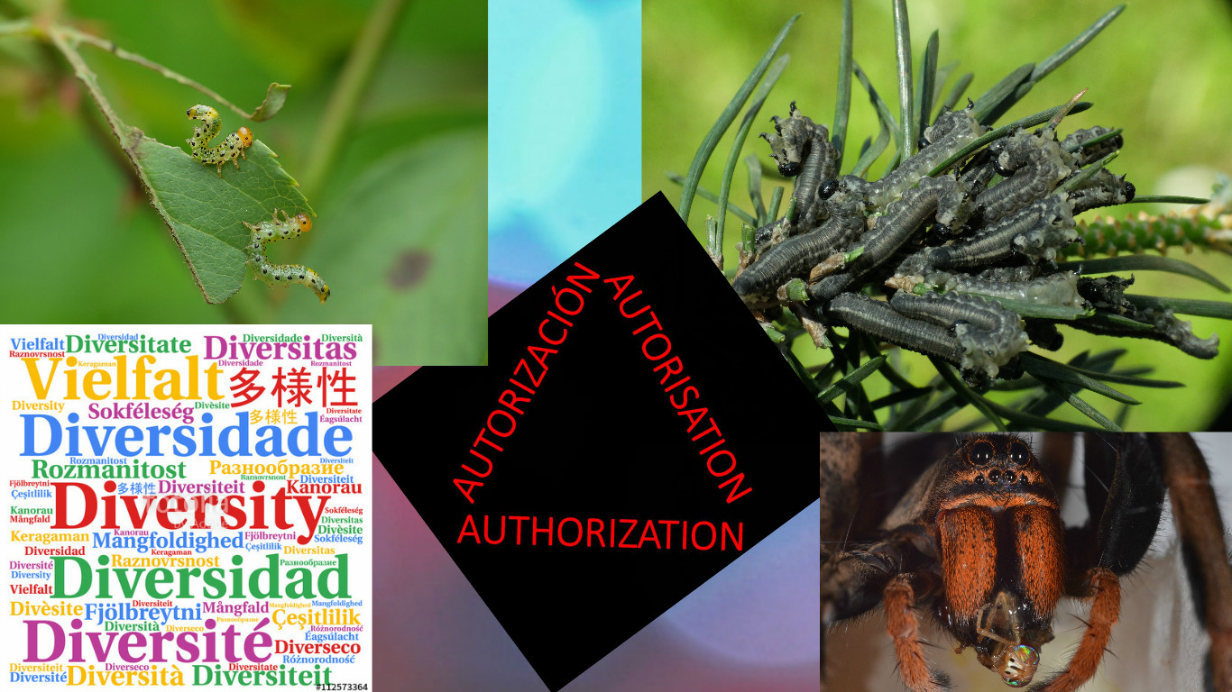

2017 Call for experts - Deadlines extended
The deadline for the submission of nominations for the Technical Panel for the Glossary (TPG) and for the Expert Working Group (EWG) on Revision of ISPM 8: Determination of pest status in an area (2009-005) has been extended.
The new deadline for the submission of these nominations is 28 April 2017.
The call for experts for the EWG to develop draft ISPM on Authorization of entities to perform phytosanitary actions (2014-002) is now closed.

The International Plant Protection Convention (IPPC) Secretariat is soliciting nominations for appropriately qualified experts to take part in:
• one Expert working group (EWG) to develop an international standard on Authorization of entities to perform phytosanitary actions (2014-002),
• one EWG on the Revision of ISPM 8: Determination of pest status in an area (2009-005),
• the Technical Panel for the Glossary (TPG).
Nominations are due 31 March 2017.
1. Instructions for making nominations
Nominations will be accepted from contracting parties, national or regional plant protection organizations (NPPOs or RPPOs) through their respective NPPO or RPPO official IPPC Contact Point and self-nominations should be supported by an accompanying letter from a government authority. A nomination should only be made if the nominee has agreed to his/her nomination, is available for the meeting dates as posted on the IPPC Calendar (2017) and can allocate appropriate time to the task as outlined in the Statement of Commitment. Each nomination must be accompanied by the following documentation:
• Completed nominee details and summary of expertise form - All sections should be completed, including contact details, education and professional training. A clear description of the nominee’s expertise in one of more of the areas of specific expertise is required. Word version of the document is preferred.**
• Completed and signed Statement of Commitment form - this should be read carefully by each nominee and a discussion had between the nominee and their employer. The form should then be signed by the nominee and a senior person in authority from the organization that employs the nominee and submitted with the nomination (as a scanned image file such as PDF). The file should be named as follows: COUNTRY_SURNAME_Firstname_committment.
• The nominee’s Curriculum Vitae (CV) – electronic copy of the nominee’s CV (only as a word processing file such as MS Word) with the file named as follows:
COUNTRY_SURNAME_Firstname_CV. Word version of the document is preferred.
Submissions should be sent to the IPPC Secretariat by e-mail ippc@fao.org no later than 31 March 2017. The name of the nominating country or RPPO and the words “Call for Experts” should be placed in the subject line of the email message. The SC will review the nominations and select experts based on the experience presented. Selected experts will be contacted by the Secretariat once the nomination has been confirmed.
2. Criteria used for prioritizing participants to receive IPPC Secretariat assistance to attend meetings
The organization that employs an IPPC meeting participant is responsible for funding the travel and daily subsistence allowance for that person to attend. If the employer is unable to allocate sufficient funds, participants are first encouraged to seek assistance from sources other than the IPPC Secretariat. Where such demonstrated efforts to secure assistance have been unsuccessful, requests for assistance (i.e. travel and subsistence costs) from the IPPC Secretariat may be made. IPPC funds available to assist attendance at meetings are usually limited and the IPPC Secretariat follows the IPPC Funding Criteria.
It is expected that participants will attend all sessions of the meeting and those participants who plan to attend only part of a meeting should fund their own travel.
3. Specific expertise required
The Standards Committee (SC) selects experts based on how closely an expert’s skills and experience match the specific expertise required. The discussions and work of technical panels and expert working groups (EWGs) take place in English, so experts should have a strong working knowledge of English. The experts should also be available to attend the next meeting of the relevant Technical panel or EWG meeting, which can be found on the IPPC Calendar (2017).
4. Expertise required for the EWG on the Authorization of entities to perform phytosanitary actions (2014-002) (see Specification 65)
Five to seven phytosanitary experts with collective expertise and experience in:
• authorization of entities to perform phytosanitary actions
• the development of authorization programmes and the relating training elements and
• knowledge in auditing compliance with authorization programmes.
The expert should preferably have experience in developing or implementing International Standards for Phytosanitary Measures (ISPMs).
The selected experts should be available to attend the EWG meeting in 2017, which is tentatively scheduled for 12-16 June 2017 in Ottawa, Canada, and any change will be published on the IPPC Calendar (2017)
5. Expertise required for the EWG on the Revision of ISPM 8: Determination of pest status in an area (2009-005) (see Specification 59)
Five to seven phytosanitary experts with collective expertise and experience in:
• phytosanitary systems;
• pest risk analysis;
• the development and implementation of ISPMs;
• surveillance, monitoring or eradication programmes for regulated pests;
• determination of pest status and;
• verification of pest records and have an understanding of the use of terminology within those systems.
The expert should preferably have experience in developing or implementing International Standards for Phytosanitary Measures (ISPMs).
The selected experts should be available to attend the EWG meeting in 2017, which is tentatively scheduled for 18-23 September 2017 in Hanoi, Viet Nam, and any change will be published on the IPPC Calendar (2017).
6. Expertise required (see Specification TP 5 -Technical Panel for the Glossary (2016))
TPG – Arabic, Chinese, and English speaking members
Three experts for a five-year term beginning in 2017 as members of the TPG for the Chinese, Arabic and English language.
• The phytosanitary, terminology and language expertise required is described in the specification.
This is for a five-year term and the selected experts should be available to attend all meetings of the TPG with the next one scheduled for 04-07 December 2017 in Rome, Italy and any change will be published on the IPPC Calendar (2017).

