Notes from Secretariat: The paragraph numbers and formatting will be adjusted after adoption.
[1]Draft annex to ISPM 27: Conotrachelus nenuphar (2013-002)
[2]Status box
[3]This is not an official part of the standard and will be modified after adoption
[4]Date of this document | [5]2018-06-13
[6]Document category | [7]Draft annex to ISPM 27 (Diagnostic protocols for regulated pests)
[8]Current document stage | [9]To DP notification period
[10]Origin | [11]Work programme topic: Insects and mites (2006-007)  [12]Original subject: Conotrachelus nenuphar (2013-002)
[13]Major stages | [14]2013-05: Standards Committee (SC) added original subject: Conotrachelus nenuphar (2013-002).  [15]2015-04-10: Diagnostic Protocol (DP) drafting group formed.  [16]2016-09-29 First draft of document produced.  [17]2016-11: Expert consultation.  [18]2017-02: Technical Panel on Diagnostic Protocols (TPDP) review.  [19]2017-05 TPDP recommendation for consultation (2017_eTPDP_May_02).  [20]2017-06 SC approval for consultation (2017_eSC_Nov_02).  2017-07 First consultation.  2017-11 Draft revised by the lead based on consultation comments.  2018-02 TPDP meeting. TPDP approved to submit to SC for approval for adoption  2018-04 SC approved for the DP notification period (e-decision 2018_eSC_May_08)
[21]Discipline leads history | [22]Mr Norman BARR (US, discipline lead)  [23]Ms Geraldine ANTHOINE (FR, referee)
[24]Consultation on technical level | [25]The first draft of this protocol was written by:  - [26]Mr Samuel Nathan Crane (US)  - [27]Mr Charles W. O’Brien (US, lead author)  - [28]Ms Juliet Goldsmith (JM).  [29]In addition, the draft has also been subject to expert review and the following international experts submitted comments:  [30]Mr Hiroaki Shirato (Yokohama Plant Protection Station, Ministry of Agriculture, Forestry and Fisheries, JP) and Ms Raphaëlle Mouttet (FR).
[31]Main discussion points during development of the diagnostic protocol | [32]Comment:  [33]The inclusion of DNA methods was considered but removed from this version. The methods have not been published prior to reporting in the protocol.
0[34]Notes | [35]2017-04 Edited  2017-12 Edited  [36] Consultation period: Please note that some paragraph numbers may be missing from the document or not be in a chronological order. This is due to technical problems in the OCS but it does not affect the integrity of the content of the document.  2018-02 Edited
[37]CONTENTS
[38][To be added]
[39]Adoption
[40]This diagnostic protocol was adopted by the Standards Committee on behalf of the Commission on Phytosanitary Measures in ---- [to be completed after adoption].
[41]The annex is a prescriptive part of ISPM 27.

[42]1. Pest Information
[43]The weevil Conotrachelus nenuphar (Herbst) (Coleoptera: Curculionidae) is a native pest of fruits in eastern North America. Its main hosts include native and exotic rosaceous plant species (Chapman, 1938; CABI, 2017). It is an agricultural pest of orchard fruit – especially Prunus spp. (apricots, plums, peaches, nectarines, cherries), Malus pumila (apples), Pyrus communis (pears) and Vaccinium corymbosum (blueberries) (Quaintance and Jenne, 1912; Chapman, 1938). The adult beetles will feed on the fruits of many other kinds of rosaceous plants (including Cydonia oblonga, Fragaria ×ananassa, Sorbus aucuparia, Amelanchier arborea and Crataegus spp.), non-rosaceous plants (including Diospyros kaki, Ribes spp. and Vitis spp.) and, if given the opportunity, tropical fruits (Quaintance and Jenne, 1912; Chapman, 1938; Hallman and Gould, 2004). C. nenuphar discriminates among these potential food sources and prefers Prunus spp., M. pumila and P. communis (Jenkins et al., 2006; Leskey and Wright, 2007). Females will oviposit in these fruits, and larvae can successfully develop in any of them. Larvae have been known to develop in fungal black knot (Plowrightia morbosa) on Prunus avium (Quaintance and Jenne, 1912; Jenkins et al., 2006).
[44]The adults feed on the fruit and the larvae develop within the fruit of these plants. Crop damage arises as a result of oviposition sites on the fruit and adult as well as larval feeding on fruits. The adult feeding punctures often deform the fruit and open the skin to further damage by other insect pests or to fungal attacks. The developing larvae consume the flesh of the fruit and cause the fruit to drop from the tree before ripening. Fully developed larvae leave the dropped fruit through exit holes and burrow into the soil to pupate. All forms of fruit damage are problems for fresh market fruits, and premature drop prevents the fruit from being used as a processed food item.
[45]There are two phenological strains of C. nenuphar in its native range: a northern strain and a southern strain (Chapman, 1938; Zhang and Pfeiffer, 2008). The number of generations per year is a defining characteristic of the strains. The northern strain of C. nenuphar must diapause to become reproductively mature (obligate diapause) and has a single generation per year, with adults entering diapause in the late summer and early autumn before female reproductive features have developed. The C. nenuphar southern strain usually has only one generation per year but can develop reproductively and have a second, or even in rare cases, a third generation in a single season (facultative diapause) (Smith and Salkeld, 1964). For this reason, summer- and autumn-harvested fruit may have viable larvae in them in the southeastern United States of America, although this is rare. The two strains can successfully mate but unidirectional reproductive incompatibility between strains has been observed under laboratory conditions (Zhang and Pfeiffer, 2008). DNA analysis of C. nenuphar in the eastern United States of America supports the concept of genetic separation in the species between the northern and southern populations (Zhang et al., 2008). However, the voltinism of several populations included in the Zhang et al. (2008) study was not known, precluding a comprehensive analysis of the genetic separation between strains. The C. nenuphar populations distinguished by the genetic data were not the same as the strain distributions reported in Chapman (1938).

[46]2. Taxonomic Information
[47]Name: Conotrachelus nenuphar (Herbst, 1797)
[48]Synonyms:
[49]Curculio nenuphar Herbst, 1797
[50]Rhynchaenus argula Fabricius, 1801
[51]Rhynchaenus cerasi Peck, 1819
[54]Taxonomic position:
[55]Insecta, Coleoptera, Curculionidae, Molytinae
[56]Common names: Plum curculio, plum weevil
[57]See Schoof (1942) for more taxonomic details.

[58]3. Detection
[59]Conotrachelus nenuphar can be detected in or near plants on which it feeds. It is commonly found on the following plant parts and in plant-associated media, depending on the life stage:
- [60]eggs – found within immature fruit tissue and mature fruit tissue (if from the southern strain)
- [61]larvae – found within immature fruit tissue and mature fruit tissue (Figure 1)
- [62]pupae – found in the soil
- [63]adults – found on leaves, branches, flowers and fruits.
[64]The larvae are the life stage most likely to be transported in late-season fruit, especially from the southern extent of the C. nenuphar range. Pupae may be transported in soil along with tree seedlings or transplants. Adults may be transported in nursery material, rootstocks, branches, flowers and fresh packed fruit.

[65]3.1 Symptoms
[66]In immature fruit, a small crescent-shaped cut and scar are indicative of oviposition (Figure 2). To lay an egg, a female must puncture the skin of the developing fruit with her mouthparts and excavate a small, shallow cavity. A single egg is deposited in the centre of this cavity, after which the female cuts a crescent-shaped slit which extends beneath the egg cavity. A single female may lay multiple eggs on a single fruit. Adults also feed on fruits. Adult feeding punctures on immature fruits are circular (not crescent shaped) and extend up to 3 mm into the fruit.
[67]In mature fruit, the oviposition scar becomes more diffuse and takes on a corky appearance. These can look like mottled fans with a small scar at the base of the fan (Figure 3). Adult feeding punctures on mature fruits also appear circular and tend to cluster around the calyx of the fruit.

[68]3.2 Collection of insects from plants and plant products
[69]Eggs and larvae. Eggs can be detected by observing fresh fruit for signs of oviposition and examining the plant tissue beneath the scar. Larvae can be recovered from fruit by splitting the fruit and looking for signs of larval feeding and larvae (Figure 1). Larvae will exit the fruit only after fruit drop, so any fruit still on the stem may yield live larvae.
[70]Pupae. Pupae can be recovered from soil by sifting and examining the soil associated with plant products. Pupae tend to be found within 20 mm from the soil surface.
[71]Adults. Adults (Figure 4) can be found by examining plant parts, including fruits, flowers, leaves, branches and trunks. Adults are well camouflaged and tend to appear as small pieces of bark. The weevil exhibits thanatosis (a state of paralysis or tonic immobility) when disturbed. Collection of insects in the field is achieved by placing a white sheet underneath the plant, then jarring or disturbing the branches and small tree trunks on which the adults are found, and examining the sheet for immobile adults which fold their legs under their body, bend their rostrum under the prothorax and appear as an oblong shape.

[72]4. Identification
[73]Identification of C. nenuphar by morphological examination is limited to adult specimens because there are no adequate keys for the identification of eggs, larvae or pupae. A guide to identification of adult C. nenuphar is given below.
[74]Larval and pupal life stages are particularly at risk of being misidentified, because of the lack of reliable identification diagnostics or keys for them. Molecular methods of diagnosis for this species are still in development (Lin et al., 2008; Crane, 2011) and are not included in this protocol. Methods for molecular identification of the two phenological strains are not included in this protocol because additional studies are needed to verify that they are accurate (Zhang et al., 2008).

[75]4.1 Preparation of adult beetles for microscopic examination
[76]Adult weevils in the genus Conotrachelus are generally less than 9 mm in body length and should be examined for morphological identification under magnification of at least 20×. Most diagnostic characters can be observed at this level of magnification. For routine identification, dissection of genitalia is not usually necessary.
[77]The typical size for adult C. nenuphar specimens is between 4 mm and 6 mm body length, allowing for pin mounting directly through the right elytron. There are several important diagnostic characters on the legs, so spreading the legs, or moving them to the side and down, while mounting is recommended to facilitate identification.

[78]4.2 External morphological characters used to identify adult weevils in the family Curculionidae
[79]The weevil family, Curculionidae, is very large, with more than 50 000 described species (Anderson, 2002; Oberprieler et al., 2007). Keys to identify this family are available in general entomology references and not provided in the current protocol. The best external morphological characters for the recognition of the weevils are associated with their rostrum (snout or beak) (Figure 5), although some weevils have a very short or truncate rostrum (as seen in the subfamily Enteminae) and some have no rostrum at all (especially in the Scolytinae and Platypodinae). The length of the rostrum, its curvature, or lack of curvature, the degree of punctation or sculpturing, and the type and density of vestiture are all used in classification. Another set of diagnostic characters are those of the antennae (Figure 5). The first article (the scape) is elongate and inserted away from the base, usually near the middle and at times near the apex. It can be directed in many ways (e.g. dorsally, ventrally), has various lengths and shapes, and often rests in a lateral groove (scrobe). The number of funicular articles varies from four to eight articles, and the last three antennal articles normally form a compact club (Figure 5).

[80]4.3 Morphological identification of adults of the genus Conotrachelus
[81]Conotrachelus Dejean 1835 is a New World beetle genus with approximately 1 200 named species (O’Brien and Wibmer, 1982; Wibmer and O’Brien, 1986). The highest species diversity is concentrated in South America, where there are many endemic species. The Conotrachelus diversity found in the United States of America and Canada (where Conotrachelus nenuphar is endemic) is limited to approximately 63 of 1 200 described species. Identification of the genus Conotrachelus is possible using the adult characters provided in Table 1. For additional information, a key to North American genera in the tribe Conotrachelini, including Conotrachelus, is available (Anderson, 2002).

[82]Table 1. Diagnostic characters of the genus Conotrachelus.
[83]Body Part | [84]Characteristic
[85]Antennae | - [86]Funicle seven-segmented (Figure 5)
[87]Rostrum | - [88]In repose, received into ventral groove on prosternum (Figure 6)
[89]Prothorax | - [90]With postocular lobe at anterior lateral margin (Figure 5)  - [91]Prosternum with groove for reception of the rostrum, the groove not extending beyond the apical portion of the prosternum (Figure 6)
[92]Elytra | - [93]All or alternate intervals carinate or at least swollen throughout most of their length (Figure 7(A))
[94]Legs | - [95]Tibia of hind leg with metaunci (Figure 7(B))  - [96]Procoxae contiguous or approximate  - [97]Femora with one or two distinct teeth on ventral surface (Figure 7(B))  - [98]Tarsal claw with basal tooth, claws not contiguous  - Tarsal formula a modified 5-5-5, with the third tarsomere broadly bilobed and fourth tarsomere small and partly hidden in base of third tarsomere, formula often appearing to be 4-4-4

[99]4.4 Morphological identification of adult Conotrachelus nenuphar
[100]Of the Conotrachelus species found in the United States of America and Canada, 46 species are broadly sympatric with C. nenuphar, being found in the eastern portion of North America, here defined as north of Mexico and east of the Rocky Mountains. Of those Conotrachelus species found in the same geographical regions as C. nenuphar, only three are known to use commercial fruit trees as hosts (Schoof, 1942). Two of these are C. anaglypticus (Say) and C. carolinensis Schoof, which are closely related, and the third is C. crataegi Walsh.
[101]Critically important in the identification of many Conotrachelus species is the postmedian elytral band (Figure 7(A)). This is a region just behind the middle of the elytra, and there are diagnostic differences between species. Among species related to C. nenuphar, the most important diagnostic characters are the presence or absence of carinate elytral intervals and elytral crests, and the type of vestiture and its pattern. The minimum requirements to reliably identify C. nenuphar and separate it from C. anaglypticus, C. carolinensis and C. crataegi are contained in Table 2. For reliable identification, a C. nenuphar adult specimen must have all the characteristics described; the identification is strengthened further if the specimen has been collected from one of the known host fruits of the species. In addition, it is important to consider sexually dimorphic differences within the species: male C. nenuphar have broad dentate metaunci (uncus of the hind leg), whereas females have narrow, non-dentate metaunci (Figure 10).
[102]Four species related to C. nenuphar and from the same region from North America are also discussed and illustrated in this protocol, although they are not associated with stone fruits (Table 3). These are Conotrachelus juglandis Leconte associated with species of Juglans, Conotrachelus corni Brown on Cornus stolonifera Michx., Conotrachelus buchanani Schoof on Celtis occidentalis, and Conotrachelus iowensis Schoof , which to date has no known host. Of these species, C. corni is the most similar in appearance to C. nenuphar but is much smaller in size, with body length 2.9–3.9 mm. The prothorax of C. corni, at most, has a scarcely evident anterior median carina, and the scutellum is not sloping and is prominent on all sides; compare characters in Table 2 and Table 3 for other differences (Brown, 1966).
[103]
[104]
[105]Table 2. Diagnostic characters for C. nenuphar and three Conotrachelus species found in the same geographical regions as C. nenuphar which use stone fruit trees as hosts: C. anaglypticus, C. carolinensis and C. crataegi.
[106]Character | [107]Conotrachelus species
[108] | [109]C. nenuphar (Figures 8–10) | [110]C. anaglypticus (Figure 11) | [111]C. carolinensis (Figure 12) | [112]C. crataegi (Figure 13)
[113]Prothorax | [114]No median ridge or furrow. With four submedian tubercles (Figure 8(A)). | [115]With weak median furrow bordered rarely with distinct carinae. Lacking submedian tubercles (Figure 11(A)). | [116]With strong median furrow bordered by distinct carinae (Figure 12 (A)), with posterior margin of carina sometimes tuberculate. Lacking submedian tubercles. | [117]With median carinate crest extending from near the apex to beyond middle of prothorax. Lacking submedian tubercles (Figures 13 (A) and (B)).
[118]Thorax | [119]Scutellum gently sloping, depressed and flat on basal margin and not prominent along both side margins (Figure 8(A)). | [120]Scutellum prominent on all margins and not sloping (Figure 11(A)). | [121]Scutellum prominent on all margins and not sloping (Figure 12 (A)). | [122]Scutellum prominent on all margins and not sloping (Figure 13(A)).
[123]Elytra | [124]Humeri obliquely rounded, prominent (Figure 8(A)).  [125]Two distinct costae (or crests), one on each elytron on interval 3 (Figures 8(B) and 9(A)). Region between and around costae and costae themselves devoid of vestiture; smooth and black (Figures 9(A) and (B)).  [126]Postmedian band distinctly reddish brown to reddish yellow, vestiture with distinct lines of white recumbent setae (Figures 9(A) and (B)). | [127]Humeri not denticulate (Figure 11 (B)).  [128]Lacking distinct costae (or crests), odd-numbered intervals carinate, none interrupted. With distinct oblique posthumeral bar of yellowish vestiture (Figure 11(A)).  [129]With usually narrow postmedian band of white and tan setae, at times split into two or three separate bands (Figure 11(A)). | [130]Humeri not denticulate.  [131]Lacking distinct costae (or crests), odd-numbered intervals carinate, none interrupted. Lacking oblique posthumeral bar of yellowish vestiture. With distinct narrow postmedian band of evenly distributed dense recumbent white and fewer brown scale-like setae (Figure 12(A)). | [132]Humeri projecting, usually strongly denticulate (Figure 13(A)).  [133]Lacking distinct costae (or crests), odd-numbered intervals carinate, 3 and 5 interrupted but not crested. Vestiture with evenly distributed, dense recumbent white and brown scale-like setae. Lacking distinct postmedian band (Figure 13(A)).
[134]Venter | [135]Abdominal sterna 1 and 2 very strongly densely punctate, with many punctures more oblong than circular. Punctures each with fine reddish-brown setae. Lateral setae broader and reddish yellow (Figure 9(C)). | [136]Abdominal sterna 3 and 4 coarsely, moderately densely punctate. Vestiture of lateral sterna composed of broader setae and forming small patches (Figure 11(B)). | [137]Abdominal sterna deeply coarsely punctate. Sterna 1 and 5 densely punctate, others vary from sparse to dense. Vestiture of broader lateral setae on sterna 3 and 4 and on apical portion of sternum 1 (Figure 12(B)). | [138]Abdominal sterna 3 and 4 weakly sparsely punctate, often smooth. Vestiture moderately dense to dense on all sterna (Figure 13(B))
[139]Legs | [140]Femora with two teeth, proximal tooth larger (Figure 7(B)). Metaunci of male broad and dentate, in female narrow and non-dentate (Figure 10). Tarsal claws divergent, not close together, with prominent teeth. | [141]Femur with tooth and denticle. Tarsal claws divergent, not close together, with prominent teeth. | [142]Femur with tooth and denticle. Tarsal claws divergent, not close together, with prominent teeth. | [143] [144]Femora with one tooth. Tarsal claws divergent, not close together, with prominent teeth.
[145]Host | [146]Stone fruits (Prunus spp.), etc. (see section 1 of this protocol). | [147]Cambium and inner bark of Prunus persica (peach), Malus spp. (apple) and various other fruit and shade trees including Acer rubrum (red maple), Amelanchier spp. (serviceberry), Betula lenta (sweet birch), Carpinus caroliana (American hornbeam), Castanea dentata (American chestnut), Conopodium majus (pignut), Cornus florida (flowering dogwood), Fagus grandifolia (American beech), Liriodendron spp. (tulip tree), Nyssa sylvatica (tupelo), Oxydendrum spp. (sourwood), Pyrus spp. (pear), Quercus alba (white oak), Quercus prinus (chestnut oak) and Quercus rubra (red oak), and breed in stems of Aquilegia spp. (columbine). | [148]Prunus persica. | [149]Crataegus spp. (hawthorns), Prunus persica.

[150]Table 3. Diagnostic characters for four species of Conotrachelus not associated with stone fruit: C. juglandis, C. corni, C. buchanani and C. iowensis
[151]Character | [152]Conotrachelus species
[153] | [154]C. juglandis (Figure 14) | [155]C. corni (Figure 15) | [156]C. buchanani (Figure 16) | [157]C. iowensis (Figure 17)
[158]Prothorax | [159]No median ridge or furrow. With four submedian tubercles (Figure 14(A)). | [160]No median ridge or furrow. With faint indication of median carina anteriorly and median pair of tubercles (Figure 15(A)). | [161]No median furrow. Often with four distinct submedian tubercles (Figure 16(A)). Often with a feeble median longitudinal carina extending apically from between median tubercles. | [162]No median ridge or furrow. Often with six submedian tubercles, middle pair always evident (Figure 17(A)), other pairs at times obsolete or at times with one tubercle of the pair feeble and obscure. At most with feeble median longitudinal carina extending apically from between median tubercles.
[163]Thorax | [164]Scutellum prominent on all margins and not sloping (Figure 14(A)). | [165]Scutellum prominent on all margins and not sloping (Figure 15(A)). | [166]Scutellum gently sloping, depressed and flat on basal margin and not prominent along both side margins (Figure 16(A)). | [167]Scutellum prominent on all margins and not sloping (Figure 17(A)).
[168]Elytra | [169]Two distinct costae (or crests), one on each elytron on interval 3 (Figure 14(B)). Region between and around costae and costae themselves not devoid of vestiture; black with sparse brown and white setae.  [170]Postmedian band broad, usually white, occasionally with mix of tan setae (Figure 14(A)). | [171]Two distinct costae (or crests), one on each elytron on interval 3. Region between and around costae and costae themselves devoid of vestiture; smooth and black (Figures 15(A) and (B)).  [172]Postmedian band distinctly reddish brown and patch of white vestiture, lacking distinct lines of white recumbent setae (Figure 15(A)). | [173]Two moderately distinct costae (or crests), one on each elytron on interval 3 (Figures 16(A) and (B)). Region between and around costae and costae themselves with uniform vestiture of relatively dense brown and white setae.  [174]Postmedian band broad, of imbricate white setae (Figure 16(A)). | [175]Two distinct costae (or crests), one on each elytron on interval 3. Region between and around costae with at most sparse vestiture and costae themselves devoid of vestiture; smooth and black (Figure 17(A) and (B)). Postmedian band distinctly reddish brown with white recumbent setae, latter concentrated behind and between crests on interval 3 (Figure 17(B)).
[176]Venter | [177]Abdominal sternum 1 usually finely punctate, at most with course punctures along anterior margin. Sternum 2 sparsely and finely punctate. Punctures each with fine reddish-brown setae, lateral setae broader and light brownish yellow and white, forming patches on sterna 2, 3, 4 and 5 (Figure 14(B)). | [178]Abdominal sterna moderately coarsely and moderately sparsely punctate. Vestiture of sterna fine; white, widely scattered setae (Figure 15(B)). | [179] Abdominal sternum 1 coarsely rugulose and densely punctate, and sterna 2 to 5 moderately to densely punctate, each puncture with fine amber to reddish-brown setae, with lateral setae broader and white and yellow, forming small patches on sterna 2 and 5 (Figure 16(B)). | [181]Abdominal sterna 1 to 4 coarsely and densely punctate, with punctures round. Punctures each with fine pale amber setae; lateral setae usually white and broader, sometimes reddish yellow (Figure 17(B)).
[182]Legs | [183]Femora with two teeth, proximal tooth larger. Metaunci of male narrow and dentate. Tarsal claws divergent, not close together, with prominent teeth. | [184]Femora with two teeth. Tarsal claws divergent, not close together, with prominent teeth. | [185]Femora with two teeth, proximal tooth broader at base. Metaunci of male narrow and not dentate. Tarsal claws divergent, not close together, with prominent teeth. | [186]Femora with two teeth, small or with proximal tooth larger. Metaunci of male and female narrow and not dentate. Tarsal claws divergent, not close together, with prominent teeth.
[187]Host | [188]Numerous species of Juglans spp., with breeding in nuts and attacking cambium of young trees. | [189]Cornus stolonifera. | [190]Celtis occidentalis. | [191]Collected frequently in Quercus (oak) woodlands, but no breeding host is known.
- [192]

[196]5. Records
[197]Records and evidence should be retained as described in section 2.5 of ISPM 27 (Diagnostic protocols for regulated pests).
[198]In cases where other contracting parties may be affected by the results of the diagnosis, in particular in cases of non-compliance (ISPM 13 (Guidelines for the notification of non-compliance and emergency action)) and where Conotrachelus nenuphar is found in an area for the first time, the following records and evidence and additional material should be kept for at least one year in a manner that ensures traceability: preserved pinned or slide-mounted specimens, and photographs of distinctive taxonomic structures.

[199]6. Contact Points for Further Information
[200]Further information on this protocol can be obtained from:
[201]Caribbean Agricultural Health and Food Safety Agency, Suriname (Juliet Goldsmith; email: Juliet.goldsmith@cahfsa.org).
[202]University of Arizona, Tucson, AZ, United States of America (Charles W. O’Brien; email: cobrien6@cox.net).
[203]United States Department of Agriculture, Systematic Entomology Laboratory, MRC 168, National Museum of Natural History, Washington, DC 200137012, United States of America (Lourdes Chamorro; email: lourdes.chamorro@ars.usda.gov).
[204]A request for a revision to a diagnostic protocol may be submitted by national plant protection organizations (NPPOs), regional plant protection organizations (RPPOs) or Commission on Phytosanitary Measures (CPM) subsidiary bodies through the IPPC Secretariat (ippc@fao.org), which will in turn forward it to the Technical Panel on Diagnostic Protocols (TPDP).

[205]7. Acknowledgements
[206]This protocol was drafted by Charles W. O’Brien (University of Arizona, United States of America (see preceding section)) and Juliet Goldsmith (Caribbean Agricultural Health and Food Safety Agency, Suriname (see preceding section)) from a preliminary draft by Samuel Crane (Amplify, New York, United States of America), all with assistance from Norman Barr (Animal and Plant Health Inspection Service, United States Department of Agriculture, United States of America).
[207]In addition, the following experts were significantly involved in the development of this protocol: Nico Franz (Arizona State University, United States of America), Hiroaki Shirato (Yokohama Plant Protection Station, Ministry of Agriculture, Forestry and Fisheries, Japan) and Raphaëlle Mouttet (Plant Health Laboratory, ANSES-LSV, France).

[208]8. References
[209]The present annex may refer to ISPMs. ISPMs are available on the International Phytosanitary Portal (IPP) at https://www.ippc.int/core-activities/standards-setting/ispms.
[210]Anderson, R.S. 2002. Family 131. Curculionidae Latreille 1802. In: R.H. Arnett, Jr., M.C. Thomas, P.E. Skelley & J.H. Frank, eds. American beetles, Vol. 2. Polyphaga: Scarabaeoidea through Curculionoidea, pp. 722–815. Boca Raton, FL, CRC Press.
Brown, W.J. 1966. Chrysomelinae and Curculionidae (Coleoptera); descriptions and notes. The Canadian Entomologist, 98: 855–859.
[211]CABI. 2017. Conotrachelus nenuphar (plum curculio) datasheet. Invasive Species Compendium. Wallingford, UK, CABI. URL: http://www.cabi.org/isc/datasheet/15164 (last accessed 12 February, 2018).
[212]Chapman, P.J. 1938. The plum curculio as an apple pest. New York State Agricultural Experiment Station Bulletin, 684: 1–75.
[213]Crane, S. 2011. DNA extraction from archival museum insect specimens. URL: http://dx.doi.org/10.6084/m9.figshare.741214 (last accessed 12 February 2018).
[214]Hallman, G.J. & Gould, W.P. 2004. Evaluation of subtropical and tropical fruits as potential hosts for the southern strain of plum curculio (Coleoptera: Curculionidae). Florida Entomologist, 87(2): 241–243.
[215]Jenkins, D., Cottrell, T., Horton, D., Hodges, A. & Hodges, G. 2006. Hosts of plum curculio, Conotrachelus nenuphar (Coleoptera: Curculionidae), in central Georgia. Environmental Entomology, 35(1): 48–55.
[216]Leskey, T.C. & Wright, S.E. 2007. Host preference of the plum curculio. Entomologia Experimentalis et Applicata, 123(3): 217–227.
Lin, G.W., Lu, S.L., Huang, T.Y., Shih, C.L., Wu, W.J. & Chang, C.C. 2008. [Molecular identification of weevils significant for customs inspection and quarantine importance.] Formosan Entomologist, 28: 43–55 (in Chinese).
[218]O’Brien, C.W. & Wibmer, G.J. 1982. Annotated checklist of the weevils (Curculionidae sensu lato) of North America, Central America, and the West Indies (Coleoptera: Curculionoidea). Memoirs of the American Entomological Institute, No. 34. 384 pp.
[217]Oberprieler R.G., Marvaldi, A.E. & Anderson R.S. 2007. Weevils, weevils, weevils everywhere. Zootaza, 1668: 491–520.
[219]Quaintance, A.L. & Jenne, E.L. 1912. The plum curculio. U.S. Department of Agriculture Bureau of Entomology Bulletin, 103: 1–250.
[220]Schoof, H.F. 1942. The genus Conotrachelus Dejean (Coleoptera, Curculionidae) in the North Central United States. Illinois Biological Monographs, Vol. 19, No. 3. Urbana, IL, University of Illinois Press. 170 pp.
[221]Smith, E.H. & Salkeld, E.H. 1964. Ovary development and oviposition rates in the plum curculio, Conotrachelus nenuphar (Coleoptera: Curculionidae). Annals of the Entomological Society of America, 57(6): 781–787.
[222]Wibmer, G.J. & O’Brien, C.W. 1986. Annotated checklist of the weevils (Curculionidae sensu lato) of South America (Coleoptera: Curculionoidea). Memoirs of the American Entomological Institute, No. 39. xvi + 563 pp.
Zhang, X. & Pfeiffer, D.G. 2008. Evaluation of reproductive compatibility of interstrain matings among plum curculio populations in the eastern United States. Environmental Entomology 37: 1208–1213.
Zhang, X., Tu, Z., Luckhart, S. & Pfeiffer, D.G. 2008. Genetic diversity of plum curculio (Coleoptera: Curculionidae) among geographical populations in the eastern United States. Annals of the Entomological Society of America 101: 824–832.

[223]9. Figures
[224]
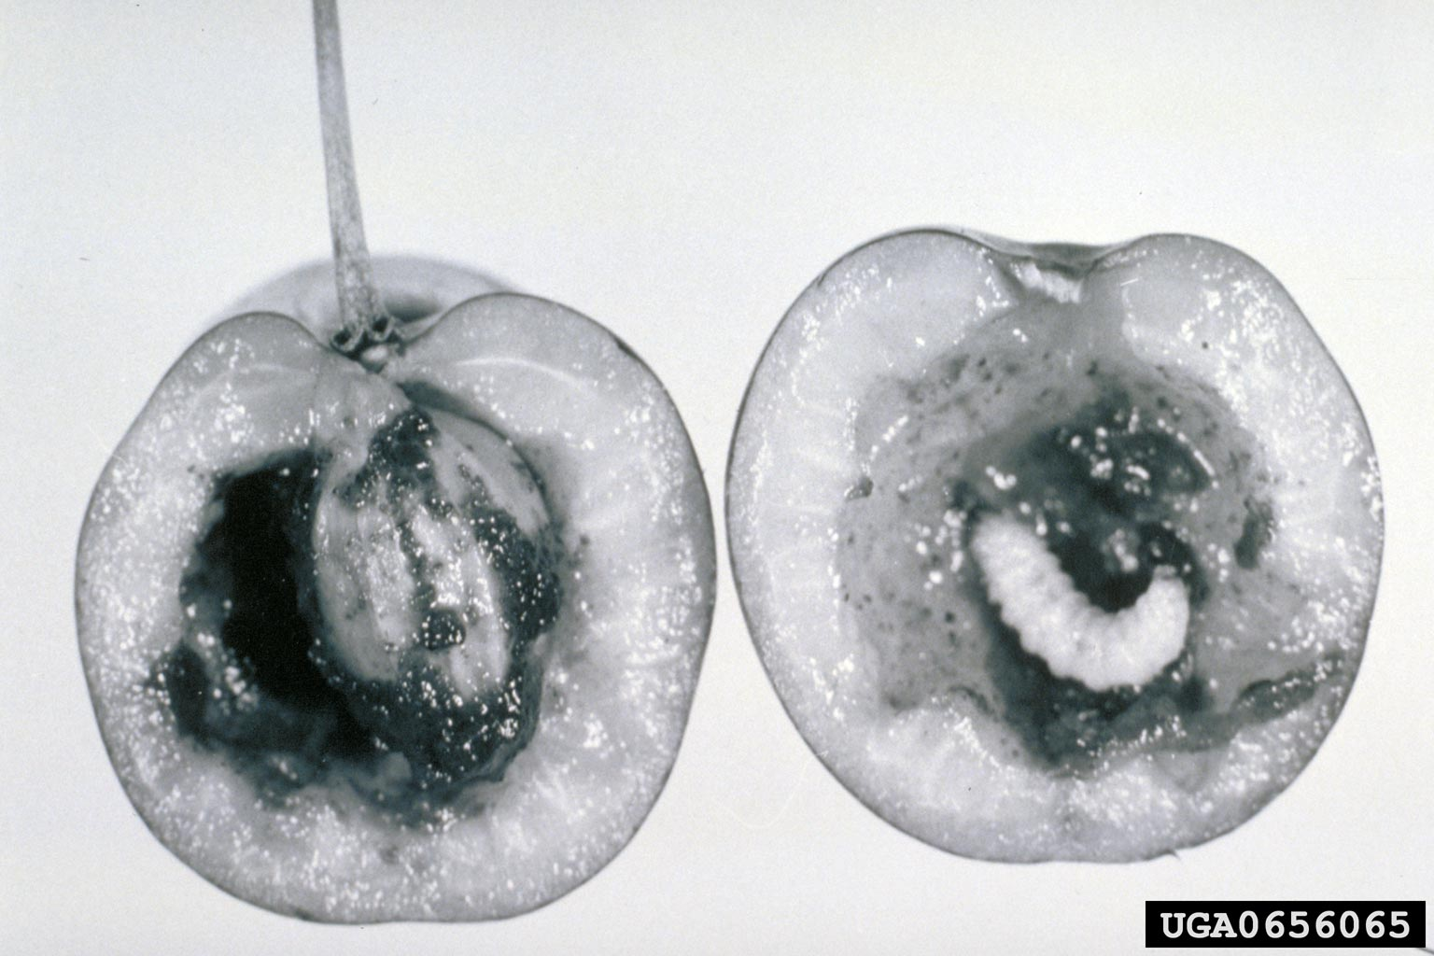
Figure 1. Conotrachelus nenuphar larva in cherry fruit.
Photo courtesy of P.J. Chapman, New York State Agricultural Experiment Station, Bugwood.org.

[225]
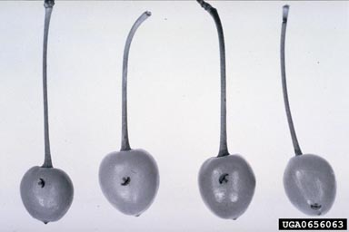
Figure 2. Fruit damage by Conotrachelus nenuphar.
Photo courtesy of P.J. Chapman, New York State Agricultural Experiment Station, Bugwood.org.
[226]
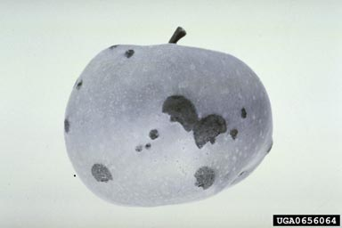
Figure 3. Fruit damage by Conotrachelus nenuphar.
Photo courtesy of P.J. Chapman New York State Agriculture Experiment Station, Bugwood.org.
[227]
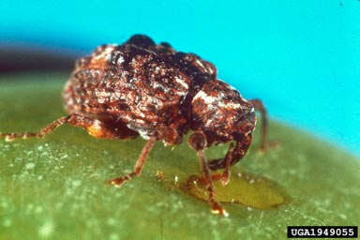
Figure 4. Conotrachelus nenuphar adult on fruit.
Photo courtesy of E. Levine, The Ohio State University, Bugwood.org.

[228]

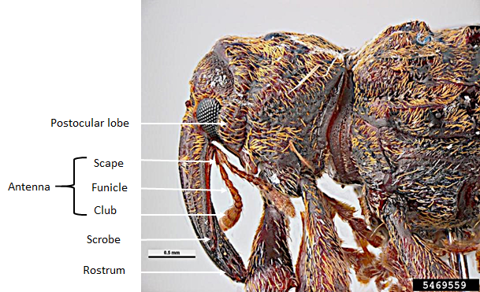
Figure 5. Lateral view of the head and prothorax of Conotrachelus sp. Scale bar: 0.5 mm.
Photo Pest and Diseases Image Library, Bugwood.org.

[229]

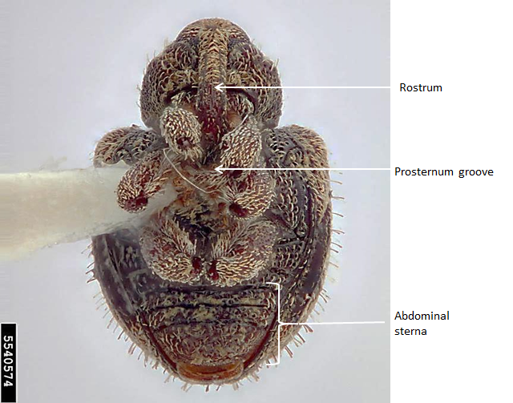
Figure 6. Conotrachelus sp. Adult, ventral view.
Photo courtesy of Hanna Royals, Museum Collections: Coleoptera, USDA APHIS ITP, Bugwood.org.
[230]

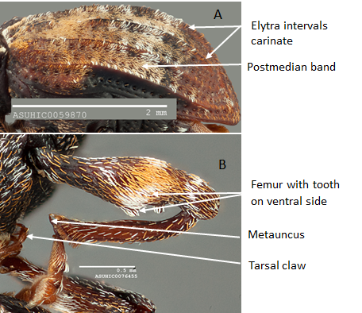
Figure 7. (A) Conotrachelus anaglypticus, lateral view of elytra; (B) Conotrachelus nenuphar, leg. Scale bars: (A) 2 mm; (B) 0.5 mm.
Photos courtesy of Nico Franz, Arizona State University Hasbrouck Insect Collection, AZ, United States of America.
[231]
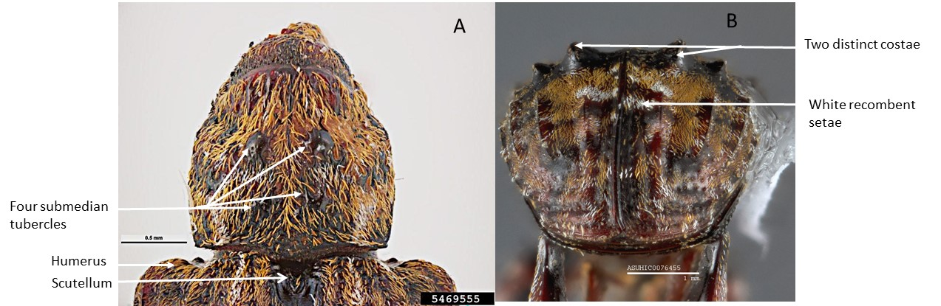
Figure 8. Conotrachelus nenuphar adult: (A) prothorax dorsal; (B) elytra posterior. Scale bars (A) 0.5 mm; (B) 1 mm.
Photos (A) Pest and Diseases Image Library, Bugwood.org; (B) courtesy of Nico Franz, Arizona State University Hasbrouck Insect Collection, AZ, United States of America.
[232]
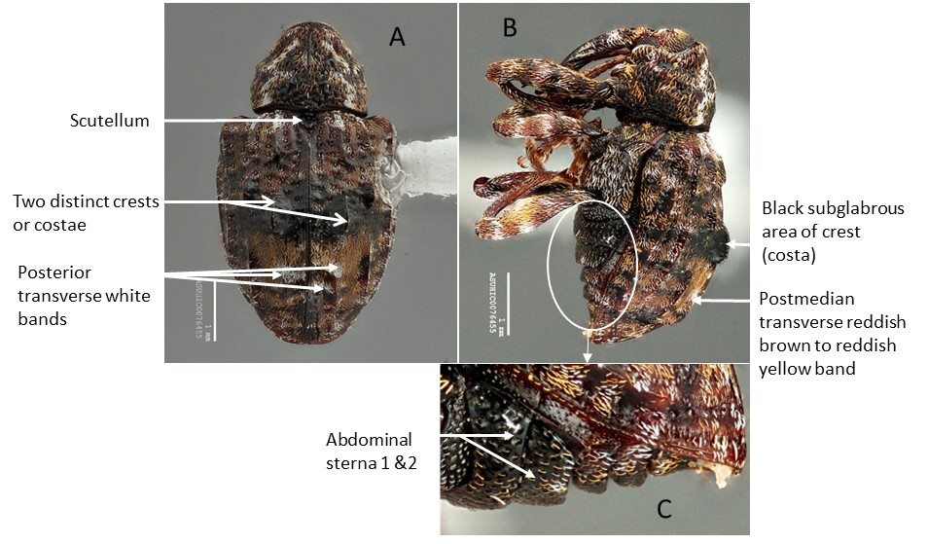
Figure 9. Conotrachelus nenuphar adult: (A) dorsal view; (B) lateral view; (C) abdominal sterna. Scale bars: 1 mm.
Photos courtesy of Nico Franz, Arizona State University Hasbrouck Insect Collection, AZ, United States of America.
[233]
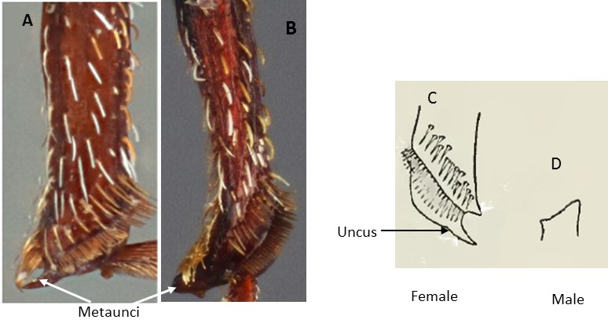
Figure 10. Conotrachelus nenuphar metatibia showing metauncus: (A) female; (B) male; (C) anterior aspect of apex of metatibia of female showing uncus; (D) posterior view of male uncus.
Photos (A) and (B) courtesy of Nico Franz, Arizona State University Hasbrouck Insect Collection, AZ, United States of America; (C) and (D) from Schoof (1942).
[234]

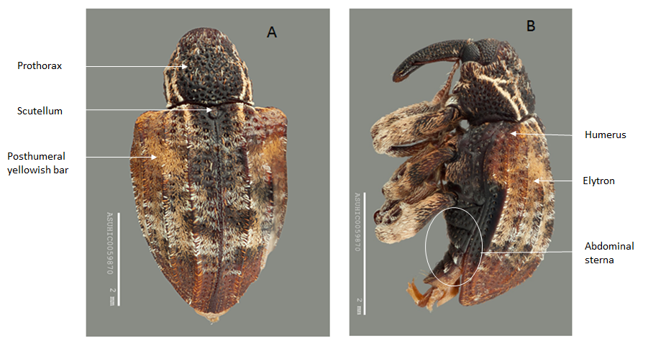
Figure 11. Conotrachelus anaglypticus adult: (A) dorsal view; (B) lateral view. Scale bars: 2 mm.
Photos courtesy of Nico Franz, Arizona State University Hasbrouck Insect Collection, AZ, United States of America.
[235]

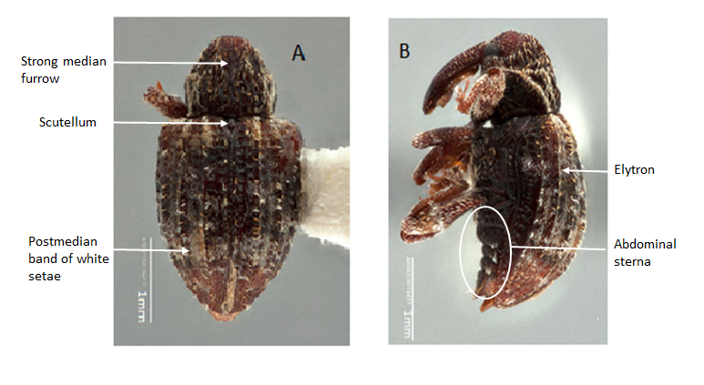
Figure 12. Conotrachelus carolinensis adult. (A) dorsal view; (B) lateral view. Scale bars: 1 mm.
Photos courtesy of Nico Franz, Arizona State University Hasbrouck Insect Collection, AZ, United States of America.
[236]

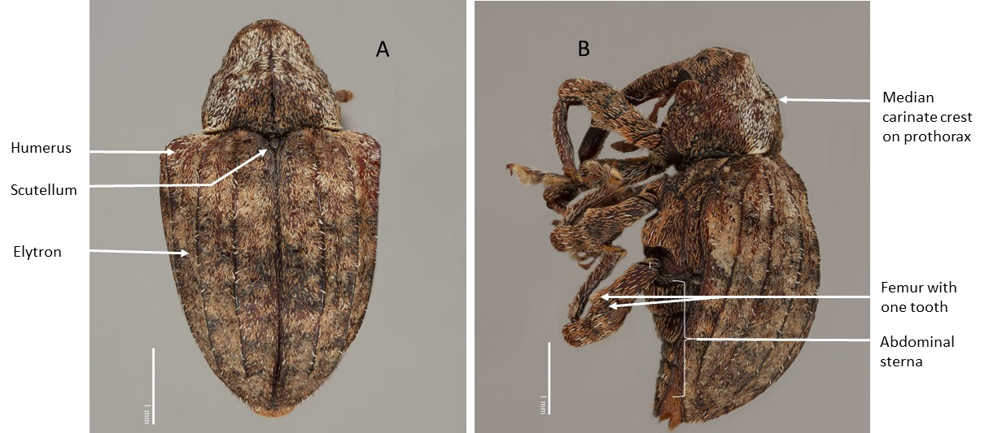
Figure 13. Conotrachelus crataegi adult: (A) dorsal view; (B) lateral view. Scale bars: 1 mm.
Photos courtesy of Nico Franz, Arizona State University Hasbrouck Insect Collection, AZ, United States of America.
[237]

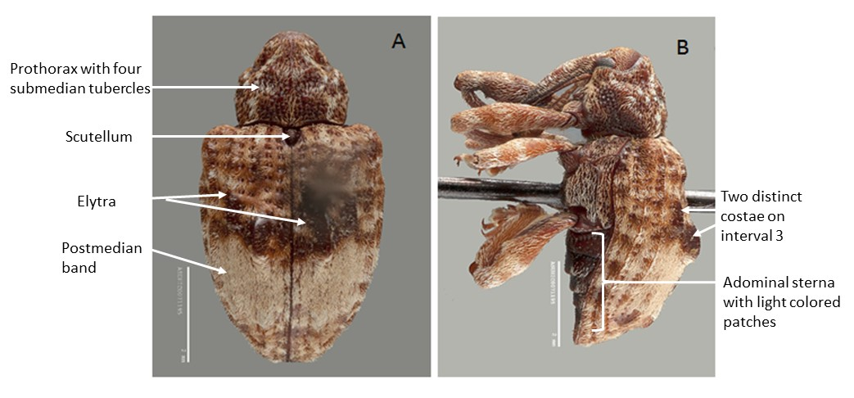
Figure 14. Conotrachelus juglandis adult: (A) dorsal view; (B) lateral view. Scale bars: 2 mm.
Photos courtesy of Nico Franz, Arizona State University Hasbrouck Insect Collection, AZ, United States of America.[238]

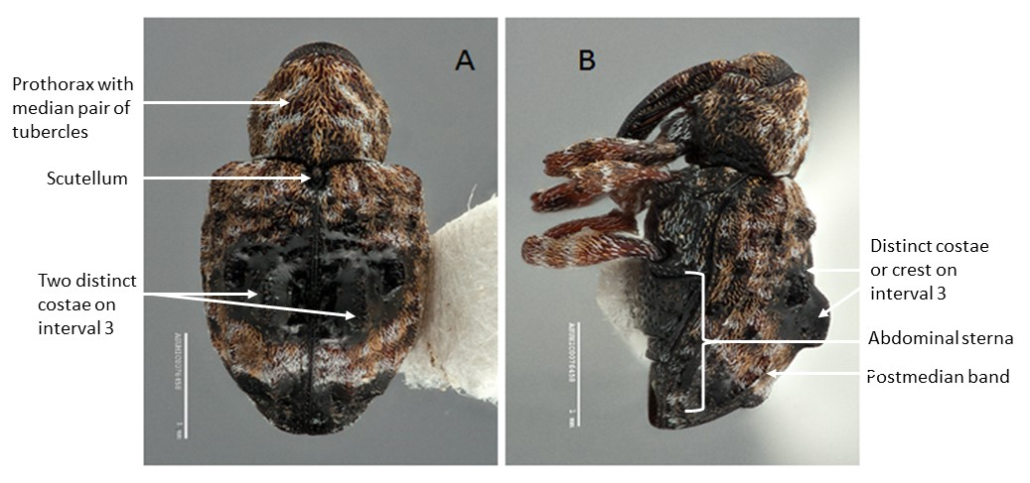
Figure 15. Conotrachelus corni adult: (A) dorsal view; (B) lateral view. Scale bars: 2 mm.
Photos courtesy of Nico Franz, Arizona State University Hasbrouck Insect Collection, AZ, United States of America.

[239]

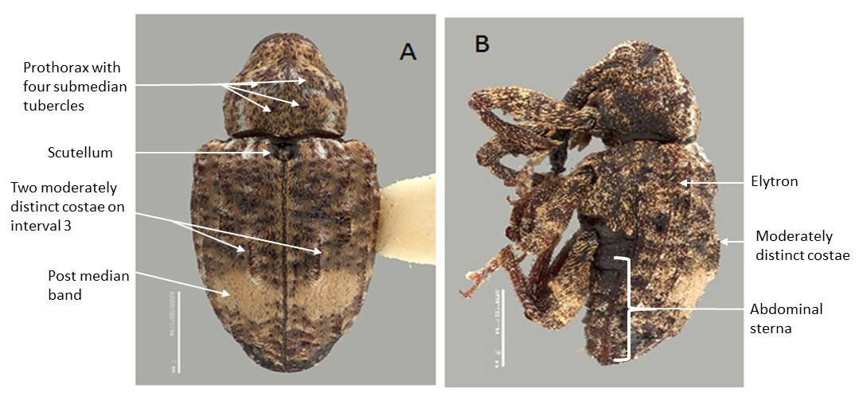
Figure 16. Conotrachelus buchanani adult: (A) dorsal view; (B) lateral view. Scale bars: 2 mm.
Photos courtesy of Nico Franz, Arizona State University Hasbrouck Insect Collection, AZ, United States of America.

[240]

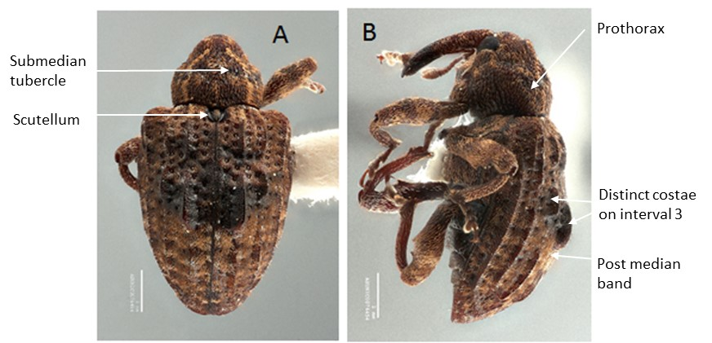

Figure 17. Conotrachelus iowensis adult: (A) dorsal view; (B) lateral view. Scale bars: 2 mm.
Photos courtesy of Nico Franz, Arizona State University Hasbrouck Insect Collection, AZ, United States of America.

