31st Technical Consultation among IPPC Regional Plant Protection Organizations (RPPO)
21st – 25th October, 2019; Abuja, Nigeria
LOGISTICS INFORMATION
- Contact information
- Mr. Obaje John Abah
Director, Plant Quarantine,
Nigeria Agricultural Quarantine Service,
+2348035059047
edwardsonobj2009@yahoo.com
- Dr. Solomon Sunday,
Nigeria Agricultural Quarantine Service,
+2348061679908
solomonpqs@yahoo.com
- Dr C. P. Nwodo,
Nigeria Agricultural Quarantine Service,
+2348037791133
cpnwodo@yahoo.com

- Location
The meeting will hold at Sheraton Abuja Hotel.
Address: Ladi Kwali Way, Wuse 900001, Abuja
Telephone: +234 9 461 2000
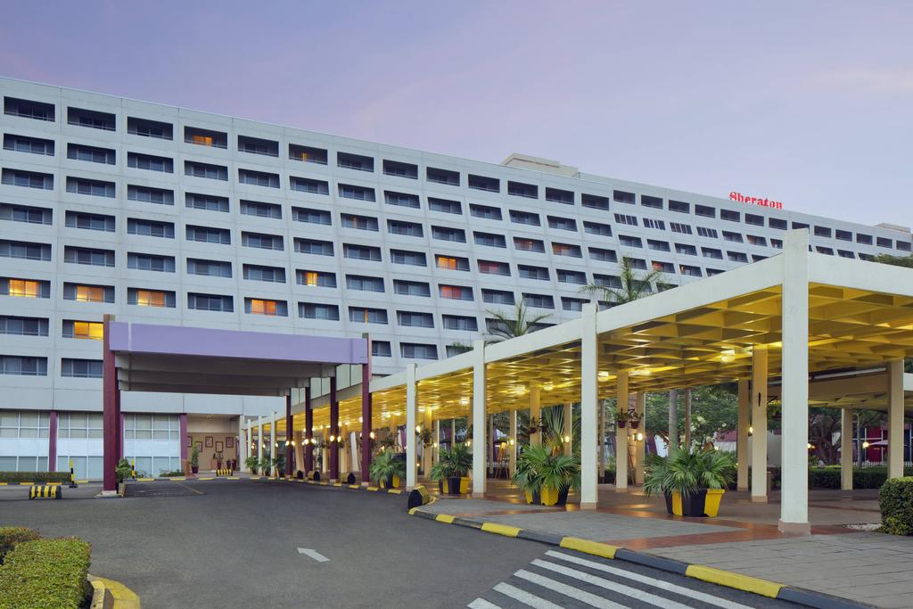

- General Information and Travel Requirements
  - Visas
A valid passport and visa are required for entry into Nigeria. The only nationals who are excluded from having to apply for a Nigerian visa to enter the country are citizens of ECOWAS (Economic Community of West African States) nations. Visitors from these countries are not required to hold a visa when entering Nigeria.
Application for Nigerian visas can be completed online from anywhere in the globe. A Nigerian business visa can be granted to foreign nationals wishing to travel to Nigeria for meetings, conferences and other business activities. It is issued at a standard length of 90 days validity. To secure a business visa, the applicant must support his application with a letter of invitation from an acknowledged Nigerian organization.
Click on this link if you need a visa:
https://portal.immigration.gov.ng/pages/visaguidelines
3.2 Vaccination
A mandatory yellow fever vaccination certificate is required for entry to Nigeria. Vaccination regulations can change at short notice, but yellow fever inoculation is currently compulsory and should be not done later than 10 days' old before arrival.
3.3 Currency
The ‘’Naira’’ is the official currency of Nigeria. All hotels, restaurants, shops and gas stations accept the naira.
It is possible to exchange US dollars and other currencies in banks and currency exchange agencies between the hours of 8:00 am and 4: 00 pm on weekdays (Monday -Friday).
The current exchange rate is 360 naira per US dollar.

Click on this link to check the official exchange rate:
https://www.cbn.gov.ng/rates/ExchRateByCurrency.asp
3.4 Time Zone
Nigeria has one time zone: GMT + 1.
3.5 Voltage and plugs
The standard voltage in Nigeria is 230 V and the frequency is 50 Hz. There are two associated plug types, types D and G.
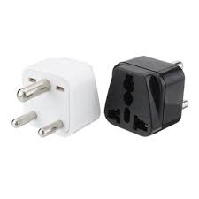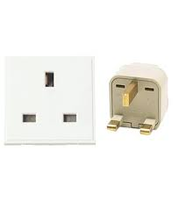
Type D Type G

3.6 Telephone prefix
The country code is 234 and the city code is 9.

3.7 Hotels

- Bon Hotel Abuja
Website: https://www.bonhotels.com/abuja/rooms
Address: 3 Negro Crescent, Maitama, Abuja.
Tel: +234-708-630-0440
Rooms: $170 per night
Email for reservations: gm.bonhotelabuja@outlook.com

- Fraser Suites Abuja
Address: Plot 294, Leventis Close, Central Business District, Abuja.
Tel: +234-813-988-888
Rooms: $260 per night
Email for reservation: reservations.abuja@frasershospitality.com

- Sheraton Abuja Hotel
Website: https://www.marriott.com/hotels/fact-sheet/travel/abvsi-sheraton-abuja-hotel/
Address: Ladi Kwali Way, Wuse 900001, Abuja.
Tel: +234 94 612 000
Rooms: $139 per night
Email for reservations: reservations.abuja@sheraton.com

- Transcorp Hilton Abuja
Website:
Address: 1 Aguiyi Ironsi Street, Maitama 900001, Abuja.
Tel: +234-708 060 3000
Rooms: $203 per night.
Email for reservations: Reservations.abuja@hilton.com

- Stonehedge Abuja Hotel
Website: www. stonehedgehotels.com/home/
Address: 1041 Kur Mohammed Street, Central Business District, Abuja.
Telephone: +234 92 922 090
Rooms: US$ 70 per night
Email: reservations@stonehedgehotels.com

- Reiz Continental Hotel
Website: www.reizcontinentalhotels.com
Address: Plot 779, Cadastral Zone, Central District, Abuja.
Telephone: +234 96 419 110
Rooms: US$112 – US$250 per night
Email for reservations: info@reizcontinentalhotels.com

- Chelsea Hotel
Website: http://www.chelseahotelabuja.com/
Address: Plot 374E Adetokunbo Ademola Crescent, Wuse2, Abuja.
Tel: +234 929 189 112
Rooms: US$ 139 –US$500 per night
Email for reservations: info@chelseahotelabuja.com

- Petrus Hotels Royale
Website: www.petrushotelsroyale.com
Address: 7 Agatu Street, by Gimbiya Street, Off Ahmadu Bellow Way, Area 11, Garki, Abuja.
Tel: +234 803 884 4196
Rooms: US$56 per night
Email for reservation: reservations@petrushotelsroyale.com

- Treasures Suites & Conferences
Website: www.treasures.ng
Address: Plot 66, 1st Avenue by Shehu Shagari Way, Central Business District, Opposite Federal High Court Headquarters, Abuja.
Tel: +234 908 781 2100
Rooms: US$98 –US$834 per night
Email for reservations: reservations@treasures.ng

- Hotel Rosebud
Website: www.hotelrosebud.com
Address: Ekiti House, Plot 1042, Kur Mohammed Street, Opposite This Day Dome, Central Business District, Abuja.
Tel: +234 703 656 3772
Rooms: US$56 per night
Email for reservations: rosebudapartments@hotelsrosebud.com

- Statement Suites and Hotels
Website: www.statementhotel.com
Address: Plot 1002, 1st Avenue, Off Ahmadu Bello Way, Central Business District, Abuja.
Tel: +234 813 443 4342
Rooms: US$ 64 per night.
3.8 Transport from airport to hotel
Nnnamdi Azikiwe International Airport Abuja is located 40.5 km to the city. Hotels are concentrated in the heart of town. The best way to reach them is by taxi. Many taxis are available at the airport. But we recommend that participants use the services of accredited taxi companies who have small desks located outside the arrival halls. Their rates range between 5,000 and 6,000 naira.
3.9 Moving around on your own
To move around Abuja, we advise that participants arrange for taxis at the hotel reception. In the alternative, you may use the taxi service apps Uber or Bolt to organize a pick up.
Abuja is the capital city of Nigeria. It is located in the center of the country. It is a planned city, one of the few purpose-built capital cities in Africa. It was marked in the 1980s to replace the nation’s most populous city, Lagos.
Abuja’s landscape is defined by the massive Aso Rock, a 400-metre monolith smoothened by water erosion. Zuma Rock, another monolith of 792 metre, lies north of the city on the expressway to Kaduna.
Abuja is a key capital on the African continent due to Nigeria's geo-political influence in regional affairs.
The city is home to several parks and green areas, with the largest one being the Millennium Park. The Millennium Park was designed by the Italian architect Manfredi Nicoletti and was officially opened by Queen Elizabeth II in December 2003.

3.10 Restaurants
The Nigerian cuisine comprises of the dishes and food items of hundreds of ethnic groups that make up Nigeria. Like most West African cuisines, it uses spices and vegetables with palm oil and groundnut oil to create flavoured and tasty soups and sauces.
3.11 Weather
October marks the beginning of the end of the rainy season in Nigeria. The weather of Abuja in this month is mildly warm, with low relative humidity. We recommend warm clothing during the day and light sweaters during the night.
Click on this link for weather forecast:
https://www.accuweather.com/en/ng/nigeria-weather.

3.12 Additional precautions
Abuja is a relatively safe city. Care should be taken, however, to minimize the risk of falling victim to felony.

