Complementary studies to validate the proposed fumigation schedules of sulfuryl fluoride for inclusion in ISPM No. 15 for the eradication of pine wood nematode (Bursaphelenchus xylophilus) from wood packaging material

L. Bonifácio¹, M. L. Inácio¹, E. Sousa¹, S. Buckley² and E. M. Thoms³

¹ INIAV – Instituto Nacional de Investigação Agrária e Veterinária (ex-INRB), Avenida da República, Quinta do Marquês 2780 - 159 Oeiras, Portugal
² Dow AgroSciences S.A.S., Marco Polo/B-ZAC du Font de l’Orme, 790, Mougins, 06250, France
³ Dow AgroSciences LLC, 7257 NW 4th Blvd. No. 20, Gainesville, Florida, USA

Abstract
Sulfuryl fluoride (SF), a broad-spectrum fumigant for controlling insects and nematodes, is under evaluation for inclusion in ISPM No. 15 - Guidelines for Regulating Wood Packaging Material in International Trade. A new study was completed on pine wood nematode (PWN, Bursaphelenchus xylophilus) in Portugal in 2013 to validate the proposed treatment schedule for 20-29.9°C. Wood, naturally infected with PWN, was collected from maritime pine (Pinus pinaster) in Portugal. This wood was incubated to achieve high populations of PWN, including the dispersal juvenile life stage (J_{III}) of PWN, to provide a demanding ‘worst case’ test. Bioassays boards were fumigated with 2,514 to 4,263 g-h/m³ of SF for 24 h exposure, and with 2,459 to 3,216 g-h/m³ for 48 h exposure. Following fumigation, the nematode population in the controls increased from more than 3 million pretreatment to 4.6-21 million in the last assessment, 21 days after treatment (T₂₁). Wood moisture content decreased from 43-61% pretreatment to 15.7-19.4 % at T₂₁ post treatment. Control of PWN from 99.99% to 100% was achieved at T₃ and T₂₁ for the dosages of 3,000 g-h/m³ for 48 h exposure. This dosage and exposure time will be added in the fumigation schedule for 20°C-29.9°C. A revised fumigation schedule is proposed, which also includes dosages for temperatures of 15ºC-19.9ºC, and 30ºC and above that were validated to provide probit 9 control of PWN in the 2010 study.

Introduction

The International Standard for Phytosanitary Measures (ISPM) No. 15 for wood packaging material was first published in 2002 and revised in 2009. In the 2009 revision the scope was given as: ‘This standard describes phytosanitary measures that reduce the risk of introduction and spread of quarantine pests associated with the movement in international trade of wood packaging material made from raw wood. Wood packaging material covered by this Standard includes dunnage but excludes wood packaging made from wood processed in such a way that it is free from pests (e.g. plywood).’

There are two control measures currently included in the Standard: these are the fumigant methyl bromide and heat treatment (either conventional using a steam or dry kiln heat chamber, or with dielectric heating). Methyl bromide is being phased out of use globally and is no longer registered for use in the European Union (EU). Effective alternatives to heat treatment are also needed for some wood products (Magnusson and Schröder, 2009).
The fumigant Sulfuryl Fluoride (SF) has been submitted to the Technical Panel on Phytosanitary Treatments (TPPT) for inclusion in ISPM No. 15. SF is a broad-spectrum fumigant controlling insects and nematodes. In cooperation with leading researchers, user groups and the fumigation industry, Dow AgroSciences has developed, registered and commercialised SF under the trade names Vikane® gas fumigant and ProFume® gas fumigant. These products are registered in many countries for a range of uses including control of stored product insects and eradication of wood destroying pests. In the EU, SF has been granted Annex 1 listing under EU Directive 98/8/EC (Biocides) for Product Type 8 (Wood Preservative) and Product Type 18 (Insecticides). Annex 1 listing under EU Directive 91/414 (Pesticides) was granted with entry into force on 1 November 2010; pest types include insects and nematodes.

The TPPT has evaluated the efficacy data submitted on SF against a range of insect species and pine wood nematode (Bursaphelenchus xylophilus Steiner and Buhrer, 1934 Nickle, 1970) [PWN] to support the fumigant inclusion in the Standard. Following their evaluation, the TPPT considered that published papers and historical use of SF fumigations have demonstrated that this treatment practically eliminates insect species of concern associated with the wood packaging material used in international trade. However, whilst there were no further requirements for insects, additional information on PWN was requested.

Background about previous submissions of SF to the TPPT for inclusion in ISPM N° 15

Submission October 2006

An efficacy dossier (compiled according to the FAO Secretariat of the International Plant Protection Convention [IPPC] Guidelines) to support the inclusion of SF fumigation as a treatment in ISPM No.15 (Guidelines for Regulating Wood Packaging Material in International Trade) was submitted in October 2006 to the IPPC. These data had been prepared by Dow AgroSciences and reviewed by a Research Scientist of the Department for National and International Plant Health, Germany. Following the positive review, the Federal Ministry of Food, Agriculture and Consumer Protection of Germany proposed the application of SF to the IPPC. The dossier contained extensive supportive data on wood destroying insects and included data from the registration dossier on SF (to support Annex I listing in Directive 98/8/EC) which had been evaluated by the Rapporteur Member State Sweden and peer reviewed by the other Member States of the EU Commission.

These efficacy data have enabled SF to be granted Annex 1 listing under EU Directive 98/8/EC (Biocides) for Product Type 8 (Wood Preservative). It was considered important to present a comprehensive efficacy data set of both quarantine and other wood destroying pests to ensure that experts of the IPPC had all the available efficacy data and other relevant information on SF. In July 2007, the TPPT requested a resubmission of the application in a requested format that would allow the Panel to complete their assessment more easily.

Submission July 2007

To help the Technical Panel on Forest Quarantine (TPFQ) in their assessment of SF in their July 2007 meeting, the application for inclusion of SF was resubmitted in the required submission format. In this form, detailed data included two quarantine pests Pine wood nematode (PWN, Bursaphelenchus xylophilus) and Asian longhorned beetle (ALB, Anoplophora glabripennis). A proposed fumigation schedule was given, based on the higher dosages which are required for the eradication of PWN. The PWN dosages proposed would also control ALB and other wood destroying insect pests, e.g. bark beetles (Table 1).

Table 1. Proposed schedule for inclusion in ISPM N° 15 (2007).

Mean Temp. (ºC) | Min. Target CT Dosage (g-h/m³) | SF Dose  (g/m³) | Minimum Concentration (g/m³) at hour:
Mean Temp. (ºC) | Min. Target CT Dosage (g-h/m³) | SF Dose  (g/m³) | 0.5 | 2 | 4 | 12 | 24
15 to 19.9 | 3,000 | 175 | 179 | 165 | 155 | 123 | 87
20 to 24.9 | 2,100 | 124 | 130 | 118 | 111 | 88 | 62
25 to 29.9 | 1,500 | 88 | 94 | 83 | 78 | 62 | 44
30 to 34.9 | 1,400 | 82 | 87 | 78 | 73 | 58 | 41

The submission of the SF treatment was subsequently evaluated by the TPFQ in July 2007 and by the TPPT in December 2007. The TPPT recommended that the treatment should be resubmitted with addition information relating on PWN by the 15 November 2008 to enable further evaluation in early 2009.

Submission 2008

A new study on PWN was initiated and completed in 2008 – ‘Confirmation of Proposed Quarantine Fumigation CT Dosage Rates for the Control of Pinewood Nematode [Bursaphelenchus xylophilius] in Unseasoned Pine at 20ºC and 25ºC’, E. Flack, A. Barak, M. Messenger and E. Thoms. The comments given from the TPPT on previous studies together with the responses to provide the required information on PWN in this study are itemised below:

1. “The TPPT could not determine the level of efficacy of this treatment against B. xvlophilus as no information was provided on either the numbers of test individuals required to demonstrate statistically the target efficacy level, or through fitting dose-response data to known mortality curves.”

Response: The number of nematodes emerging from treated and untreated wood was determined, which was not done in the previous research. This was undertaken to confirm the infestation level of PWN in the samples.

2. “Levels of resistance may vary significantly between life stages, and ratios of life stages in wood may also vary. The submission did not provide information demonstrating which life stage of B. xvlophilus was most resistant to sulfuryl fluoride fumigation, and which life stages are most likely to be present in wood packaging material during the most likely period of treatment application.”

Response: The number of each life stage (adults and juveniles) of PWN emerging from treated and untreated wood, were determined, which was not done in the previous research. All life stages of PWN were present in wood samples prior to treatment, based on inoculation of all wood samples with cultured PWN.

3. “An incubation period is important for the efficacy of mortality testing of B. xylophilus. Mortality should be measured using a Baermann funnel at 6 and 21 days (of incubation) after treatment. The submission did not indicate how long after treatment the mortality measurements were made.”

Response: Treated and untreated wood samples were extracted at 7 and 21 d after the fumigation was completed to ensure that any nematodes surviving treatment in the egg stage emerged and were mobile for extraction.

4. “Sample weight may be a significant factor on the efficacy of mortality testing for B. xylophilus, as stated by Hirata et al. (2004)”.

Response: Entire wood sticks (2.5 x 2.5 x 20 cm) were sampled to extract nematodes. Wood slivers from wood sticks of the same dimensions were extracted in the previous research.

This new study on PWN confirmed that the proposed quarantine dosage at 25°C was effective. Therefore, no changes were made to the proposed treatment for temperatures at or above 25°C. These results did document PWN survival at a CT (Concentration x Time) dosage 43 g-h/m³ above the proposed quarantine CT dosage for 20°C. This difference could be due to the higher mean wood moisture content (WMC, 59%) of sticks in these trials compared to lowest mean WMC (37%) of sticks in previous laboratory chamber fumigations used to derive the quarantine CT dosage rates for 15° and 20°C. Therefore, the proposed quarantine dosages for 20°C and 15°C were increased by 200 g-h/m³ to account for variability in WMC (Table 2).

Table 2. Revised sulfuryl fluoride (SF) treatment schedules for inclusion in ISPM-15 (2008).

24 hour Exposure Period
Mean Temperature (ºC) | Minimum Target CT Dosage (g-h/m³) | SF Dose (g/m³) | Minimum Concentration (g/m³) at hour:
Mean Temperature (ºC) | Minimum Target CT Dosage (g-h/m³) | SF Dose (g/m³) | 0.5 | 2 | 4 | 12 | 24
15-19.9 | 3,200 | 183 | 188 | 176 | 163 | 131 | 93
20-24.9 | 2,300 | 131 | 136 | 128 | 118 | 95 | 67
25-29.9 | 1,500 | 88 | 94 | 83 | 78 | 62 | 44
30-34.9 | 1,400 | 82 | 87 | 78 | 73 | 58 | 41
35 or above | 1,000 | 60 | 63 | 57 | 53 | 42 | 30

36 hour Exposure Period
Mean Temperature (ºC) | Minimum Target CT Dosage (g-h/m³) | SF Dose  (g/m³) | Minimum Concentration (g/m³) at hour:
Mean Temperature (ºC) | Minimum Target CT Dosage (g-h/m³) | SF Dose  (g/m³) | 0.5 | 2 | 4 | 12 | 24 | 36
15-19.9 | 3,200 | 141 | 143 | 132 | 127 | 100 | 72 | 52
20-24.9 | 2,300 | 107 | 109 | 100 | 94 | 75 | 52 | 37
25-29.9 | 1,500 | 68 | 70 | 64 | 60 | 48 | 34 | 24
30-34.9 | 1,400 | 64 | 66 | 60 | 56 | 44 | 32 | 23
35 or above | 1,000 | 46 | 48 | 44 | 42 | 34 | 24 | 16

48 hour Exposure Period
Mean Temperature (ºC) | Minimum Target CT Dosage (g-h/m³) | SF Dose  (g/m³) | Minimum Concentration (g/m³) at hour:
Mean Temperature (ºC) | Minimum Target CT Dosage (g-h/m³) | SF Dose  (g/m³) | 0.5 | 2 | 4 | 12 | 24 | 36 | 48
15-19.9 | 3,200 | 122 | 124 | 116 | 109 | 87 | 62 | 44 | 31
20-24.9 | 2,300 | 90 | 92 | 84 | 80 | 63 | 44 | 31 | 22
25-29.9 | 1,500 | 60 | 62 | 56 | 53 | 42 | 30 | 21 | 15
30-34.9 | 1,400 | 56 | 58 | 52 | 49 | 39 | 28 | 20 | 14
35 or above | 1,000 | 38 | 40 | 36 | 34 | 27 | 20 | 14 | 10

The new evidence/data on PWN was prepared by Dow AgroSciences in the required format and reviewed a Research Scientist of the Department for National and International Plant Health of Germany. Following the positive review of the new data, the Federal Ministry of Food, Agriculture and Consumer Protection of Germany resubmitted the application of sulfuryl fluoride for inclusion in ISPM No.15 in 2008.
Submission 2010

Additional information on PWN was requested to be provided. A new study was completed on PWN in Portugal in 2010 to provide additional information to validate the proposed treatment schedule (Sousa et al., 2010; Bonifácio et al., 2013). The comments given from the TPPT for the study by Flack et al. (2008) with the responses based on the 2010 study to provide the requested information on PWN are summarized below:

1. “The TPPT could not determine the level of efficacy of this treatment against
PWN as no evidence was provided that the treatment achieved complete mortality of at least 94,400 nematodes to demonstrate an efficacy level of greater than 99.99683% at the level of confidence presented by Couey and Chew (1986). The design of the experiment undertaken by Flack et al. (2008) precluded the determination of an efficacy level due to the lack of a representative sample demonstrating the number of nematodes present in the wood prior to fumigation. Nematode numbers should be measured or estimated before and after the treatment in both test samples and controls. Soma et al. (2003) provides an example of an experimental design demonstrating treatment efficacy against nematodes in wood.”

Response: To enable the TPPT to determine the level of efficacy of SF and to validate the SF treatment schedule, a new Study was undertaken and an experimental design developed to address the requirement for mortality of at least 94,400 PWN for each treatment at efficacy level of greater than 99.99683% i.e. Probit 9. Pre-treatment PWN levels were determined as close to the time of treatment as possible. It was important in the untreated controls to estimate natural mortality e.g. due to treatment temperature or changes in wood moisture. Post-treatment assessments of PWN were conducted at 24 h, 72 h and 21 days. The 21 days post-treatment interval was considered long enough for any surviving nematodes to reproduce and reach detectable levels.

2. “Levels of resistance may vary significantly between life stages, and ratios of life stages in wood may also vary. While the experiment undertaken by Flack et al. (2008) measured some of the life stages present in the test samples at the time of treatment, the submission did not provide information demonstrating which life stage of PWN was most resistant to SF fumigation, and which life stages are most likely to be present in wood packaging material during the most likely period of treatment application. In the absence of knowing the most resistant life stage, evidence should be provided that all life stages associated with wood packaging material during the most likely period of treatment application, including the dispersal stage, were present in significant proportions at the time of treatment efficacy testing.”

Response: In the new Study the bioassay material was collected from naturally infected trees and incubated under optimal conditions 25ºC and 70% r.h. (relative humidity) to increase the number of the propagative PWN life stages. The temperature was then lowered to favour the development of the J_{III} dispersal juvenile stage, considered to be the most resistant life stage (Mamiya, 1984). The objective was to achieve at least 60% of this stage for the treatment bioassay material.
3. “The new information provided included two time schedules for SF fumigation; namely 36 h and 48 h schedules. No information was provided supporting the extrapolation of the testing conditions (24h tests) to these extended durations schedules. The TPPT requested additional information supporting the extrapolation of the treatment to 36h and 48h schedules.”

Response: Since no new information is provided to support extrapolation of the testing conditions from 24h to 36h and 48h, these schedules have been removed.

4. “The new information provided raised issues related to the effectiveness of SF fumigation in wood with high moisture contents. Based on the information provided the TPPT considers a restriction on the use of SF fumigation is required with moisture contents less than 60%. Should this restriction of use be of concern to the submitter, the TPPT requests that the submitter provide additional information supporting the application of SF fumigation to wood with moisture contents greater than 59%.”

Response: The maximum wood moisture content in wood previously fumigated for methyl bromide trials was 59% for small chamber fumigations (Soma et al., 2001) and 30% for tarped stack, simulated field fumigations (Soma et al., 2002). Therefore moisture content of tested wood will be maximised prior to fumigation but cannot be specified above 60%. This is because maximum wood moisture content will be dependent upon the wood species tested, the age and density of harvested wood.

Bioassay boards were fumigated with SF at three fumigation temperatures and a range of SF dosages as follows: 15ºC, 3,169 – 4,407 g-h/m³; 20ºC, 1,901 – 4,051 g-h/m³; 30ºC, 1,385-2,141 g-h/m³. Complete mortality of PWN was recorded 21-42 days after fumigation of boards at 15 and 30ºC validating the proposed dosage. Survival was recorded at 20ºC and an increase in dosage was proposed (Table 3).

Table 3. Revised proposed sulfuryl fluoride (SF) schedule in ISPM No. 15 (2010).

Mean temperature (ºC) | Minimum Target CT Dosage  (g-h/m³) | SF Dose  (g/m³) | Minimum Concentration (g/m³) at hour:
Mean temperature (ºC) | Minimum Target CT Dosage  (g-h/m³) | SF Dose  (g/m³) | 0.5 | 2 | 4 | 12 | 24
15-19.9 | 3,200 | 183 | 188 | 176 | 163 | 131 | 93
20-24.9 | 4,400 | 250 | 255 | 240 | 228 | 183 | 130
25-29.9 | 3,200 | 183 | 188 | 176 | 163 | 131 | 93
30 and above | 1,400 | 82 | 87 | 78 | 73 | 58 | 41

Submission 2013

Additional information on PWN was requested to that provided by Dwinell et al. (2003, 2005), Flack et al. (2008) and Sousa et al. (2010). “The TPPT could not determine the level of efficacy of this treatment against Bursaphelenchus xylophilus (Pine wood nematode) for temperatures within a range greater than 18°C and less than 30°C.”

Response: A new set of trials were conducted in 2013, following the same material and methods as in the 2010 field studies, at 20°C at different dosages and two exposure times to better understand the level of efficacy at this critical temperature. An effective dosage has been identified and will be proposed to cover the 20-29°C range of temperature.

Materials and Methods
The proposed study plan for the 2013 trials is in Appendix 1.
The field study to validate the SF fumigation schedule for inclusion in ISPM No.15 was undertaken at the INIAV - Instituto Nacional de Investigação Agrária e Veterinária. Quinta do Marquês 2780 - 159 Oeiras, Portugal (former INRB) in April 2013. The following entomologists, nematologists and fumigation specialists participated in conducting the study:
Dr. E. Sousa, Dr L. Bonifácio (Entomologists), Dr M. L. Inácio (Nematologist) – INIAV,
Mr. J. Roca (Fumigation Specialist) – Roca Defisan S. L. Spain,
Mr. João Palma (Fumigation Specialist) – Fumitech, Portugal,
Mr. S. Buckley (Fumigation Specialist) – Dow AgroSciences, France.

As in 2010, Portugal was selected as the country to undertake the new Study since PWN has become naturalized and the supply of bioassay material assured. In addition research collaborators could provide the needed expertise in PWN bioassay preparation, extraction, assessment and data analysis.

Collection and preparation of test wood material
Dead maritime pines, cluster pine [English], pinheiro bravo [Portuguese] (Pinus pinaster) were surveyed at Herdade da Comporta, Setúbal Province, Portugal during January 2013. Wood samples were taken from the trunk at breast height (1.30 m) and transported to INIAV nematology laboratory at Oeiras for PWN extraction, identification and counting. Later, in March, the two more infected trees were selected, felled and six logs of 2.50m length were taken to MADECA sawmill to be cut into long boards of 10 x 5 cm in cross-section. These boards were then transported to INIAV and stored in incubation chambers at optimum conditions for PWN propagative development (25º C, 75% r.h.). On the week prior to fumigation, the long boards were sampled to assess the size and composition of nematode populations (T₀ sampling) and sawn into 5 wood boards 45cm long for fumigation assays.

Incubation of test wood material, PWN number and life stage
The 45 cm boards from each long board were distributed among different treatments. This procedure was intended to minimize the effect of wood structure variability on nematode distribution. The boards were then marked with a water proof marker to identify the treatment (Figure 1) and maintained in incubation chambers at 25º C, 75% r.h. to provide optimal conditions for regeneration (growth and reproduction) of the propagative life stages of the nematode until placed in fumigation chambers. This was needed to increase the target density to at least 100,000 nematodes per treatment. The high r.h. was also needed to prevent the wood from drying.

Preliminary sampling of wood assured the presence of a sufficient nematode population and, at least 60% in the dispersal juvenile stage (J_{III}), considered being the most resistant stage of PWN.

In each sampling, the numbers of PWN at each different life stage were added and then divided by the weight of the wood sampled to obtain number of nematodes per gram of fresh wood. This number was then multiplied by the total weight of the fumigated board (45cm x 10cm x 5cm), to estimate the total population of PWN.

Procedure for PWN extraction from wood
The procedure for wood sampling at INIAV started by cutting and discarding 5cm from each end of the boards because these sections were presumed to be too dry to support PWN. Then, representative samples from both ends of boards were prepared by cutting them into wood cubes of ca. 1 cm³ using a mechanical timber saw (Figure 2). To avoid cross contamination, wood dust was carefully removed by brushing and vacuuming the saw blade and saw equipment and by washing the saw blade and saw surfaces with alcohol between each wood piece preparation. The cut wood sections were placed into individual labelled polyethylene bags and weighed to prepare samples 100.2 ± 0.2 g (Figure 3).

Immediately following wood section preparation, live PWN were extracted using the method described by Penas et al. (2002). Each wood sample was removed from the polyethylene bag, placed on filter paper (Trapicel, Futurlab, Portugal), wrapped in “etamine” tissue (Figure 4) and then placed on a plastic mesh overlaying a plastic tray. The tray was filled with tap water until the wood sample was completely immersed (Figure 5). After 48 h, the plastic mesh supporting the samples was carefully removed and the water in the tray was passed through a 400 mesh (38 µm) sieve (Figure 6). The nematodes and minute debris remaining on the sieve were shower washed, concentrated with distilled water into small plastic or glass containers (Figure 7) and preserved at 4ºC until observation.

After each extraction, the sieve was thoroughly washed with water and ethanol and exposed to ultrasounds for about 1 minute to release pine resin that, with time, may occlude the sieve.

Wood moisture content
After PWN extraction, each wood sample was oven dried for 48 h and weighed again. The initial moisture was calculated by subtracting the initial moisture weight from the dry weight and dividing by the dry weight.

Site and bioassay preparation for fumigation

Temperature management
Fumigations were conducted at 20°C. To achieve the required temperature, the floors, inside walls, ends and doors of two vans were lined with 4 mm thick polystyrene insulation panels (WallmateTM, The Dow Chemical Company, Midland, MI, USA). These panels were also placed at approximately 2.5 m above the floor to create an inner chamber. Thermostatic controlled air conditioners and coil-in-oil electric heaters were used to achieve the required temperature. Temperature was measured using thermocouples lines (Figure 8).

Fumigation chambers
Four 1m³ fumigation chambers identical to those used in 2010 (Sousa et al., 2010; Bonifacio et al., 2013) were constructed and placed into each van representing three treatment chambers and one untreated chamber (Figure 9). Each of the three treatment chambers were connected to a 30 m long x 4 mm inner diameter SF introduction tube, a 20 m thermocouple line and two 30 m long x 2.5 mm monitoring tubes located in the top and bottom open air space of each chamber. The untreated chamber had the same set-up as those to be treated with SF apart from no introduction tube, so the fumigant entry port was sealed.

Bioassay preparation
Following incubation, 72 boards were placed into each fumigation chamber in two separate stacks, 45 cm high x 40 cm wide x 45 cm long, each stack formed by 36 boards (Figure 10). In one of the stacks, nine boards selected for PWN sampling were placed in sets of three at the top, middle and bottom of the stack. The chambers, loaded with wood, were held within the each van set at the target temperature of 20ºC and allowed to acclimate for ca. 48 h prior to introduction of SF (Figure 11).

Sulfuryl fluoride introduction, concentration and temperature measurements and dosage
A small 2.2 liter double ended sample steel cylinder, with needle valve (Swagelok U.S.A ref 304L-HDF4-2250C) connected to the introduction tube at one end, was filled with commercial grade ProFume® gas fumigant (99.9% sulfuryl fluoride, Dow AgroSciences, Indianapolis, IN, USA). This small cylinder was secured to a stand and placed on an electronic charging scale (Ritchie engineering Co, Bloomington, MN, USA) to measure the weight of SF introduced (Figure 12). Following introduction of SF, concentration measurements of SF were taken (Figure 13) using both SF-ContainIR and SF-ReportIR monitors (Spectros Instruments Inc., Hopedale, MA, USA,) at the target intervals of 0.5, 2, 4, 12, and 24 h; 36 and 48 h monitoring were added for 48 h exposure time. Temperature measurements were also taken at these same time intervals. Concentration readings were entered into a computer program to calculate accumulated dosages (g-h/m³). Following 24 h or 48 h exposure, SF was vented from the chambers via extraction tubes and fans. The chambers were then aerated for approximately 2 h (Figure 14). Following clearance, which was confirmed with a SF-ExplorIR (Spectros Instruments Inc., Hopedale, MA, USA), the wood bioassays were removed for assessment.

Four series of three replicated fumigations at two exposure times were conducted at 20°C. Two series of fumigations were conducted 9-11 April 2013, and another two series were conducted 22-24 April 2013. This schedule was necessary to accommodate the workload of the lab personnel to count nematodes.

In 2010, the target dosage at 20°C was 2,300 g-h/m³. Since inconsistent results were achieved in 2010 at this temperature with 2,300 g-h/m³ and higher dosages, the target dosages for the 2013 trials were 1.25 X 2,300 g-h/m³ = 2,875 g-h/m³ and 1.5 X = 3,450 g-h/m³ to check for a dose response. These dosages were tested at both 24 h and 48 h exposure times.

Assessment for PWN mortality
Following removal from the fumigation chambers, the wood bioassay material was stored in an incubation chamber set at the optimum conditions for PWN propagative development, (25ºC, 75% r.h.). Wood bioassay material from each treatment replicate was stored in separate containers to prevent cross contamination between treatments. Two 8 cm long sections, sawn from the cut ends of each board, were sawn into ca. 1 cm³ wood cubes. For each board, these cubes were combined, weighed to prepare a 100.2 ± 0.2 g sample and placed into a labelled polyethylene bag. Samples were prepared from the nine boards from each treated and untreated fumigation chamber per post treatment sample interval and were assessed for PWN mortality.

Assessments were made immediately before treatment (T₀), 72 h after treatment (T₃) and 21 days (T₂₁) after treatment. Separate wood bioassays were prepared for each sampling interval and treatment.

Following extraction from the wood samples, PWN were identified under an inverted microscope Olympus BX30 (Olympus Corporation, Tokyo, Japan). For T₀ samples and T ₃ and T₂₁ untreated control treatments, the sample was homogeneously mixed and was placed inside a 1ml counting slide (Chalex Corporation, USA). The total number of PWN present (mixed stages) and number of J_{III} juvenile stage were determined. If less than 100 individuals were present, a new aliquot was taken. This process was repeated until 100 individuals were achieved or 5 x 1ml accounted for. The number of individuals (or the mean) was then multiplied by the sample volume. For the remaining fumigated samples (T₃ and T₂₁) the entire sample volume was placed in a Doncaster Petri dish, and the total number of PWN present and number of J_{III} determined.

When only a few sub-adult surviving nematodes were observed, they were analysed by molecular chemistry to check they were Bursaphelenchus xylophilus since the larval stages of other species of nematodes are morphologically very similar.

Molecular PWN identification
Total genomic DNA from all samples was isolated using the DNeasy Plant Mini kit (Qiagen, GmbH), following the manufacturer’s instructions. Total genomic DNA was amplified by PCR using the species-specific primers (from the ITS region) to the PWN: forward primer ITS1 (5′-TACGTGCTGTTGTTGAGTTGG-3′) and reverse primer ITS2 (5′- GCACGGACAAACAGTGCGTAG-3′) (Takeuchi et al., 2005).

All PCRs were carried out in a Biometra TGradient thermocycler in a final reaction volume of 25 µl. The reaction mixture contained 1 µl of template DNA, 0.4 µM of each primer and 1x PCR Master Mix (Fermentas, Germany), which included 0.025 units of Taq DNA Polymerase, 2 mM MgCl₂ and 0.2 mM of each dNTP.

The thermal cycling programme was as follows: denaturation at 94°C for 1 minute, followed by 1 minute at 94°C, 1 minute at 51°C, 2 minutes at 72°C for 35 cycles and a final extension of 72°C for 5 minutes. After amplification, 10 µl of the amplified product was loaded onto a 2% agarose gel containing 0.5 µg/ml ethidium bromide and 0.5x TBE running buffer and electrophoresed at 5 V/cm. Data analysis was visualized using the VersaDoc Gel Imaging System (Bio-Rad).

Amplification products from BxPt46GO B. xylophilus isolate (Laboratory of Nematology, ICAAM, Universidade de Évora) and BmPt0 B. mucronatus isolate (Laboratory of Nematology, ICAAM, Universidade de Évora) DNA extracts were used as positive and negative controls, respectively.

Statistical analysis
The data were subjected to statistical analysis to meet the needs of a quarantine treatment (Follet and Nevan, 2006). A direct method of efficacy calculation (exposing more than 100,000 individuals to the treatment) followed that of Couey and Chew (1986) and the appropriate adjustment to account for natural mortality was made based on the population variation on the untreated controls (Henderson and Tilton, 1955).

Results and Discussion

Temperature and relative humidity
The management system was effective in achieving consistent temperatures following SF introduction. The temperatures recorded in the chambers were close to the target temperatures of 20°C (Tables 4-7) at all assessment periods except in the afternoon of the 22 April 2013. At this time, a malfunction in air conditioning caused the temperature to rise in chamber 9, 10 and 11 during the first 4 h of fumigation (Table 6); the temperature returned to 19-21°C for the remaining 43 h of the 48 h exposure. Given the thermal insulating properties of wood, this relatively brief temperature increase would not significantly impact the internal temperature of boards. Nonetheless, the brief increase in temperature remained within the temperature range for both optimal development of PWN and the new proposed SF treatment dosage.

Table 4. First series fumigation: Target Temperature: 20ºC; Target dosage: 2,875 g-h/m³ in 48 hours. Introduction of sulfuryl fluoride: 11:15, 10 April 2013.

Chamber No. | Temperature (ºC). Date, hour of record and elapsed time since fumigant introduction
Chamber No. | 10/04/13  11:15 | 10/04/13  11:45 | 10/04/13  13:15 | 10/04/13  15:15 | 10/04/13  10:45 | 11/04/13  11:15 | 11/04/13  22:45 | 12/04/13  11:15
 | 0h | 0.5 h | 2 h | 4 h | 11.5 h | 24 h | 35.5 h | 48 h
1 | 20 | 20 | 21 | 21 | 21 | 21 | 20 | 21
2 | 20 | 20 | 21 | 21 | 20 | 21 | 20 | 20
3 | 20 | 20 | 20 | 20 | 20 | 20 | 20 | 19
4 (control) | 20 | 20 | 20 | 20 | 20 | 20 | 20 | 19

Table 5. Second series fumigation: Target Temperature: 20ºC; Target dosage: 2,875 g-h/m³ in 24 hours. Introduction of sulfuryl fluoride: 11:30, 11 April 2013.

Chamber No. | Temperature (ºC). Date, hour of record and elapsed time since fumigant introduction
Chamber No. | 11/04/13  11:30 | 11/04/13  12:00 | 11/04/13  13h30 | 11/04/13  15:30 | 11/04/13  22:45 | 12/04/13  11:30
Chamber No. | 0h | 0.5 h | 2 h | 4 h | 11.25 h | 24 h
5 | 19 | 19 | 20 | 20 | 20 | 20
6 | 20 | 20 | 20 | 21 | 19 | 20
7 | 20 | 20 | 19 | 20 | 19 | 20
8 (control) | 20 | 20 | 19 | 20 | 19 | 20

Table 6. Third series fumigation: Target Temperature: 20ºC; Target dosage: 2,300 g-h/m³ in 48 hours. Introduction of sulfuryl fluoride: 12:45, 22 April 2013.

Chamber No. | Temperature (ºC). Date, hour of record and elapsed time since fumigant introduction
 | 22/04/13  12:45 | 22/04/13  13:15 | 22/04/13  15:15 | 22/04/13  16:45 | 2/04/13  18h45 | 22/04/13  22:45 | 11/04/13  12:45 | 11/04/13  22:45 | 12/04/13  12:45
 | 0h | 0.5 h | 2 h | 4 h | 5h | 11.5 h | 24 h | 30h | 48 h
9 | 23 | 25 | 27 | 24 | 21 | 21 | 19 | 19 | 21
10 | 24 | 25 | 26 | 24 | 19 | 21 | 19 | 19 | 21
11 | 24 | 24 | 27 | 25 | 22 | 21 | 21 | 19 | 19
12 (control) | 25 | 26 | 27 | 25 | 21 | 21 | 21 | 19 | 20

Table 7. Fourth series fumigation: Target Temperature: 20ºC; Target dosage: 3,500 and 4,025 g-h/m³ in 24 hours. Introduction of sulfuryl fluoride: 13:05, 23 April 2013.

Chamber No. | Temperature (ºC). Date, hour of record and elapsed time since fumigant introduction
 | 23/04/13  13:05 | 23/04/13  13:35 | 23/04/13  15:05 | 23/04/13  17:05 | 23/04/13  23:05 | 24/04/13  13:05
 | 0h | 0.5 h | 2 h | 4 h | 10 h | 24 h
13 | 20 | 21 | 21 | 23 | 20 | 20
14 | 21 | 20 | 21 | 23 | 20 | 20
15 | 23 | 23 | 24 | 24 | 20 | 21
16 (control) | 20 | 21 | 21 | 22 | 20 | 21

Wood moisture content
The average wood moisture content (WMC) of boards was measured before and after fumigation with SF at 20°C. Although wood had been felled recently and boards kept in a controlled environment chamber with 75% r.h. after application, the wood dried between first and second set of fumigations, and between first and last assessment of PWN numbers. In the first set of fumigations ( introduction 11-12 April 2013), wood moisture before fumigation was 55.1- 61.4%. In the second set of fumigations (Table 9 - Introduction 22-23 April 2013), wood moisture was 43.0 - 44.7%. It should be emphasized that these initial levels of WMC far exceeded usual level of WMC in wood packaging. Recommendation for pallet manufacturing is a maximum of 22% for deckboards and 26% for stringers and blocks (USDA). After 21 days, wood moisture in all boards had dropped to 15.7-19.4%, which is the WMC typically found in wood packaging materials. These data illustrate that after logs are cut in boards e.g. for wood packaging purposes, the wood dries out very fast even in high r.h. controlled environments (Sousa et al., 2011).
Table 8. Moisture content of boards before and after first and second series of fumigation with sulfuryl fluoride at 20ºC, introduction 10-11 April 2013.

Chamber | Introduction Date | Exposure time | Dosage (g-h/m³) | Wood moisture content (%)
 |  |  |  | 48 h before application |  | T₃ |  | T₂₁
 |  |  |  | Mean | SD¹ | Mean | SD | Mean | SD
1 | 10/04/2013 | 48h | 2,997 | 61.4 | 10.6 | 38.3 | 5.4 | 19.4 | 1.9
2 | 10/04/2013 | 48h | 2,606 | 61.3 | 10.6 | 38.5 | 6.9 | 19.2 | 0.9
3 | 10/04/2013 | 48h | 3,216 | 61.3 | 10.6 | 37.5 | 6.5 | 18.6 | 1.2
4 | 10/04/2013 | 48h | 0 | 60.7 | 11.1 | 33.2 | 3.6 | 18.6 | 1.2
5 | 11/04/2013 | 24h | 2,541 | 61.4 | 10.4 | 40.0 | 5.0 | 19.3 | 1.3
6 | 11/04/2013 | 24h | 2,514 | 55.5 | 6.9 | 36.2 | 6.6 | 18.7 | 1.5
7 | 11/04/2013 | 24h | 3,431 | 57.3 | 7.0 | 30.1 | 4.0 | 18.4 | 1.2
8 | 11/04/2013 | 24h | 0 | 55.5 | 6.5 | 31.1 | 3.9 | 17.7 | 0.8
¹Standard deviation

Table 9. Moisture content of boards before and after third and fourth series of fumigation with sulfuryl fluoride at 20ºC, introduction 22-23 April 2013.

Chamber | Introduction Date | Exposure time | Dosage (g-h/m³) | Wood moisture content (%)
 |  |  |  | 48 h before application |  | T₃ |  | T₂₁
 |  |  |  | Mean | SD¹ | Mean | SD | Mean | SD
9 | 22/04/2013 | 48h | 2,711 | 44.7 | 5.9 | 38.1 | 5.2 | 16.3 | 1.2
10 | 22/04/2013 | 48h | 2,459 | 44.9 | 5.7 | 41.1 | 9.0 | 16.1 | 1.6
11 | 22/04/2013 | 48h | 2,478 | 44.9 | 5.7 | 39.8 | 9.3 | 15.9 | 1.4
12 | 22/04/2013 | 48h | 0 | 42.9 | 4.1 | 34.1 | 6.8 | 15.7 | 1.7
13 | 23/04/2013 | 24h | 4,263 | 45.1 | 5.8 | 34.4 | 5.6 | 17.3 | 1.7
14 | 23/04/2013 | 24h | 3,602 | 43.8 | 3.8 | 34.8 | 4.7 | 16.7 | 1.1
15 | 23/04/2013 | 24h | 3,459 | 43.8 | 3.8 | 28.5 | 4.3 | 17.2 | 0.9
16 | 23/04/2013 | 24h | 0 | 43.0 | 4.1 | 26.9 | 3.8 | 16.1 | 1.9
¹Standard deviation

Sulfuryl fluoride concentration and dosage
The SF concentration measurements used for dosage determination and the final accumulated dosages for fumigations at 20°C are given in Appendix 2. Both monitoring instruments (SF-ReportIR and SF- Contain IR) provided similar measurements differing only by 1-2 g/m³. Only readings with SF-ContainIR were used to calculate the accumulated CT dosages.

Although every effort was made to generate true replicates, each chamber behaved slightly differently and a range of dosages was achieved. There was minimal gas loss during fumigation.

48 hour exposure time
In the first series of fumigations (48 h exposure time - introduction 10 April 2013), the actual dosage in chambers 1 and 3 (2,997 and 3,217 g-h/m³, respectively, Table 10) slightly exceeded the target dosage of 2,875 g-h/m³. Since counts conducted at 3 days following those fumigations (T₃) showed no survivors, it was decided to target a slightly lower dosage in the third series of fumigations (48 h exposure time - introduction 22 April 2013, Table 12).

24 hour exposure time
In the second series of fumigations (24 h exposure time – introduction 11 April 2013) the accumulated dosage obtained in two (2,514 and 2,544 g-h/m³) of the three fumigations was slightly below target of 2,875 g-h/m³ (Table 11). In the third fumigation, more gas was introduced due to low concentration measured after 30minutes, but then the concentration went up too high and the target CT dosage was exceeded (3,431 g-h/m³). This may have been due to insufficient distribution of the gas in the chamber following introduction. Since the counts at 3 days following those fumigations (T₃) indicated that survivors were observed in all boards, it was decided in the fourth series of fumigations (24 h exposure time, introduction 23rd April 2013) to target 1.5 X (3,475 g-h/m³) in two chambers and 1.75 X (4,075 g-h/m³) in one chamber (Table 13).

Table 10. Concentrations and dosages achieved following introduction of sulfuryl fluoride at 20ºC in first fumigation series, introduction 10 April 2013, 11:15.

Chamber | g Sulfuryl fluoride introduced | Mean concentration of sulfuryl fluoride (g/m³) after introduction (h:min) |  |  |  |  |  |  |  | Dosage  (g-h/m³)
Chamber | g Sulfuryl fluoride introduced | 0:30 | 1:00 | 2:00 | 4:00 | 10:30 | 24:00 | 35:30 | 48:00 | Dosage  (g-h/m³)
1 | 60 | 72.0 | 68.0 | 64.4 | 64.25 | 62.75 | 62.25 | 62.25 | 61.5 | 2,997
2 | 60 | 67.25 | 64.1 | 61.5 | 60.1 | 57.75 | 54.6 | 50.6 | 48.9 | 2,606
3 | 60 | 87.25 | 83.2 | 77.9 | 72.3 | 70.1 | 68.9 | 62.2 | 61.1 | 3,217
4 | 0 | 0 | 0 | 0 | 0 | 0 | 0 | 0 | 0 | 0

Table 11. Concentrations and dosages achieved following introduction of sulfuryl fluoride in the second fumigation series at 20ºC, introduction 11 April 2013, 11:30.

Chamber | g Sulfuryl fluoride introduced | Mean concentration of sulfuryl fluoride (g/m³) after introduction (h:min) |  |  |  |  |  |  |  | Dosage  (g-h/m³)
Chamber | g Sulfuryl fluoride introduced | 00:30 | 01:00 | 02:00 | 03:45 | 04:00 | 04:45 | 11:15 | 24:00 | Dosage  (g-h/m³)
5 | 140 | 116.6 | 113.2 | 112.6 | - | 111.15 | 111.6 | 103.0 | 107.25 | 2,544
6 | 110 +20* | 102.3 | 97.8 | 100.1 | 98.6 | 117.7 | 112.5 | 104.1 | 107.5 | 2,514
7 | 110 + 50** | 71.4 | 95.0 | 130.6 | - | 151.75 | 152.6 | 147.6 | 148.4 | 3,431
8 | 0 | 0 | 0 | 0 | 0 | 0 | 0 | 0 | 0 | 0
*Second introduction made at 15:15.
**Second introduction made at 12:15.

Table 12. Concentrations achieved following introduction of sulfuryl fluoride in the third fumigation series at 20ºC, introduction 22 April 2013, 12:45.

Ch. | g Sulfuryl fluoride introduced | Mean concentration of sulfuryl fluoride (g/m³) after introduction (h:min) |  |  |  |  |  |  |  |  |  |  | Dosage  (g-h/m³)
Ch. | g Sulfuryl fluoride introduced | 00:30 | 01:00 | 02:30 | 04:00 | 04:55 | 05:00 | 06:00 | 10:00 | 24:00 | 34:00 | 48:00 | Dosage  (g-h/m³)
9 | 60 + 5* | 31.4 | 48.3 | 55.3 | 59.6 | 59.1 | 66.7 | 64.2 | 60.15 | 57.3 | 54.9 | 53.0 | 2,711
10 | 50 | 56.5 | 57.1 | 53.9 | 53.4 | - | - | 52.9 | 53.45 | 50.1 | 52.3 | 47.2 | 2,460
11 | 50 | 52.5 | 53.3 | 52.1 | 54.3 | - | - | 54.3 | 53.6 | 51.9 | 50.9 | 49.6 | 2,478
12 | 0 | 0 | 0 | 0 | 0 | 0 | 0 | 0 | 0 | 0 | 0 | 0 | 0
*Second introduction made at 17h40.

Table 13. Concentrations and dosages achieved following introduction of sulfuryl fluoride in the fourth fumigation series at 20ºC, introduction 23 April 2013, 13:15.

Chamber | g Sulfuryl fluoride introduced | Mean concentration of sulfuryl fluoride (g/m³) after introduction (h:min) |  |  |  |  |  | Dosage  (g-h/m³)
Chamber | g Sulfuryl fluoride introduced | 00:30 | 01:00 | 02:00 | 04:00 | 10:00 | 24:00 | Dosage  (g-h/m³)
13 | 165 | 203.7 | 204.1 | 188.3 | 180.05 | 178.2 | 174.9 | 4,263
14 | 140 | 168.2 | 163.2 | 160.5 | 154.0 | 150.6 | 147.6 | 3,602
15 | 140 | 178.8 | 158.5 | 157.2 | 147.0 | 144.2 | 140.7 | 3,459
16 | 0 | 0 | 0 | 0 | 0 | 0 | 0 | 0

Initial population in each fumigation chamber before application
Pine wood nematode numbers naturally varied among boards but all nine boards from each chamber were positive to PWN. Pine wood nematode numbers ranged from 3.3-4.5 million nematodes per treatment (Table 14). The mean number of nematodes per treatment and per series of fumigation, minus two standard deviations, was 3.3-3.9 million, which greatly exceeded the minimum requirement of 100,000 nematodes per treatment.

Mortality of pine wood nematode
The mortality assessments of PWN in maritime pine boards at different exposure times and dosages of SF achieved at 20ºC are given in Tables 15 -18.

Fumigation results at 48 h exposure time and 20°C
In series 1, the J_{III} dispersal juvenile stage exceeded 90% of the whole population, and was eliminated from all replicates (Table 15). In the series 3, 53.6-57.5% of PWN were the J_{III} stage (close to the 60% required by TPPT). All treatments, except the dosage 2,478 g-h/m³, achieved complete eradication of J_{III}.

In series 1 (Table 16), a dramatic increase of the population in the control was observed, rising from over 3 million individuals for nine boards of each chamber to 21 million after 21 days. In the series 3, the population dropped from about 4 million to 2 million then rose again to 4.6 million.

In these extremely challenging conditions, four of six dosages tested at 48 h exposure exceeded Probit 9 level and two dosages exceeded 99.99% control at T₂₁ (Table 16).

Fumigation results at 24 h exposure time and 20°C
In assessments at third day after fumigation (T₃), J_{III} stage disappeared completely but a small number of survivors, mainly young stages (J₂ and J₃), was recorded for all dosages (Table 17). The efficacy increased at T₂₁ possibly because young larvae could not survive inside rapidly drying wood that reached less than 20% WMC. At T₂₁ samples, two dosages exceeded Probit 9 requirements, two dosages exceeded 99.99% control and the lowest dosages (2,544 and 2,514 g-/m³) reached 99.93 and 99.85% control, respectively (Table 18).

Summary of results
When summarizing all results (Table 19), it appears that with similar dosage, there is a benefit for PWN control of extending the exposure from 24 h to 48 h. Forty-eight hour exposure, compared to 24 h exposure, resulted in a higher level of control at T₃ and T₂₁. Three dosages at 48 h exposure achieved 100% mortality at T₃, compared to one dosage at 24h exposure. Four dosages at 48 h, compared to two dosages at 24h, achieved 100% control or exceeded Probit 9 efficacy at T₂₁.

Table 14. Initial population of pine wood nematode, evaluated in samples 48 hours before fumigation, in treated and control.

Fumigation series | Chamber | Date of Introduction | Treatment  Dosage  (g h/m³) | N¹ | Total number per chamber | Number per chamber for each fumigation series |  |  | % J_{III}
 |  |  |  |  |  | Mean | Standard deviation | Mean – 2 stdev. | Mean | Standard deviation
1 | 1 | 10 April | 2,997 | 9 | 3,234,673 | 3,289,234 | 102,565.5 | 3,084,103 | 93.9 | 7.36
1 | 2 | 10 April | 2,606 | 9 | 3,440,866 | 3,289,234 | 102,565.5 | 3,084,103 | 93.5 | 7.26
1 | 3 | 10 April | 3,216 | 9 | 3,261,653 | 3,289,234 | 102,565.5 | 3,084,103 | 93.5 | 7.26
1 | 4 | - | untreated | 9 | 3,219,742 | 3,289,234 | 102,565.5 | 3,084,103 | 92.9 | 8.24
2 | 5 | 11 April | 2,544 | 9 | 3,269,177 | 3,420,435 | 190,560.8 | 3,039,313 | 94.5 | 5.20
2 | 6 | 11 April | 2,514 | 9 | 3,499,806 | 3,420,435 | 190,560.8 | 3,039,313 | 93.5 | 7.20
2 | 7 | 11 April | 3,431 | 9 | 3,259,937 | 3,420,435 | 190,560.8 | 3,039,313 | 93.4 | 7.20
2 | 8 | - | 0 | 9 | 3,652,818 | 3,420,435 | 190,560.8 | 3,039,313 | 94.5 | 5.20
3 | 9 | 22 April | 2,711 | 9 | 3,910,097 | 3,949,905 | 63,009.6 | 3,823,886 | 53.6 | 12.18
3 | 10 | 22 April | 2,459 | 9 | 3,953,238 | 3,949,905 | 63,009.6 | 3,823,886 | 57.5 | 10.46
3 | 11 | 22 April | 2,478 | 9 | 3,898,681 | 3,949,905 | 63,009.6 | 3,823,886 | 57.5 | 10.46
3 | 12 | - | untreated | 9 | 4,037,603 | 3,949,905 | 63,009.6 | 3,823,886 | 53.9 | 12.26
4 | 13 | 23 April | 4,263 | 9 | 3,532,424 | 3,883,909 | 343,369.7 | 3,197,170 | 54.8 | 13.00
4 | 14 | 23 April | 3,602 | 9 | 3,784,401 | 3,883,909 | 343,369.7 | 3,197,170 | 55.2 | 13.10
4 | 15 | 23 April | 3,459 | 9 | 3,865,924 | 3,883,909 | 343,369.7 | 3,197,170 | 55.2 | 13.10
4 | 16 | - | untreated | 9 | 4,352,888 | 3,883,909 | 343,369.7 | 3,197,170 | 53.9 | 12.30
¹ number of infected boards
Table 15. Mean number of pine wood nematodes per gram of wood sampled from boards of maritime pine before and 48 hours after fumigation with sulfuryl fluoride at 20°C.

Treatment  Dosage  (g-h/m3) | 48 h before fumigation (T₀) |  |  |  |  | 72 h after fumigation (T₃) |  |  |  |  |  | 21days after fumigation (T₂₁)
Treatment  Dosage  (g-h/m3) | ¹NI/NT | % J_{III}  Life stage |  | number of nematodes per gram |  | NI/NT | % J_{III} Life stage |  | number of nematodes per gram |  |  | NI/NT |  |  | % J_{III}  Life Stage |  | number of nematodes per gram
 | ¹NI/NT | Mean | SD² | Mean | SD | NI/NT | Mean | SD |  | Mean | SD |  |  | Mean |  | SD |  | Mean | SD
2,606 | 9/9 | 93.5 | 7.26 | 237 | 146 | 0/9 | 0 | 0 |  | 0.0 | 0 |  | 3/9 | 0 |  | 0 |  | 0.144 | 0.39
2,997 | 9/9 | 93.9 | 7.36 | 233 | 146 | 0/9 | 0 | 0 |  | 0.0 | 0 |  | 2/9 | 0 |  | 0 |  | 0.012 | 0.03
3,216 | 9/9 | 93.5 | 7.26 | 237 | 146 | 0/9 | 0 | 0 |  | 0 | 0 |  | 5/9 | 0 |  | 0 |  | 0.114 | 0.28
untreated | 9/9 | 92.9 | 8.24 | 237 | 146 | 9/9 | 40.0 | 6.10 |  | 553.4 | 461.7 |  | 9/9 | 36.4 |  | 6.9 |  | 1,622.0 | 2,120.9
2,459 | 9/9 | 57.5 | 10.46 | 286 | 194 | 2/9 | 0 | 0 |  | 0.04 | 0.12 |  | 2/9 | 25.0 |  | 35.4 |  | 0.003 | 0.01
2,478 | 9/9 | 57.5 | 10.46 | 286 | 194 | 3/9 | 0 | 0 |  | 0.03 | 0.08 |  | 0/9 | 0 |  | 0 |  | 0.0 | 0.0
2,711 | 9/9 | 53.6 | 12.18 | 267 | 188 | 3/9 | 0 | 0 |  | 0.0 | 0.0 |  | 0/9 | 0 |  | 0 |  | 0.0 | 0.0
untreated | 9/9 | 53.9 | 12.26 | 295 | 223 | 9/9 | 35.7 | 11.10 |  | 166.8 | 179.3 |  | 9/9 | 50.2 |  | 9.1 |  | 389.4 | 560.9
¹NI: Number of infected boards where presence of nematode was recorded; NT: Number of boards sampled.
² Standard Deviation.

Table 16 . Total number of pine wood nematodes in infected boards of maritime pine before and after 48 hours fumigation with sulfuryl fluoride at 20ºC and percent control.

Fumigation series | Treatment  Dosage  (g h/m³) | Total number of nematode per chamber and stages observed |  |  |  |  | % Control
Fumigation series | Treatment  Dosage  (g h/m³) | 48 before fumigation | T₃ |  | T₂₁ |  | T₃ |  | T₂₁
 |  |  |  |  |  |  | Abbott | Tilton and Henderson | Abbott | Tilton and Henderson
Fumigation series | Treatment  Dosage  (g h/m³) | 48 before fumigation | number | Stages | Number | Stages
1 | 2,606 | 3,440,866 | 0 | - | 2062 | all | 100 | 100 | 99.991 | 99.991
1 | 2,997 | 3,234,673 | 0 | - | 168 | all | 100 | 100 | 99.999 | 99.999
1 | 3,216 | 3,261,653 | 0 | - | 1827 | all | 100 | 100 | 99.992 | 99.992
1 | untreated | 3,219,742 | 7,502,192 | all | 21,785,648 | all
3 | 2,459 | 3,953,238 | 602 | J₂ | 49 | all | 99.972 | 99.971 | 99.999 | 99.999
3 | 2,478 | 3,898,681 | 470 | J₂ | 0 | - | 99.978 | 99.977 | 100 | 100
3 | 2,711 | 3,910,097 | 212 | J₂ | 0 | - | 99.990 | 99.990 | 100 | 100
3 | untreated | 4,037,603 | 2,123,919 | all | 4,693,696 | all

Table 17. Mean number of pine wood nematodes per gram of wood sampled from boards of maritime pine before and after 24 hours fumigation with sulfuryl fluoride at 20ºC.

Treatment  Dosage  (g h/m³) | 48 h before fumigation (T₀) |  |  |  |  | 72 h after fumigation (T₃) |  |  |  |  |  |  | 21days after fumigation (T₂₁)
Treatment  Dosage  (g h/m³) | ¹NI/NT | % J_{III}  Life stage |  | Number of nematodes per gram |  | NI/NT | % J_{III}  Life stage |  |  | Number of nematodes per gram |  |  | NI/NT | % J_{III}  Life Stage |  |  | Number of nematodes per gram
Treatment  Dosage  (g h/m³) | ¹NI/NT | Mean | SD² | Mean | SD | NI/NT | Mean |  | SD | Mean |  | SD | NI/NT | Mean | SD |  | Mean |  | SD
2,544 | 9/9 | 94.5 | 5.2 | 239.4 | 141.3 | 8/9 | 0 |  | 0 | 1.392 |  | 3.38 | 7/9 | 12.0 | 20.6 |  | 0.49 |  | 1.34
2,514 | 9/9 | 93.5 | 7.2 | 268.5 | 161.4 | 6/9 | 0 |  | 0 | 0.837 |  | 1.87 | 5/9 | 27.3 | 16.2 |  | 1.09 |  | 1.94
3,431 | 9/9 | 93.4 | 7.2 | 254.6 | 154.7 | 4/9 | 0 |  | 0 | 0.152 |  | 0.39 | 3/9 | 15.4 | 26.8 |  | 0.06 |  | 0.13
0 | 9/9 | 94.5 | 5.2 | 275.0 | 155.8 | 9/9 | 45.9 |  | 4.0 | 410.7 |  | 373.7 | 9/9 | 44.2 | 10.1 |  | 736.9 |  | 671.1
4,263 | 9/9 | 54.8 | 13.0 | 248.9 | 204.6 | 1/9 | 0 | 0 |  | 0.003 | 0.01 |  | 1/9 | 66.7 |  | - | 0.003 | 0.01
3,602 | 9/9 | 55.2 | 13.1 | 274.4 | 205.7 | 4/9 | 0 |  | 0 | 0.172 |  | 0.28 | 4/9 | 8.3 | 16.7 |  | 0.023 |  | 0.03
3,459 | 9/9 | 55.2 | 13.1 | 274.4 | 205.7 | 4/9 | 0 |  | 0 | 0.014 |  | 0.02 | 4/9 | 50.0 | 70.7 |  | 0.006 |  | 0.01
0 | 9/9 | 53.9 | 12.3 | 331.9 | 197.9 | 9/9 | 47.0 |  | 7.6 | 238.1 |  | 261.6 | 9/9 | 59.7 | 11.4 |  | 658.4 |  | 931.1
¹NI: Number of infected boards where presence of nematode was recorded, NT: Number of boards sampled
² Standard Deviation.

Table 18. Total number of pine wood nematodes in infected boards of maritime pine before and after 24 hours fumigation with sulfuryl fluoride at 20ºC and percent control.

Fumigation series | Treatment  Dosage  (g h/m³) | Total number of nematode per chamber and stage observed |  |  |  |  | % Control
Fumigation series | Treatment  Dosage  (g h/m³) | 48 before fumigation | T₃ |  | T₂₁ |  | T₃ |  | T₂₁
 |  |  |  |  |  |  | Abbott | Tilton and Henderson | Abbott | Tilton and Henderson
Fumigation series | Treatment  Dosage  (g h/m³) | 48 before fumigation | Number | Stage | Number | Stage
2 | 2,544 | 3,269,177 | 18,490 | J₂* | 6,583 | All | 99.657 | 99.617 | 99.933 | 99.925
2 | 2,514 | 3,499,806 | 10,651 | J₂,J₃ | 13,969 | All | 99.802 | 99.794 | 99.858 | 99.852
2 | 3,431 | 3,259,937 | 2,223 | J₂ | 888 | All | 99.959 | 99.954 | 99.991 | 99.990
2 | 0 | 3,652,818 | 5,387,982 |  | 9,824,425
4 | 4,263 | 3,532,424 | 49 | J₂ | 58 | J₃, Ad** | 99.998 | 99.998 | 99.999 | 99.999
4 | 3,602 | 3,784,401 | 2,506 | J₂ | 339 | All | 99.911 | 99.898 | 99.996 | 99.995
4 | 3,459 | 3,865,924 | 200 | J₂ | 84 | J_{III}, Ad | 99.993 | 99.992 | 99.999 | 99.999
4 | 0 | 4,352,888 | 2,815,171 |  | 8,625,409
*1 female was detected on one of the samples among 1,254 nematode larvae counted.
**Adults

Table 19. Summary of percent control achieved in 2013 fumigation series sorted by increasing dosages and exposure time (in bold, % control exceeding Probit 9 requirements).

Treatment  Dosage  (g h/m³) | Exposure Time | % Control
Treatment  Dosage  (g h/m³) | Exposure Time | T₃ |  | T₂₁
Treatment  Dosage  (g h/m³) | Exposure Time | Abbott | Tilton and Henderson | Abbott | Tilton and Henderson
2,514 | 24h | 99.802 | 99.794 | 99.858 | 99.852
2,544 | 24h | 99.657 | 99.617 | 99.933 | 99.925
3,431 | 24h | 99.959 | 99.954 | 99.991 | 99.990
3,459 | 24h | 99.993 | 99.992 | 99.999 | 99.999
3,602 | 24h | 99.911 | 99.898 | 99.996 | 99.995
4,263 | 24h | 99.998 | 99.998 | 99.999 | 99.999
2,459 | 48h | 99.972 | 99.971 | 99.999 | 99.999
2,478 | 48h | 99.978 | 99.977 | 100 | 100
2,606 | 48h | 100 | 100 | 99.991 | 99.991
2,711 | 48h | 99.990 | 99.990 | 100 | 100
2,997 | 48h | 100 | 100 | 99.999 | 99.999
3,216 | 48h | 100 | 100 | 99.992 | 99.992

Discussion

Trials conducted in 2013represent demanding worst case scenarios for several reasons:

- Due to optimal incubation conditions before application, the number of nematodes increased to densities which do not occur in wood packaging materials. (Sousa et al., 2011). The average number of nematodes per treatment reached more than 3 million nematodes, exceeding by 30-fold the population required for testing. The optimal conditions following application until final counts allowed the nematode population in the control to further increase from 3 million to 4-21 million.

- In spite of high r.h. in a controlled environment chamber, wood moisture content declined from initial 44-59% to less than 20% at sampling of 21 days after fumigation. These trials clearly illustrate that wood moisture decreases very rapidly after timber is debarked and cut in boards to make wood packaging materials, as described by Sousa et al. (2011). These authors also documented that PWN populations are expected to substantially decline when WMC drops below 15%.

- These trials illustrate that the J_{III} dispersal stage, which develops when the PWN population is stressed by suboptimal temperature and r.h., is not more resistant to SF than any other stage. Even though proportion of J_{III} reached 55-90% in the population before treatment, they disappeared after 3 days for all SF treatments.

One explanation that could explain the presence 3 days after application of survivors at a predominately young stage (J₂) after 24h fumigation, but not after 4 h fumigation, could be that eggs of pine wood nematode are more tolerant to SF than the post embryonic stages. Outram (1967) documented that the chorion (outer membrane) of egg shell of insects was a barrier to SF penetration. As a result, higher SF dosages are required for control of insect eggs compared to post-embryonic life stages (Thoms and Scheffrahn, 1993).
The PWN life cycle consists of four larval stages and one adult stage (Ishibashi & Kondo, 1977; Mamiya, 1984). Each female lays 80 to 150 eggs during a 28-day oviposition period (Mamiya, 1975; Kishi, 1995). The development of the first juvenile stage occurs inside the egg, which means the individuals hatch as second-stage juveniles (J₂) and pass through two more immature stages prior to becoming adults (Mamiya, 1975). After hatching, PWN takes as few as four to five days to complete the life cycle from egg to adult under favourable conditions (25ºC) (Ishibashi and Kondo, 1977; Mamiya, 1984).
Laboratory studies determined under constant temperature of 20 and 25ºC, nematodes developed inside the eggshell and hatched as a J₂ stage juvenile in less than 48 h (Mamiya, 1975; Hasegawa et al., 2004) (). By increasing the fumigation exposure time to 48 h, eggs laid before fumigation have time to incubate for emergence of J₂ which are extremely sensitive to SF. A 24 h exposure would not leave enough time for all eggs to eclose.

Table 20. Pine wood nematode Bursaphelenchus xylophilus embryogenesis duration (development until egg hatching) and hatching rate, under constant temperatures in laboratory (adapted from Hasegawa et al., 2004).

Temperature (ºC) | Duration - hours  (mean±std dev) | Hatching rate (%)
20 | less than 48 | 100
25 | 25.1 ± 1.0 | 95.7
30 | 13.7 ± 0.5 | 100
35 | 13.9 ± 1.9 | 61.5

It should be emphasized again that all the SF dosages verified in 2013 and 2010 to eliminate PWN would also eliminate the vector of the PWN (Monochamus spp, Cerambycidae) thereby removing the transmission risk. The dosages for elimination of PWN are more than 3-fold higher than the dosages required for control of Cerambycid beetles in wood packaging material (Barak et al., 2006).

Selection of SF exposure time and dosage for 20ºC

As previously discussed, it appears that with similar dosages, there is a benefit for PWN control of extending the exposure from 24 h to 48 h. Forty-eight hour exposure, compared to 24 h exposure, resulted in a higher level of PWN control at T₃ and T₂₁. With 48 h exposure, all dosages tested exceeded 99.99 % control at T₂₁ (Table 16), with differences of efficacy ranging from 99.991 – 100%. These minimal differences can be attributed to the exceptionally high numbers of PWN nematodes tested and very high initial wood moisture content. When fumigating wood with a high moisture content for wood packaging material, control of PWN at T₂₁ exceeded Probit 9 at SF dosages at and above 2459 g-h/m³ (Table 16, series 3). In addition, with a 48 h exposure, the J_{III} stage was eradicated at T₃ and T₂₁ using SF dosages at and above of 2470 g-h/m³ (Table 15). Therefore, a dosage of 3000 g-h/m³ for a 48 h exposure was selected for 20ºC. This dosage provides an additional dosage margin to ensure the required level of PWN control is obtained in wood packaging materials fumigated at 20ºC.

Extrapolation of results in the range 20ºC-29.9 °C
In 2013, confirmatory trials were conducted at a single temperature of 20°C which was the temperature where survivors were observed in the 2010 trials with no obvious dose response. As a general rule, fumigant dosage decreases as temperature increases because temperature increases the rate of respiration of poikilothermic target organisms.
Previous studies on PWN (Flack et al., 2008) demonstrated that total mortality was achieved with a lower dosage at 25°C (1,487 g-h/m³) compared to 20°C (2,183 g-h/m³ ) (Table 21). It has also been demonstrated that the time for PWN eggs to hatch into J₂ is shorter at 25°C than 20°C (Table 20).

Since no data were generated with temperatures from 21ºC-29.9°C in 2013, we recommend the same dosage and same exposure time developed at 20ºC for this entire temperature range. This contributes an additional dosage margin to ensure control of PWN.

Table 21. Pine wood nematode (PWN) extracted from unseasoned pine, 7 days and 21 days following 24 h fumigation with sulfuryl fluoride (SF) at 20°C and 25°C (data extraction from Flack et al., 2008).
Temp.  (°C) | Chamber # | Cumulative  SF Dosage  (g-h/m³) | PWN extracted 7 days post fumigation |  |  | PWN extracted 21 days post fumigation
Temp.  (°C) | Chamber # | Cumulative  SF Dosage  (g-h/m³) | No. Juvenile PWN | No. Adult PWN | Total No. PWN | No. Juvenile PWN | No. Adult PWN | Total No. PWN
20 | 1 | 1,962 | 2 | 0 | 2 | 8 | 1 | 9
20 | 2 | 2,046 | 46 | 3 | 49 | 30 | 6 | 36
20 | 3 | 2,143 | 334 | 41 | 375 | 220 | 42 | 262
20 | 4 | 1,947 | 2 | 0 | 2 | 0 | 0 | 2
20 | 5 | 2,183 | 0 | 0 | 0 | 0 | 0 | 0
20 | 6 | 2,287 | 0 | 0 | 0 | 0 | 0 | 0
20 | 7 | 0 | 2,850 | 150 | 3,000 | 690 | 156 | 846
25 | 1 | 1,342 | 0 | 0 | 0 | 2 | 0 | 2
25 | 2 | 1,487 | 0 | 0 | 0 | 0 | 0 | 0
25 | 3 | 1,586 | 0 | 0 | 0 | 0 | 0 | 0
25 | 4 | 1,334 | 0 | 0 | 0 | 0 | 0 | 0
25 | 5 | 1,495 | 0 | 0 | 0 | 0 | 0 | 0
25 | 6 | 1,568 | 0 | 0 | 0 | 0 | 0 | 0
25 | 7 | 0 | 1,040 | 260 | 1,300 | 54 | 24 | 78

New proposed fumigation schedule

The new proposed fumigation schedule uses the SF schedule developed in 2010 for temperatures below 20°C and above 29.9°C, and adds 3,000 g-h/m³ with 48 h exposure time for 20ºC-29.9°C (Table 22).

Table 22. Proposed minimum concentrations of sulfuryl fluoride (SF) to reach target accumulated CT dosages.

Mean  (ºC) | Min. Target CT Dosage  (g-h/m³) | SF Dose (g/m³) | Minimum Concentration (g/m³) at hour:
Mean  (ºC) | Min. Target CT Dosage  (g-h/m³) | SF Dose (g/m³) | 0.5 | 2 | 4 | 12 | 24 | 36 | 48
15-19.9 | 3,200 | 183 | 188 | 176 | 163 | 131 | 93 | - | -
20-29.9 | 3,000 | 120 | 124 | 112 | 104 | 82 | 58 | 41 | 29
>30 | 1,400 | 82 | 87 | 78 | 73 | 58 | 41 | - | -

The above schedule is based on a mean SF half loss time of 24h, which is readily obtained during quarantine fumigations using SF (Barak et al., 2010; E. M. Thoms, unpublished research).

Conclusions

- Four series of fumigations were conducted at INIAV in Portugal in 2013 to complete the studies set up at the same institute in 2010 to better understand the efficacy of sulfuryl fluoride (SF) on pine wood nematode (PWN) Bursaphelenchus xylophilus at 20°C.
- Samples of nine boards per treatment were prepared from contaminated trees felled in Portugal, where this pest is now naturalized, using the same material and methods as in the 2010 trials.
- Incubation procedures and sample preparation were effective in developing elevated populations of nematode exceeding 3 million individuals per treatment and containing 53-90% of the J_{III} juvenile dispersal stage. The nematode population in the controls increased after fumigation to reach 4.6-21 million individuals. This was a demanding worst case scenario as these nematode populations would not be expected in commercial wood packaging materials.
- A range of SF dosages and two exposure times were tested as follows; 2,514-4,263 g-h/m³ at 24 hours exposure and 2,459-3,216 g-h/m³ at 48 hours exposure.
- Wood moisture content was 43-61.4% before fumigation and decreased to 15.7-19.4%, 21 days after fumigation, even though wood boards had been kept in climate-controlled chambers with high r.h.
- 100% control of the J_{III} juvenile dispersal stage was achieved 3 days after application with all SF dosages and exposure times.
- Sulfuryl fluoride was confirmed to be very effective on all stages of PWN at 20°C three days after application. All dosages tested at 48 h exposure, compared to similar dosages at 24 h exposure, achieved better nematode control; 99.971-100% versus 99.617-99.998%, respectively.
- Survivors at T₃ for 24 h exposure were mainly young larvae (J₂, J₃ stages), which would support the assumption that only eggs survived the SF treatment at 24h. At 21 days after application, nematode control was 99.852-99.999% at 24h exposure and 99.99-100% at 48 h exposure. The dosage of 3,000 g-h/m³ in 48h achieved 99.99% to 100% control at T₃ and T₂₁, and is selected for fumigation at 20ºC-29.9°C.
- As a general rule, fumigant dosage decreases as temperature increases because temperature increases the rate of respiration of poikilothermic target organisms. Since no data were generated with temperatures from 21ºC-29.9°C, we recommend the same dosage developed for 20ºC throughout this higher temperature range.

- The new revised proposed sulfuryl fluoride schedule for ISPM No. 15 is:

Mean  (ºC) | Min. Target CT Dosage  (g-h/m³) | SF Dose | Minimum Concentration (g/m³) at hour:
Mean  (ºC) | Min. Target CT Dosage  (g-h/m³) | (g/m³) | 0.5 | 2 | 4 | 12 | 24 | 36 | 48
15-19.9 | 3,200 | 183 | 188 | 176 | 163 | 131 | 93 | - | -
20-29.9 | 3,000 | 120 | 124 | 112 | 104 | 82 | 58 | 41 | 29
>30 | 1,400 | 82 | 87 | 78 | 73 | 58 | 41 | - | -
References

Barak, A. V., Wang, Y., Zhan, G., Wu, Y., Xu, L., and Huang, Q. (2006). Sulfuryl Fluoride as a Quarantine Treatment for Anoplophora glabripennis (Coleoptera: Cerambycidae) in Regulated Wood Packing Material. Journal of Economic Entomology, 99, 1628-1635.

Barak, A. V., Messenger, M., Neese, P., Thoms, E. M., and Fraser, I. (2010). Sulfuryl fluoride as a quarantine treatment for Emerald Ash Borer (Coleoptera: Buprestidae) in ash logs. Journal of Economic Entomology, 79, 603-611.

Bonifácio, L.F, Sousa, E., Naves, P., Inácio, M.L., Henriques, J., Mota, M., Barbosa, P., Drinkall, M.J.J and Buckley, S. (2013). Efficacy of Sulfuryl Fluoride against the Pinewood Nematode, Bursaphelenchus xylophilus (Nematoda: Aphelenchidae), in Pinus pinaster Aiton. boards. Pest Management Science. DOI 10.1002/ ps.3507

Couey, H. M., and Chew, V. (1986). Confidence limits and sample size in quarantine research. Journal of Economic Entomology, 79, 887-890.

Dwinell, L. D., Thoms, E., and Prabhakaran, S. (2003). Effect of sulfuryl fluoride on the pinewood nematode in pine wood. Proceedings Annual International Research Conference on Methyl Bromide Alternatives and Emissions, November 2003, San Diego, 94-104.

Dwinell, L. D., Thoms, E., and Prabhakaran, S. (2005). Sulfuryl fluoride as a quarantine treatment for the pinewood nematode in unseasoned pine. Proceedings Annual International Research Conference on Methyl Bromide Alternatives and Emissions, pp. 68, 1-6, November 2005, San Diego.

Flack, E., Barak, A., Messenger, M. and Thoms, E. (2008). Confirmation of Proposed Quarantine Fumigation CT Dosage Rates for the Control of Pine wood Nematode (Bursaphelenchus xylophilus) in Unseasoned Pine at 20ºC and 25ºC. Submitted to the TPPT

Follet, P. A., and Nevan, L.G. (2006). Current trends in quarantine entomology. Annual Review of Entomology, 51, 539-585.

Follet, P., A., and M_{C}Quate, G.T. (2001). Accelerated development of quarantine treatment for insects on poor hosts. Journal of Economic Entomology, 94 (5), 1005-1001.

Hasegawa, K., Futai, K., Miwa, S., and Miwa, J. (2004). Early embryogenesis of the pinewood nematode Bursaphelenchus xylophilus. Develop. Growth Differ., 46, 153-161.

Henderson, C.F., and Tilton, E.W. (1955). Tests with acaracides against brown wheat mite. Journal of Economic Entomology, 48 (2), 157-161.
Hirata K., Suzuki, K., Hisai, J. (2004). A comparative study on the efficiency of cutting and drilling methods for the Baermann funnel to extract pine wood nematodes (Bursaphelenchus xylophilus) from wood sample. Research Bulletin of the Plant Protection Service. 40, 75-77.

Ishibashi, N. and Kondo, E. (1977). Occurrence and survival of the dispersal forms of the pine wood nematode, Bursaphelenchus lignicolus Mamiya and Kiyohara. Appl. Entomol. Zool. 12, 293-302.

Kishi, Y. (1995). Pine wood nematode and the Japanese pine sawyer. Thomas Comp. Limited. Tokyo. Japan. 302 pp.

Mamiya, Y. (1975). The life history of the pine wood nematode, Bursaphelenchus lignicolus. Jap. J. Nematol. 5, 16-25.

Mamiya, Y. (1984). The Pine Wood Nematode. In Nickle, W.R. (ed.) Plant and Insect Nematodes. Marcel Dekker Inc., 589-626.

Magnusson, C., and Schröder, T. (2009). Technical Protocol for Testing Nematodes during Treatment Development. International Forestry Quarantine Research Group Meeting, September 2008, Rome.

Outram, I. (1967), Factors Affecting the Resistance of Insect Eggs to Sulphuryl Fluoride-II: The Distribution of Sulphuryl-³⁵S Fluoride in Insect Eggs after Fumigation. J. Stored Prod. Res. 3, 353-358.

Penas, A. C., Dias, L. S. and Mota, M. M. (2002). Precision and selection of extraction methods of aphelenchid nematodes from maritime pine wood, Pinus pinaster L. Journal of Nematology. 34, 62-65.

Schröder, T., McNamara, D. G. and Gaar, V. (2009). Guidance on sampling to detect pine wood nematode Bursaphelenchus xylophilus in trees, wood and insects. OEPP/EPPO Bulletin. 39, 179-188.

Soma, Y., Naito, H., Misumi, T., Mizobuchi, M., Tsuchiya, Y., Matsoka, I., Kawakami, F., Hirata, K. and Komatsu, H. (2001). Effects of Some Fumigation on Pine Wood Nematode Bursaphelenchus xylophilus infesting Wooden Packages. 1. Susceptibility of Pine Wood Nematode to Methyl bromide, Sulfuryl fluoride and Methyl Isothiocyanate. Research Bulletin Plant Protection Japan, 37, 19-26.

Soma, Y., Naito, H., Misumi, T., Tsuchiya, Y., Mizobuchi, M., Matsoka, I., Kawakami, F., Hirata, K. and Komatsu, H. (2002). Effects of Some Fumigation on Pine Wood Nematode Bursaphelenchus xylophilus infesting Wooden Packages. 2. Mortality of Pine Wood Nematode by Methyl bromide Tent Fumigation. Research Bulletin Plant Protection Japan, 38, 13-19.

Soma, Y., Goto, M., Naito, H., Ogawa, N., Kawakami, F., Hirata, K., Komatus, H. and Matsumoto, Y. (2003). Effects of some fumigation on pine wood nematode (Bursaphelenchus xylophilus) infesting wooden packages. 3. Mortality and fumigation standards for pine wood nematode by methyl bromide. Research Bulletin Plant Protection Japan 39, 7-14.

E. Sousa, L. Bonifácio, P. Naves, M. Lurdes Silva Inácio, J. Henriques, M. Mota, P. Barbosa , M. Espada, T. Wontner-Smith, S. Cardew, M. J. Drinkall, S. Buckley and E. M. Thoms., (2010). Studies to validate the proposed fumigation schedules of sulfuryl fluoride for inclusion in ISPM No. 15 for the eradication of pine wood nematode (Bursaphelenchus xylophilus) from wood packaging material. Report submitted to TPPT.

Sousa, E., Naves, P., Bonifácio, L., Inácio, L., Henriques, J. and Evans, H. (2011). Survival of Bursaphelenchus xylophilus and Monochamus galloprovincialis in pine branches and wood packaging material. EPPO Bull. 41, 203-207.

Takeuchi, Y., Kanzaki, N., and Futai, K., (2005). A nested PCR-based method for detecting the pine wood nematode, Bursaphelenchus xylophilus, from pine wood. Nematology. 7, 775–782.

Thoms, E. M. and R. H. Scheffrahn, R. H. (1994). Control of Pests by Fumigation with Vikane Gas Fumigant. Down To Earth. 49 (2), 23-30.

USDA . Wood pallet manufacturing (1971) . Forest service research note FPL-0213

Acknowledgements

The authors thank the following individuals for their valued contributions to this project:

Adérito Matos, Vitor Gonçalves, Paulo Frutuoso and Francisco Martins (INIAV) for processing wood samples for nematode extraction.
Margarida Fontes (INIAV) for help in the identification and counting of the nematodes.
Filomena Nóbrega (INIAV) for nematode molecular identification when morphology wasn’t conclusive.
Marina Soares and Florinda Meireles (INIAV) for laboratory nematode extraction support.
Eng Cecília Rego (Agronomic Institute from Technical University of Lisbon) for statistical advice.
Jose Roca Michavila, Jose Ramon Torres, Jacinto Gallardo, (Roca Defisan S. L.) and Joao Palma (Fumitech) for fumigation technical support.
Duncan Rix and Christopher Guy (Dow AgroSciences) for logistical support for fumigation equipment.
Steve Nolting (Dow AgroSciences) for statistical advice.

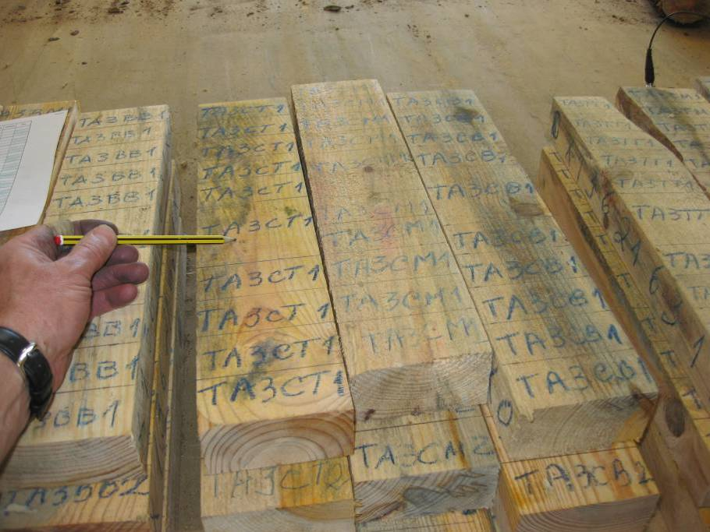

Figure 1. Pine boards cut to size showing treatment coding.

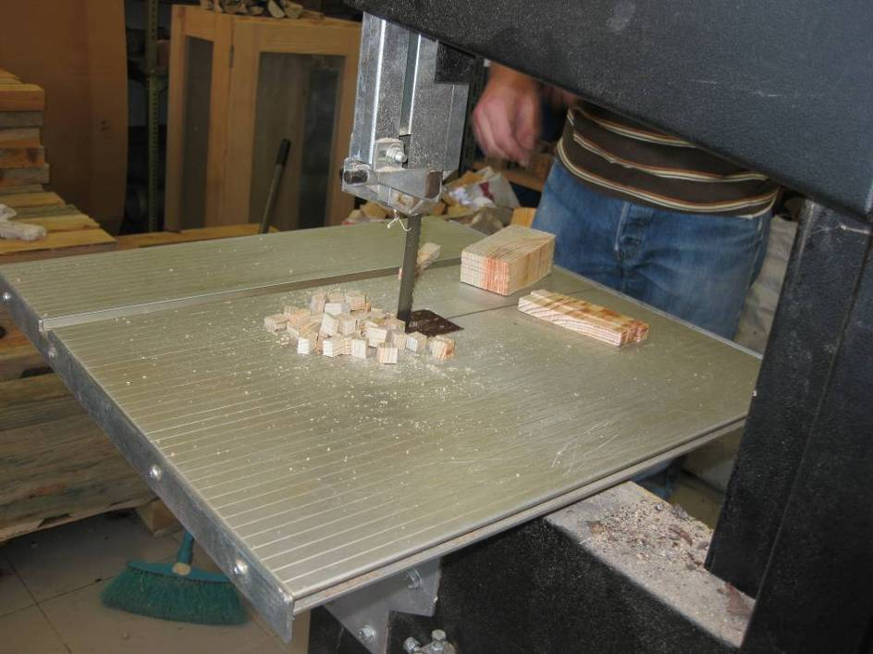
Figure 2. Mechanical saw used for preparing wood cubes.

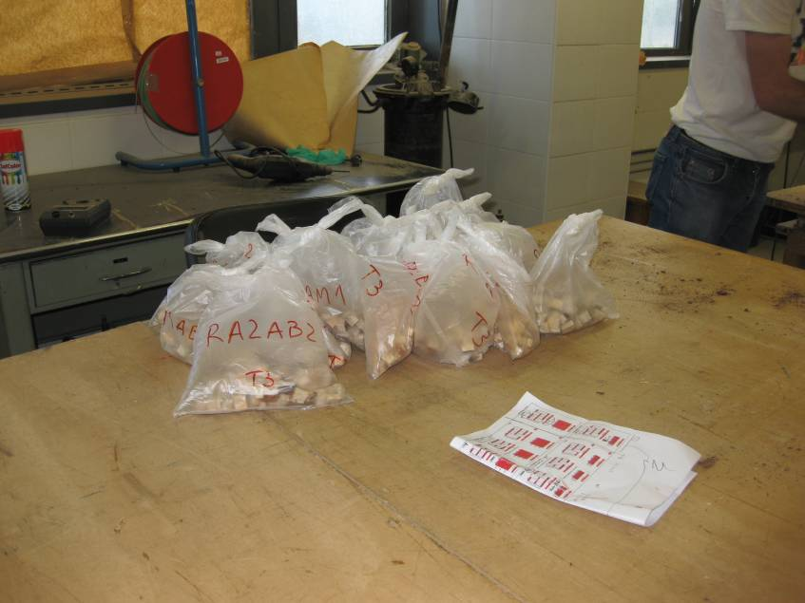
Figure 3. Bagged bioassay samples of wood cubes (individual bag
weight = 100 g).

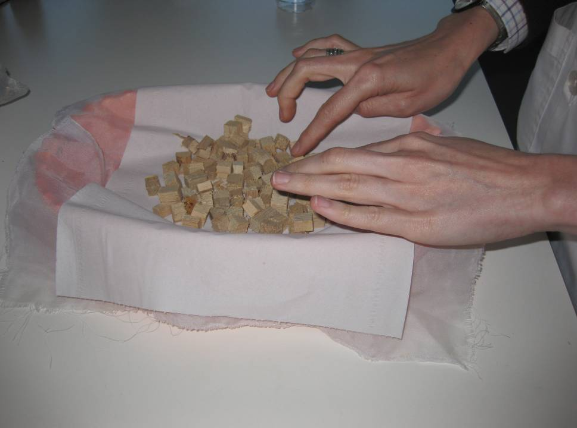

Figure 4. Placement of 200 g sample of bioassay wood cubes on plastic tray.

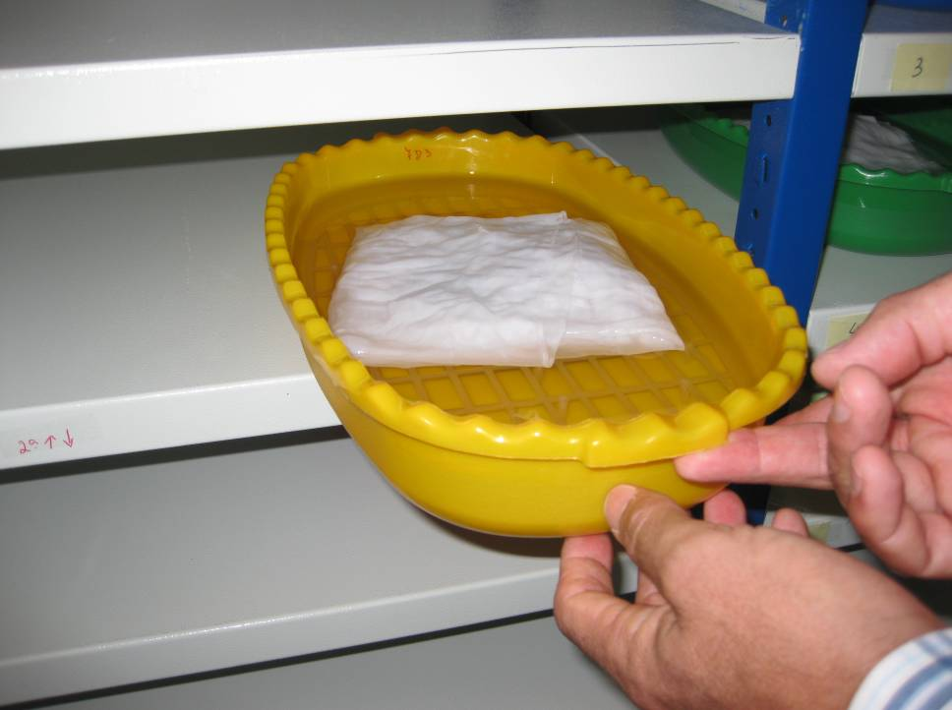

Figure 5. Wood cubes bioassay immersed in tap water.

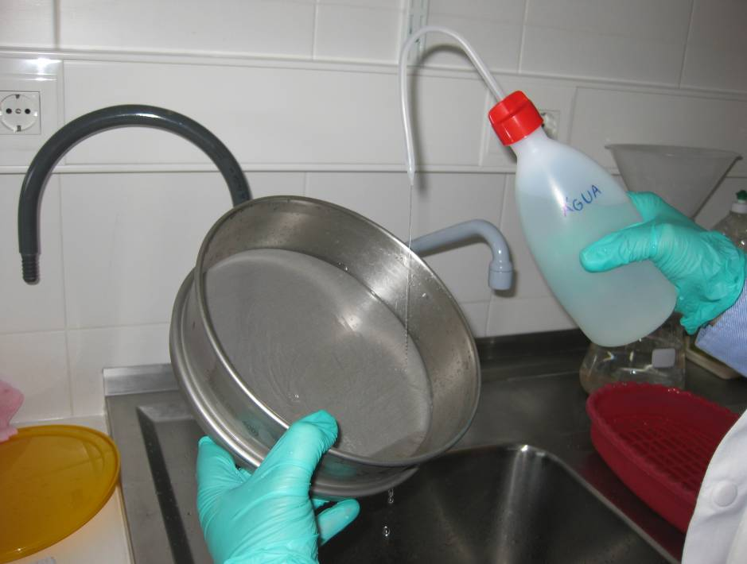

Figure 6. Filtration and concentration of pine wood nematodes following extraction.

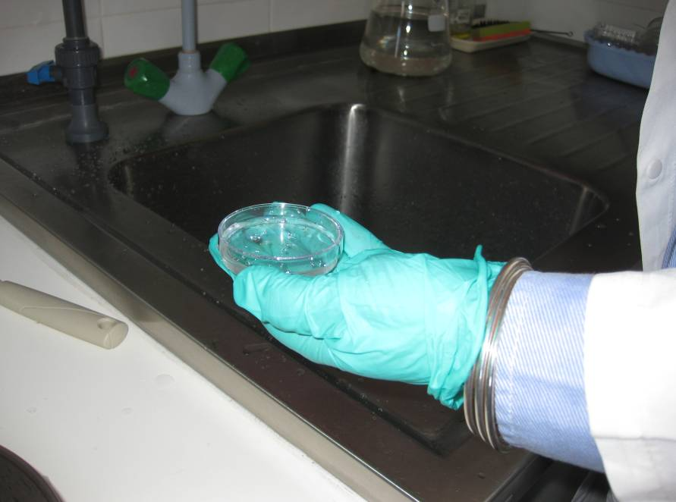

Figure 7. Watch glass containing concentrated pine wood nematodes transferred from the micro-mesh filter.

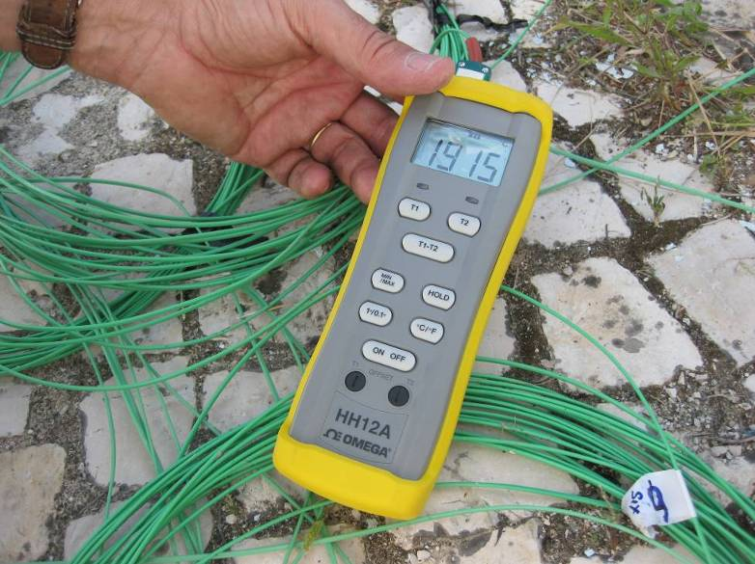
Figure 8. Thermocouple wire and meter for measuring temperature inside fumigation chamber.

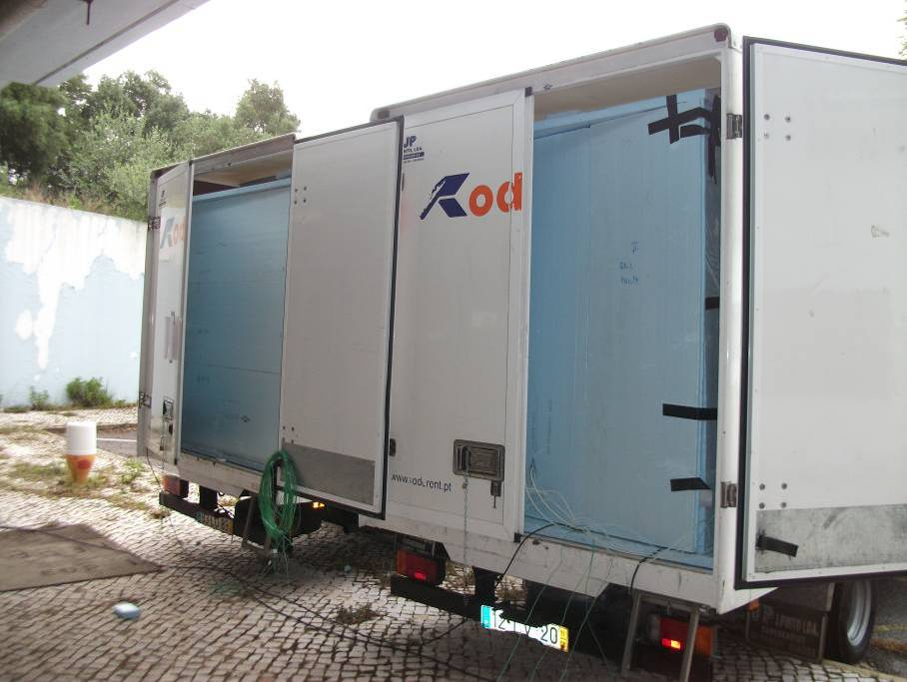

Figure 9. Vans used for fumigation (each van contained 4 chambers).

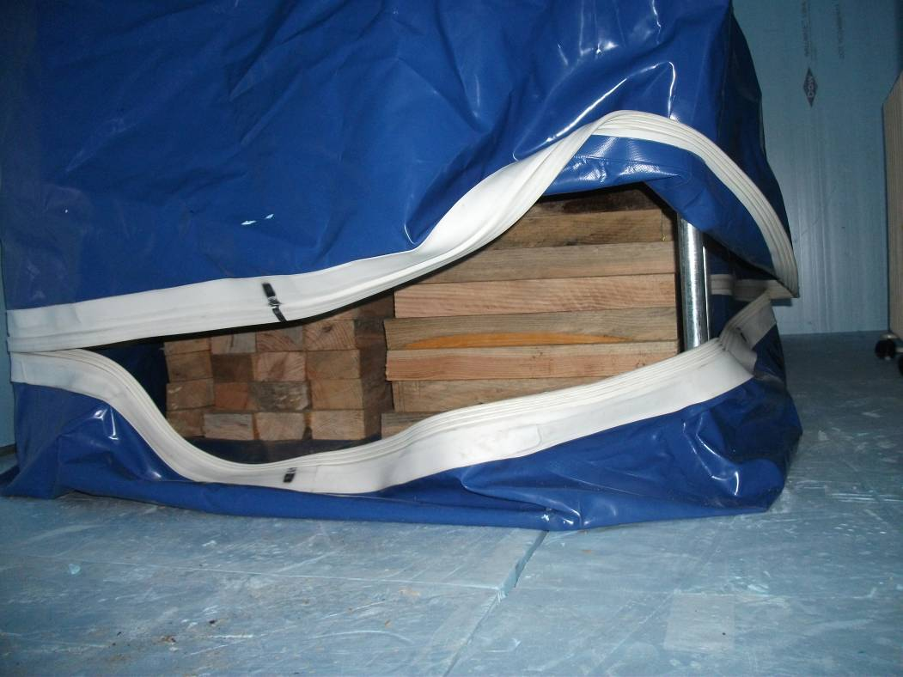
Figure 10. Fumigation chamber filled with pine boards.

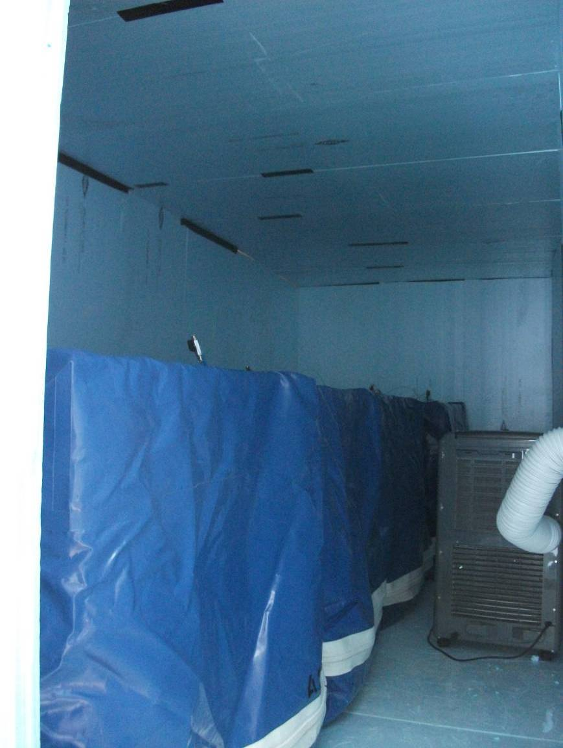

Figure 11. Fumigation chambers inside van insulated with polystyrene panels and fitted with air conditioning and electric heaters.

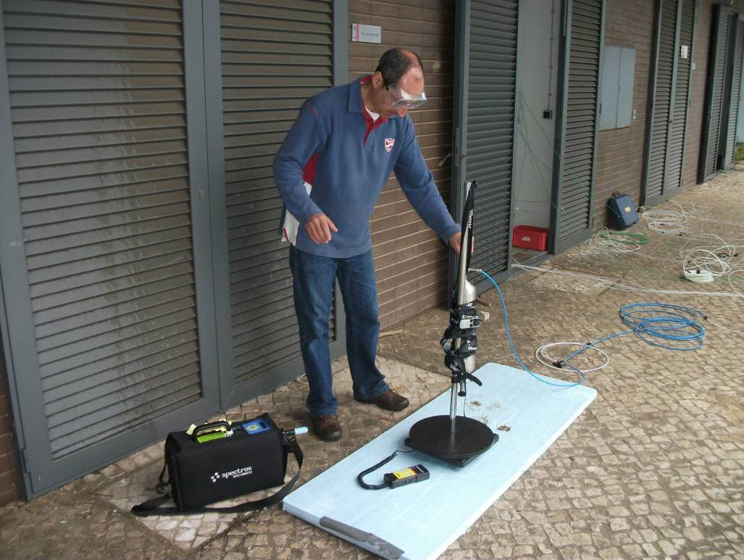
Figure 12 . Introduction of fumigant with small cylinder and electronic scale.

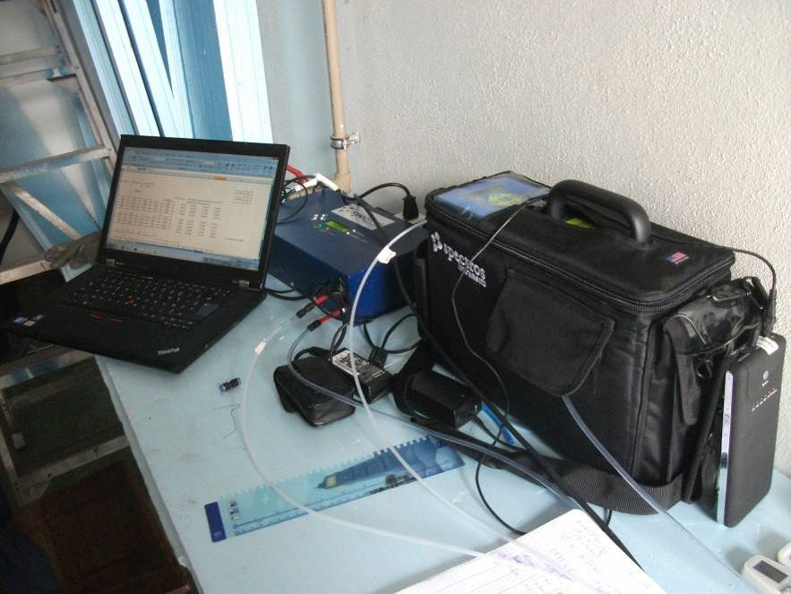

Figure 13. Sulfuryl fluoride monitoring equipment (SF-ReportIR and SF- ContainIR).

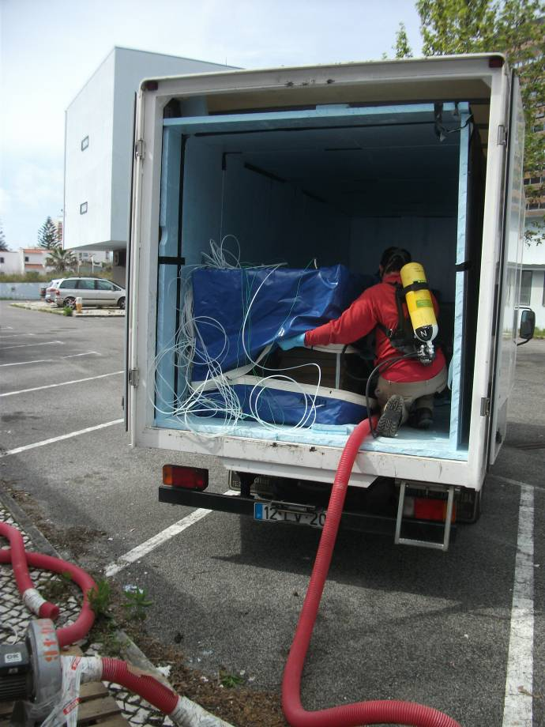
Figure 14. Aeration of chambers at the end of the fumigation.

Appendix 1

Study plan to validate the proposed fumigation schedule of sulfuryl fluoride for inclusion in ISPM No. 15 for eradication of pine wood nematode (Bursaphelenchus xylophilus) from wood packaging material

S. Buckley – Dow AgroSciences, France
E. Thoms – Dow AgroSciences, USA

Reviewers

L. Bonifácio, INIAV – Instituto Nacional de Investigação Agrária e Veterinária (ex-INRB), Portugal
E. Sousa, INIAV – Instituto Nacional de Investigação Agrária e Veterinária (ex-INRB), Portugal
Thomas Schroeder
Brent Larson
Mike Ormsby

- Introduction

Sulfuryl fluoride (SF) has been submitted for inclusion in the International Standard for Phytosanitary Measures (ISPM) No. 15. The standard was first published in 2002 and revised in 2009. In the 2009 revision the scope was given as: “This standard describes phytosanitary measures that reduce the risk of introduction and spread of quarantine pests associated with the movement in international trade of wood packaging material made from raw wood. Wood packaging material covered by this standard includes dunnage but excludes wood packaging made from wood processed in such a way that it is free from pest (e.g. plywood).

The Technical Panel on Phytosanitary Treatments (TPPT) evaluated the efficacy data submitted on SF against a range of insect species and pine wood nematode to support its inclusion in the Standard. Following their evaluations, whilst there were no further requirements for insects, additional information on pine wood nematode was requested.
The comments given from the TPPT and the information needed are listed below:

“The TPPT could not determine the level of efficacy of this treatment against Bursaphelenchus xylophilus (Pine wood nematode) for temperatures within a range greater than 18°C and less than 30 °C”

This protocol is based on experimental design, evaluation and testing guidance for pinewood nematodes described by Soma et al , Schröder et al ,Magnusson & Schröder and Uzunovic & Cook.

- Collection and Preparation of Test Wood Material

Pine wood e.g. Pinus pinaster, naturally infested with pine wood nematode (PWN) will be collected in Portugal. The wood will be checked for moisture content using an oven dry method of determination as described below.
A baseline check of the pine wood will be carried out to confirm the presence of PWN.

Without removing the bark the wood will be sawn into boards 10cm x 5cm x 45 cm long.
Wood must contain at least 100 nematodes/g of wood to reach the target population of 100,000 nematodes per treatment sample.

- Incubation of Test Wood Material and Nematode Extraction

Test wood material will be incubated before and after fumigation at optimal development conditions of 25ºC and 70% r.h. to increase the number of the PWN propagative life stages. Suitable numbers of PWN, at least 100 nematodes/g of wood, should be present throughout the wood pieces.

Environmental conditions, i.e. the temperature and r.h., will be changed to favour the development of the 3rd resistant stage (J_{III}) of the PWN to achieve at least 60% of the population prior to fumigation treatment.

The total number of nematodes included per treatment should be at least 100,000 (required for Probit 9 statistical analysis). Nematode numbers will be evaluated by nematode extraction as described below.

Representative samples of wood pieces (treated and control) will be prepared by cutting 100 g section at each end of the wood board, and cutting each section into cubes of ca. 1 cm³ using a mechanical timber saw. To avoid cross contamination, wood dust will be carefully removed from the saw blade and saw equipment by brushing, vacuuming and washing the saw blade and saw surfaces with alcohol after preparation of wood section. . The cut wood sections will be placed into individually labelled polyethylene bags.

Following wood section preparation, live PWN will be extracted using the method described by Penas et al. (2002) and used in the 2010 study.

Each wood sample will be removed from the polyethylene bag, placed on filter paper (Trapicel, Futurlab, Portugal), wrapped in “etamine” tissue, and placed on a plastic mesh overlaying a plastic tray. The tray will be filled with tap water to completely immerse the wood sample. After 48 h, the supporting net containing the sample will be carefully removed and the water in the tray passed through a 400 mesh (38 µm) sieve. The remaining material will be shower washed and concentrated with distilled water into small plastic or glass containers and preserved at 4ºC until examination.

After each extraction, the sieve will be thoroughly washed with ethanol and water.

- Wood Moisture Content

Three ca. 2.5 cm thick sections will be sawn from the middle of three representative pieces of boards and oven dried (ASTM 1992) to determine mean wood moisture contents before and after fumigation.

- Preparation for fumigation

Following incubation, thirty six boards and nine logs will be placed into each fumigation chamber in two separate stacks of 45 cm high x 40 cm wide x 45 cm long (boards) and 45 cm high x 45 cm wide x 40 cm long (logs). (Logs will be used to fill the air space of the fumigation chamber and are not part of the evaluation of efficacy for PWN control). Fumigation chambers will consist in 1 m³ chamber made of a metal structure and PVC (same chambers used in 2010 trials). Nine of the 36 boards will be used for PWN sampling. Sets of three will be placed at the top, middle and bottom of the stack. The chambers, loaded with wood, will be held in an enclosure constructed with 4 mm thick polystyrene insulation panels (WallmateTM, The Dow Chemical Company, Midland, MI, USA) to control the temperature. The number of boards used for each treatment should result in at least 100,000 individual PWN life stages being present in the control for evaluations pre- and post-treatment with at least 60% at the 3rd larvae dispersal stage. The number of wood pieces used should also take into account for any significant mortality (>5%) which may occur in the untreated controls.

6. Temperature management

Fumigations will be undertaken at 20°C: this was the temperature at which probit 9 level of control was not achieved in one replicate series in the 2010 trials⁶. Thermostatic controlled air conditioners and coil-in-oil electric heaters will be used to maintain the required temperature in the insulated enclosure. Temperature will be measured using thermocouples lines and data loggers (Tinytag^{TM,} Gemini Data Loggers, UK).

7. Fumigation chambers

Four fumigation chambers will be assembled in constructed and placed into each arena representing three treatment chambers and one untreated chamber. Each of the three treated chambers will be connected to a 30 m long x 4 mm inner diameter SF introduction hose, a 20 m thermocouple line and two 30 m long x 2.5 mm monitoring hoses located in the top and bottom open air space of each chamber. The untreated chamber will have the same set up as those to be treated with SF, except no introduction hose will be used and the entry port for this hose will be sealed.

8. Treatments

In the 2010 trial, results at 20°C did not achieve consistent results. In the first fumigation series, PWN survivors were observed at the highest dosage of 4051 g-h/m³. In contrast, in the second fumigation series, 100% PWN control was achieved at a lower dosage of 2300 g-h/m³ (Table 1).

Table 1. Percentage mortality of all life stages of pine wood nematodes in infected boards of maritime pine before and after 24 h fumigation with sulfuryl fluoride at 20ºC in 2010 trials (first and second fumigation series)

Treatment  Dosage  (g h/m³) | Number of nematodes  (mean/g of wood x ¹weight of infected boards) |  |  | % Mortality² | %  Mortality  (corrected)³ | Series
Treatment  Dosage  (g h/m³) | 48 h Before fumigation |  | 21-42 days after fumigation | % Mortality² | %  Mortality  (corrected)³ | Series
Treatment  Dosage  (g h/m³) | Total | % J_{III}
Untreated | 550669 | 74.2306 | 426057 |  |  | 1
1901 | 128701 | 38.2748 | 224 | 99.8259 | 99.7750484 | 1
3768 | 302672 | 47.5594 | 1286 | 99.5751 | 99.4508492 | 1
3852 | 511441 | 61.5486 | 23474 | 95.4102 | 94.0678178 | 1
4036 | 983573 | 48.0619 | 4057 | 99.5875 | 99.4668845 | 1
4045 | 841584 | 55.9672 | 523 | 99.9377 | 99.9195258 | 1
4051 | 1230429 | 80.0051 | 32399 | 97.3669 | 96.5967177 | 1
Untreated | 1067130 | 81.3826 | 125892 |  |  | 2
2145 | 1278907 | 79.0143 | 0 | 100 | 100 | 2
2352 | 1050567 | 75.8833 | 0 | 100 | 100 | 2
2488 | 449506 | 62.1436 | 15 | 99.9967 | 99.9717138 | 2

¹ Mean weight of board = 1500 g
² Not adjusted for untreated mortality
³ Adjusted for untreated mortality (Henderson and Hilton formula)

Since no clear dose response was observed for this temperature and this exposure time, a new parameter will be evaluated in 2013: the exposure time.
The target dosage will be 2875 g-h/m3 which is 1.25X the target dosage evaluated in the 2010 trials at 20ºC tested at two exposure time of 24h and 48h.

 | Temperature | Dosage | Exposure Time
Treatment 1 | 20°C | 2875 g-h/m³ | 24 h
Treatment 2 | 20°C | 2875 g-h/m³ | 48 h

If Probit 9 level of efficacy is not achieved in any of the above treatments, another fumigation series will be conducted at 1.5 X dosage (3450 g-h/m³) at two exposure times: 24 h and 48 h.

9. Fumigation

Commercial grade SF (99.8%; Dow AgroSciences, Indianapolis, Indiana, USA) will be introduced gravimetrically from a small sample cylinder (Swagelok 2.2 l stainless steel cylinder), fitted with a needle valve and weighed on a Yellow Jacket electronic weighing scale.

SF concentrations will be measured at least 0.5, 2, 24 and 48 h after fumigant introduction using an Infra Red detector (Spectros SF ReportIR )

After the fumigation exposure period, fumigation units will be ventilated using a secured system for a minimum of one hour. A clearance detector of appropriate sensitivity (e. g. Interscan gas analyzer or Spectros SF-ExplorIR) will be used to monitor the work area during aeration to confirm that SF concentrations are 3 ppm or less in the breathing zone.

Following fumigation and aeration, the wood bioassays will be placed in separate containers to avoid any possible cross contamination. Each set of treated and untreated wood bioassays will be placed in an incubation chamber and maintained at optimal conditions for nematode development i.e. 25ºC and 75% r.h.

- Assessments

Gas concentration and accumulated dosage (g-h/m³)

For each treatment replicate, SF concentration will be recorded at 0.5, 2 and 24 h after fumigant introduction is completed, and the accumulated dosage will be calculated.

Chamber temperature, Wood moisture content, Weight of lumber/wood

For each treatment replicate and the untreated controls, the chamber temperature, the moisture content and weight of wood /boards before and after the fumigation will be recorded.

Nematode mortality

Nematode mortality from each treatment replicate and in the untreated control will be conducted. Nematode extraction should take place from 100 g wood samples taken from each of the wood lumber and board pieces and the number of nematodes expressed per gram of sample to determine the % survivorship. These assessments should be made before treatment, and 3 and 21 days after fumigation.

If natural mortality in the controls is significant (> 5%), this will need to be taken into account in the test numbers as well (original numbers adjusted down by the level of mortality in the controls).
Appendix 2

Measurements of sulfuryl fluoride concentrations and temperature

Time of  Reading | TOP g/m³  SF | BOT g/m³  SF | Mean g/m³  SF | Time  Interval | CT Dosage per  Interval | Cumulative  Time | Cumulative  CT Dosage (g-h/m³) | Temperature  (°C) | g SF introduced
4/10/13 11:15 | 0.00 | 0.00 | 0 | 00:00 | 0 | 0:00:00 | 0 | 20 | 60
4/10/13 11:45 | 44.2 | 99.8 | 71.98 | 00:30 | 18 | 0:30:00 | 18 | 20
4/10/13 12:15 | 46.20 | 89.70 | 67.95 | 00:30 | 35 | 1:00:00 | 53 | 20
4/10/13 13:15 | 58.50 | 70.30 | 64.4 | 01:00 | 66 | 2:00:00 | 119 | 21
4/10/13 15:15 | 64.30 | 64.20 | 64.25 | 02:00 | 129 | 4:00:00 | 248 | 21
4/10/13 21:45 | 63.00 | 62.50 | 62.75 | 06:30 | 413 | 10:30:00 | 661 | 21
4/11/13 11:15 | 62.60 | 61.90 | 62.25 | 13:30 | 844 | 24:00:00 | 1504 | 21
4/11/13 13:45 | 62.80 | 63.00 | 62.9 | 02:30 | 156 | 26:30:00 | 1661 | 22
4/11/13 22:45 | 62.20 | 62.30 | 62.25 | 09:00 | 563 | 35:30:00 | 2224 | 20
4/12/13 11:15 | 60.90 | 62.10 | 61.5 | 12:30 | 773 | 48:00:00 | 2997 | 21
Chamber 1: Introduction 10 April 2013, 11:15, exposure time 48 h, target dosage 2875 g-h/m³.

Time of  Reading | TOP g/m³  SF | BOT g/m³  SF | Mean g/m³  SF | Time  Interval | CT Dosage per  Interval | Cumulative  Time | Cumulative  CT Dosage (g-h/m³) | Temperature  (°C) | g SF introduced
4/10/13 11:15 | 0.00 | 0.00 | 0 | 00:00 | 0 | 0:00:00 | 0 | 20 | 60
4/10/13 11:45 | 52.95 | 81.55 | 67.25 | 00:30 | 17 | 0:30:00 | 17 | 20
4/10/13 12:15 | 52.30 | 75.80 | 64.05 | 00:30 | 33 | 1:00:00 | 50 | 20
4/10/13 13:15 | 57.60 | 65.40 | 61.50 | 01:00 | 63 | 2:00:00 | 112 | 21
4/10/13 15:15 | 60.20 | 60.00 | 60.10 | 02:00 | 122 | 4:00:00 | 234 | 21
4/10/13 21:45 | 57.70 | 57.80 | 57.75 | 06:30 | 383 | 10:30:00 | 617 | 20
4/11/13 11:15 | 54.20 | 55.00 | 54.60 | 13:30 | 758 | 24:00:00 | 1375 | 21
4/11/13 13:45 | 54.50 | 54.40 | 54.45 | 02:30 | 136 | 26:30:00 | 1512 | 21
4/11/13 22:45 | 50.60 | 50.60 | 50.60 | 09:00 | 473 | 35:30:00 | 1984 | 20
4/12/13 11:15 | 48.90 | 48.90 | 48.90 | 12:30 | 622 | 48:00:00 | 2606 | 20
Chamber 2: Introduction 10 April 2013, 11:15, exposure time 48 h, target dosage 2875 g-h/m³.

Time of  Reading | TOP g/m³  SF | BOT g/m³  SF | Mean g/m³  SF | Time  Interval | CT Dosage per  Interval | Cumulative  Time | Cumulative  CT Dosage (g-h/m³) | Temperature  (°C) | g SF introduced
4/10/13 11:15 | 0.00 | 0.00 | 0 | 00:00 | 0 | 0:00:00 | 0 | 20 | 60
4/10/13 11:45 | 60.58 | 113.91 | 87.25 | 00:30 | 22 | 0:30:00 | 22 | 20
4/10/13 12:15 | 59.80 | 106.50 | 83.15 | 00:30 | 43 | 1:00:00 | 64 | 19
4/10/13 13:15 | 63.70 | 92.00 | 77.85 | 01:00 | 81 | 2:00:00 | 145 | 20
4/10/13 15:15 | 70.40 | 74.20 | 72.30 | 02:00 | 150 | 4:00:00 | 295 | 20
4/10/13 21:45 | 70.00 | 70.10 | 70.05 | 06:30 | 463 | 10:30:00 | 758 | 20
4/11/13 11:15 | 68.80 | 69.00 | 68.90 | 13:30 | 938 | 24:00:00 | 1696 | 20
4/11/13 13:45 | 66.80 | 67.00 | 66.90 | 02:30 | 170 | 26:30:00 | 1865 | 20
4/11/13 22:45 | 62.30 | 62.10 | 62.20 | 09:00 | 581 | 35:30:00 | 2446 | 20
4/12/13 11:15 | 61.00 | 61.10 | 61.05 | 12:30 | 770 | 48:00:00 | 3217 | 19
Chamber 3: Introduction 10 April 2013, 11:15, exposure time 48 h, target dosage 2875 g-h/m³.

Time of  Reading | TOP g/m³  SF | BOT g/m³  SF | Mean g/m³  SF | Time  Interval | CT Dosage per  Interval | Cumulative  Time | Cumulative  CT Dosage (g-h/m³) | Temperature  (°C) | g SF introduced
4/11/13 11:30 | 0.00 | 0.00 | 0 | 00:00 | 0 | 0:00:00 | 0 | 19 | 140
4/11/13 12:00 | 114.10 | 119.10 | 116.6 | 00:30 | 29 | 0:30:00 | 29 | 19
4/11/13 12:30 | 113.20 | 113.20 | 113.2 | 00:30 | 57 | 1:00:00 | 87 | 19
4/11/13 13:30 | 112.60 | 112.60 | 112.6 | 01:00 | 113 | 2:00:00 | 200 | 20
4/11/13 15:30 | 111.30 | 111.00 | 111.15 | 02:00 | 224 | 4:00:00 | 423 | 20
4/11/13 16:15 | 111.40 | 111.70 | 111.55 | 00:45 | 84 | 4:45:00 | 507 | 21
4/11/13 22:45 | 102.10 | 103.90 | 103 | 06:30 | 697 | 11:15:00 | 1204 | 20
4/12/13 11:30 | 107.20 | 107.30 | 107.25 | 12:45 | 1340 | 24:00:00 | 2544 | 20
Chamber 5: Introduction 11 April 2013, 11:30, exposure time 24 h, target dosage 2875 g-h/m³.

Time of  Reading | TOP g/m³  SF | BOT g/m³  SF | Mean g/m³  SF | Time  Interval | CT Dosage per  Interval | Cumulative  Time | Cumulative  CT Dosage (g-h/m³) | Temperature  (°C) | g SF introduced
4/11/13 11:30 | 0.00 | 0.00 | 0 | 00:00 | 0 | 0:00:00 | 0 | 20 | 110
4/11/13 12:00 | 81.30 | 123.30 | 102.3 | 00:30 | 26 | 0:30:00 | 26 | 20
4/11/13 12:30 | 82.30 | 113.30 | 97.8 | 00:30 | 50 | 1:00:00 | 76 | 20
4/11/13 13:30 | 100.20 | 100.00 | 100.1 | 01:00 | 99 | 2:00:00 | 175 | 20
4/11/13 15:15 | 98.60 | 98.60 | 98.6 | 01:45 | 174 | 3:45:00 | 348 | 21 | 20
4/11/13 15:30 | 102.20 | 133.20 | 117.7 | 00:15 | 27 | 4:00:00 | 375
4/11/13 16:15 | 112.20 | 112.80 | 112.5 | 00:45 | 86 | 4:45:00 | 462 | 22
4/11/13 22:45 | 104.10 | 104.00 | 104.05 | 06:30 | 704 | 11:15:00 | 1166 | 19
4/12/13 11:30 | 107.50 | 107.50 | 107.5 | 12:45 | 1349 | 24:00:00 | 2514 | 20
Chamber 6: Introduction 11 April 2013 11:30, exposure time 24 h, target dosage 2875 g-h/m³.

Time of  Reading | TOP g/m³  SF | BOT g/m³  SF | Mean g/m³  SF | Time  Interval | CT Dosage per  Interval | Cumulative  Time | Cumulative  CT Dosage (g-h/m³) | Temperature  (°C) | g SF introduced
4/11/13 11:30 | 0.00 | 0.00 | 0 | 00:00 | 0 | 0:00:00 | 0 | 20 | 110
4/11/13 12:00 | 72.80 | 69.90 | 71.35 | 00:30 | 18 | 0:30:00 | 18 | 20
4/11/13 12:30 | 109.90 | 80.00 | 94.95 | 00:30 | 42 | 1:00:00 | 59 | 20 | 50
4/11/13 13:30 | 131.90 | 129.20 | 130.55 | 01:00 | 113 | 2:00:00 | 172 | 19
4/11/13 15:30 | 151.90 | 151.60 | 151.75 | 02:00 | 282 | 4:00:00 | 454 | 20
4/11/13 16:15 | 152.50 | 152.60 | 152.55 | 00:45 | 114 | 4:45:00 | 569 | 21
4/11/13 22:45 | 147.70 | 147.50 | 147.6 | 06:30 | 975 | 11:15:00 | 1544 | 19
4/12/13 11:30 | 148.20 | 148.50 | 148.35 | 12:45 | 1887 | 24:00:00 | 3431 | 20
Chamber 7: Introduction 11 April 2013, 11:30, exposure time 24 h, target dosage 2875 g-h/m³.

Time of  Reading | TOP g/m³  SF | BOT g/m³  SF | Mean g/m³  SF | Time  Interval | CT Dosage per  Interval | Cumulative  Time | Cumulative  CT Dosage (g-h/m³) | Temperature  (°C) | g SF introduced
4/22/13 12:45 | 0.00 | 0.00 | 0 | 00:00 | 0 | 0:00:00 | 0 | 23 | 60
4/22/13 13:15 | 28.9 | 33.9 | 31.40 | 00:30 | 8 | 0:30:00 | 8
4/22/13 13:45 | 45.60 | 50.90 | 48.25 | 00:30 | 20 | 1:00:00 | 28 | 27
4/22/13 15:15 | 51.90 | 58.70 | 55.3 | 01:30 | 78 | 2:30:00 | 105 | 27
4/22/13 16:45 | 59.60 | 59.60 | 59.6 | 01:30 | 86 | 4:00:00 | 192 | 24
4/22/13 17:40 | 59.10 | 59.10 | 59.1 | 00:55 | 54 | 4:55:00 | 246 |  | 5
4/22/13 17:45 | 66.70 | 66.60 | 66.65 | 00:05 | 5 | 5:00:00 | 251 | 21
4/22/13 18:45 | 64.20 | 64.10 | 64.15 | 01:00 | 65 | 6:00:00 | 317 | 19
4/22/13 22:45 | 59.30 | 61.00 | 60.15 | 04:00 | 249 | 10:00:00 | 565 | 21
4/23/13 9:30 | 58.60 | 58.60 | 58.6 | 10:45 | 638 | 20:45:00 | 1204 | 19
4/23/13 12:45 | 57.20 | 57.30 | 57.25 | 03:15 | 188 | 24:00:00 | 1392 | 19
4/23/13 17:15 | 56.90 | 57.00 | 56.95 | 04:30 | 257 | 28:30:00 | 1649 | 19
4/23/13 22:45 | 55.00 | 54.80 | 54.9 | 05:30 | 308 | 34:00:00 | 1956 | 19
4/24/13 12:45 | 53.00 | 52.90 | 52.95 | 14:00 | 755 | 48:00:00 | 2711 | 21
Chamber 9 : introduction 22nd April 12:45, exposure time 48 h, target dosage 2875 g-h/m³.

Time of  Reading | TOP g/m³  SF | BOT g/m³  SF | Mean g/m³  SF | Time  Interval | CT Dosage per  Interval | Cumulative  Time | Cumulative  CT Dosage (g-h/m³) | Temperature  (°C) | g SF introduced
4/22/13 12:45 | 0.00 | 0.00 | 0 | 00:00 | 0 | 0:00:00 | 0 | 24 | 50
4/22/13 13:15 | 40.60 | 72.30 | 56.45 | 00:30 | 14 | 0:30:00 | 14
4/22/13 13:45 | 49.70 | 64.40 | 57.05 | 00:30 | 28 | 1:00:00 | 42 | 27
4/22/13 15:15 | 53.80 | 53.90 | 53.85 | 01:30 | 83 | 2:30:00 | 126 | 26
4/22/13 16:45 | 53.30 | 53.40 | 53.35 | 01:30 | 80 | 4:00:00 | 206 | 24
4/22/13 18:45 | 53.10 | 52.70 | 52.90 | 02:00 | 106 | 6:00:00 | 312 | 19
4/22/13 22:45 | 53.30 | 53.60 | 53.45 | 04:00 | 213 | 10:00:00 | 525 | 21
4/23/13 9:30 | 50.30 | 50.20 | 50.25 | 10:45 | 557 | 20:45:00 | 1082 | 19
4/23/13 12:45 | 50.00 | 50.10 | 50.05 | 03:15 | 163 | 24:00:00 | 1245 | 19
4/23/13 17:15 | 52.30 | 52.30 | 52.30 | 04:30 | 230 | 28:30:00 | 1476 | 20
4/23/13 22:45 | 52.30 | 52.30 | 52.30 | 05:30 | 288 | 34:00:00 | 1763 | 19
4/24/13 12:45 | 47.10 | 47.30 | 47.20 | 14:00 | 697 | 48:00:00 | 2460 | 21
Chamber 10: Introduction 22 April 2013, 12:45, exposure time 48 h, target dosage 2300 g-h/m³.

Time of  Reading | TOP g/m³  SF | BOT g/m³  SF | Mean g/m³  SF | Time  Interval | CT Dosage per  Interval | Cumulative  Time | Cumulative  CT Dosage (g-h/m³) | Temperature  (°C) | g SF introduced
4/22/13 12:45 | 0.00 | 0.00 | 0 | 00:00 | 0 | 0:00:00 | 0 | 24 | 50
4/22/13 13:15 | 28.70 | 76.30 | 52.50 | 00:30 | 13 | 0:30:00 | 13
4/22/13 13:45 | 40.60 | 66.00 | 53.30 | 00:30 | 26 | 1:00:00 | 40 | 25
4/22/13 15:15 | 53.50 | 50.70 | 52.10 | 01:30 | 79 | 2:30:00 | 119 | 27
4/22/13 16:45 | 54.20 | 54.30 | 54.25 | 01:30 | 80 | 4:00:00 | 198 | 25
4/22/13 18:45 | 54.20 | 54.30 | 54.25 | 02:00 | 109 | 6:00:00 | 307 | 22
4/22/13 22:45 | 53.60 | 53.60 | 53.60 | 04:00 | 216 | 10:00:00 | 523 | 21
4/23/13  9:30 | 52.00 | 52.00 | 52.00 | 10:45 | 568 | 20:45:00 | 1090 | 19
4/23/13 12:45 | 51.90 | 51.90 | 51.90 | 03:15 | 169 | 24:00:00 | 1259 | 21
4/23/13 17:15 | 51.80 | 51.80 | 51.80 | 04:30 | 233 | 28:30:00 | 1492 | 21
4/23/13 22:45 | 51.00 | 50.80 | 50.90 | 05:30 | 282 | 34:00:00 | 1775 | 19
4/24/13 12:45 | 49.60 | 49.60 | 49.60 | 14:00 | 704 | 48:00:00 | 2478 | 19
Chamber 11: Introduction 22 April 2013, 12:45, exposure time 48 h, target dosage 2300 g-h/m³.

Time of  Reading | TOP g/m³  SF | BOT g/m³  SF | Mean g/m³  SF | Time  Interval | CT Dosage per  Interval | Cumulative  Time | Cumulative  CT Dosage (g-h/m³) | Temperature  (°C) | g SF introduced
4/23/13 13:05 | 0.00 | 0.00 | 0 | 00:00 | 0 | 0:00:00 | 0 | 20 | 165
4/23/13 13:35 | 94.40 | 313.00 | 203.7 | 00:30 | 51 | 0:30:00 | 51 | 21
4/23/13 14:05 | 119.50 | 288.60 | 204.05 | 00:30 | 102 | 1:00:00 | 153 | 22
4/23/13 15:05 | 132.60 | 244.00 | 188.3 | 01:00 | 196 | 2:00:00 | 349 | 21
4/23/13 17:05 | 173.60 | 186.50 | 180.05 | 02:00 | 368 | 4:00:00 | 717 | 23
4/23/13 23:05 | 178.20 | 178.10 | 178.15 | 06:00 | 1075 | 10:00:00 | 1792 | 20
4/24/13 13:05 | 175.00 | 174.80 | 174.9 | 14:00 | 2471 | 24:00:00 | 4263 | 20
Chamber 13: Introduction 23 April 2013, 13:05, exposure time 24 h, target dosage 4025 g-h/m³.

Time of  Reading | TOP g/m³  SF | BOT g/m³  SF | Mean g/m³  SF | Time  Interval | CT Dosage per  Interval | Cumulative  Time | Cumulative  CT Dosage (g-h/m³) | Temperature  (°C) | g SF introduced
4/23/13 13:05 | 0.00 | 0.00 | 0 | 00:00 | 0 | 0:00:00 | 0 | 21 | 140
4/23/13 13:35 | 109.80 | 226.60 | 168.2 | 00:30 | 42 | 0:30:00 | 42 | 20
4/23/13 14:05 | 115.50 | 210.90 | 163.2 | 00:30 | 83 | 1:00:00 | 125 | 21
4/23/13 15:05 | 142.00 | 179.00 | 160.5 | 01:00 | 162 | 2:00:00 | 287 | 21
4/23/13 17:05 | 153.80 | 154.10 | 153.95 | 02:00 | 314 | 4:00:00 | 601 | 23
4/23/13 23:05 | 150.70 | 150.40 | 150.55 | 06:00 | 914 | 10:00:00 | 1515 | 20
4/24/13 13:05 | 148.00 | 147.20 | 147.6 | 14:00 | 2087 | 24:00:00 | 3602 | 20
Chamber 14: Introduction 23 April 2013, 13:05, exposure time 24 h, target Dosage 3475 g-h/m³.

Time of  Reading | TOP g/m³  SF | BOT g/m³  SF | Mean g/m³  SF | Time  Interval | CT Dosage per  Interval | Cumulative  Time | Cumulative  CT Dosage (g-h/m³) | Temperature  (°C) | g SF introduced
4/23/13 13:05 | 0.00 | 0.00 | 0 | 00:00 | 0 | 0:00:00 | 0 | 23 | 140
4/23/13 13:35 | 87.50 | 270.10 | 178.8 | 00:30 | 45 | 0:30:00 | 45 | 23
4/23/13 14:05 | 97.50 | 219.40 | 158.45 | 00:30 | 84 | 1:00:00 | 129 | 24
4/23/13 15:05 | 149.20 | 165.10 | 157.15 | 01:00 | 158 | 2:00:00 | 287 | 24
4/23/13 17:05 | 146.90 | 147.10 | 147 | 02:00 | 304 | 4:00:00 | 591 | 24
4/23/13 23:05 | 144.00 | 144.40 | 144.2 | 06:00 | 874 | 10:00:00 | 1465 | 20
4/24/13 13:05 | 141.00 | 140.30 | 140.65 | 14:00 | 1994 | 24:00:00 | 3459 | 21
Chamber 15: Introduction 23 April 2013, 13:05, exposure time 24 h, target dosage 3475 g-h/m³.

Soma, Y., Naito, H , Misumi, T., Mizobuchi, M., Tsuchiya, Y., Matsoka, I., Kawakami, F. Hirata, K., and Komatsu, H. (2001) Effects of Some Fumigation on Pine Wood Nematode Bursaphelenchus xylophilus infesting Wooden Packages. 1. Susceptibility of Pine Wood Nematode to Methyl bromide, Sulfuryl fluoride, and Methyl Isothiocyanate. Research Bulletin Plant Protection Japan, 37: 19-26.
Schröder, T., McNamara, D. G. and Gaar, V. (2009) Guidance on sampling to detect pine wood nematode Bursaphelenchus xylophilus in trees, wood and insects. OEPP/EPPO Bulletin 39, 179-188.
Magnusson, C. and Schröder, (2008) Technical Protocol for Testing Nematodes during Treatment Development. International Forestry Quarantine Research Group Meeting, September 2008, Rome.
Uzunovic, A. and Cook, J. (2007). Proving that a pest is eradicated or cannot spread out of the wood. International Forestry Quarantine Research Group Meeting, September 2007, Rome,
Penas, A. C., Dias, L. S. and Mota, M. M. (2002) Precision and selection of extraction methods of aphelenchid nematodes from maritime pine wood, Pinus pinaster L. Journal of Nematology, 34, 62-65.
E. Sousa1, L. Bonifácio1, et al. Studies to validate the proposed fumigation schedules of sulfuryl fluoride for inclusion in ISPM No. 15 for the eradication of pine wood nematode (Bursaphelenchus xylophilus) from wood packaging material
[ASTM] American Society for Testing and Materials. 1992. Standard test methods for direct moisture content measurement of wood and wood-base materials. ASTM International, 100 Bar Harbor Drive, West Conshohocken, PA.

