Office of Evaluation
Food and Agriculture Organization of the United Nations

IPPC Secretariat Enhancement Evaluation
February 2015

Annexes 1, 2, 3, 4 and 5 to the Final Report
Food and Agriculture Organization of the United Nations

Office of Evaluation (OED)

This report is available in electronic format at: http://www.fao.org/evaluation

The designations employed and the presentation of material in this information product do not imply the expression of any opinion whatsoever on the part of the Food and Agriculture Organization of the United Nations (FAO) concerning the legal or development status of any country, territory, city or area or of its authorities, or concerning the delimitation of its frontiers or boundaries. The mention of specific companies or products of manufacturers, whether or not these have been patented, does not imply that these have been endorsed or recommended by FAO in preference to others of a similar nature that are not mentioned.

The views expressed in this information product are those of the author(s) and do not necessarily reflect the views or policies of FAO.

© FAO 2015

FAO encourages the use, reproduction and dissemination of material in this information product. Except where otherwise indicated, material may be copied, downloaded and printed for private study, research and teaching purposes, or for use in non-commercial products or services, provided that appropriate acknowledgement of FAO as the source and copyright holder is given and that FAO’s endorsement of users’ views, products or services is not implied in any way.

All requests for translation and adaptation rights, and for resale and other commercial use rights should be made via www.fao.org/contact-us/licence-request or addressed to copyright@fao.org.

For further information on this report, please contact:

Director, OED
Viale delle Terme di Caracalla 1, 00153
Rome, Italy
Email: evaluation@fao.org

Table of contents

Annex 1. Terms of Reference of the IPPC Secretariat Enhancement Evaluation 1
Annex 2. IPPC Secretariat Enhancement Evaluation team profiles 1
Annex 3. IPPC Secretariat Enhancement Evaluation: list of stakeholders interviewed 1
Annex 4. IPPC Secretariat Enhancement Evaluation: analysis of survey questionnaire to National Plant Protection Organizations 1
Annex 5. Report of the Expert Panel of the IPPC Secretariat Enhancement Evaluation 1

- Terms of Reference of the IPPC Secretariat Enhancement Evaluation

1 Introduction 1
1.1 Background 1
1.2 Context for the evaluation 2
2 Evaluation framework 3
2.1 Purpose 3
2.2 Evaluation key questions and scope 4
2.3 Evaluation criteria and issues 4
3 Evaluation methodology 6
3.1 Approach and tools 6
3.2 Stakeholders and consultation process 6
4 Organizational arrangements 7
4.1 Roles and responsibilities 7
4.2 Evaluation team competences and composition 8
4.3 Time-table 9
4.4 Budget 9
1 Purpose, scope and methodology of the survey 1
2 Findings 2
1 Background 1
2 Assessment 1
Overall 1
3 Conclusion 4

Acronyms
FPMIS Field Programme Management Information System
CBD the Convention on Biological Diversity;
CP Contracting Parties
CPM Commission on Phytosanitary Measures
IPPC International Plant Protection Convention
ISPMs International Standards for Phytosanitary Measures
OED FAO Office of Evaluation
OIE International Animal Health Organization
PC Programme Committee
RPPOs Regional Plant Protection Organizations
SPG Strategic Planning Group
ToR Terms of Reference
WTO World Trade Organization

Introduction

Background
- The International Plant Protection Convention (IPPC) is an international treaty that aims to secure coordinated, effective action to prevent and to control the introduction and spread of pests of plants and plant products. The IPPC was adopted by FAO Conference in 1951 deposited with the Director General of FAO under Article XIV of the Organization’s Constitution and came into force in 1952, superseding all previous international plant protection agreements. Amendments were brought by the parties to the Convention at various points in time: the current text of the Convention became operational in 2005. As of 2014, 181 countries adhere to the IPPC.

- The Convention extends beyond the protection of cultivated plants to the protection of natural flora and plant products and takes into consideration both direct and indirect damage by plants as pests. It also covers vehicles, aircraft and vessels, containers, storage places, soil and other objects or material that can harbour or spread pests. The Convention provides a framework and a forum for international cooperation, harmonization and technical exchange between Contracting Parties (CP), which are ultimately responsible for implementation of and compliance with the IPPC at national level.

- The IPPC is governed by the Commission on Phytosanitary Measures (CPM), whose mission is cooperation between nations in protecting the world’s cultivated and natural plant resources from the spread and introduction of pests of plants, while minimizing interference with the international movement of goods and people. The CPM meets annually and is directed between sessions by the CPM Bureau: this is a seven-member elected body that provides guidance to the IPPC Secretariat and CPM on strategic direction, cooperation, financial and operational management.

- The Secretariat of the IPPC, which is provided and hosted by FAO, was first established in 1992 and is responsible for the coordination of core activities under the IPPC work programme. Its core mandate is articulated around the following pillars of action:
- Development of International Standards for Phytosanitary Measures (ISPMs);
- Capacity Development (CD) in Member countries, which has gained importance in recent years;
- Information exchange, now called National Reporting Obligations;
- Dispute settlement; and
- Coordination and cooperation with other international conventions and agreements, e.g. the World Trade Organization (WTO), the Convention on Biological Diversity (CBD), Codex Alimentarius, the World Organization for Animal Health (OIE).

- IPPC Strategic Framework 2012-2019 was formulated to bring ‘the IPPC’s activities into closer alignment with the FAO strategic goals and the new FAO Results Based Management (RBM) system’ as formulated in FAO Strategic Framework 2010-2019. It states that ‘IPPC has been and remains a key FAO instrument among its members for ensuring food security, conservation of plant resources, and phytosanitary capacity development’ and defines IPPC Strategic Goals as follows:
- A - protect sustainable agriculture and enhance global food security through the prevention of pest spread;
- B - protect the environment, forests and biodiversity from plant pests;
- C - facilitate economic and trade development through the promotion of harmonized scientifically based phytosanitary measures; and
- D - develop phytosanitary capacity for members to accomplish A, B and C.

- Since then, FAO reviewed its own Strategic Framework: this however did not affect the core mandate of the Organization and the close relevance of IPPC work to FAO’s reviewed Strategic Objectives.

Context for the evaluation
- In 2007, FAO Office of Evaluation (OED) conducted the Independent Evaluation of the Workings of the International Plant Protection Convention and its Institutional Arrangements. This was an extended exercise that included, in addition to the analysis of the relevance and effectiveness of IPPC’s work at global and national level, also some analysis of the structure and role of the Secretariat. A number of measures were recommended to enhance its efficiency and effectiveness, several of which were accepted by FAO Management and implemented. The evaluation confirmed that the successful and efficient operation and organization of the Secretariat of the IPPC is fundamental to the achievement of the IPPC objectives and of the CPM work program. It is thus vital for the CPM that the Secretariat’s capacity and success continue into the future.

- In 2012/13, in the context of the implementation of the FAO Immediate Plan of Action approved by FAO Members in 2008, the Legal Office conducted a review of Article XIV Bodies, to identify measures to enhance their financial and administrative authority. Measures proposed were approved by FAO Council, which ‘acknowledged, in view of FAP’s general accountability for the operation of Article XIV Bodies, the need for Management to follow a flexible but prudent approach, by recognizing the functional requirements of these bodies, while ensuring as far as appropriate observance of FAO’s policies and procedures’. The effects of this decision should have enhanced the autonomy of the Secretariat, possibly contributing to its efficiency and effectiveness.

- Because of the ever dynamic, changing environment, organizations periodically review their procedures and systems in order to adapt and continue functioning effectively and efficiently. Many organizations have adopted a philosophy and process of “continuous improvement” as a means to continually evolve and maintain their organizational health, performance, and effectiveness. The IPPC members consider that such an approach is in the interests of both the IPPC Secretariat and Contracting Parties (CPs).

- In this context, in 2013 a Discussion paper was presented to the Strategic Planning Group suggesting the need for IPPC to move towards supporting implementation of the ISPMs at national level. This could require a significant shift in the work of the Secretariat, in terms of internal working arrangements, Resource Mobilization efforts, as well as, possibly, some re-profiling of technical expertise. The CPM-9 in April 2014 “agreed to strengthen the focus of the CPM on implementation, recognizing that this will require strong commitment from each CPM member and the Secretariat, and additional financial resources”, requested the Secretariat and the Bureau to work through an Open-Ended Working Group “to develop and define the scope of a pilot work plan to implement ISPM 6:1997 (Guidelines for surveillance) (2009-004) and to submit a strategic work plan to CPM-10 (2015) for approval.”

- At the same session of the CPM, Members, after discussing a proposal of draft Terms of Reference, agreed to launch an evaluation of the IPPC Secretariat, aimed at identifying how to strengthen its performance in view of the emerging challenges in the implementation of the Convention itself. FAO Office of Evaluation (OED), which is an independent unit within FAO responsible for the evaluation of FAO’s work, was asked to manage and support the process, in collaboration with the CPM Bureau.

- Appendix 5 of the CPM-9 Report contains the Terms of Reference agreed by the CPM. As per its standard practice, OED carried out some consultation with IPPC Bureau members, the Secretariat and FAO Senior Manager, to better refine the evaluation issues and question. This version fully encompasses and builds on Appendix 5, to capture aspects and issues that could not be discussed in detail at CPM-9.

- Due to delays in the process of finalizing the ToRs, the evaluation work will be concentrated in the period September-December 2014, and the final report is due for presentation at the CPM-10, planned in March 2015. The team will provide an update on progress in data collection and analysis at the October 2014 meetings of the SPG and of the CPM Bureau.

Evaluation framework

Purpose
- The main purposes of the IPPC Secretariat Enhancement Evaluation (hereinafter called Evaluation) were identified by the CPM as follows:
- identify existing strengths in the Secretariat’s structure and operations as well as current constraints to performance and delivery of services, and
- formulate recommendations for enhancing the Secretariat’s capacity to facilitate, coordinate, support, and advance the CPM’s strategic goals and annual work program, taking particular account of the focus on implementation, communication and partnerships.

- In addition to these core purposes, the Evaluation will also contribute to accountability and lessons learning for both FAO and IPPC Members, including on the synergies and areas for improvement in the collaboration between the IPPC Secretariat and FAO and the framework regulating Article XIV Bodies in FAO.

Evaluation key questions and scope
- The CPM-9 identified a number of issues to be assessed, listed below. These can be summarized in three key evaluation questions:
- Is the IPPC Secretariat structured, organized and resourced to the extent that it can fulfil its mandate and meet the current and upcoming requests from its Members?;
- What are the successful Secretariat organization structures, procedures and practices that are critical to the IPPC to facilitate the cooperative approach needed for the implementation of the IPPC and its ISPMs?;
- What are the existing business processes that must be maintained and areas where enhancements and/or new initiatives could be considered?

- In order to answer these questions, the Evaluation will focus on the functioning of the Secretariat of the IPPC: this will include organization, working procedures, management, resources, strengths and weaknesses in implementing its mandate. This will also include the work and initiatives developed by the IPPC Secretariat to facilitate members’ compliance with the Convention as well as the enabling and constraining factors in the functioning of the Secretariat, derived from its status as FAO Article XIV Body.

- The Evaluation will focus on the set-up of the Secretariat as of 2014, to ensure optimal use of resources available to the exercise. In order to contextualize the current situation, it will also include a light analysis of the events which occurred in the organization of the Secretariat since 2007, when the first evaluation of IPPC was completed.

- Given its limited time and financial resources, the Evaluation will not assess the extent of the uptake and impact of the IPPC rules and regulations at global, regional and national level.

Evaluation criteria and issues
- The IPPC Secretariat will be assessed against a sub-set of the internationally accepted evaluation criteria, to match the scope of this Evaluation. These will be:
- Relevance: extent to which the institutional set-up and organizational structure of the Secretariat enables the implementation of the IPPC and its ISPMs by the Contracting Parties;
- Efficiency: extent to which the set-up and working procedures of the Secretariat enable an efficient use of available resources and delivery of planned products;
- Effectiveness: extent to which the Secretariat’s activities contribute to meeting Members’ expectations on Standard Settings, Capacity Development, National Reporting Obligations (i.e. ex Information Exchange) and Dispute Settlement.

- In addition, in compliance with the standard OED criterion of gender equality, progress towards gender parity in the staffing of the Secretariat will be assessed.

- As mentioned above, Appendix 5 of CPM-9 Report lists a number of issues for the Evaluation to assess, included below. The Evaluation team will be able to further detail the list of questions, after a first round of interviews with key stakeholders.
- The current structure, practices, relationships, team-working modality and processes, as well as any internal performance monitoring and assessment, of the Secretariat in relation to its mandate and function and the strengthened focus of the CPM on implementation;
- Adequacy of financial and human resources and modality of their availability, for the Secretariat to effectively fulfil its role and mandate and to respond to Members’ needs and expectations;
- The relationships between the Secretariat and:
- the IPPC governance structure, including the CPM, the CPM Bureau, IPPC subsidiary bodies;
- IPPC members at large;
- other multilateral bodies with complementary mandates, within and outside FAO, including Regional Plant Protection Organizations.

- Actual and perceived strengths and constraints in the functioning of the Secretariat; this will include:
- reporting lines and general relationships and collaboration with FAO as the host organization;
- hiring and staffing practices, including their merits, drawbacks, and constraints in terms of building and sustaining a strong professional Secretariat in relation to its support of the IPPC and CPM;
- autonomy in terms of development and implementation of work-plans;
- support from FAO on administrative and financial matters, Resource Mobilization and communication with Members;
- mechanisms and process used by FAO to manage performance relative to the requirements of the convention and ensure accountability on the IPPC Secretariat and assess the effectiveness of how these mechanisms and processes are used within the IPPC Secretariat;
- internal IPPC-Secretariat mechanisms for performance management and assessment, if any different from those established by FAO; and
- effects of the decision by the Council in 2013 at its 146th session, on the autonomy of the FAO Article XIV Bodies and possibly on the efficiency and effectiveness of the IPPC Secretariat.

- The potential of the Secretariat to take on the role of supporting ISPM implementation at national level in Member Countries, according to the latter’s expectations and needs.

Evaluation methodology

Approach and tools
- The Evaluation will be formative and forward-looking: information, data and evidence gathered will be used to draw conclusions against the agreed criteria, identify gaps and/or needs for remedial action and accordingly formulate recommendations. These will have to be actionable and realistic, addressed to responsible stakeholder/s and detailed in terms of time-frame.

- The Evaluation will make use of the following methods and tools, as appropriate:
- Analysis of IPPC governance and Secretariat documents, including work-plans and budget, activity and financial reports, technical reports, etc.;
- Stock-taking of previous evaluations, and audits if any, of the IPPC Secretariat and progress made since their finalization, including results stemming from the implementation of accepted recommendations;
- Stock-taking of the FAO Review of Article XIV Bodies and subsequent decisions;
- Benchmarking based on comparison with best practices of relevant multilateral, regional or national organizations, including regional and national Plant protection organizations and the secretariats of sister international standard setting bodies, namely Codex, OIE and the CBD;
- Semi-structured group and individual interviews with key informants and stakeholders, supported by check lists and/or interview protocols; these will include IPPC Secretariat staff, including some former experts and consultants; FAO staff collaborating with IPPC Secretariat and Plant Protection Officers located in FAO Regional Offices; IPPC Contact Points, senior staff in Regional Plant Protection Organizations and in other partner organizations (OIE, Codex, CBD, etc.); former CPM Chairperson, SC and RPPOs members; etc.
- Questionnaire to IPPC Contact Points through the National Plant Protection Officers, on the relations with and services by the Secretariat;
- Direct observation through participation in a sample of governance, management and technical meetings;
- An evaluation matrix that will relate issues and criteria, with indicators, tools and sources of information to guide the work of the team.

- Triangulation of evidence and information gathered will underpin the Review’s validation and analysis and support its conclusions and recommendations.

- A small expert panel selected by OED, in agreement with the Bureau, will be established to independently peer-review the Evaluation deliverables, i.e. the Terms of Reference and the draft report. The Expert Panel will contribute to strengthen the quality of the evaluation products, by providing additional advice.

Stakeholders and consultation process
- The primary stakeholders for the Evaluation are:
- The CPM and the Bureau, in their role of initiators and recipients of the evaluation;
- The IPPC Secretariat, in its role in the IPPC structure and as main subject of the Evaluation; and
- FAO Senior Management, in particular the Agriculture and Consumer Protection Department in its role of oversight of the Secretariat; and the Legal Office, in its capacity as lead unit on the Review of Article XIV Bodies.

- Additional stakeholders for the Evaluation are:
- Bodies related to the IPPC: the Standards Committee and its Technical Panels; the Strategic Planning Group (SPG); the Subsidiary Body on Dispute Settlement (SBDS); the Capacity Development Committee (CDC);
- the Secretariats of CBD, Codex Alimentarius, OIE and WTO that collaborate with the IPPC on ISPMs development and implementation; and
- Regional Plant Protection Organizations.

- The Evaluation will adopt a consultative approach and will interact extensively with stakeholders at different points in time; this will include sharing of the present Terms of Reference and the Evaluation report, in draft version for comments and suggestions, as well as presentation of preliminary findings, conclusions and recommendations at the SPG meeting planned for October 2014.

Organizational arrangements

Roles and responsibilities
- As the host organisation, FAO, through its Office of Evaluation, was commissioned to manage the IPPC Secretariat Enhancement Evaluation. The Bureau will assist the FAO Office of Evaluation in its work by representing the CPM and its contracting parties.

- The Bureau of the CPM, FAO Senior Management and the IPPC Secretariat will be responsible for providing comments and suggestions to the draft deliverables presented by OED and the team in a timely manner. They will also make time available to meet with the team and provide all requested information, including documents and reports. The Evaluation team will take their views and suggestions into full account, as appropriate considering its independence.

- FAO Senior Management will be responsible for preparing the Management Response to the evaluation, should there be recommendations addressed to it. The Bureau, on behalf of the CPM, will decide whether it will prepare its own Management Response to the evaluation or develop an internal tool for discussion, endorsement and follow-up on, or rejection of, the recommendations, as appropriate.

- OED will be responsible for the development of the Terms of Reference, the selection of the evaluation team members, quality assurance of the process and of the final report. OED staff assigned to the Evaluation will also contribute to:
- supporting the team in terms of organization of meetings, interviews, list of stakeholders, documents, etc.;
- developing the Evaluation tools, including the questionnaire and its analysis;
- providing knowledge about FAO and evaluation methods;
- developing the team’s conclusions and recommendations;
- recruitment, administration and logistics of and for the team.

- Under the overall responsibility of the Director, OED, and in close collaboration with the Evaluation Manager, the Team Leader will be responsible for the technical guidance of the evaluation. S/he will be the chief spokesperson for the evaluation team and will present the team’s findings at the debriefing meeting(s). The Team members will contribute for their area of technical expertise to the evaluation work. OED will prepare separate specific terms of reference for each consultant. The tasks of the team as a whole will include:
- contribution to the fine-tuning of the key issues and evaluative questions for the evaluation, as well as its methodology and analytical tools;
- substantive and coordinated technical contribution to the overall conduct of the evaluation, including document review, primary and secondary data gathering and analysis, identification of key findings, formulation of conclusions and recommendations;
- interviews with key stakeholders in FAO HQ, in Member Countries and in any other institution considered relevant;
- presentation of the key findings, conclusions and recommendations of the evaluation in debriefing meetings with CPM, IPPC, FAO and other stakeholders; and
- contribution to the preparation of the report outline, of the draft evaluation report, to the revision and integration of comments and suggestions in the final report.

- The evaluation team will also take into account the suggestions and comments by the Expert Panel on the ToRs and draft report, as considered appropriate.

Evaluation team competences and composition
- The evaluation team will have, as a whole, expertise in the following areas:
- Familiarity with the IPPC and CPM structures and goals;
- Experience with the implementation of IPPC standards in IPPC Member countries;
- Experience in organizational and management performance review;
- Experience in business improvement processes;
- Experience with international multilateral organizations;
- Knowledge of Secretariat-type organizations and related staffing arrangements;
- Ability to understand FAO processes and staff regulations;
- Evaluation of international conventions and their secretariats.

- The team will comprise one Team Leader and two team members, selected on the basis of their background, competences and availability. All will hold advanced University degree and above 15 years of experience in any of the areas listed above. They will be fluent in English, written and spoken, will have proven capacity in writing clearly and concisely and in leading teams of consultants of diverse cultural and professional backgrounds. The Team Leader and the Team Member will not have had any professional relationship in any capacity with the IPPC Secretariat related work since 2010. They will sign the Declaration of Interest form of the FAO Office of Evaluation.

- To the extent possible, the team will be balanced in terms of geographical and gender representation to ensure diversity and complementarity of perspectives. If this will not be possible, broader geographic diversity will be attained through the composition of the Expert Panel.

Time-table
- The Evaluation will start in August 2014 and be completed by December 2014. Box 1 indicates the tentative time-table, as planned at the time of finalizing the Terms of Reference.

- The work of the team will be completed with the finalization of the report. Presentation by the Team Leader to the CPM in 2015 will be decided later in the process.

- Tentative timetable of the Evaluation
Activity | Responsibility | Period/deadline
Team selection and recruitment | OED | April-July 2014
Circulation draft ToR | OED | 5 June 204
Comments to draft ToRs | Primary stakeholders | 13 June 2014
Presentation of ToRs to Bureau and final endorsement | Bureau, OED | 26 June 2014
Organization of expert panel | OED | June-July 2014
TL observation of OEWG on implementation | OED, TL | 4-7 August
Team working in FAO HQ, for developing tools, face-to-face interviews and teleconferences with CPM members | OED, Team members | 22-26 September
Face-to-face interviews in HQ | OED, team member | 29 September-3 October
Development of questionnaire, mailing it, work from home on reading documents etc. | Team members; OED | 3 October
Team in HQ, observing SPG and interacting with Bureau members, update on progress | Team members; OED | 6-10 October
Deadline for questionnaire responses | CPM members | 20 October
Analysis of documents; interviews through teleconferences, analysis of responses to questionnaire (team home based) | Team members; OED | 13 October-7 November
Preliminary written inputs to Team Leader and OED | Team members | 31 October
Team in HQ for observation Standard Setting group, final round of interviews, joint work on conclusions and recommendations | Team | 10-14 November
Presentation of draft report to OED | Team leader | 21 November
Circulation of draft report to stakeholders | Team Leader, OED | 5 December
Teleconference with Bureau on draft report | Primary stakeholders | 17-18 December
Comments to draft report | Primary stakeholders | Early January 2015
Circulation of final report to stakeholders | Team Leader, OED | Mid-January
Preparation of Management Response | FAO Senior Management; CPM Bureau | Early February2015
Presentation of final report to CPM | To be decided | March 2015

Budget
- The IPPC Members will make available additional extra-budgetary the financial resources for the conduct of the Evaluation. Some contracting Parties have contributed dedicated funding for this evaluation and others may be in a position to also pledge further resources. Funding may also be available through existing trust funds.

- The estimated budget for the Evaluation is USD 160,000. This includes the honorarium for the consultants and OED evaluation analyst and consultants’ travel to FAO HQ. The cost for the translation of the report in the IPPC official languages, if required, is not included.

Appendix Article XIV of FAO Constitution, Conventions and Agreements

1. The Conference may, by a two-thirds majority of the votes cast and in conformity with rules adopted by the Conference, approve and submit to Member Nations conventions and agreements concerning questions relating to food and agriculture.
2. The Council, under rules to be adopted by the Conference, may, by a vote concurred in by at least two thirds of the membership of the Council, approve and submit to Member Nations:
(a) agreements concerning questions relating to food and agriculture which are of particular interest to Member Nations of geographical areas specified in such agreements and are designed to apply only to such areas;
(b) supplementary conventions or agreements designed to implement any convention or agreement which has come into force under paragraphs 1 or 2(a).
3. Conventions, agreements, and supplementary conventions and agreements shall:
(a) be submitted to the Conference or Council through the Director-General on behalf of a technical meeting or conference comprising Member Nations, which has assisted in drafting the convention or agreement and has suggested that it be submitted to Member Nations concerned for acceptance;
(b) contain provisions concerning the Member Nations of the Organization, and such non-member States as are members of the United Nations, any of its specialized agencies or the International Atomic Energy Agency, and regional economic integration organizations, including Member Organizations, to which their Member States have transferred competence over matters within the purview of the
conventions, agreements, supplementary conventions and agreements, including the power to enter into treaties in respect thereto, which may become parties thereto and the number of acceptances by Member Nations necessary to bring such convention, agreement, supplementary convention or agreement into force, and thus to ensure that it will constitute a real contribution to the achievement of its objectives. In the case of conventions, agreements, supplementary conventions and agreements establishing commissions or committees, participation by non-member States of the Organization that are members of the United Nations, any of its specialized agencies or the International Atomic Energy Agency or by regional economic integration organizations other than Member Organizations, shall in addition be subject to prior approval by at least two-thirds of the membership of such commissions or committees. Where any convention, agreement, supplementary convention or agreement provides that a Member Organization or a regional economic integration organization that is not a Member Organization may become a party thereto, the voting rights to be exercised by such organizations and the other terms of participation shall be defined therein. Any such convention, agreement, supplementary convention or agreement shall, where the Member States of the Organization do not participate in that convention, agreement, supplementary convention or agreement, and where other parties exercise one vote only, provide that the organization shall exercise only one vote in any body established by such convention, agreement, supplementary convention or agreement, but shall enjoy equal rights of participation with Member Nations parties to such convention, agreement, supplementary convention or agreement;
(c) not entail any financial obligations for Member Nations not parties to it other than their contributions to the Organization provided for in Article XVIII, paragraph 2 of this Constitution.
4. Any convention, agreement, supplementary convention or agreement approved by the Conference or Council for submission to Member Nations shall come into force for each contracting party as the convention, agreement, supplementary convention or agreement may prescribe.
5. As regards an Associate Member, conventions, agreements, supplementary conventions and agreements shall be submitted to the authority having responsibility for the international relations of the Associate Member.
6. The Conference shall make rules laying down the procedure to be followed to secure proper consultation with governments and adequate technical preparations prior to consideration by the Conference or the Council of proposed conventions, agreements, supplementary conventions and agreements.
7. Two copies in the authentic language or languages of any convention, agreement, supplementary convention or agreement approved by the Conference or the Council shall be certified by the Chairperson of the Conference or of the Council respectively and by the Director-General. One of these copies shall be deposited in the archives of the Organization. The other copy shall be transmitted to the Secretary-General of the United Nations for registration once the convention, agreement, supplementary convention or agreement has come into force as a result of action taken under this Article. In addition, the Director-General shall certify copies of those conventions, agreements, supplementary conventions or agreements and transmit one copy to each Member Nation of the Organization and to such non-member States or regional economic integration organizations as may become parties to the conventions, agreements, supplementary conventions or agreements.

- IPPC Secretariat Enhancement Evaluation team profiles

Mr Nico van Opstal obtained his MSC from the Agricultural University in Wageningen/NL. He has been working with the Dutch Ministry of Agriculture in several responsibilities, in particular as agricultural counsellor in the Foreign Agricultural Service and dealing with SPS issues among other things. In that capacity he worked in Portugal, China, Greece, Israel and the Palestinian Territories. He got very familiar with phytosanitary issues including the principles and relevance of IPPC as deputy director of the Netherlands Plant Protection Organization. Furthermore he served for 5 years as Director-General of the European and Mediterranean Plant Protection Organization, which is one of the Regional Plant Protection Organizations recognized by the IPPC. Currently Nico van Opstal is attached to Embassy of the Netherlands in Paris.

Ms Teresa Amador is a fully qualified Portuguese lawyer with an LLM in Environmental Law who has been practicing since 1998 as an environmental lawyer working as legal advisor to governments and international organisations worldwide (FAO, UNEP, UNIDO and the EU). Teresa´s skills include multilateral negotiation namely on Climate change, Access to information, GMOs and Chemicals; evaluation of international organisations, programmes and projects; drafting of national and international legislation; assessing and reviewing environmental legislation and elaboration of legal advises; and training. She has published several papers on environmental law and policy.

Mr Rod Wilckzack, CPA, CGA, MBA. Chartered Professional Accountant with an MBA from Simon Fraser University in Canada. Extensive experience as Chief of Finance for several UN Agencies including United Nations Office for Project Services (UNOPS) and UNDP/IAPSO as well as for international NGOs including CARE International Indonesia. Numerous audit assignments in recent years as Team Leader for the World Food Programme, UNRWA and the FAO in many countries. University lecturer in Canada in organizational behaviour and business management.

Ms Tullia Aiazzi, Evaluation Manager and Senior Evaluation Officer. She joined FAO Office of Evaluation in 2003, holds a MSc in Agricultural and Rural Development and has more than 25 years of professional experience in development related issues. She joined FAO Evaluation Service in 2003: since then, she has managed several thematic and institutional evaluations for FAO Governing Bodies.

Ms Federica Bottamedi holds a MSc in International Relations and Diplomacy from the University of Trieste and a MSc in European International Relations and Diplomacy from the College of Europe, Belgium. She joined the FAO Office of Evaluation in September 2013: she supported the mid-term evaluation of the EU funded “Improved Global Governance for Hunger Reduction” programme, the “Independent Review of FAO Governance Reform” and since June 2014 she has been working as a full-time team-member in the IPPC Secretariat Enhancement Evaluation.

- IPPC Secretariat Enhancement Evaluation: list of stakeholders interviewed

Title | Name | Surname | Institution | Role | Category
Mr | Steve | Ashby | CP | Former bureau chair-person, Europe (UK) | CP
Mr | Angelo | Baggiossi | FAO AGD | Office assistant | stakeholder
Ms | Reinouw | Bast-Tjeerde | CP | Former Bureau chair, North America (Canada) | CP
Mr | Marko | Benovic | IPPC | Consultant on finance | secretariat
Mr | Shakeel | Bhatti | FAO AGDT | Secretary of the FAO International Treaty on Plant Genetic Resources for Food and Agriculture | stakeholder
Ms | Carmen | Bullon | FAO LEGN | LEGN Officer | stakeholder
Ms | Dorota | Buzon | IPPC | National Reporting Obligations | secretariat
Mr | Frederic | Castell | FAO DDND | Expert Biodiversity and Genetic Resources | stakeholder
Ms | Donatella | Castellucci | FAO CSAP | Senior Contracts Officer | stakeholder
Ms | Yosra | Chabaane | IPPC | Standard setting, intern | secretariat
Ms | Jane | Chard | CP | SC Chair 2014 | CP
Ms | Mona | Chaya | FAO AGD | Deputy Coordinator SO5 | stakeholder
Ms | Renata | Clarke | FAO AGDF | Head of Food Safety Unit | stakeholder
Mr | Fazil | Dusunceli | FAO AGPM | EMPRES Plant Pathologist officer | stakeholder
Mr | Nagat | El Tayeb | CDC | CDC member, Near East | CP
Mr | Craig | Fechock | IPPC | IPPC Secretariat Coordinator | secretariat
Ms | Celine | Germain | IPPC | Standard setting, consultant | secretariat
Ms | Mennie | Gerritsen | SBDS | Chair | stakeholder
Ms | Magda | Gonzalez | CP | SC member, Latin America | CP
Mr | John | Greifer | CP | Bureau member 2014, North America (USA) | CP
Ms | Fabienne | Grousset | IPPC | Standard setting outposted/part time | secretariat
Ms | Sonya | Hammons | IPPC | Former consultant on capacity development | secretariat
Mr | Mike | Holtzhausen | CP | Former bureau member, South Africa | CP
Mr | Allan | Hruska | FAO SLM | FAO Subregional PPO, LAC | stakeholder
Ms | Elisabetta | Iurilli | FAO AGPM | Programme Assistant | stakeholder
Mr | Alexander | Jones | FAO TCSR | Chief | stakeholder
Ms | Borka | Kabic | IPPC | Clerk | secretariat
Mr | Yuji | Kitahara | IPPC | Capacity Development | secretariat
Mr | Lucien | Kouame | CP | Bureau member 2014, Africa (Ivory Coast) | CP
Ms | Kyi | Kyaw | IPPC | Technical support | secretariat
Ms | Yim | Kyu-Ock | CP | CPM Chairperson 2014, Bureau member Asia (South Korea) | CP
Ms | Tanja | Lahti | IPPC | Programme Assistant | secretariat
Mr | Brent | Larson | IPPC | Standards Officer | secretariat
Ms | Kenza | Le Mentec | STDF/ WTO | Project Coordinator | stakeholder
Mr | Ralf | Lopian | CP | CP, Finland, FC member | CP
Ms | Ida | Mancini | IPPC | Meetings Clerk | secretariat
Mr | Masatsugu | Okita | OIE | OIE focal point | stakeholder
Mr | Ian | McDonell | NAPO | Former NAPPO director | stakeholder
Ms | Eva | Moller | IPPC | Clerk | secretariat
Mr | Matthew | Montavon | FAO AGD | Senior Programme Coordinator | stakeholder
Mr | Mirko | Montuori | IPPC | Consultant standard setting | secretariat
Ms | Adriana | Moreira | IPPC | Programme Specialist | secretariat
Mr | Jamie | Morrison | FAO EST | Deputy Coordinator SO4 | stakeholder
Ms | Joyce | Mulila Mitti | FAO RAF | FAO Regional PPO, Africa | stakeholder
Mr | Hafiz | Muminjanov | FAO SNE | FAO Sub-regional PPO, Central Asia | stakeholder
Mr | Nuri | Niyazi | IPPC | Agriculture officer, standard setting | secretariat
Mr | Ebbe | Nordbo | CP | SPG member 2013, Former SC member, Denmark | CP
Mr | Dave | Nowell | IPPC | Agricultural Officer, national reporting obligation | secretariat
Ms | Stella | Oraka | CDC | CDC member, Africa, Zonal Coordinator | CP
Ms | Marta | Pardo | FAO LEGA | Legal Officer | stakeholder
Ms | Laura | Pasetto | FAO LEGA | Legal Officer | stakeholder
Ms | Ana | Peralta | IPPC | Capacity Development | secretariat
Ms | Antuanela | Poenaru | FAO CSAP | Procurement Specialist | stakeholder
Mr | Diego | Quiroga | CP | Bureau member 2014, LARC (Argentina) | CP
Mr | Mohamed | Refaat Rasmy | CP | Bureau member 2014, Near East (Egypt) | CP
Mr | Motoi | Sakamura | CP | SC-7 member, Japan | CP
Ms | Paola | Sentinelli | IPPC | Information Management Specialist | secretariat
Mr | Herve | Sommet | IPPC | Standard Setting, Editor | secretariat
Mr | Orlando | Sosa | IPPC | Programme specialist | secretariat
Ms | Katarina | Spisiakova | IPPC | Team assistant | secretariat
Ms | Gretchen | Stanton | WTO/SPS | Former leader WTO/SPS | stakeholder
Mr | Peter | Thomson | CP | Bureau member 2014, SWP (New Zealand) | CP
Mr | Cornelius | Van Alphen | CP | Bureau member 2014, Europe (Netherlands) | CP
Mr | Niek | van der Graaff | IPPC | Former IPPC Coordinator | secretariat
Mr | Ren | Wang | FAO ADG | Assistant Director General for Agriculture | stakeholder
Mr | Martin | Ward | EPPO/OEPP | EPPO Director General 2014 | stakeholder
Mr | Yukio | Yokoi | IPPC | Secretary | secretariat
Mr | Piang | Yongfan | FAO RAP | Secretary of the Asia and Pacific Plant Protection Commission (APPPC) | stakeholder

Number of interviews per category
CP | 17 | 27%
Secretariat | 25 | 40%
Stakeholders | 21 | 33%
Total | 63 | 100%

- IPPC Secretariat Enhancement Evaluation: analysis of survey questionnaire to National Plant Protection Organizations

Purpose, scope and methodology of the survey
- One of the tools used by the Evaluation was a questionnaire survey to canvass the views of the IPPC Contracting Parties on current performance of the IPPC Secretariat and areas where improvements and changes are desirable to meet their needs and expectations.

- The survey intended for all IPPC contact points at national level. The questionnaire was made available in three FAO official languages: English, French and Spanish and was disseminated by email; it could be responded online or through a Word document, in the three languages.

- The mailing list was compiled based on the National Plant Protection Organizations (NPPOs) online directory available in the IPPC official webpage that includes contracting parties, non-contracting parties and territories. The questionnaire was sent to a total amount of 209 addressees.

- The questionnaire included 13 questions, divided into sections. The first section focused on the respondent’s profile; six closed questions, each containing a number of sub-questions for a total number of 52, focused on assessing the current work of IPPC and expectations for the future; last, there were 5 open-ended questions to allow respondents to provide richer feedback and additional information.

- The questionnaire was framed using the classical Likert scale on 6 levels of agreement from “Strongly Disagree” to “Strongly agree” and from “Very low importance” to “Very Important” with an additional level to canvass the “Do not know” answers. For ease of analysis, response rates have also been analysed to assess trends: “Strongly Disagree” with “Disagree”; “Mildly Disagree” with “Mildly Agree”; “Agree” with “Strongly Agree”.

- The total number of responses was 93. Of these, five had only replied to the first two questions (information and institution), and were excluded from the database. The valid responses represented 42% of the addressees, which is considered to be statistically representative and the views of 81 IPPC contracting parties, 3 non-contracting parties and 3 territories.

- Moreover, the statistical representation is given by the satisfactorily balanced geographical representation of the respondents amongst different categories of the World Bank classification according to income level. In fact, more than one third of the respondents were from High Income or OECD countries (HIC); one fourth from Upper Middle Income countries (UMC); one fifth from Lower Middle Income Countries (LMC) and another fifth from Low Income Countries (LIC), providing very useful and relevant insights and results allowing the team to have data from a good representative sample. For simplification they have been grouped into two categories: HIC/UMC and LMC/LIC and all the mentions in the text to “high income” or “low income” countries refer to these two broader categories.

Findings
  - Familiarity with IPPC related activities
- 62.1% of respondents were involved in IPPC related activities for more than seven years; 23% of the respondents had been involved for a period of three to six years, 9.2% from one to two years and a small minority, five respondents, had been involved for less than one year at the time of the survey. Therefore, the majority of respondents engaged with IPPC Secretariat for long time gaining a solid knowledge of IPPC activities, which guarantees that data collected through the survey for the assessment of the work of the IPPC Secretariat are relevant and reliable.

- Number of years of involvement in IPPC related activities
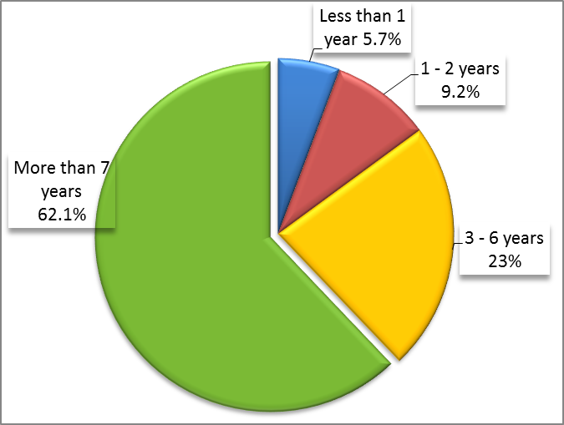

  - Assessment of IPPC Secretariat core functions
- The large majority of respondents considered almost all the IPPC core functions as defined in the IPPC Strategic Framework, to be very important as shown in Box 2 below. When adding the “very important” to the “important” ratings, the rate of response goes above 80% for all the functions, exception made for function 4, on dispute settlement.

- The data allow a classification of the importance of all IPPC core functions:
  - the activity that ranked as most important was “setting standards and recommendations and technical guidance including diagnostic protocols and phytosanitary treatments” with 95% of positive responses;
  - the function “providing support for the implementation of the IPPC and its standards” ranked second, with 84% of responses;
  - in the third place, with 83% of responses, was “providing a means for the dissemination of information and knowledge on pests and phytosanitary issues”.
  - in the fourth place, “coordinating the development of the technical support for national phytosanitary capacity” received 77% of positive responses;
  - fifth, was “undertaking resource mobilization and advocacy activities to promote the activities of the IPPC and garner funds for these activities”, with 68% of the responses; and
  - the lowest positive ranking went to “providing dispute settlement facilitation” with 46% of replies; also, this function was considered of very low or low importance by 20% of the respondents.
- There is not much difference among high income and low income countries in the assessment of the importance of IPPC activities. In fact, they are aligned on similar percentages and ranking levels. The only significant difference lies in the fact that low income countries consider the technical support for national phytosanitary capacity as the second most important IPPC activity (answer 4.3). This means that ‘providing a means for the dissemination of information’ skips to the third place and the implementation of the IPPC and its standards to the fourth place. For the high income countries the implementation of the IPPC and its standards ranks second.

- Importance of IPPC core functions
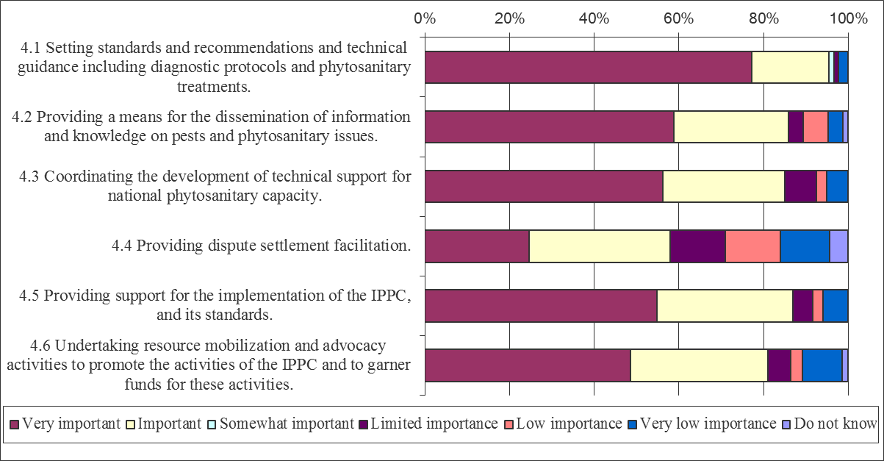

  - Assessment of the work of the IPPC Secretariat
- More than 60% of the respondents answered that they agree or strongly agree on the importance of the work of the Secretariat and on its effectiveness for 19 out of 30 questions, (63%). In particular, the areas of work that were ranked as most important were “IPPC Secretariat’s work in facilitating the drafting of new ISPMs”, with 97% of positive responses, and “collaborating with Regional Plant Protection Organizations”, with 89% of positive responses. The Secretariat was also considered very effective in facilitating the drafting of new ISPMs by the large majority of respondents, 84%.

- Further, “mobilizing new resources to sustain the IPPC activities” was considered highly important by 82% of respondents and developing capacities of NPPOs through regional workshops was considered very important activity by the 80% of respondents.

- In the assessment of the work of the Secretariat high income and low income countries were mainly aligned in their responses and their differences were not very consistent. They reflect the difference underpinned for IPPC core functions regarding a higher interest of low income countries in capacity development activities.

- It is interesting to note that low income countries in particular consider very important IPPC Secretariat’s work in maintaining contacts with WTO-SPS, OIE, Codex Alimentarius and CBD (94% versus 79% of HICs) and disseminating pest reports transmitted by the Contracting Parties (89% against 75%). They also consider more important than high income countries assisting in the use of the Phytosanitary Capacity Evaluation (PCE) (81% against 54%) and developing training materials for NPPOs (81% against 67%). The rate of agreement or strong agreement to the questions on the work of the secretariat (question 5) was generally higher for low income countries than for high income countries.

- Rates of response for other IPPC activities, with no distinction between the income level, were as follows:
- A strong majority, 75% of respondents, agreed or strongly agreed that disseminating phytosanitary requirements, restrictions and prohibitions transmitted by the Contracting Parties was important or very important;
- Assisting in the use of the Phytosanitary Capacity Evaluation (PCE) tool, was rated as positive by 73% of respondents;
- Advocating and communicating the relevance of IPPC to a wider public, was very important for 68% of respondents;
- Developing training materials for NPPOs, and assisting in the updating or drafting of National Plant Protection legislation which is consistent with IPPC and its ISPMs, were considered very important by 66% and 65% of the respondents respectively; and
- Facilitating dispute settlement procedures was considered very important by 59% of the respondents.

- The IPPC Secretariat was assessed to be very effective in providing the on-line system for comments on drafting ISPMs, at 74% of positive responses; in developing capacities through regional workshops, for 66% of respondents; and in promoting the use of the Implementation Review and Support System (IRSS), for 65% of respondents.

- Half of the respondents agreed or strongly agreed that the Secretariat was very effective in providing training opportunities on how to participate in the standard setting process; however, only 44%, considered it very effective in enabling compliance of Contracting Parties with the National Reporting Obligations.

- In relation to the Secretariat’s effectiveness in facilitating the work of the various committees, the large majority considered it to be very effective in facilitating the work of the CPM, 77%, and of the Standard Committee, 74%. Minor agreement was registered on its effectiveness in facilitating the work of the other committees such as the Capacity Development Committee, 59%, and of the Strategic Planning Group, 56%. The National Reporting Obligations Advisory Group (NROAG), 44% and of the Dispute Settlement Body, 36% are still not very well known by all the national contacts.

- With the exception of CPM and SC, more than 30% of respondents answered “Do not know” to the questions related to the effectiveness in facilitating the work of the committees (NROAG, SPG, CDC and DSB). The highest rate of “Do not know” answers regarded the National Reporting Advisory Group, for which almost half of the respondents, 44%, did not know whether documents were made available in a timely manner and 38% did not know how effective the Secretariat was in facilitating its work.

- Last, 14% of respondents expressed their strongest disagreement in relation to the effectiveness of the IPPC Secretariat in facilitating the work of the Dispute Settlement Subsidiary Body. And some dissatisfaction remained in relation to the timely availability of documents to CDC and SPG, question that gathered many “Do not know” answers, as it can be seen in Box 3. However, this may be partly due to the fact that many respondents are not part of these committees.

- Assessment of the work of the IPPC Secretariat
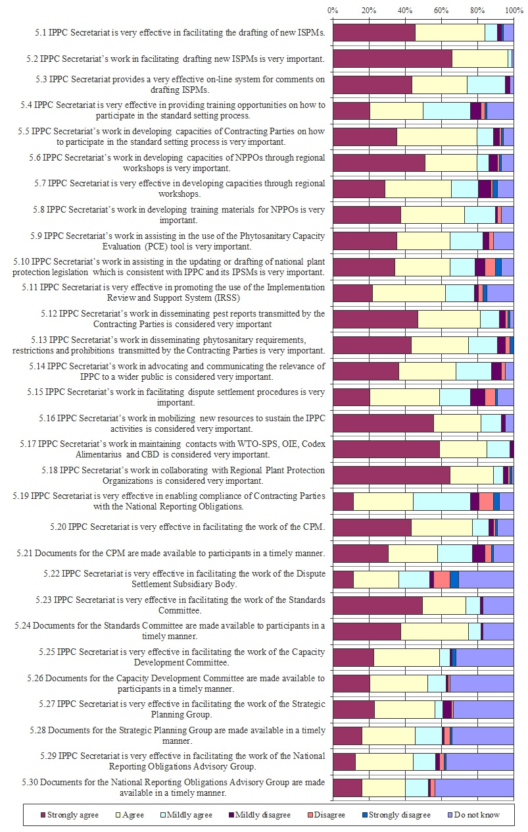
  - Frequency of NPPO’s use of IPPC online resources.
- As shown in box 4, the IPPC official website was the most frequently used Web site among the different IPPC online tools and the FAO official Web site. The IPPC Web site is the main portal from which users are directed to technical pages and where all the information on contact points and the official documents of the governing bodies are made available. A good minority of respondents, 17%, affirmed to use it on a daily basis and 43% of them consulted it every week. The IPPC pest report page is the second most consulted page, every few weeks 35% of respondents access it. The Phytosanitary Resources website was also used every week by a minority, 14%, and once every few months by 30% of the respondents. The IPPC-IRSS help-desk was the least consulted Web site, in fact, while almost one third of the respondents declared to use it regularly every few weeks, another third of them never used it. This may be partly due to the fact that it is available only in English preventing many French speakers, among others, to make a real use of it.

- Moreover, a clear issue in the utilization of the online tools is the limited access to a stable Internet connection of many developing countries in Africa and in South East Asia in particular. This situation undoubtedly affects the frequency of their usage in the first place and it requires easy accessible and technologically simple Web sites in the second place. Some respondents complained that, while there has been a general improvement in the online resources, and in particular in the Online Commenting System, they are still not entirely easily accessible and user friendly to enable a frequent access and use of them. Finally, many are still not aware of the existence of all the different online tools. Therefore, they are not using them. As shown in Box 4, based on the opinion of 80% of the respondents the IPPC Secretariat should improve the communication with the contracting parties through its Web (question 10.10).

- Frequency of the utilization of online resources by NPPOs
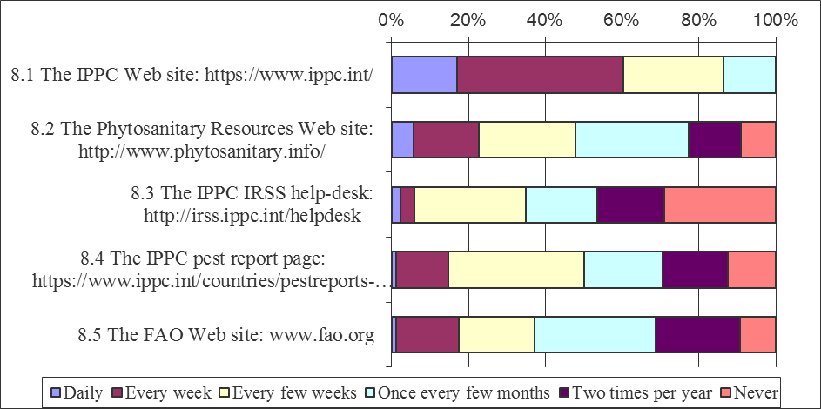

  - Expectations from the work of the IPPC Secretariat
- With regards to the expectations of the future work of the IPPC Secretariat, lightly more than one fourth of respondents, 28%, disagrees or strongly disagrees that the IPPC Secretariat should slow down its work on Standard Setting and shift focus to the implementation of IPPC and its ISPMs. At the same time, 79% of high income countries and 81% of low income countries agree or strongly agree that IPPC Secretariat should continue its work on Standard Setting and add focus on implementation of IPPC and its ISPMs. Respondents also think that IPPC Secretariat should advocate the relevance of IPPC to a wider public, 86%, and that the Secretariat should mobilize additional resources to be able to carry out the activities agreed at the CPM, 85%. Furthermore, the great majority of low income countries, 94%, also agrees or strongly agrees that the Secretariat should strengthen its role in capacity development, only 64% of high income countries share the same opinion.

- Around 80% of the respondents agree or strongly agree that IPPC, among the other activities listed in box 4, should be connected to the important priorities within Food Security Environment and Trade and provide leadership vision on phyto-sanitary issues to the Contracting Parties. Not everyone agreed that relevant industries stakeholders should be involved in IPPC activities, since they might be pushing for their specific interests.

- Expectations of the work of the secretariat
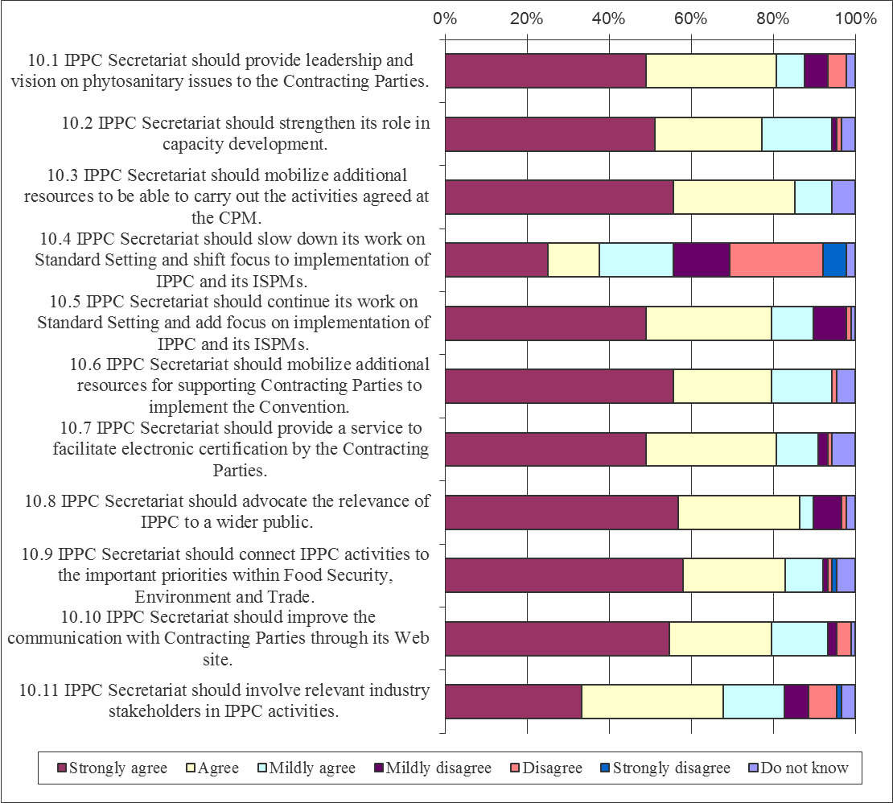

- To conclude, 91% of the respondents thought that the CPM Finance Committee should be mandated to assess the financial implications of the activities proposed by the CPM, as it is clearly shown in Box 6.

- Agreement to have a Finance Committee mandated by CPM
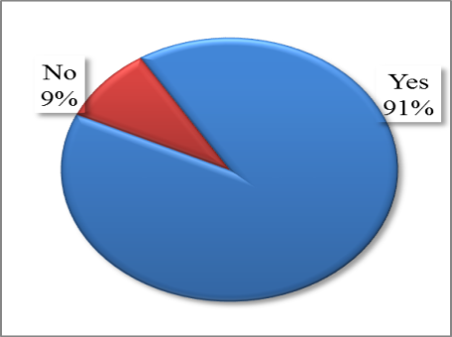

- Report of the Expert Panel of the IPPC Secretariat Enhancement Evaluation

Background
1. As part of the evaluation of the IPPC Secretariat, and following a standard approach of the FAO Office of Evaluation (OED), a small expert panel of four members was established to independently peer-review the Evaluation deliverables, i.e. the Terms of Reference and the draft report. The Panel included experts in the field of plant health, whose names had been suggested by several members of the Bureau.

2. With regard to the draft report, the Panel was specifically asked to comment on:
a. the logical structure, the relevance and the quality of the evidence-based findings and conclusions provided in the final draft evaluation report;
b. the extent to which the recommendations in the report are firmly based on evidence and analysis, are relevant and realistic, with priorities for action made clear;
c. the extent to which the report makes the information accessible and comprehensible; and
d. the transparency, rigour and inclusiveness of the evaluation process.

3. The Panel has constructed its report against the above areas.

Assessment

Overall
4. The Panel’s overall opinion of the Evaluation is that it is very well researched and constructed. The Panel believes that it is very timely and indicates a very comprehensive understanding of the problems and challenges facing the workings and structure of the Secretariat, particularly if it is to maximise the outcomes of the IPPC, via the CPM annual plan, and be a leading force in a rapidly changing trading environment. The report gives a very thorough and detailed situation analysis of the IPPC and the current Secretariat structure, which acts as a strong base for the evaluation.

5. The recommendations are clear and logical and are all supported by the Panel as are the suggestions relating to the governance of the IPPC. Of particular note relating to governance is the suggestion to hold a “main” CPM meeting once every two year. A great deal of resource is required to prepare and run a CPM meeting, including for invitations, papers, translations, budgets, reports, travel, etc., the preparation of which would start in October for the following meeting in March. An intermediate “update” meeting would release the Secretariat resource and enable a full planning cycle of 18 months. It is hoped that this suggestion will be considered in depth by IPPC Contracting Parties.

6. One concern to the Panel is the future of the Subsidiary Body on Dispute Settlement (SBDS). Although little use has been made of this body, the Panel considers it still has the potential to play a vital role in dispute settlement, particularly when considered in conjunction with the dispute settlement mechanism of the WTO. The WTO Committee on Sanitary and Phytosanitary Measures (SPS Committee) meets three times a year and one of the standing agenda items is “Specific Trade Concerns”. If a concern cannot be resolved via the SPS Committee (including the use of the good offices of the chair), Members have the option of using the WTO Dispute Settlement System. This can be very expensive and the Panel believes the IPPC SBDS could be a very useful and cheaper option, albeit a technical evaluation only, for those WTO Members that are contracting parties to the IPPC to consider before committing to the WTO system. It is recognised that support for the SBDS would need to be reviewed.

The logical structure, the relevance and the quality of the evidence-based findings and conclusions provided in the final draft evaluation report

7. The report is very thorough, with a clear statement of its purpose and objectives and follows a logical sequence. It is very well balanced and gives a strong background and frame of reference by firstly describing the IPPC and its governance systems. Against this, it discusses the structure, suitability and future challenges to the Secretariat. Based on its findings, the Evaluation Team recommends changes that will enable the Secretariat the flexibility to adapt to changing environments and needs, and fulfil the expectations of the CPM (and FAO) in an efficient and effective manner.

8. As well as the stated objectives of the evaluation, the Terms of Reference (Annex 1 of the Evaluation report) listed a number of in-depth issues for the Evaluation Team to assess. These very broadly covered such areas as; structure and workings of the Secretariat, resources (financial and human), relationships (internal FAO and external) actual and perceived strengths and weaknesses in the functioning of the Secretariat and the potential for the Secretariat to support ISPM implementation at national level in Member countries (as appropriate/required).

9. The Panel considers the evidence-based findings to be very relevant and fully contributing to the first objective of the evaluation as defined by the CPM, namely “Identify existing strengths in the Secretariat’s structure and operations as well as current constraints to performance and delivery of services.”. The findings discuss strengths and constraints to the Secretariat’s performance covering inter alia its servicing role (IPPC Governing/Statutory Bodies), organisational setup, relationship with the rest of the FAO, including the regional plant protection officers, financial resources, structure, management and relationships with external stakeholders (e.g. RPPOs, WTO SPS, other SPS recognised standard setting bodies (Codex and OIE) and the CBD). The report also discusses constraints to the modus operandi of the Secretariat associated with being an FAO Article XIV Body (e.g. travel ceiling, geographical recruitment, and fees). It is pleasing to note though that the Evaluation Team took a balanced approach when considering the IPPC’s FAO Article XIV role and also considered the benefits of being part of the FAO, which outweighed the disadvantages.

10. The quality of the evidence-based findings is related to the methodology used by the Evaluation Team, which incorporated an ongoing, highly consultative approach with the IPPC Bureau, FAO Senior Management and the IPPC Secretariat. By doing so, the report could continually be monitored for accuracy and addressing the CPM objectives. A number of tools to collect data were used including reviewing the Secretariat organisational set-up, group and individual interviews, a comprehensive questionnaire (IPPC contracting parties) and direct observation at a selection of governance meetings.

11. The Evaluation Team drew a series of conclusions based on the report’s evidence-based findings, from which it formulated its recommendations. This was in accordance with the Second main objective of the Evaluation as identified by the CPM, namely “Formulate recommendations for enhancing the Secretariat’s capacity to facilitate, coordinate, support, and advance the CPM’s strategic goals and annual work programme, taking particular account of the focus on implementation, communication and partnerships.”

12. The conclusions drawn by the Evaluation Team are logical outcomes from the data collected and do not “pull any punches”. This will be appreciated by the contracting parties as in order to enhance the workings and effectiveness of the Secretariat, the Review must first identify those areas where change is needed, ascertain what should be done and recommend accordingly, regardless of any discomfort that may be caused.

The extent to which the recommendations in the report are firmly based on evidence and analysis, are relevant and realistic, with priorities for action made clear
11. The recommendations stem from the conclusions made by the Evaluation Team, which in turn are the outcomes of information collected and assessed. The Panel believes that they are all relevant and realistic and that the CPM should develop and implement a programme that will see them realised. The report contains proposals as to how some of the more complex recommendations could be carried out. Obviously all the recommendations will not be able to be implemented over night, e.g. the Secretariat re-structuring, albeit there are some that could be implemented almost immediately, e.g. Recommendations 4, 5, 8 and 9. The CPM has the opportunity to restructure the Secretariat into a modern, flexible, effective and professional body. It is hoped this evaluation does not get “shelved”.

The extent to which the report makes the information accessible and comprehensible

13. The report, which includes the Annexes, is very detailed and contains a great deal of information. It is suggested that the Annexes be studied before considering the main body of the report. Annex 1 (Terms of Reference) discusses in detail the purpose and scope of the evaluation, issues, methodology used, etc. Annex 4 analyses the survey questionnaire sent to the contracting parties and assesses the importance of the IPPC core functions and the work of the Secretariat as well as the expectations of its work. Annex 5 gives further background information on the IPPC.

14. The main body of the report analyses the information gathered by the Evaluation Team. Each sub-heading in the Table of Contents can stand alone and be individually studied and considered. The information contained is clear and concise and any points made, appear well considered. Collectively the subheadings cover all aspects of the review and form the basis for the conclusions and recommendations.

The transparency, rigour and inclusiveness of the evaluation process

15. The Panel considers that the Evaluation Team has made an intensive effort to canvass the opinions of those parties most familiar with the workings of the IPPC as well as those that would be most affected by the outcome of an evaluation of the Secretariat. As stated in the report, in-depth interviews were held with the IPPC Bureau, FAO Senior Management and the IPPC Secretariat as well as consulting with bodies related to the IPPC (e.g. the Standards Committee) the Secretariats of organisations that may collaborate with the IPPC in standards setting (e.g. Codex, OIE, WTO, CBD) and Regional Plant Protection Organisations. A very comprehensive questionnaire was sent to all IPPC contracting parties aimed at ascertaining from Members their opinions on the existing strengths of the structure and workings of the Secretariat and constraints to effective performance.

Conclusion
16. In conclusion, the Expert Panel considers that the Evaluation report meets the Terms of Reference approved by the Bureau, as well as the spirit and detail of the request approved by the CPM in April 2014. The report provides in-depth and comprehensive information and analysis of the functioning and work of the IPPC Secretariat and of the IPPC governance mechanism. The recommendations and suggestions proposed are well grounded in the evidence made available and have the potential, when implemented, to enhance the efficiency and effectiveness of the IPPC work as a whole.

IPPC Strategic Framework 2012-19, https://www.ippc.int/sites/default/files/documents/20130603/1344410402_ippc_strategicframework_e_w_201305101054en_2013060314%3A48_3.17%20MB.pdf
http://www.fao.org/docrep/meeting/027/mf490e.pdf
ftp://ftp.fao.org/docrep/fao/meeting/012/k0233e02.pdf;
FC 147/20, Review of Article XIV Statutory Bodies with a view to allowing them to exercise greater financial and administrative authority while remaining within the framework of FAO at http://www.fao.org/docrep/meeting/028/mf025e.pdf; FC 148/21 at http://www.fao.org/docrep/meeting/029/mf980e.pdf.
CL 146/3 at http://www.fao.org/docrep/meeting/027/MG229E.pdf.
CPM-9 report, section 10.2.1
See Annex 1 and Volume II of FAO Basic Texts, Chapter ), Principles and Procedures which should govern conventions and agreements concluded under articles xiv and xv of the constitution, and commissions and committees established under article vi of the constitution: https://www.google.com/url?q=http://www.fao.org/docrep/meeting/022/k8024e.pdf&sa=U&ei=DxSQU_qYE5D-yAPqyoDQBg&ved=0CAUQFjAA&client=internal-uds-cse&usg=AFQjCNGXmtO-YZzpsYblGAhX64ZzmtNS6A
The internationally accepted evaluation criteria were proposed by the OECD/DAC and adopted by the United Nations Evaluation Group (UNEG, http://www.uneval.org) of which OED is a member. They are: relevance, efficiency, effectiveness, sustainability and impact. OED introduced gender equality in 2010 as a standard criterion.
This point will be mostly assessed through a questionnaire for Secretaries of Article XIV Bodies in FAO that was developed and will be analysed in the framework of the Independent Review of the Immediate Plan of Action-related governance reforms. This will contribute to reduce time devoted by the IPPC Secretariat Evaluation team to this issue.

