Guide to Information Exchange & the International Phytosanitary Portal

International Plant Protection Convention
Secretariat
Rome, Italy

JUNE 2008

NB Before making any changes to the IPP, it is necessary to get approval from IPPC Official Contact Point

INTRODUCTION 5
The International Plant Protection Convention 5
Information exchange & the International Phytosanitary Portal 5
I. GUIDE TO THE INTERNATIONAL PHYTOSANITARY PORTAL (IPP) 6
Navigating in the IPP 7
Layout 7
Information tabs 11
Function tabs 16
Search 16
Sitemap 20
Help 21
User account management 22
Member login 23
Password reminder 24
User preferences 25
Accessing and updating contact information 26
Correspondence format 28
Tips on filling in forms on the IPP 29
II. GUIDE TO USING THE IPP FOR INFORMATION EXCHANGE 30
National reporting obligations 31
IPP Official Contact Point 31
Official Pest Reports 32
All other reporting obligations 33
Description of the National Plant Protection Organization 34
Phytosanitary restrictions, requirements and prohibitions 34
Points of entry 34
List of regulated pests 34
Emergency actions 34
Optional national reporting 35
Non-compliance 36
Organizational arrangements of plant protection 36
Pest status 36
Rationale for phytosanitary requirements 36
Other forms of national information exchange 36
Other information exchange tools 37
To stay informed… 37
To inform others… 38

INTRODUCTION

The International Plant Protection Convention
The purpose of the International Plant Protection Convention (IPPC) is “international cooperation in controlling pests of plants and plant products and in preventing their international spread, and especially their introduction into endangered areas” (Preamble). It includes numerous provisions designed to help countries establish and implement effective phytosanitary systems that are also consistent with international obligations. The Convention is governed by the Commission on Phytosanitary Measures (CPM), and the IPPC Secretariat is responsible for the coordination of the work programme of the Convention, particularly the areas of information exchange, standard setting, and technical assistance. The IPPC Secretariat is provided by the FAO.

Information exchange & the International Phytosanitary Portal
Exchange of technical and official information is extremely important to the effective implementation of the Convention. The International Plant Protection Convention (1997) outlines that it is the responsibility of contracting parties to engage in the exchange of official phytosanitary information. The CPM has established the International Phytosanitary Portal (IPP) (https://www.ippc.int) as the primary forum for information exchange by Contracting Parties and the IPPC Secretariat. The IPP is an internet-based information system designed to hold phytosanitary information published in accordance with the Convention and Commission on Phytosanitary Measures decisions. The majority of the information in the IPP is available to all users of the site. However, only officially nominated individuals with password-protected user accounts have the ability to enter and edit information, ensuring its accuracy and validity.
The first section of this manual contains general information on the site’s layout, organization of information, and navigation tools. It also describes the steps necessary to complete common tasks such as logging in, setting up personal preferences, and updating your contact information.
The second part of the manual lists the contracting parties’ information exchange obligations as well as optional reporting areas under the Convention. Likewise, it provides step-by-step explanations on how to use the IPP to meet national reporting obligations.

I. GUIDE TO THE INTERNATIONAL PHYTOSANITARY PORTAL (IPP)

While the primary obligation for the exchange of official information belongs to the contracting parties, the IPPC Secretariat promotes and facilitates national phytosanitary information exchange by providing the IPP (www.ippc.int). The IPP is a single forum which contracting parties can use to comply with their reporting obligations.

The IPP enhances the accessibility of phytosanitary information by providing:
- rapid communication and dissemination of information between IPPC contracting parties, the IPPC Secretariat and the phytosanitary community at large
- phytosanitary information in electronic format
- a global repository of phytosanitary information
- increased transparency among the phytosanitary community
- the ability to display and retrieve information in the FAO languages
- a searchable database
- various means by which to receive notifications of changes or updates to information on the IPP
- a system for the online submission of comments on draft ISPMs

Navigating in the IPP
Over 160 different countries, regional, and international organizations are able to add phytosanitary information to the IPP. Likewise, the IPPC Secretariat posts announcements, meeting documents and reports on the IPP. Other regional and international organizations also publish some information on the IPP.
Given the amount of information available and the rate at which new information is being added, navigating in the IPP can be a challenge. Understanding the site’s layout, information organization, and search tools facilitates site navigation.

Layout
Certain elements of the page layout are consistent throughout the site: the header bar, side bar, topic / sub-topic navigation bar. Each of these layout elements is described below.
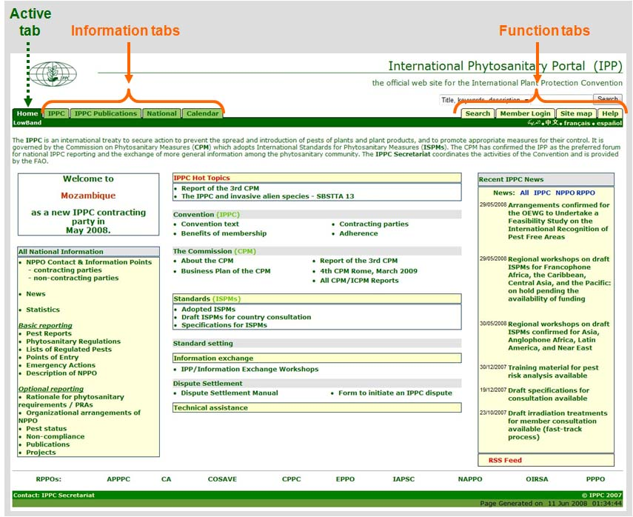
HEADER
A header bar with navigation links is located near the top of each page (below the IPPC logo). The tabs on the header bar allow users to navigate easily to different parts of the site.

The active tab indicates the current position and is always dark green.

Home The first tab on the far left-hand side of the header is a link to the IPP homepage.

Information tabs The tabs on the left-hand side of the header are information tabs. The information tabs correspond to the following general categories:
IPPC
IPPC Publications
National
Calendar
Work Area (only visible when logged in)

Function tabs: The tabs on the right-hand side of the header are function tabs.
Search
Member login
Explorer (only visible when logged in)
Sitemap
Help

: This links to a low bandwidth version of the portal to facilitate access for users in areas with slow internet connections.

: These links allow you to select the language version of the site. Currently, Arabic, English, Spanish, and French are available. Chinese and Russian will be available soon.

Layout (cont.)
SIDEBAR
Each of the information tabs is like a file folder containing information that is further divided into topics. Clicking on an information tab opens the sidebar (located on the left-hand side of the page), which lists its associated topics.
To further divide and group information, sub-topics are often nested within the topics. The sidebar lets you navigate between the topics and sub-topics.
On the sidebar, the different levels in the hierarchy can be distinguished by the indentation and the shading of the text and the indicator arrows. The active topic or sub-topic is always underlined.

Topics
Clicking on a subtopic or topic on the sidebar opens the page for that item. Descriptive text generally accompanies each topic or sub-topic.

Clicking on See more opens an external webpage outside of the IPP.
Clicking Expand text opens the window to reveal additional text.

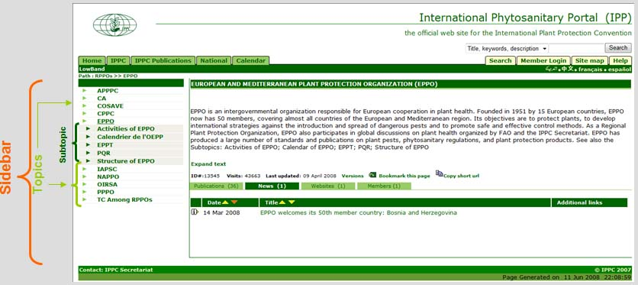

Layout (cont.)
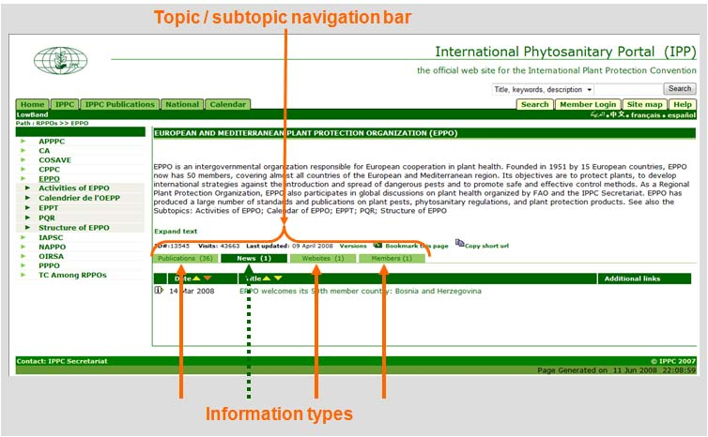
Topic / subtopic navigation bar
On the page for each topic or sub-topic there is another navigation bar with tabs for information types, which further group like information.

As with the Header, the active tab on the Topic / subtopic navigation bar is dark green. Each of the tabs is clickable, revealing documents or other information.

Information types
The specific information associated with a topic or sub-topic is grouped into information types. Information types include national reporting obligations, optional reporting obligations, publications, contacts, news, calendar items, and links to websites.

Layout (cont.)
Page statistics
At the bottom of each window for each topic, subtopic or type of information, you can view the topic ID, the number of visits to the page, the date it was created, and the last time it was updated. There are also links that allow you to view the historical versions of the page, bookmark the page, and copy the page’s short URL.

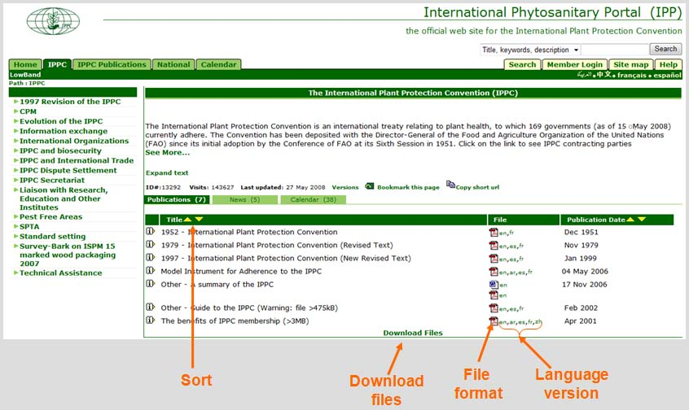
Files
The various information types usually contain files in the form of Word, PDF, PowerPoint, image or links to websites. The file format is indicated by an icon located to the right of the title of the page.
The two letter abbreviations (to the right of the file format icons) refer to the language of the file (ar = Arabic, en = English, es = Spanish, fr = French, etc.) Clicking on the desired language opens the file in a new window.
Click on the yellow arrows to sort the files by document number, agenda item number, title, date of publication, etc.
Clicking on the
icon to the left of the file’s title will open a page with more information about the file (such as when it was added and a short description of the content).

Information tabs
The information tabs represent the top level of the hierarchy of information (and are often referred to as topics). Each of the information tabs is like a file folder and contains information divided into topics and sub-topics.

IPPC
This tab opens the area for information on the IPPC and the activities carried out under the Convention.

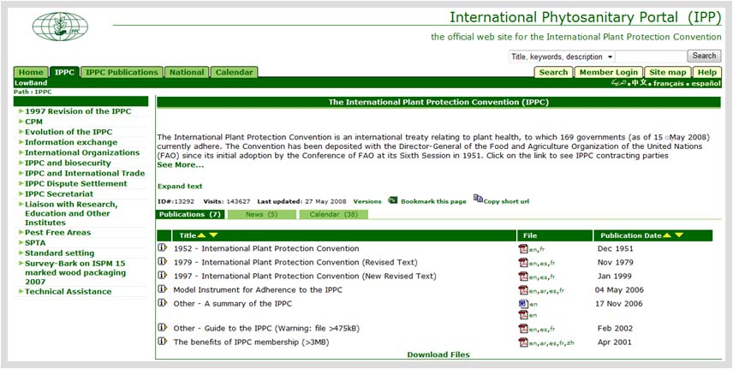
Information tabs (cont.)

IPPC Publications
This tab is the principal area for documents published by the IPPC Secretariat.

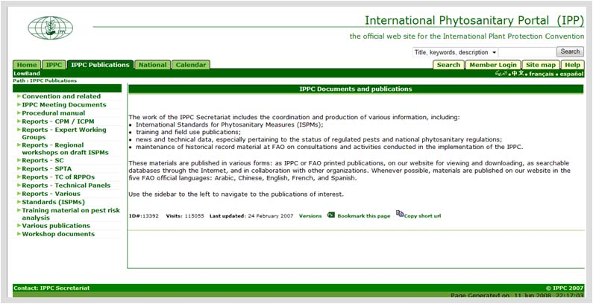

Information tabs (cont.)

National
This tab opens the area of the IPP for party and non-party information exchange. Information relating to national reporting obligations and other national phytosanitary matters, as entered by the IPPC Contact Points or officially nominated IPP editors.
There are multiple ways to access the IPP pages for individual countries:
From the homepage
it is possible to click on the link labelled NPPO Contact and Information Points (or the links below to Contracting parties and Non-contracting parties)
the tab in the header labelled National; from there it is possible to navigate to the countries either using the sidebar or the clickable map
the site map
the simple or advanced search engines
Using the country’s information ID:
https://www.ippc.int/id/nppo + two letter ISO code
Argentina =https://www.ippc.int/id/nppoar
México = https://www.ippc.int/id/nppomx
Uganda = https://www.ippc.int/id/nppoug

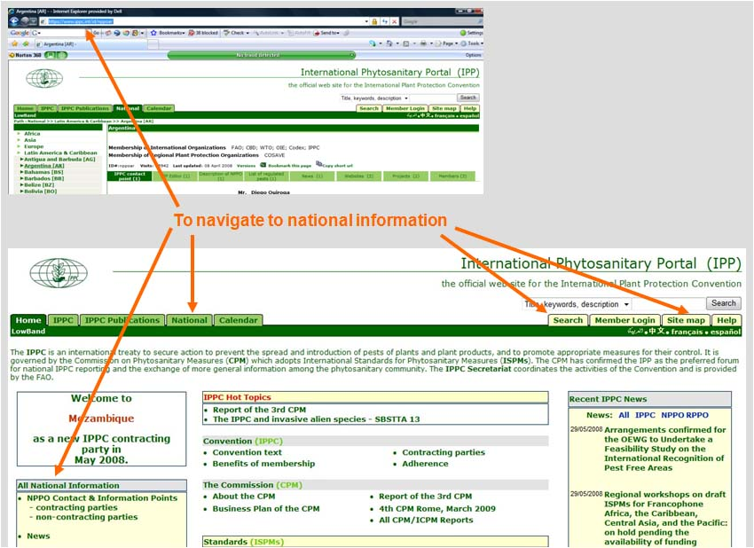
Information tabs (cont.)
National (cont.)
From the top level of the National tab, it is possible to navigate to the countries either using the sidebar or the clickable map. On the Sidebar, countries are grouped by FAO region.

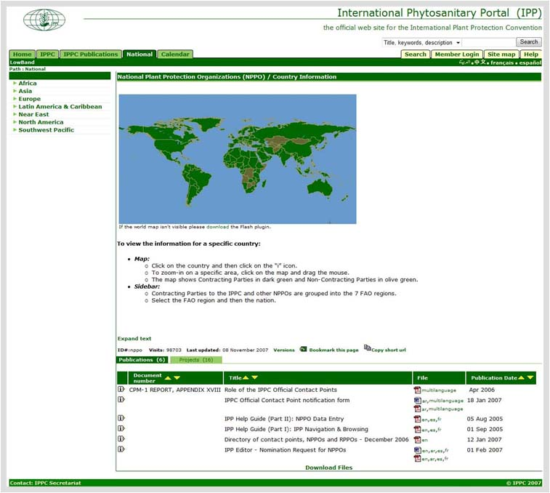
Information tabs (cont.)
Calendar
This tab lists information on events and meetings hosted by the IPPC, NPPOs, RPPOs and other relevant organizations. By default, the calendar displays the IPPC events for the current year.
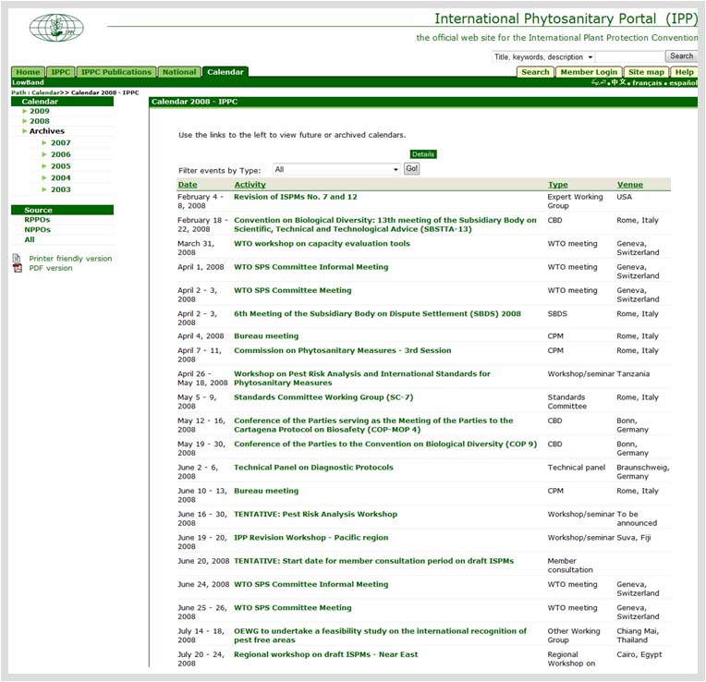
The calendar sidebar can be used to navigate to the event archives as well as upcoming meetings sponsored by NPPOs or RPPOs.

From the sidebar, it is also possible to access printer friendly and PDF versions of the calendar.
Click on Details to see additional information on an event.

Click on the title of the event to go to the page for that event.

Function tabs
The tabs on the right of the header are function tabs. They enable you to search, log in, set personal preferences, view the site map and access help information.

Search
Searching is an easy and fast way to find information on the IPP. A simple search and an advanced search tool are available on the IPP.

Simple search
The simple search allows you to quickly find records containing your queried search term or phrase, either in the text or in the record information.

Searching…
The simple search is located on the upper right-hand side of the page, just above the Header.
Type a descriptive word(s) or phrase in the search box.
Select the type of search you would like to perform using the drop-down-box:
Title and description: This will search the record information (the title, keyword and description) for the word(s) you entered into the search box.
Full text: The Full Text search mechanism looks through the full text document (pdf, htm, doc, etc.) for the word(s) you entered in the search box.
If you do not make a selection, the Title and Description is the default search.
Click the Search button.

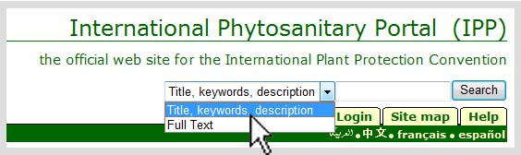

Simple search (cont.)
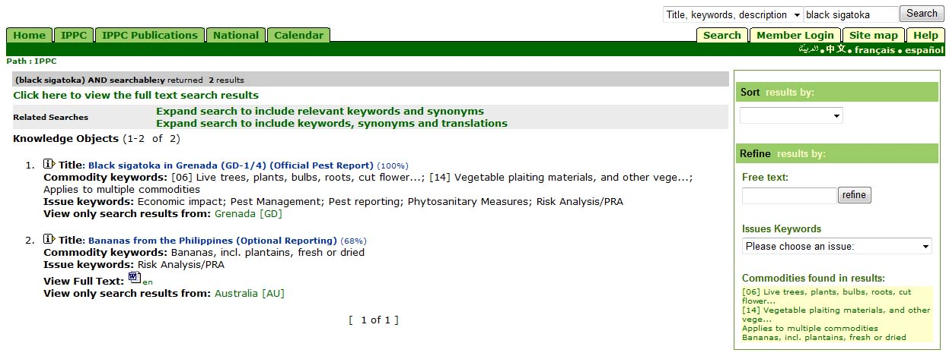
Results
If there are multiple pages of results, click Next » at the bottom of the page to go to the next page.

Too many results?
The box on the right-hand side of the results page can be used to refine your search by selecting keywords or entering terms and clicking "refine". It also allows you to sort the results by date of publication and to quick select topics that match the search terms.

Little or no results?
You can find similar results by using the following features (listed above the search output):
Toggle results: Use the link found at the top of the results page to alternate between the two types of results: (View Full Text Search Results and View Metadata results)
Did you mean: This is the built-in spell check. Limited results are often due to a misspelled word.
Related Searches: When you have performed a search that includes a keyword, synonym or translation, one or both of the following links will appear. Clicking on one of the following links will automatically perform a search to include the new term(s).

Advanced search
The function tab on the header bar labelled Search opens the Advanced Search engine. Advanced Search is designed to fine-tune your search, giving you more specific results.
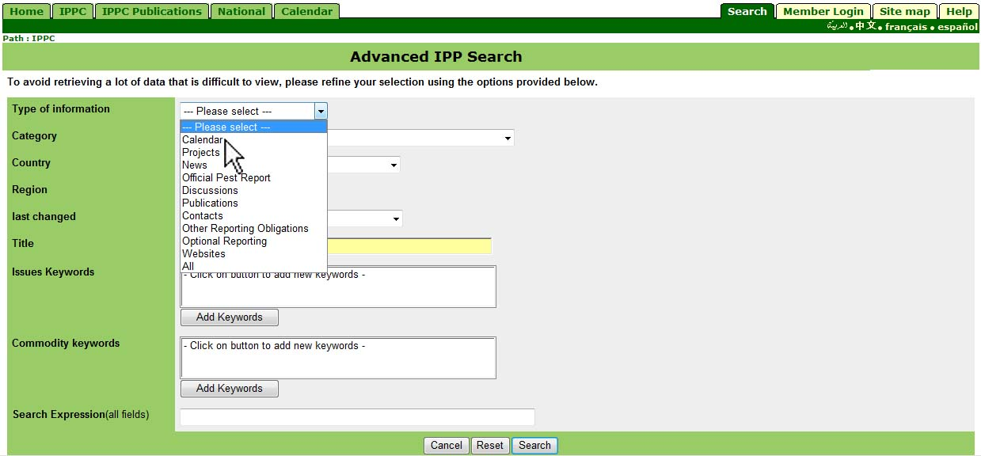
Searching
Clicking on the function tab labelled Search opens the page for the advanced search engine.
Select values for the following fields to limit your search and provide more accurate results:
Type of information: Allows selection of the information type (e.g. publications).
Category: This field allows the selection of specific document categories (e.g. draft ISPMs).
Country: Use this field to specify a country of interest.
Region: Use this field to select a specific FAO region
Last changed: Use this field to find results published within specific dates. This field is useful if you are looking for the most recent information.
Title: Document title
Issues Keywords & Commodity keywords: These two fields can be used to specify the keywords from the defined list used to index all the records in the portal. Commodity keywords are associated with Customs codes for commodities. You may select one or more from each topic; however, selecting numerous keywords will limit the number of results.
Search expression: word or phrases
Click on the Search button to run the search.
Operators for search expressions
The IPP supports some search operators (query words that have special functions when used in search expressions). The following is useful to keep in mind when using search operators in search expressions:

AND | Unless you specify an operator between search terms, the uppercase AND will be used by default. This will function the same as using plus (+) symbol.  risk analysis will find all documents that contain both "risk" and "analysis"  risk AND analysis and +risk +analysis will provide the same results
OR | To search results that include either risk or analysis, use an uppercase OR between terms.  risk OR analysis will find all documents that contain "risk" or "analysis"
NOT | Use uppercase NOT, or precede your search term with a minus (-) symbol to exclude documents that contain that term.  risk NOT analysis will find all documents that contain "risk", but not "analysis"  +risk -analysis will provide the same results
Phrases | Find an exact phrase by surrounding multiple words in quotes.  "pest free area'' will find documents that contain those three words together in that order
Asterisk | The asterisk (*) can be used to find terms that contain 0 or more characters within or after the search term. Please note, the asterisk cannot be used at the beginning of a search term.  the asterisk matches 0 or more characters of any kind, i.e., organ* will find all documents that contain ''organ'', "organisms", "organization", etc.

Sitemap
The sitemap enables you to view the organization and levels of information in the IPP and to navigate directly to topics of interest.
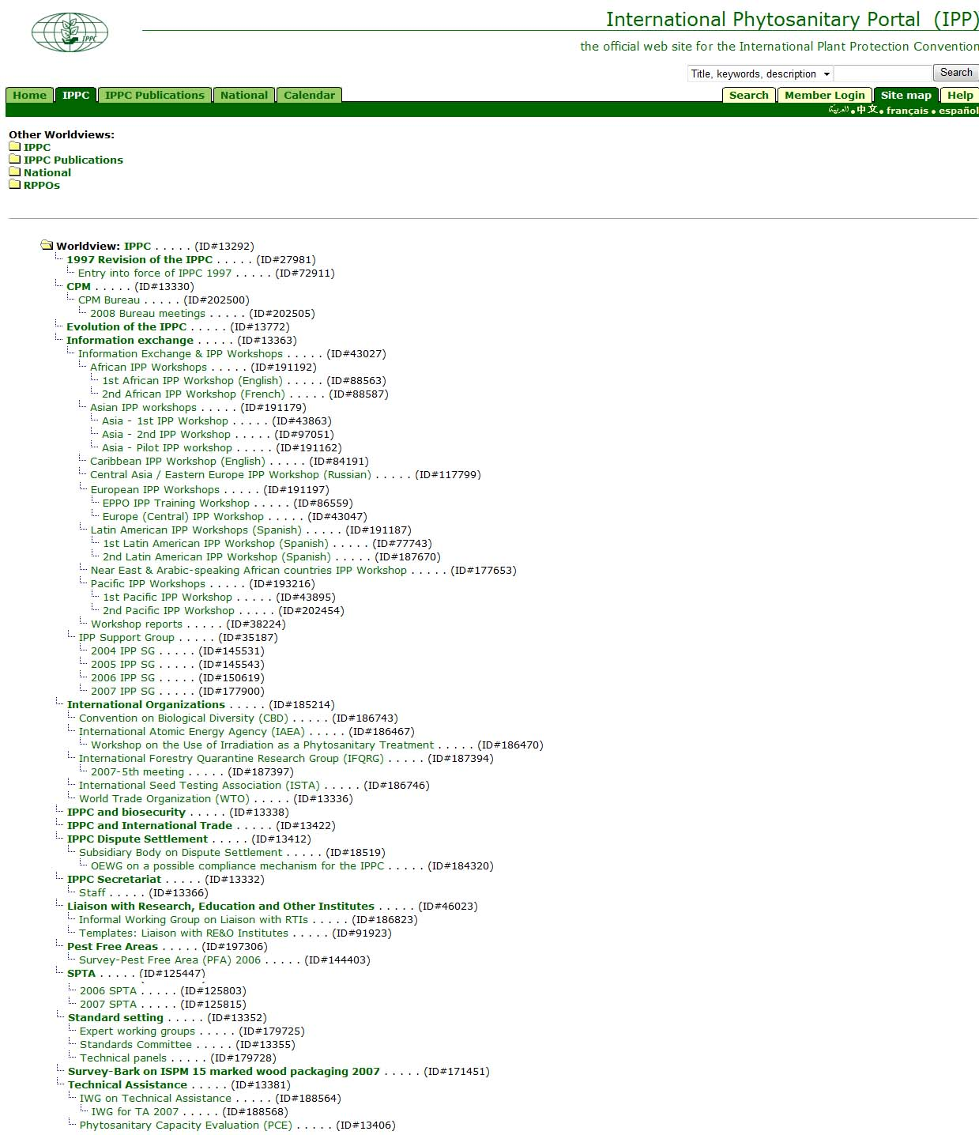
Click on the function tab labelled Site map to open the page with the site map.
Click on the folders to toggle between the IPPC, Publications, and National information tabs as well as the RPPO information.
Click on an item of interest to go to the page for that topic or subtopic.

Help
Guidance for users is available in several places in the IPP.
From the header bar, click on the function tab labelled Help to open the page with the online help manual.
When entering data into a form, clicking on the
icon accesses help information specific to that form.
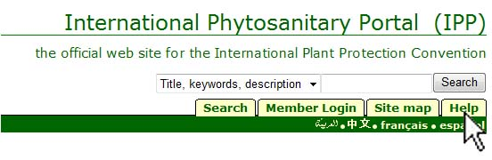

User account management

An “IPP editor” is anyone with password-protected user account that can make changes to specified areas of the IPP. For example, the IPPC Official Contact Point of a contracting party can logon and edit the IPP pages associated with the country that they represent. Likewise, individuals who have been officially nominated by an IPPC Contact Point can also edit the pages associated with their NPPO, including information pertaining to reporting obligations.
User accounts are associated with a particular individual. Consequently, the name, nationality, role (editor, expert, contact point, etc.), date of receipt of nomination, source of nomination information (e.g. official government correspondence), and group memberships can only be changed by the IPPC Secretariat. It is the responsibility of the individuals to maintain all other information (e.g. surface mail address, correspondence languages, email address, telephone, and fax number). In particular, it is critical that the e-mail address that is listed on the IPP is functioning.
This section of the manual describes how to access, personalize, update, and manage IPP user accounts and contact information. It also describes how users may customize certain user settings. For example, a user can select a particular page to go to upon logging on to the IPP.

Member login
Whenever the IPPC Secretariat creates a password-protected user account, an email is automatically sent to the user containing their username and password.

Logging in…
Click the Member Login tab at the right-hand side of header. This opens the login area. It is possible to login from any page where the Member Login tab is visible.
Enter your user name (usually the first name and last name in lowercase letters, e.g. john smith) and password.
At the end of every session, log out of the IPP by clicking Logout (top right hand side of page)

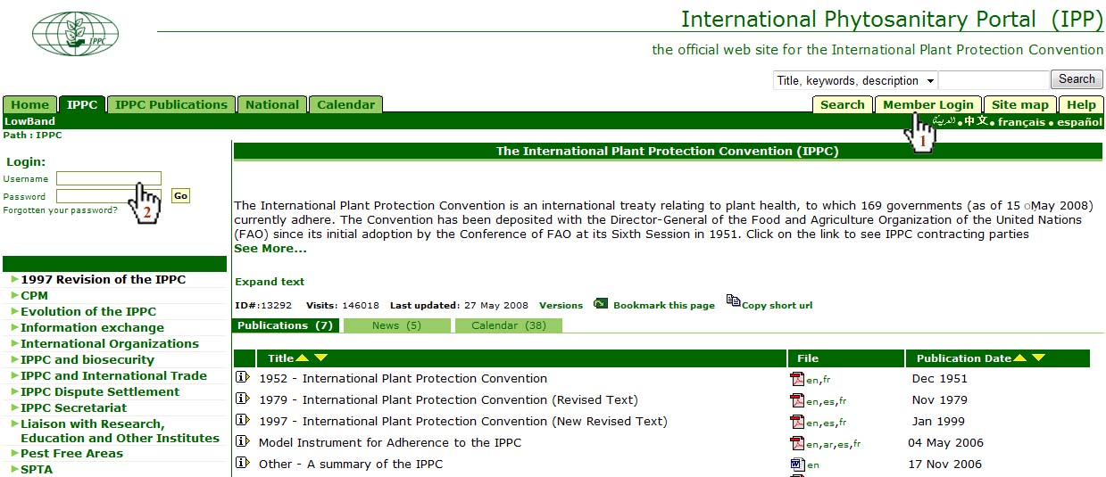

Password reminder
If you forget your password, you can request that a password reminder be sent to you.
Click Member Login
Click Forgotten your password
Enter either your username (first and last name in lowercase letters) or your e-mail address (the email listed as your primary email address on the IPP).
An email with your password in it will be sent to the e-mail address listed as your primary e-mail address.

If you have lost your password and the e-mail address listed for you on the IPP is no longer valid, you will need to request your password from the IPPC Secretariat (ippc@fao.org).

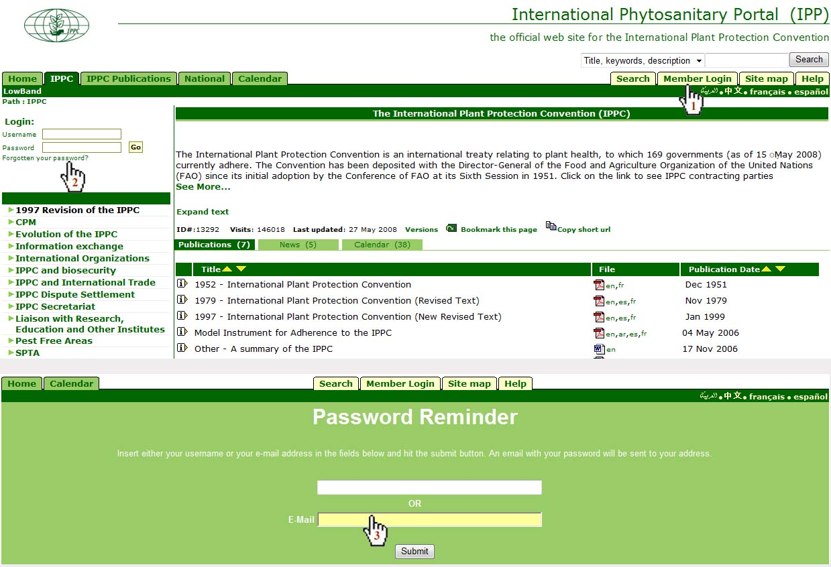

User preferences
Users may customize certain user attributes (e.g. change their password, see what groups they belong to, or select a page to go to automatically upon logging in to the site).
After logging in, select the Explorer tab at top right-hand side of page
Select the Preferences tab
To change passwords:
Enter old password
Enter new password; confirm by entering it again in the next field
Click Change
To open a specific page directly on logging in (e.g. national page):
Under Your favourite location, click on Specified URL Location
Enter the relative path for URL Address into the field for the URL Address.
Example: The URL for the national page for Paraguay is https://www.ippc.int/id/nppopy. The relative path is /id/nppopy
Under Login Settings when trying to login in the system? click Favourite (Go to your favourite location after logging in)
Click Apply Settings

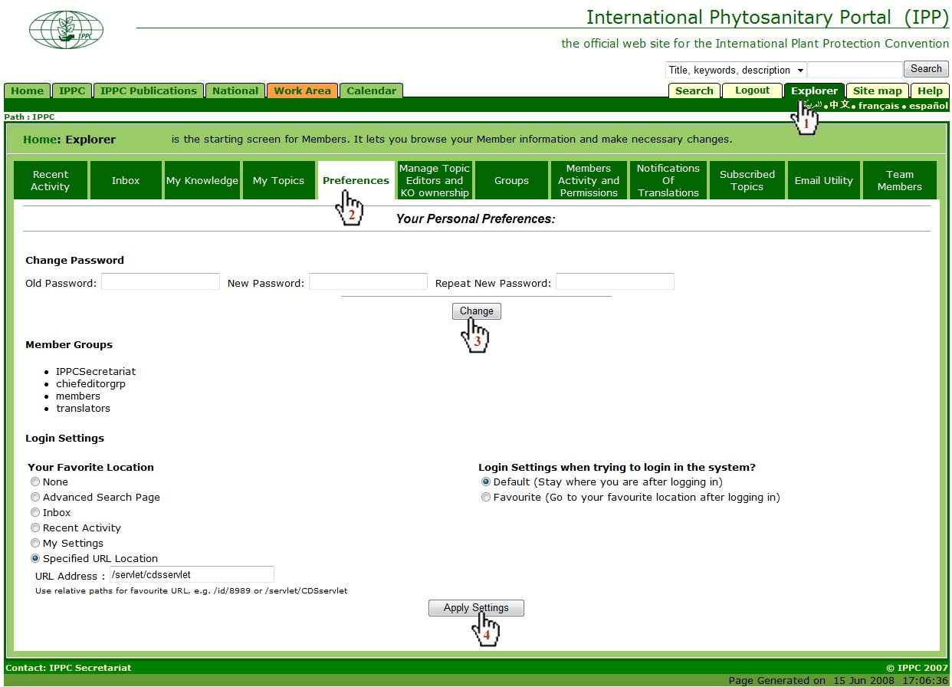

Accessing and updating contact information
When a password protected user account is created by the IPPC Secretariat, the user’s contact information is entered into the IPP. Thereafter, it is the user’s responsibility to ensure that the contact information is up-to-date. Once the account has been created, the user can update their contact information at any time. Since the IPPC Secretariat uses the contact information listed on the IPP for correspondence, it is important that this information be kept up-to-date.
After logging in, go to the page with your contact information. (Find your contact information by typing your name into the search engine or by navigating to your home country’s IPP page
Click edit or update to open the form for updating contact information.
This opens the form for editing your contact information (refer to the next page for instructions on how to complete the form).

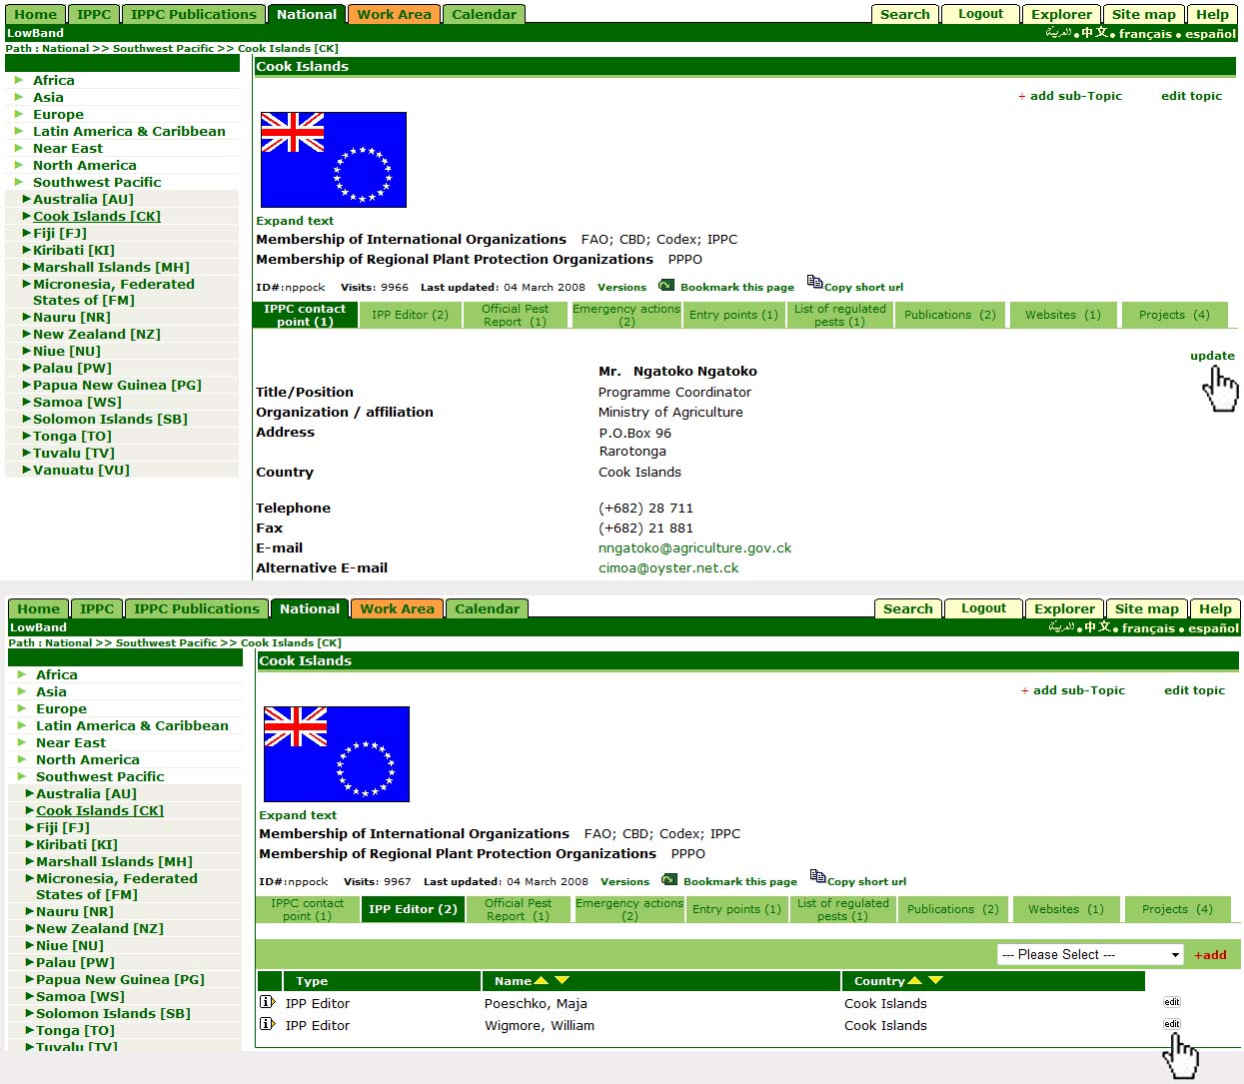

Accessing and updating contact information (cont.)
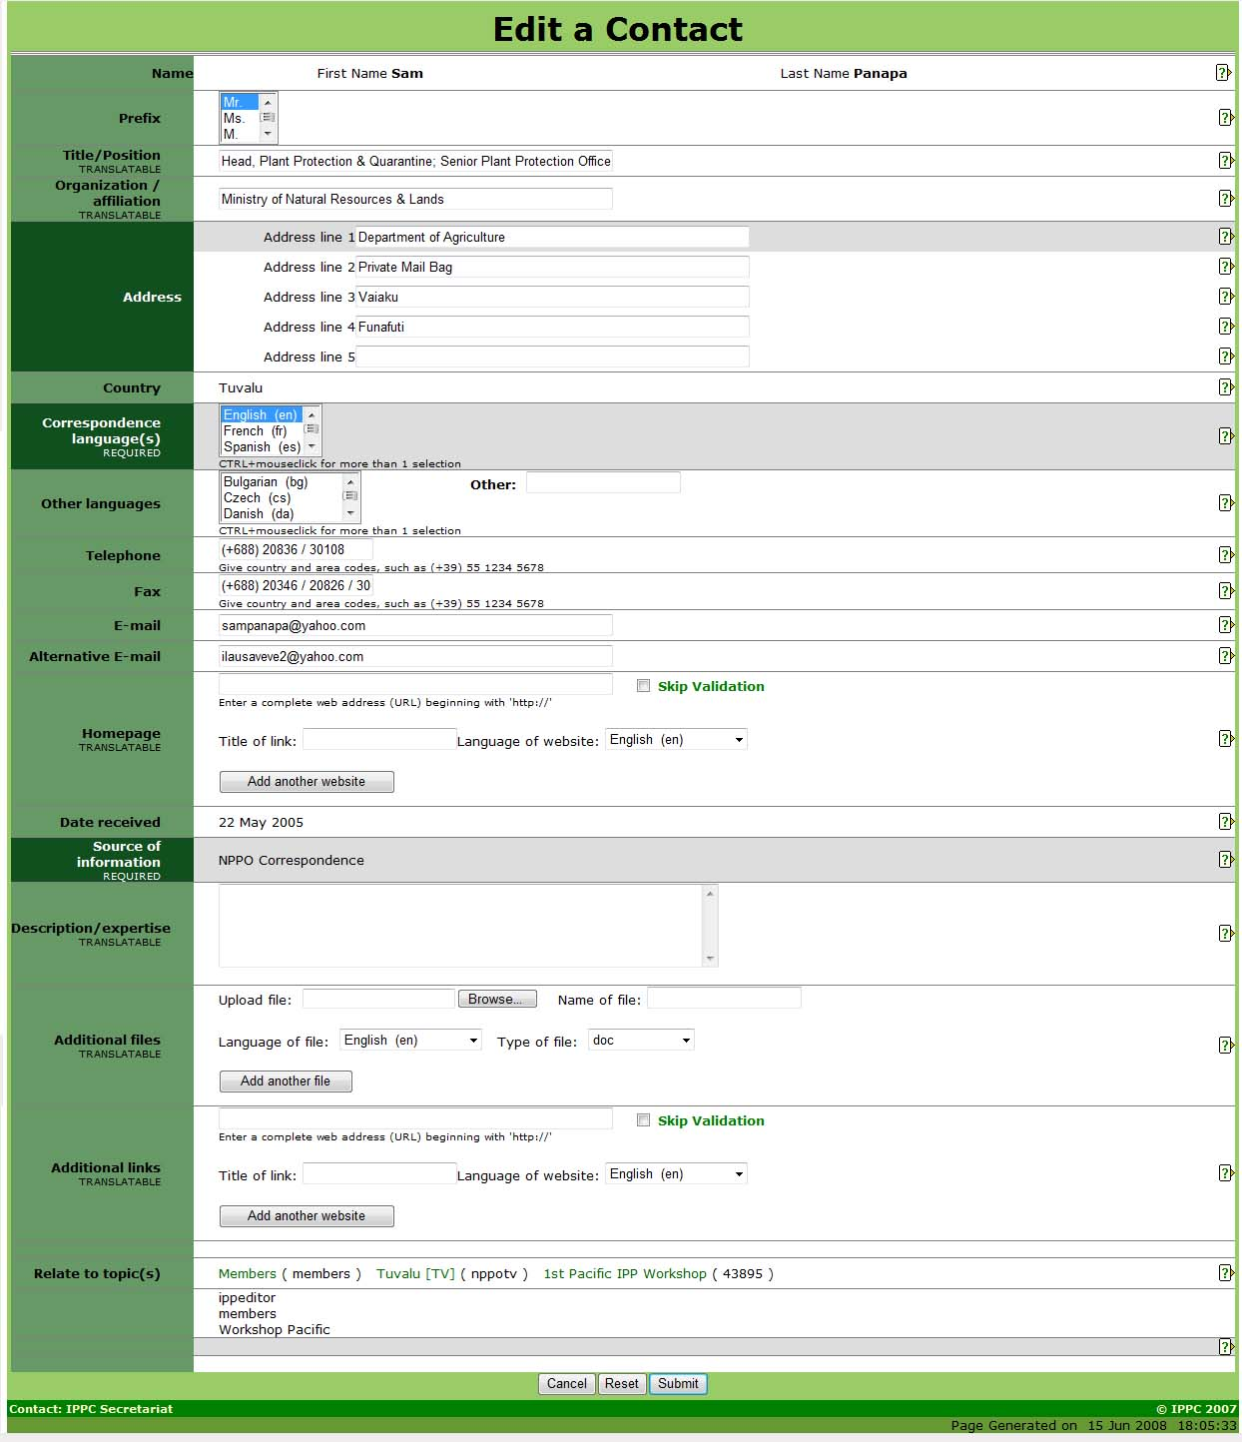

The fields in the form to update contact information are as follows:
Name: This field can only be changed by the IPPC Secretariat.
Prefix: Choose one of the options from the list. It is recommended that this field be completed as it is very useful in identifying how to address the individual in a letter or e-mail (for example, ‘Dear Ms. Smith’).
Title / position: Job title or job position.
Organization / affiliation: Organization or institution with which affiliated.
Address: The full mailing address, with each line of the address entered into a new field. Excess fields not needed for the address can be left blank.
Country: This field can only be changed by the IPPC Secretariat.
Correspondence language(s): Indicates the FAO official language(s) the contact may be addressed in. To select more than one language, press Ctrl on your keyboard and mouse-click on the languages desired.
Other language(s): Language(s), in addition to the FAO languages, in which the contact may be addressed. To select more than one language, press Ctrl on your keyboard and mouse-click on the languages desired. If the applicable language is not in the list, choose Other (specify) and type in the language in the field to the right.
Telephone: Telephone number should be written with a plus sign (+) and the country code in brackets, followed by the area codes, city code (if applicable) and number. For example, a telephone number in Rome, Italy would be: (+39) 06 1234 5678.
Fax: Fax number should be written with a plus sign (+) and the country code in brackets, followed by the area codes, city code (if applicable) and number.
E-mail: E-mail address to which the contact may be written.
Alternative email: Enter an e-mail address that can be used in addition to or as an alternative to the e-mail address given in the field E-mail. Multiple email addresses should be separated by semicolons.
Homepage: Enter a complete web address, beginning with ‘http://’.
Date received: Can only be changed by the IPPC Secretariat.
Source of information: Can only be changed by the IPPC Secretariat.
Description / expertise: Enter short description (250 words max) of expertise.
Additional files: Enter a related file.
Additional links: Enter a related website address.

Correspondence format
Countries can specify the format in which they wish to receive correspondence from the IPP Secretariat.
After logging in, go to the homepage for your country and click edit topic.
Scroll to the field labelled Correspondence format (near the bottom of the form) and click View Form
Select your preferred correspondence format and the click Save and close

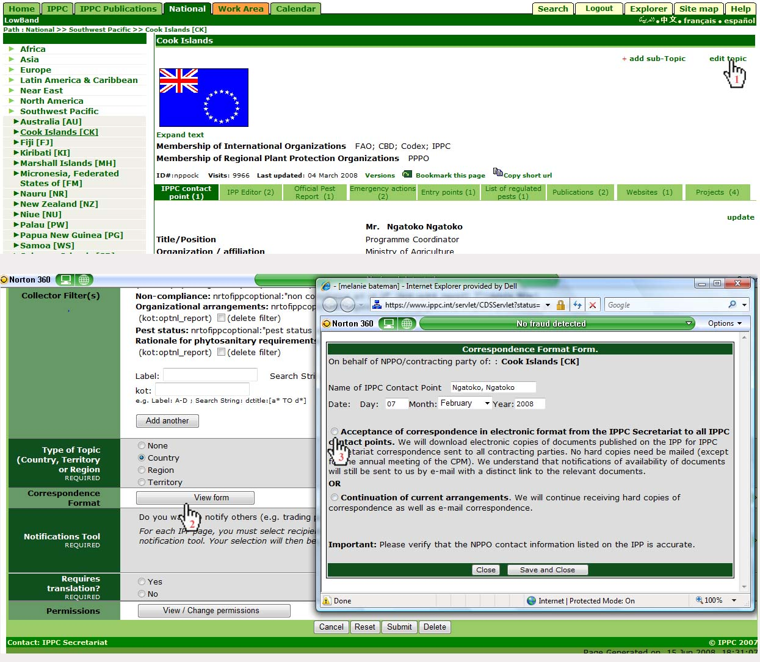

Tips on filling in forms on the IPP
Certain fields and conventions are present in almost all forms on the IPP. These are described below.
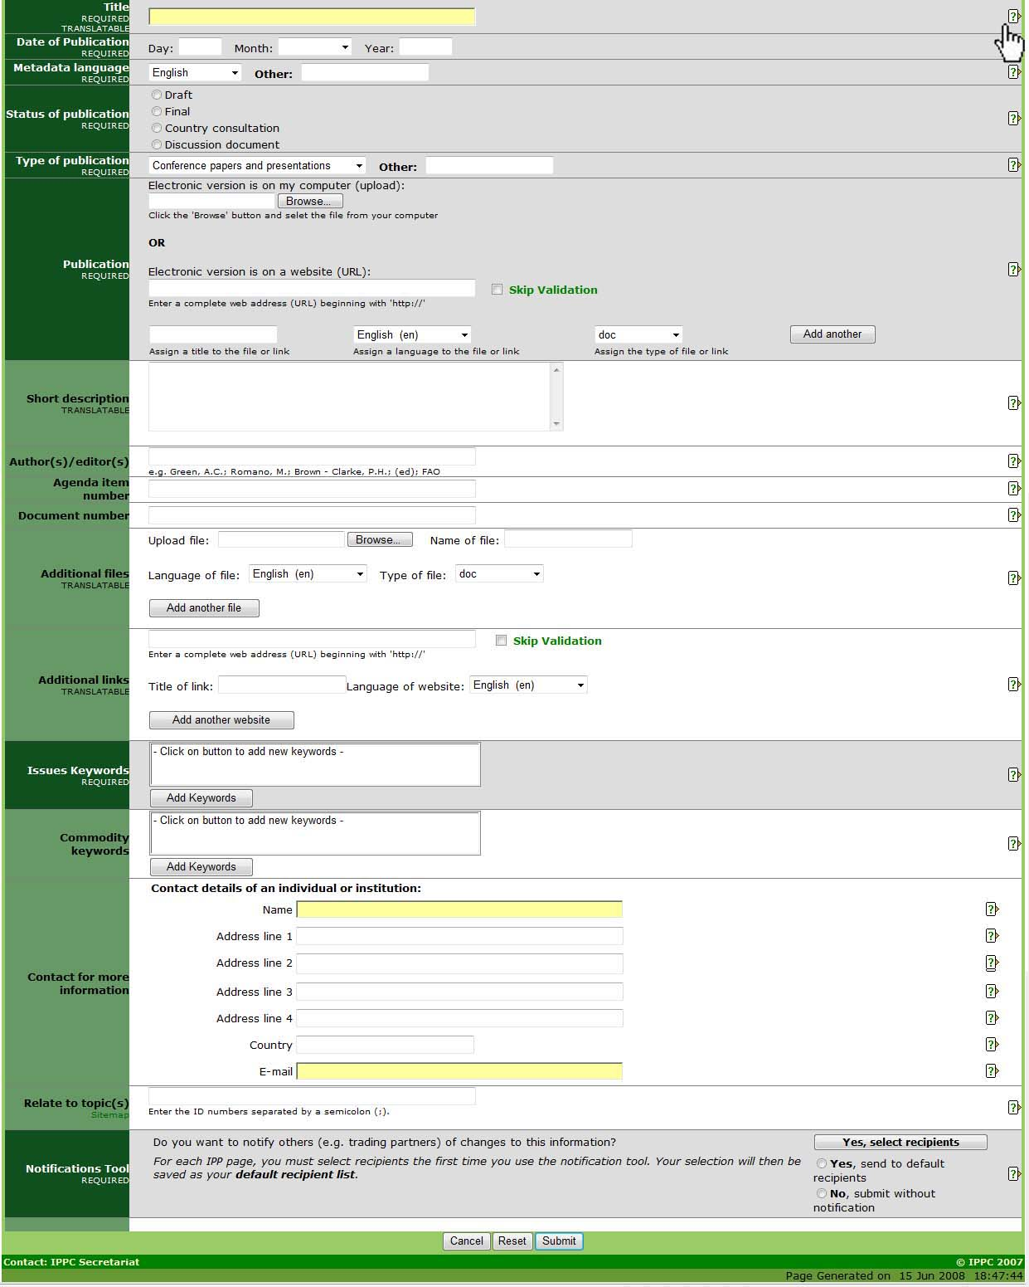
Help text for data entry forms. Click on this icon to view information on how to fill in a field.
Title: Enter a short, descriptive title to indicate what the item is about.
Metadata language: Language in which data is being entered into fields such as Title and Short description. This may or may not be the same as the file or website that may be attached (i.e. data fields may be completed in English but the attached file is in French). It is recommended that the Metadata be completed in one of the five FAO languages (Arabic, Chinese, English, French and Spanish) to ensure that as wide an audience as possible is able to understand what the item is about. If the language being used for the Metadata is not in the drop-down list provided, select Other and enter the language in the field to the right.
Brief description / summary: The information in this field will appear as a mouse-over on the file or website. Enter a brief phrase or description of the file or website using important and descriptive words. It is recommended this field contain no more than approximately 15 words.
Additional files: Enter a file that relates to the information added in the upper portion of this form. Upload the file following these steps:
Click on the Browse button to locate the file to be added on your computer.
Assign a title to the file. This is the title the file will be given when it is being saved by a user. It is not necessary to include the file extension (e.g. pdf, doc etc.).
Choose the language of the file from the drop-down list. The option chosen defines which language link (e.g. en, es, fr etc.) appears next to the icon for the file. If the applicable language is not in the list, choose Other.
Choose the type of file from the drop-down list. The option chosen defines which icon appears to users indicating the type of file. If the applicable type of file is not in the list, choose Other.
To add another file, click on the Add another file button and repeat the above steps.
To edit a file that is already uploaded, check the box next to delete file and re-enter the file with the correct or updated information following the steps above.
Additional links: Enter a website address that relates to the information added in the upper portion of this form. Follow these steps:
Enter a complete website address, beginning with http:// It is recommended that cut and paste be used to reduce typographic errors.
Click the box next to Skip validation if you do not want the IPP to confirm the validity of the website address. It is recommended to leave this box unchecked unless there are problems submitting the form due to the website address. Assign a title to the website link. This title is what will appear to users.
Choose the language of the website from the drop-down list. The option chosen defines which language link (e.g. en, es, fr, etc.) will appear next to the link title. If the applicable language is not in the list, choose Other.
To add another website, click on the Add another website button and repeat the above steps.
To edit a website that is already uploaded, check the box next to delete link and re-enter the website with the correct or updated information following the steps above.
Issues keywords: Keywords are a way of tagging information so users can easily relate it to other relevant information. To add keywords:
Click on the Add keywords button. A new window will open listing the keywords that can be chosen.
Click the check boxes of the keyword(s) that describe the information being added. It is recommended that no more than a total of six keywords be chosen.
To un-check a keyword, click on the check box a second time.
To search for a keyword, enter a word or phrase in the search field located at the top left of the keywords window.
Once all desired keywords are selected, click the Save and close button.
To close the window without saving the keywords selected, click the Close button.
Commodity keywords: Commodity keywords are associated with Customs codes for commodities. To add commodity keywords, follow the instructions for issues keywords.
Contact for more information: Enter the contact details of an individual who can be contacted for additional information on the subject.
Relate to topic: Relating to another topic means that the information will appear in both the topic in which it was entered and the topic to which it has been related. Click on the Sitemap link to find the topic and ID number to relate to. Enter only the ID number of the topic in the text field provided, separating multiple ID numbers with a semicolon (;).
Notifications tool: The Notifications tool enables you to automatically inform selected recipients when your country’s NPPO page has been updated or modified.
Cancel / Reset / Submit: Cancel will closing the form without saving any of the data. Reset will clear the fields of the form. Submit will post the information in the form on to the IPP. Once posted, the information may be edited but not removed.
Fields with dark green labels must be filled in. If you try to submit without filling in all of the required fields, you will receive an error message.

II. GUIDE TO USING THE IPP FOR INFORMATION EXCHANGE

The IPPC (1997) clearly identifies the phytosanitary information which contracting parties’ reporting obligations:

- IPPC Official Contact Point (Article VIII.2)
- Official Pest Reports (Articles IV.2b & VIII.1a)
- Description of the National Plant Protection Organization (Article IV.4)
- Phytosanitary restrictions, requirements and prohibitions (Article VII.2b)
- Points of entry (Article VII.2d)
- List of regulated pests (Article VII.2i)
- Emergency actions (Article VII.6)

The Convention also lists several optional reporting areas:
- Non compliance (Article VII.2f)
- Organizational arrangements of plant protection (Article IV.4)
- Pest status (Article VII.2j)
- Rational for phytosanitary requirements (Article VII.2c)

The following section provides more information on the reporting categories and how to use the IPP to exchange information related these reporting categories. See also the section entitled Tips on filling in forms on the IPP for information on common fields that appear in most forms on the IPP.

National reporting obligations

IPP Official Contact Point
Under Article VIII.2 of the New Revised Text of the Convention (1997), each contracting party is obliged to provide the IPPC Secretariat with an official contact point for the exchange of information connected with the implementation of the Convention. This facilitates information sharing and transparency amongst contracting parties and the IPPC Secretariat. The network of official contact points is indispensable to achieving effective and rapid exchange of reliable official information in the cooperative spirit of the Convention.
The Official Contact Point can enter national information into the IPP, and they can also nominate IPP Editors to enter national information on their behalf. The IPPC Official Contact Point is the channel by which the IPPC Secretariat should receive all official communications from contracting parties as well nominations for experts, submissions for new topics for ISPMs, and comments on draft ISPMs.
Under Article VIII.2, the contracting party is responsible for designating and informing the Secretariat of the nomination. Notification of the new Contact Point must come through official channels (i.e. the notification must be signed by a relevant person more senior than the IPPC Contact Point). The contracting party, by making the nomination, agrees that the nominee has the necessary authority to fulfil the functions of the contact point as determined within the framework of the IPPC. Individual persons cannot self-appoint themselves as contact points. There can be only one contact point per contracting party.
A model form for the purpose of nominating new contact points is available on the IPP (https://www.ippc.int/id/99595?language=en) and can be submitted to the FAO via surface mail (International Plant Protection Convention Secretariat, AGPP - FAO, Viale delle Terme di Caracalla, 00153 Rome, Italy), fax (+39-06-5705-4819), or e-mail (IPPC@fao.org).

To update contact information follow the procedure outlined in the Contact Information section.

Official Pest Reports
Articles IV.2b: “The responsibilities of an official national plant protection organization shall include the following: the surveillance of growing plants, including both areas under cultivation (interalia fields, plantations, nurseries, gardens, greenhouses and laboratories) and wild flora, and of plants and plant products in storage or in transportation, particularly with the object of reporting the occurrence, outbreak and spread of pests, and of controlling those pests, including the reporting referred to under Article VIII paragraph 1(a)…”
Article VIII.1a: “The contracting parties shall cooperate with one another to the fullest practicable extent in achieving the aims of this Convention, and shall in particular: a) cooperate in the exchange of information on plant pests, particularly the reporting of the occurrence, outbreak or spread of pests that may be of immediate or potential danger, in accordance with such procedures as may be established by the Commission…”
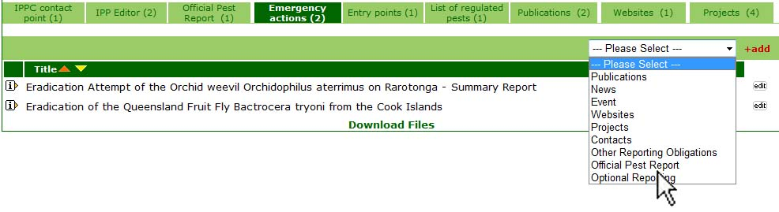
The fields in the forms for submitting official pest reports are as follows:
Report date: The date is automatically generated by the system.
Report number: This number is automatically generated by the system. The first two letters are the ISO country code of the country entering the report and the number following is a sequential number of the pest reports entered by that country. Updated pest reports are given a sub-number (e.g. CA-1/1) to denote that they are updated versions of the original pest report.
Title
Metadata language
Status of the report: When entering a new pest report: According to ISPM No. 8 (Determination of pest status in an area) if all information on the pest situation is not available a preliminary report should be made. In this case, or if further updates to the report are expected, choose Preliminary. If all information is available at the time of first posting, choose Final. When an already existing report is being updated: If further updates are expected, choose Update. If no further updates are expected, choose Final.
Status of the pest: Choose the option that best describes the pest's status. The options in the drop-down list, along with further explanation, are found in ISPM No. 8 (Determination of pest status in an area). If Unknown is chosen from the drop-down list, the pest report will automatically be flagged as Preliminary.
Identity of the pest: Scientific name (where possible, to the species level or below).
Host(s): Enter the name(s) of the affected species or commodity(ies). If the space provided is not sufficient, scroll down the form and use the option Additional files or Additional links. Pest reports with this field left blank will automatically have their status marked as Preliminary so if a file or website with the information in it is being added using the Additional option, type See Additional files or See Additional links (whichever is appropriate) in this space.
Geographical distribution: Enter the geographical distribution of the pest. If the space provided is not sufficient or if a map can be attached, scroll down the form and use the option Additional files or Additional links. Pest reports with this field left blank will automatically have their status marked as Preliminary so if a file or website with the geographical distribution information in it is being added using the Additional option, type See Additional files or See Additional links (whichever is appropriate) in this space.
Reason for reporting: Enter the nature of the immediate or potential danger, or any other reason for the pest report. If the space provided is not sufficient, scroll down the form and use the option Additional files or Additional links. Pest reports with this field left blank will automatically have their status marked as Preliminary so if a file or website with the information in it is being added using the Additional option, type See Additional files or See Additional links (whichever is appropriate) in this space.
Summary
Additional files
Additional links
Issues keywords
Commodity keywords
Contact for more information
Relate to topic
Notifications tool
To submit an official pest report:
Click on any of the information types other than the tab for the IPPC Contact Point.
Select Official Pest Report from the drop down menu.
Click on +add.
This opens the form for uploading and editing official pest reports.

All other reporting obligations
The steps to add information pertaining to all other reporting obligations is the same.
To submit all other reporting obligation:
Click on any of the information types other than the tab for the IPPC Contact Point.
Select Other reporting obligations from the drop down menu.
Click on +add.
This opens the form for uploading and editing information in support of all other reporting obligations.

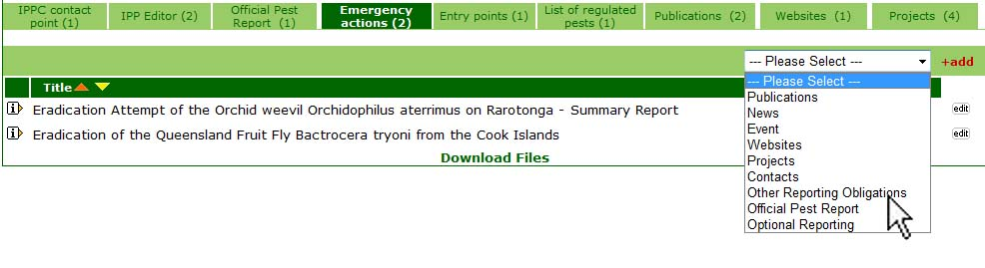
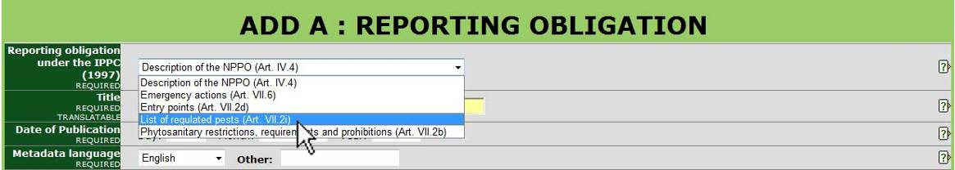
The fields in the forms for submitting other reporting obligations are as follows:
Reporting obligation under the IPPC: Select the reporting obligation from the drop down menu.
Title
Date of publication: Date the information was published (either print or electronically), posted, or entered into the IPP. If the exact date is not known, the Day field can be left blank or entered as the first of the month.
Metadata language
Report: Information can be added as a file or a website, or both.

For a file:
Click on the Browse button to locate the file to be added on your computer.
Assign a title to the file. This is the title the file will be given when it is being saved by a user. It is not necessary to include the file extension (e.g. pdf, doc etc.).
Choose the language of the file from the drop-down list. The option chosen defines which language link (e.g. en, es, fr etc.) appears next to the icon for the file. If the applicable language is not in the list, choose Other.

Choose the type of file from the drop-down list. The option chosen defines which icon appears to users indicating the type of file. If the applicable type of file is not in the list, choose Other.
To add another file or to add a website, click on the Add another button and repeat the above steps.

For a website:
Enter a complete website address, beginning with http:// It is recommended that cut and paste be used to reduce typographic errors.
Click the box next to Skip validation if you do not want the IPP to confirm the validity of the website address. It is recommended to leave this box unchecked unless there are problems submitting the form due to the website address.
Assign a title to the website link. This is the title the link will be given when it is being saved by a user. It is not necessary to include the file extension (e.g. html).
Choose the language of the website from the drop-down list. The option chosen defines which language link (e.g. en, es, fr, etc.) that will appear next to the icon for the website. If the applicable language is not in the list, choose Other.
For the type of link, choose the option html from the drop-down list.

To add another website or to add a file, click on the Add another button and repeat the above steps.
When editing:
If an already uploaded file or website needs to be removed, check the box next to delete file/link.
If an already uploaded file or website needs to be edited, check the box next to delete file/link and re-enter the file or website with the correct or updated information following the steps above.
Summary
Additional files
Additional links
Issues keywords
Commodity keywords
Contact for more information
Relate to topic
Notifications tool
The Other reporting obligations are as follows:

Description of the National Plant Protection Organization
Article IV.4: “Each contracting party shall submit a description of its official national plant protection organization and of changes in such organization to the Secretary. A contracting party shall provide a description of its organizational arrangements for plant protection to another contracting party, upon request.”

Phytosanitary restrictions, requirements and prohibitions
Article VII.2b: “With the aim of preventing the introduction and/or spread of regulated pests into their territories, contracting parties shall have sovereign authority to regulate, in accordance with applicable international agreements, the entry of plants and plant products and other regulated articles and, to this end, may: …refuse entry or detain, or require treatment, destruction or removal from the territory of the contracting party, of plants, plant products and other regulated articles or consignments thereof that do not comply with the phytosanitary measures prescribed or adopted under subparagraph (a)…”

Points of entry
Article VII.2d: “In order to minimize interference with international trade, each contracting party, in exercising its authority under paragraph 1 of this Article, undertakes to act in conformity with the following: … If a contracting party requires consignments of particular plants or plant products to be imported only through specified points of entry, such points shall be so selected as not to unnecessarily impede international trade. The contracting party shall publish a list of such points of entry and communicate it to the Secretary, any regional plant protection organization of which the contracting party is a member, all contracting parties which the contracting party believes to be directly affected, and other contracting parties upon request. Such restrictions on points of entry shall not be made unless the plants, plant products or other regulated articles concerned are required to be accompanied by phytosanitary certificates or to be submitted to inspection or treatment.”

List of regulated pests
Article VII.2i: “Contracting parties shall, to the best of their ability, establish and update lists of regulated pests, using scientific names, and make such lists available to the Secretary, to regional plant protection organizations of which they are members and, on request, to other contracting parties.”

Emergency actions
Article VII.6: “Nothing in this Article shall prevent any contracting party from taking appropriate emergency action on the detection of a pest posing a potential threat to its territories or the report of such a detection. Any such action shall be evaluated as soon as possible to ensure that its continuance is justified. The action taken shall be immediately reported to contracting parties concerned, the Secretary, and any regional plant protection organization of which the contracting party is a member.”

Optional national reporting
This is information that is generally provided upon request.
The fields in the forms for submitting optional reporting are as follows:
Optional reporting type under the IPPC: Select the optional reporting type from the drop down menu.
Title
Date of publication: Date the information was published (either print or electronically), posted, or entered into the IPP. If the exact date is not known, the Day field can be left blank or entered as the first of the month.
Metadata language
Report: Information can be added as a file or a website, or both.

For a file:
Click on the Browse button to locate the file to be added on your computer.
Assign a title to the file. This is the title the file will be given when it is being saved by a user. It is not necessary to include the file extension (e.g. pdf, doc etc.).
Choose the language of the file from the drop-down list. The option chosen defines which language link (e.g. en, es, fr etc.) appears next to the icon for the file. If the applicable language is not in the list, choose Other.

Choose the type of file from the drop-down list. The option chosen defines which icon appears to users indicating the type of file. If the applicable type of file is not in the list, choose Other.
To add another file or to add a website, click on the Add another button and repeat the above steps.

For a website:
Enter a complete website address, beginning with http:// It is recommended that cut and paste be used to reduce typographic errors.
Click the box next to Skip validation if you do not want the IPP to confirm the validity of the website address. It is recommended to leave this box unchecked unless there are problems submitting the form due to the website address.
Assign a title to the website link. This is the title the link will be given when it is being saved by a user. It is not necessary to include the file extension (e.g. html).
Choose the language of the website from the drop-down list. The option chosen defines which language link (e.g. en, es, fr, etc.) that will appear next to the icon for the website. If the applicable language is not in the list, choose Other.
For the type of link, choose the option html from the drop-down list.

To add another website or to add a file, click on the Add another button and repeat the above steps.
When editing:
If an already uploaded file or website needs to be removed, check the box next to delete file/link.
If an already uploaded file or website needs to be edited, check the box next to delete file/link and re-enter the file or website with the correct or updated information following the steps above.
Summary
Additional files
Additional links
Issues keywords
Commodity keywords
Contact for more information
Relate to topic
Notifications tool
To submit all other reporting obligation:
Click on any of the information types other than the tab for the IPPC Contact Point.
Select Optional reporting from the drop down menu.
Click on +add.
This opens the form for uploading and editing information in support of optional reporting.

The other optional reporting types are as follows:

Non-compliance
Article VII.2f: “Importing contracting parties shall, as soon as possible, inform the exporting contracting party concerned or, where appropriate, the re-exporting contracting party concerned, of significant instances of non-compliance with phytosanitary certification. The exporting contracting party or, where appropriate, the reexporting contracting party concerned, should investigate and, on request, report the result of its investigation to the importing contracting party concerned.”

Organizational arrangements of plant protection
Article IV.4: “Each contracting party shall submit a description of its official national plant protection organization and of changes in such organization to the Secretary. A contracting party shall provide a description of its organizational arrangements for plant protection to another contracting party, upon request.”

Pest status
Article VII.2j: “Contracting parties shall, to the best of their ability, conduct surveillance for pests and develop and maintain adequate information on pest status in order to support categorization of pests, and for the development of appropriate phytosanitary measures. This information shall be made available to contracting parties, on request.”

Rationale for phytosanitary requirements
Article VII.2c: “Contracting parties shall, on request, make available to any contracting party the rationale for phytosanitary requirements, restrictions and prohibitions.”

Other forms of national information exchange
Countries can also opt to post other information that does not fall into the categories listed above. These other types of information can be calendar events, news items, projects and publications.

Other information exchange tools

To stay informed…
Information is constantly being added to the IPP. There are several ways to be informed when new information becomes available.
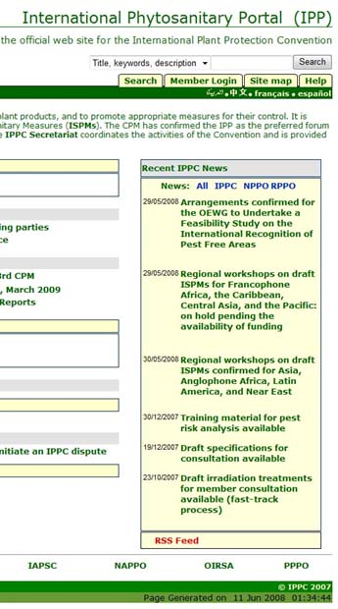
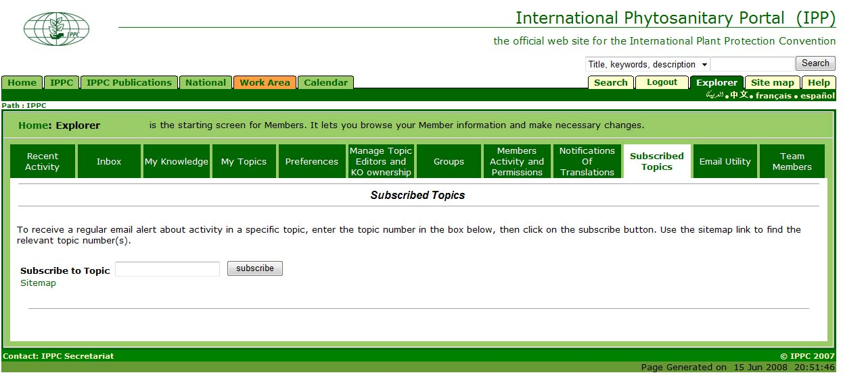
If there is a topic that is of particular interest, you can subscribe to the topic to receive e-mail notifications whenever the topic has been updated.
Login
Click on Explorer
Click on Subscribed topics
Enter the ID for the topic which you wish to subscribe (e.g. Standards Committee reports are posted on the following page https://www.ippc.int/id/13402. To subscribe to that page, enter 13402.
Click Subscribe
Recent IPPC News is listed on the right-hand side of the homepage. Below the news items, you can access a link for subscribing to RSS Feeds.

To inform others…
This tool enables IPPC Contact Points and Editors to directly notify selected recipients whenever they make changes or additions to their NPPO page. Potential recipients of these notifications include the IPPC Official Contact Point for trading partner nations, representatives of RPPOs, and the IPPC Secretariat. Once selected, recipients will automatically receive an email notifying them when a change has been made to the NPPO webpage along with a link to the part of the NPPO page that has been modified. In this way, the selected recipients are made aware of updates to contact information, the addition of pest reports, the publication of phytosanitary regulations, etc, and this is more consistent with the reporting requirements of the IPPC.
To use the Notification tool, please follow these steps:
Login to the IPP.
Go to your NPPO “home page” (e.g. https://www.ippc.int/id/nppoXX).
Add or update information by
selecting a reporting type from the drop-down menu
clicking on + add sub-Topic
clicking on edit topic or update
Go to the “Notifications Tool” (a square button at the very bottom of the form) and make a selection. This is a required field.
If you wish to notify others of the availability of new information, you must select recipients the first time you use the notification tool. Your selection will then be saved as your default recipient list.
Once you have selected your default recipient list, to send out notifications in the future you can select Yes, send to default recipients.
If you do not want to notify others of changes, select No, submit without notification.
•Click submit



