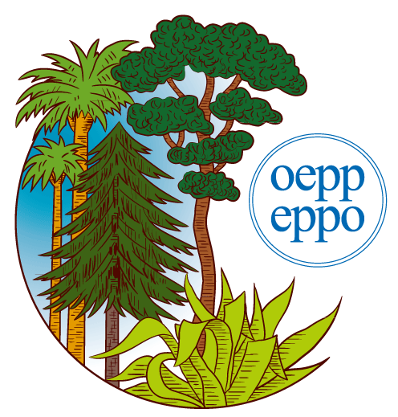 | EUROPEAN AND MEDITERRANEAN PLANT PROTECTION ORGANIZATION  ЕВРОПЕЙСКАЯ И СРЕДИЗЕМНОМОРСКАЯ ОРГАНИЗАЦИЯ ПО КАРАНТИНУ И ЗАЩИТЕ РАСТЕНИЙ  ORGANISATION EUROPEENNE ET MEDITERRANEENNE POUR LA PROTECTION DES PLANTES

To: Mr Avetik Nersisyan
Plant Production and Protection Officer
Copy to: Ms Fernanda Guerrieri
Regional FAO Office for Europe and Central Asia, Budapest

12/18024

Paris, 25 July 2012

TECHNICAL REPORT
ON THE ORGANIZATION OF THE WORKSHOP FOR CENTRAL ASIAN AND EASTERN EUROPEAN COUNTRIES ON DRAFT INTERNATIONAL STANDARDS FOR PHYTOSANITARY MEASURES

Ref: REU/LoA/2012/002

Date and place of the Workshop

The Workshop was held from Tuesday 17 July to Friday 20 July 2012 in Bykovo, Moscow region, Russia

FAO-supported speaker

1. Ms Astra Garkaje (Latvia)
2. Mr Vaclovas Kucinskas (Lithuania)
3. Ms Olga Junus (Estonia)

IPPC-supported speaker

1. Mr Craig Fedchock (IPPC Secretariat)

EPPO-supported speaker

1. Mr Ringolds Arnitis (EPPO Secretariat)

Draft agenda of the workshop prepared (attached)

PowerPoint presentations, submitted by the FAO-supported speaker (in Russian)

1. Updated review of EPPO - R. Arnitis (EPPO Secretariat)
2. Draft Appendix to ISPM 12: Electronic certification, information on standard XML schemes and exchange mechanisms (2006-003) – A. Garkaje (Latvia)
3. Protocol to determine host status of fruits and vegetables to fruit fly (Tephritidae) infestations (2006-031) – V. Kucinskas (Lithuania)
4. Draft Annex to ISPM 26: Establishment of fruit fly quarantine areas within a pest free area in the event of an outbreak (2009-007) – O. Junus (Estonia)
5. Implementation problems of ISPM No. 13 and possible actions to improve the current situation – C. Fedchock (IPPC Secretariat)
6. Implementation problems of ISPM No. 15 and possible actions to improve the current situation – C. Fedchock (IPPC Secretariat)
7. Provision of technical resources by the NPPOs for the phytosanitary info page – C. Fedchock (IPPC Secretariat)
8. Fulfillment of reporting obligations in the IPP – C. Fedchock (IPPC Secretariat)
9. Regional priorities for capacity development activities in the region – C. Fedchock (IPPC Secretariat)

Information about the Workshop

The Workshop lasted 4 days, according to the programme. Nine presentations (see above) were made, followed by questions and discussions.

The Workshop was attended by 50 participants coming from 20 countries including speakers and observers. Participants’ background included management, inspection, research and regulation in the field of plant quarantine. The comments received regarding the organization and content of the Workshop have been largely positive.

The material distributed to the participants of the Workshop included dissemination material in English and Russian provided by EPPO, IPPC and FAO.

Publication of presentations

There are no plans to publish proceedings of the Workshop as a separate publication. All presentations were made available to participants, speakers and observers. Summary of the Workshop will be published on the EPPO website. A brochure (attached) was printed for participants with the list of participants, Workshop agenda, and presentations.

Financial statement

The expenditure remained within allocated budget. A detailed Statement of Expenditures has been submitted.

Summary overview of draft International Standards for Phytosanitary Measures (ISPMs) and summary of discussions

The agenda for the Workshop prepared by the IPPC Secretariat was primarily focused on engaging Russian-speaking experts and experts from countries of former Yugoslavia in generating comments on the IPPC draft standards (and/or amendments to standards) currently open for review and comment under IPPC country consultation procedure. The Workshop also aimed to discuss the implementation of ISPMs 13 and 15 as well as some issue of information exchange (using NPPOs technical resources and IPP) and regional capacity development. This discussion was intended to ensure that Russian-speaking experts and experts of former Yugoslavia countries were fully informed of the details of these issues. The meeting was conducted in Russian and English languages.

Three draft ISPMs (and/or amendments to ISPMs) has been discussed at the Workshop (IPPC’s on-line comment system (OCS) being not downloadable for some technical reasons, all comments were made by the Workshop in Word format for future transmission to OCS):

1. Draft Appendix to ISPM 12: Electronic certification, information on standard XML schemes and exchange mechanisms (2006-003) (given by A. Garkaje) generated several discussions, the most important on the term “electronic certification” and “electronic certificates”. Participants decided that the term “electronic certification” was not consistent with the Glossary definition of “phytosanitary certification” and should be replaced where it is possible by “issuance of electronic phytosanitary certificates” to avoid confusion. They also proposed to avoid the use of term “phytosanitary certificate for export” to avoid confusion because only two terms are used in IPPC: “phytosanitary certificate” and “phytosanitary certificate for re-export”.

2. Presentation on the protocol to determine host status of fruits and vegetables to fruit fly (Tephritidae) infestations (2006-031) (given by V. Kucinskas) entailed discussions with a lot of editorial and technical corrections, for example the repetitive use of the term “surveillance” in a non-Glossary sense.

3. Presentation on draft annex to ISPM 26: Establishment of fruit fly quarantine areas within a pest free area in the event of an outbreak (2009-007) (given by O. Junus) did not provoke conceptual discussions but a lot of editorial and technical changes were proposed: to correct the term “endemic” wrongly used instead of “native”, to replace “removal of quarantine status” by “withdrawal of quarantine status”, etc.

All comments of the Workshop to the discussed documents were formulated in Russian and translated into English during the meeting.

Presentations on implementation problems of ISPMs № 13 & 15 (given by C. Fedchock) provided details to participants on the concerns on implementation of these standards and related real and potential problems. Participants are expected to react to these presentations by sending their comments to the IPPC Secretariat.

Presentations on technical resources by the NPPOs for the phytosanitary info page and fulfillment of reporting obligations in the IPP (given by C. Fedchock) entailed a discussion on the problems of getting information by NPPOs on phytosanitary regulations of importing countries raised by Ukraine. Participants agreed to continue this discussion at the next workshop. Another problem raised by several countries was the difficulty for NPPOs to get new password for IPP from IPPC in case when the ancient contact person leaves the service.

The presentation on regional priorities for capacity development activities in the region (given by C. Fedchock) also was of high interest for participants. Russia wondered on whether it would be possible to invite European Union experts to a similar workshop to get clarification on EU phytosanitary regulations. FAO explained that it could organize not only international but also national workshops inviting resource persons requested by the target country. Armenia wondered whether it would be possible to organize a workshop on PRA for Armenia inviting foreign experts in PRA. FAO explained that it would be possible to organize this and that the NPPO of Armenia should officially contact FAO on this subject.

The organization and support provided to participants from Russian NPPO was excellent. The meeting ran consistently within the intended timeframes, and the level of participation from all participants was very high. The comments were well thought out and indicative that the participants had a good familiarity with the material being discussed.

As a final discussion point, there was a general consensus, after some discussion, that the next EPPO/FAO Workshop for Russian-speaking Central Asian and Eastern European experts should cover the topic of pest reporting and exchange of phytosanitary information involving implementation of ISPMs 8, 9, 13 and 17, and Latvia invited to host this workshop approximately in May 2013.

Ringolds Arnitis
Director General of EPPO

Paris, 2012-07-30

