Official ports of the entry of agricultural commodities and plant quarantine purposes in SURINAME
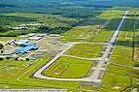
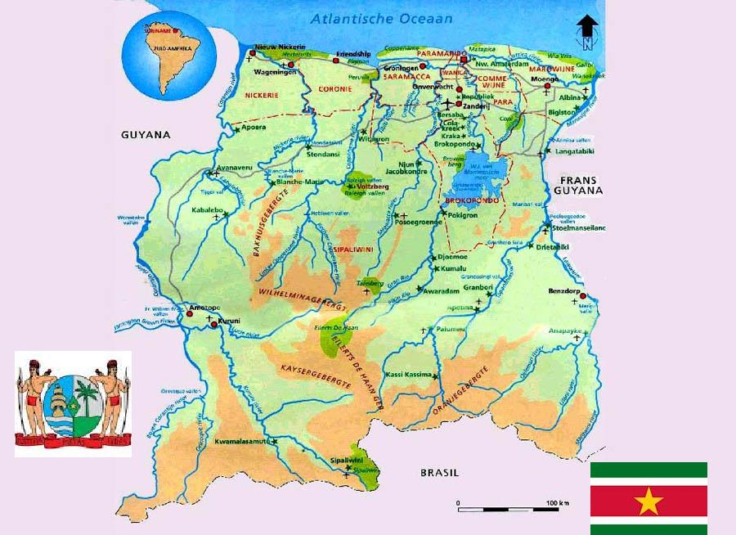
Para: Airport : Johan Adolf
Pengel luchthaven
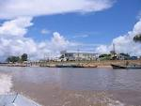
Marowijne : port of entry :Albina
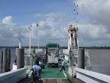
Nickerie : port of entry : South Drain
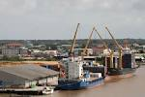
Paramaribo: Sea port: Nieuwe Haven

Ministry of Agriculture, Animal Husbandries and Fisheries
Directorate Agricultural Research, Processing and Marketing
Department: Plant Protection
Email:ppsur@sr.net

